[Type the company name]
Safety Staff Reference Guide
October 2016

Table of Contents
Overview of Click® Safety 2
Workflow States and Transitions 3
Actions and State Transitions 4
Terms Used in This Quick Reference 6
Roles in Click Safety 6
Navigation and Basic Tasks 7
Where do I find? 7
What do I do? 7
Open a Submission 7
View Submission History 7
Find All Submissions 8
Find specific entries in a table 8
Assign a Safety Specialist 9
Where do I start? 9
Assign a Safety specialist 9
Initiate a BSO or Member Review 10
Where do I start? 10
Send Submission to BSO or Member Review 10
Send Submission into Committee Review 11
Where do I start? 11
Submit specialist’s review to the Safety committee 11
Approve a Submission Administratively 12
Where do I start? 12
Approve the Submission 12
Submit the Committee Review 13
Prerequisites for this task 13
Where do I start? 13
Characterize the review and submit 13
Manage the Determination Letter 14
Where do I start? 14
Prepare the determination letter 14
If needed, have the letter reviewed 14
Make any changes requested 14
When ready, send the letter to the PI 14
Review the Determination Letter 15
Where do I start? 15
Review the determination letter 15
Request any needed changes 15
Alternatively, make changes yourself 15
Verify Required Modifications 16
Where do I start? 16
View and comment on modifications 16
Request committee member review 16
Request clarification or changes 16
Send the submission to Post-Review 16
Set Up Ancillary Reviews 17
Where do I start? 17
Set up the review 17
Submit an Ancillary Review 18
Where do I start? 18
Submit the review. 18
Suspend a Protocol 19
Where do I start?: 19
Suspend the protocol. 19
Lift Suspension from a Protocol 20
Where do I start? 20
Lift the suspension. 20
Manage Committee Meetings 21
Open a Meeting 21
Create a New Meeting 21
Run a Meeting 21

Overview of Click® Safety
The Click® Safety solution enables protocol teams to submit safety protocols and follow-on submissions (amendments and continuing reviews) for review by the Safety committee and other personnel with safety-related roles. The Click Safety system shepherds protocols through a series of states based on the actions of personnel participating in the review cycle.
- A member of the protocol team enters a new protocol into the system, which puts it into the Pre-Submission state. When the PI submits it for review, its state changes to Specialist Review.
- During Specialist Review, the Safety specialist assigned to oversee this process reviews the protocol and determines which additional reviews (if any) are needed—biosafety officer review (for biosafety protocols only), member review, and/or committee review. If the protocol goes through a biosafety review or member review, the protocol returns to the assigned specialist when that review is complete so the specialist can determine the next course of action. When a protocol is in the Specialist Review state, the specialist can decide to administratively approve the protocol thereby bypassing committee review and moving it directly to the Post-Review state.
At any point during a specialist, biosafety, or member review, a reviewer can request changes to the protocol resulting in a back and forth exchange between the PI and reviewer before the reviewer submits a review.
- After all the requested biosafety and member reviews are complete, if the specialist determines a committee review is needed, the specialist submits a review and the protocol moves to the Committee Review state. The appropriate Safety committee reviews the protocol during a committee meeting. The committee can also request clarification from the protocol team as needed to come to a determination.
- Generally, the specialist enters the committee determination in the system, which moves the protocol to the Post-Review state. During Post-Review, the specialist prepares the decision letter and sends it to the protocol team.
If the protocol is approved, the submission moves to the Approved state. If not approved, depending on the determination, the protocol might cycle back through some part of the review process again.
- Once the protocol is approved, the protocol team can submit amendments as needed and continuing reviews as required by the institution. Amendments and continuing reviews follow the same review process as the original protocol submission. An approved protocol can have only one outstanding amendment or continuing review at a time.
The Click Safety workspace displays the high-level view of the review process shown below, highlighting the stage of the process the protocol is currently in.
High-Level View of the Safety Review Process
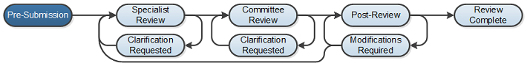

Workflow States and Transitions
This diagram shows some of the more common states and transitions a safety protocol might go through during the review process. The workflow a submission actually follows depends on the actions, choices and data entered at different junctures. Though most actions can be performed by multiple roles, this diagram shows the roles that typically perform certain actions. When the submission is in an editable state (highlighted in yellow below), a member of the protocol team edits it as needed and submits or resubmits it.
Approval Withheld
Approved
Modifications Required

Pre-Submission

Lorem ipsum dolor sit amet, consecte
_{Lorem ipsum dolor sit amet,}
Lorem ipsum dolor sit amet, consectetur
_{Lorem ipsum dolor sit amet}
_{Lorem ipsum dolor}
_{Lorem ipsum}
Protocol team member
creates a protocol.
PI submits the protocol.
Specialist administratively approves the submission.
Specialist submits
a review.
Clarification Requested
Legend
Regular submission state
States in which submission can be edited
Submit or approve
Request an optional review or verification
Request or require clarification or modification

Specialist submits the committee review.
Specialist sends a determination letter.
Clarification Requested
Determination from Committee Review
Modifications Required
Approved
Approval Withheld
Specialist administratively verifies that the required changes have been made.
Clarification Requested
Post-Review
Specialist Review
Chair Letter Review
Committee Review
Member Review
BSO Review
Clarification Requested
Modifications Review by Member
Specialist sends submission to member review.
Committee member sends submission to specialist review.
Modifications Review
The table on the next page lists all actions that change the state of the submission and the roles that can perform them. (For role definitions, see Roles in Click Safety on page 6.)

Actions and State Transitions
In this state… | These roles… | Can perform these actions… | Changing the submission state to…
(No State) | Any registered user | Create a new safety protocol | Pre-Submission
Pre-Submission | Principal Investigator or PI Proxy | Submit | Specialist Review
Specialist Review | Safety Specialist | - Send to BSO Review | BSO Review
 |  | Send to Member Review | Member Review
 |  | Approve Submission (Admin) | Post-Review
 | Safety Specialist,  Safety Administrator | Request Clarification by Specialist | Clarifications Requested (Specialist Review)
 | Safety Specialist | Submit Specialist Review | Committee Review
Clarification Requested  (Specialist Review) | Principal Investigator or PI Proxy | Submit Response | Specialist Review
BSO Review | Biosafety Officer | Submit Biosafety Risk Assessment | Specialist Review
 |  | Request Clarification by BSO | Clarification Requested (BSO Review)
Clarification Requested  (BSO Review) | Principal Investigator or PI Proxy | Submit Response | BSO Review
Member Review | Committee Member,  Safety Specialist,  Safety Administrator | Submit Member Review | Specialist Review
 | Committee Member | Request Clarification by Member | Clarification Requested (Member Review)
Clarification Requested  (Member Review) | Principal Investigator or PI Proxy | Submit Response | Member Review
Committee Review | Safety Specialist,  Safety Administrator,  Committee Chair | Submit Committee Review | Post-Review
Clarification Requested  (Committee Review) | Principal Investigator or PI Proxy | Submit Response | Committee Review
Post-Review | Safety Specialist,  Safety Administrator | Forward Letter for Review. (A determination letter must be prepared beforehand.) | Chair Letter Review
 | Committee Chair,  Safety Specialist,  Safety Administrator | Send Letter (A determination letter must be prepared beforehand.) | A state reflecting the committee decision entered during the Submit Committee Review action:
 |  |  | - Approved  - Approval Withheld | - Modifications Required  - Deferred
Chair Letter Review | Safety Specialist,  Safety Administrator,  Committee Chair | Send Letter (A determination letter must be prepared beforehand.) | A state reflecting the committee decision entered during the Submit Committee Review action:
 |  |  | - Approved  - Approval Withheld | - Modifications Required  - Deferred
 | Committee Chair | Request changes to Letter | Post-Review
Modifications Required | Principal Investigator or PI Proxy | Submit Response | Modifications Review
Modifications Review | Safety Specialist | Send to Member Review | Modifications Review by Member
 |  | Request Clarifications by Modifications Reviewer | Modifications Required
 |  | Verify (Admin) | Post-Review
Modifications Review by Member | Committee Member | Submit Modifications Review Findings | - Specialist Review (if committee review is required)  - Post-Review (if committee review is not required)
Approval Withheld | Principal Investigator or PI Proxy | Submit Response | Specialist Review
Approved | Principal Investigator,  Protocol team members | Request Closure | Closure Requested
 | Safety Specialist,  Safety Administrator | Suspend | Suspended
 |  | Close Protocol | Closed
Closure Requested | Safety Specialist,  Safety Administrator | Close Protocol | Closed
 |  | Request Clarification from Specialist | Clarification Requested (Closure Requested)
Clarification Requested (Closure Requested) | Principal Investigator or PI Proxy | Submit Response | Closure Requested
 |  | Withdraw Closure Request | Approved
Deferred | Principal Investigator or PI Proxy | Submit Response | Specialist Review
All states before Post-Review | Assigned Principal Investigator,  Protocol team members | Discard | Discarded
All states before Post-Review except Pre-Submission | Assigned Principal Investigator,  Protocol team members | Withdraw | Pre-Submission

Terms Used in This Quick Reference
Term | Definition
Protocol | A “safety protocol.” Documents the aspects of a research project that pose a potential safety risk to humans or animals and the precautions that will be taken to mitigate those risks. In this Quick Reference, “protocol” also refers to the representation of a safety protocol in the Safety solution.
Submission | A protocol, amendment or continuing review defined in the Safety solution that has been submitted for review.

Roles in Click Safety
Some of the Safety roles defined below are fundamental, predefined user roles, but others are secondary, contextual roles that must be explicitly assigned in Click Safety. For example, ”Study Staff” is a fundamental user role, whereas “PI” is a contextual role; a user with the Study Staff role must be explicitly assigned the role of “PI.” For additional information on roles, see the Safety Deployment Guide.
Position | Typical Activities
PI | The Principal Investigator (PI) listed on the submission. While others assist the PI in developing and editing the submission, only the PI (or designated PI proxies) can submit the protocol or follow-on submission to start the review process.
Protocol Team | Individuals involved in developing the submission and listed on the submission as protocol team members. The protocol team always includes a PI but can also include a PI proxy, other co-investigators, science contributors, and administrative staff.
Safety Specialist | Individuals who guide submissions through the review process. The specialist reviews a newly submitted protocol for completeness, determines the level of review it needs, and ensures correspondence with the PI is completed in a timely manner.
Biosafety Officer | Individuals responsible for reviewing biosafety protocols and follow-on submissions.
Committee Member | Individuals on a Safety committee.
Committee Chair | A Safety committee member assigned to chair the committee.
Safety Administrator | An individual with Safety oversight responsibilities. Can perform the same actions as specialists, but is typically less involved in the day-to-day processing of submissions.
Committee Administrator | An individual responsible for managing committee meetings. See Manage Committee Meetings on page 21 for tasks this person performs.
Site Manager | An individual who has system-wide access. This includes full access to security and system settings, and all data, workspaces, activities, and actions in the system.

Navigation and Basic Tasks
When you first log in, you will be on the My Inbox page. This topic shows where to find Safety submissions and the basic tasks you will perform.
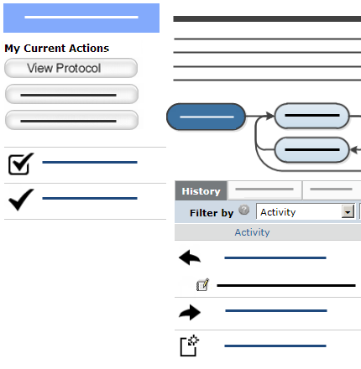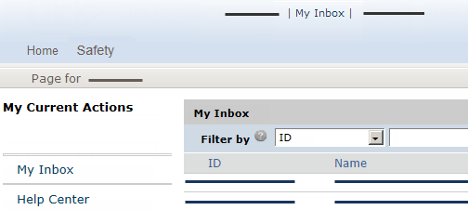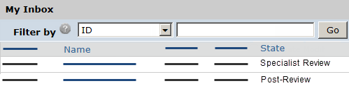  Submission Workspace  2  4  3  5  7  1  My Inbox page  6 | Where do I find?
- From My Inbox, you can find: Submissions that require you to take action.
- Shortcuts to other items such as the Help Center.
 | What do I do?
- Review the state of submissions in My Inbox. The state gives a clue as to what to do next.
For example, “Specialist Review” means the submission is currently ready for review or being reviewed by a Safety specialist.
 | Open a Submission
- From My Inbox, click the submission name.
- The submission workspace opens.
 | View Submission History
- If the History tab is not already displayed in the submission workspace, click it.
- The history lists the activity taken on a submission including any comments, attachments, or correspondence added.

Navigation and Basic Tasks (Continued)
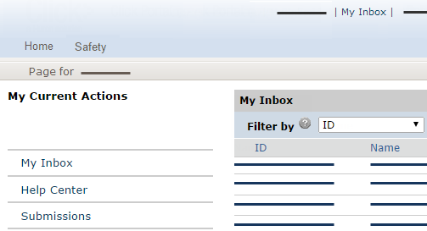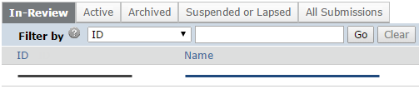  8  10  12  14  13  9  11 | Find All Submissions
- On the left, click Submissions.
- Click the appropriate tab to see all of your submissions:
- In-Review: All submissions undergoing Safety committee review
- Active: All approved submissions
- Archived: All discarded and closed submissions
- Suspended or Lapsed: All submissions that have been suspended or whose annual review due dates have passed
- All Submissions: All submissions, in any state
 | Find specific entries in a table
To find one entry or set of entries in a table, use the Filter by feature:
- Select the column to filter by.
- Type the beginning characters for the entries you want to find. You can also type a % symbol as a wildcard before the characters. For example:
- 71 shows all items
beginning with 71
- %71 shows all items containing 71
- For a list of special search operators you can type in the text box, click the Help icon.
- Click Go to apply the filter.
- To combine multiple filter criteria, click Advanced and then click Add Another Row.

Assign a Safety Specialist
After the PI submits a protocol or follow-on submission for review, it appears in the Inbox of all Safety specialists for the administrative office specified in the protocol. The first step is to assign a specialist to handle the submission. Any user with the specialist or administrator role can do this.
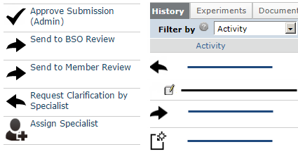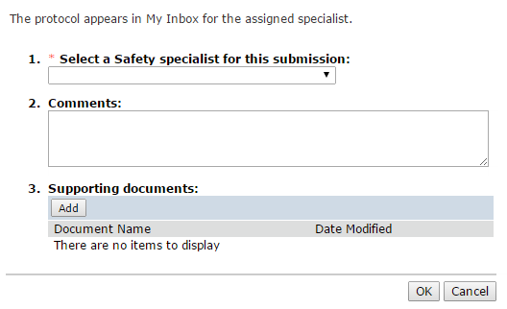  1  2  3  4 | Where do I start?
 | - From My Inbox or the In Review submission tabs, click the submission name.
 | Assign a Safety specialist
- From the submission workspace, click Assign Specialist on the left.
- Select a Safety specialist from the list.
- Click OK.
Note: You can also assign a specialist on the page that appears when you submit a specialist review or administratively approve a submission.
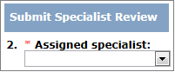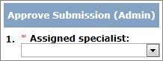

 | Once you assign a specialist, when the submission enters a state requiring specialist attention, it appears only in the assigned specialist’s Inbox.

Initiate a BSO or Member Review
As the assigned specialist, you might decide that you want a review performed by the biosafety officer or a particular committee member.
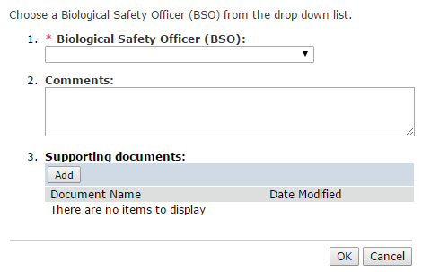  2  3  4  1 | Where do I start?
 | - From My Inbox or the In Review submissions tab, click the submission name.

Send Submission to BSO or
Member Review
- From the submission workspace, click Send to BSO Review or Send to Member Review.
- Select the biosafety officer or committee member.
- Click OK.
The submission returns to the assigned specialist’s inbox.

Send Submission into Committee Review
As the assigned specialist, you can send a submission that is in the Specialist Review state into committee review. Alternatively, you can send the submission to a biosafety officer or committee member for review first, or approve it administratively instead. See Initiate a BSO or Member Review on page 10 or Approve a Submission Administratively on page 12.
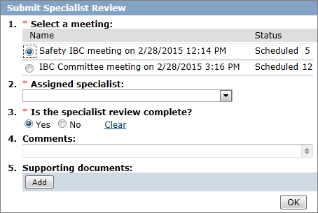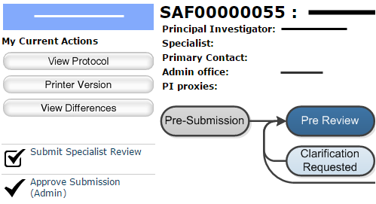  1  2  4  3  5  7  6 | Where do I start?
 | - From My Inbox or the In Review submissions tab, click the submission name.
 | Submit specialist’s review to the Safety committee
- From the submission workspace, Click Submit Specialist Review.
- Select a committee meeting.
- If not already assigned, select yourself or another specialist to handle this submission.
- Select Yes to indicate you completed the review.
- Add any comments or supporting documents.
- Click OK to send the submission to committee review.
See Manage Committee Meetings on page 21 to set up meetings and perform meeting related tasks.

Approve a Submission Administratively
If you determine a committee review is not necessary, as the assigned specialist, you can administratively approve a submission that is in the Specialist Review state, sending it directly into Post-Review.
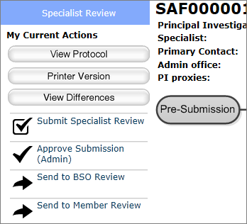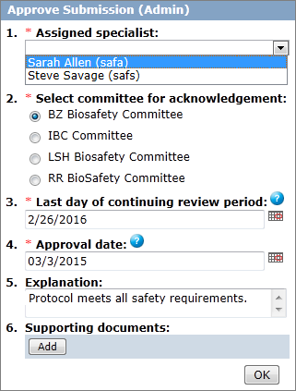  2  3  4  8  7  5  6 | Where do I start?
 | - From My Inbox or the in Review submissions tab, click the submission name.
 | Approve the Submission
- After any reviews you requested have been submitted, in the Submission workspace, click Approve Submission (Admin).
- If not already assigned, select yourself or another specialist to handle this submission.
- Select the committee to acknowledge that the submission has been approved.
- The last day of the continuing review period populates automatically, but you can override this date.
- Select the date you are approving the submission.
- Add any comments or supporting documents.
- Click OK.
The submission enters the Post-Review state, which enables you to manage the approval letter.

Submit the Committee Review
Once the Safety committee has reviewed a submission and determined how to handle it, a specialist typically records the committee’s decisions by submitting the committee review.
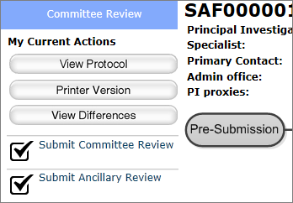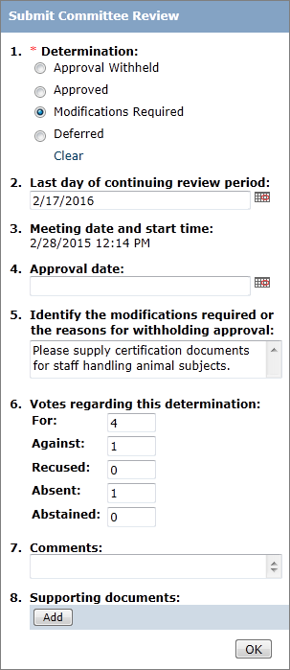  2  3  5b  (If needed)  6  5a  7  4 | Prerequisites for this task
- The submission is in the Committee Review state.
- You are logged in with the safety administrator, safety specialist or committee chair role.
 | Where do I start?
- Open the submission.
- Click Submit Committee Review.
 | Characterize the review and submit
- Select your determination.
- The last day of the continuing review period populates automatically. However, if necessary, you can modify this date.
- If the committee…
  - Approved the submission: Select the approval date (typically the committee meeting date).
  - Withheld approval or required changes:
Type those details in the Identify... box.
- If desired, you can also document the committee’s vote, supply additional comments, and attach supporting documents.
- Click OK to submit the committee review.
The submission enters the Post-Review state, which enables you to notify the PI of the review decision.

Manage the Determination Letter
When a submission enters the Post-Review state, Safety staff or the committee chair can prepare and send the determination letter. If a staff person prepares the letter, he or she can forward it for review by the committee chair.
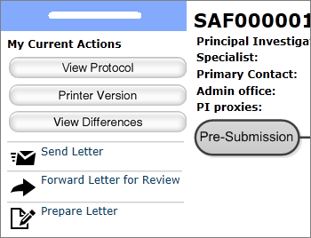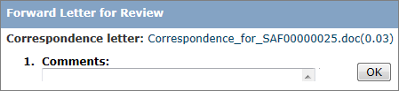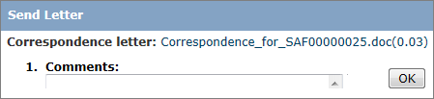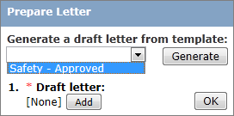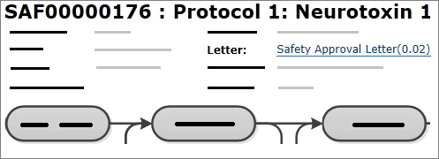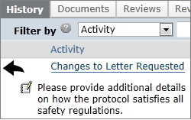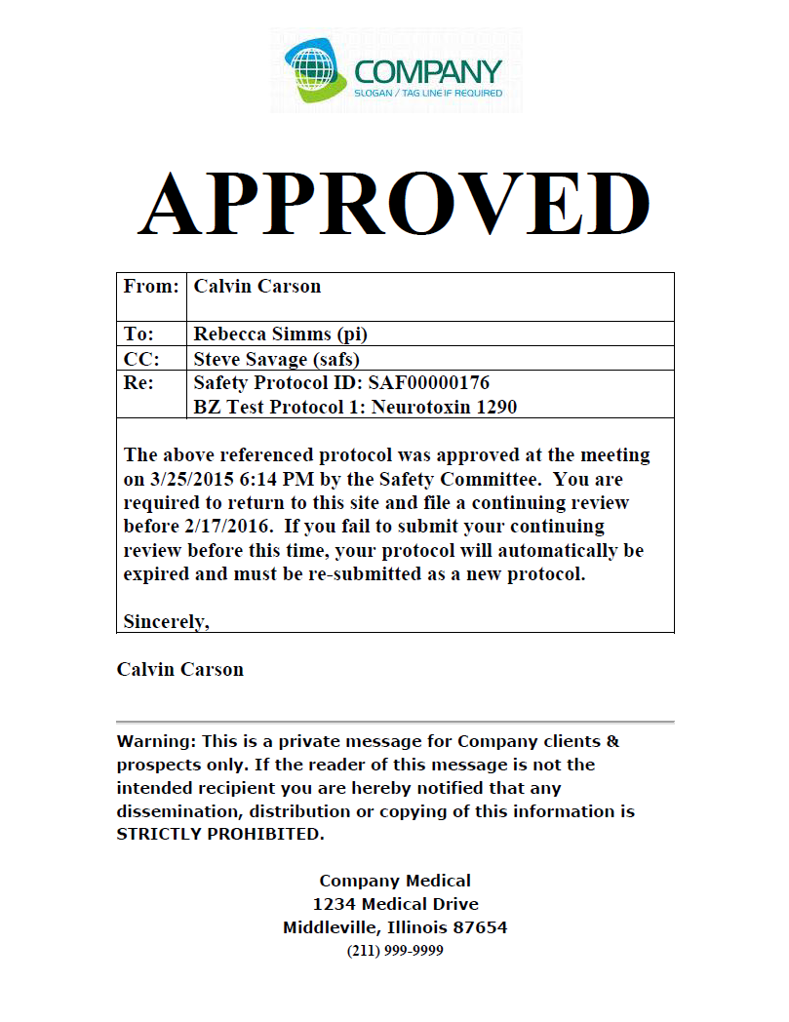  2  13  7  6  14  3a  b  3b  4  b  5  9  8  10 | Where do I start?
 | - From My Inbox, click the submission.
 | Prepare the determination letter
- From the submission workspace, click Prepare Letter.
- To create a letter from a template:
  - Select a letter template.
  - Click Generate.
- Alternatively, click Add, then navigate to a prepared document.
- Click OK.
 | If needed, have the letter reviewed
- Click Forward Letter for Review.
- Click OK.
The state changes to Chair Letter Review and the submission appears in the chair’s Inbox.
 | Make any changes requested
- Read the change request on the History tab.
- Click the letter name to open.
- Revise the letter and save it.
- Repeat 4–5 to upload the letter.
- Repeat 6–10 for another review.
 | When ready, send the letter to the PI
- Click Send Letter.
- Click OK.
Depending on the determination selected in Committee Review, the state changes to Approved, Modifications Required, Approval Withheld or Deferred.

Review the Determination Letter
As committee chair, you might receive determination letters to review before they are sent.
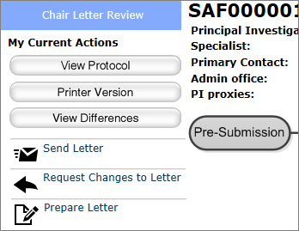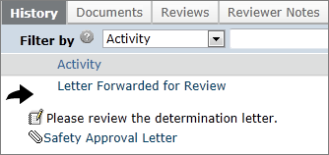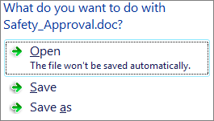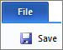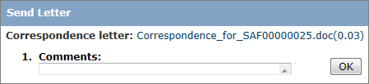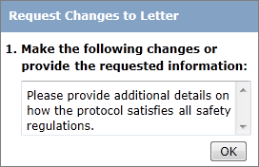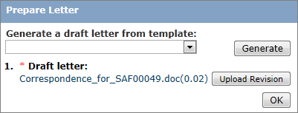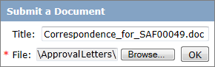  2  3  5  8  6′  4  Committee  Chair changes  9  7  6  5′  7′  8′  9′  10 | Where do I start?
 | - From My Inbox click the submission.
 | Review the determination letter
- On the History tab, under Letter Forwarded for Review, click the name of the letter.
- On the resulting query, click Open.
- Examine the letter.
 | Request any needed changes
5. From the workspace, Click Request Changes to Letter.
6. Describe the requested changes.
7. Click OK.
The state changes to Post-Review and the submission reappears in the specialist’s Inbox.
8. From the submission workspace, click Send Letter.
9. Click OK.
Depending on the determination selected in Committee Review, the state changes to Approved, Modifications Required, Approval Withheld or Deferred.
 | Alternatively, make changes yourself
5′. Make the needed revisions to the determination letter and save it.
6′. Click Prepare Letter.
7′. Click Upload Revision.
8′. Upload the revised letter.
9′. Click OK.
10. Click OK on the Prepare Letter page.
11. Send the letter as described in 8a–9a.

Verify Required Modifications
When a PI resubmits a protocol with modifications that the Safety committee required for approval, the submission moves to the Modifications Review state. The Safety specialist then verifies the modifications as described below.
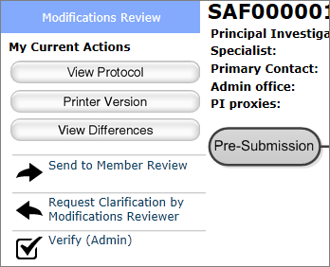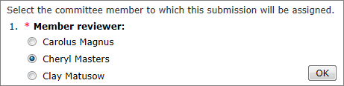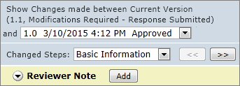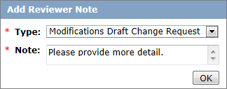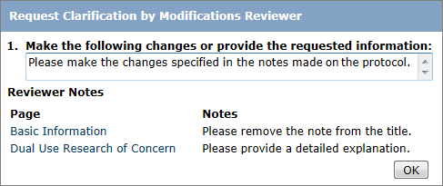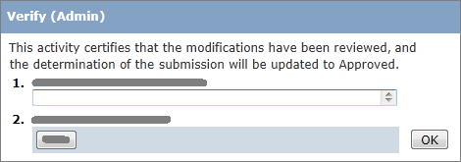  11  8  5  6  7  2  4a  4b  4c  4d  3  9  10  12 | Where do I start?
 | - From My Inbox or the In Review submissions tab, click the submission name.
 | View and comment on modifications
- From the submission workspace, click View Differences.
- Click the directional buttons to page through the modifications.
- To comment on a modification:
  - In the Note bar click Add.
  - Select the type of note to add.
  - Type your question or comment.
  - Click OK.
Based on your assessment, perform one of the following three tasks.
 | Request committee member review
- From the submission workspace, Click Send to Member Review.
- Select the committee member.
- Click OK.
The state changes to Modifications Review by Member.
 | Request clarification or changes
- From the submission workspace, click Request Clarification by Modification Reviewer.
- Describe the required changes.
- Click OK.
 | Send the submission to Post-Review
- From the submission workspace, click Verify (Admin).
- Click OK.
The determination changes to “Approved,” and the submission returns to Post-Review.

Set Up Ancillary Reviews
Principal Investigators can set up ancillary reviews when a submission is in any editable state, and Safety staff can do so anytime from protocol creation through Post-Review). Ancillary reviews occur in parallel with other activities and do not block them. All ancillary reviewers receive notifications stating they have been assigned. In addition, the submission appears in required reviewers’ Inboxes, where it remains until they accept or reject it (see Submit an Ancillary Review on page 18). If a protocol is in the Pre-Submission state, notifications and Inbox updating do not occur until the protocol gets submitted.
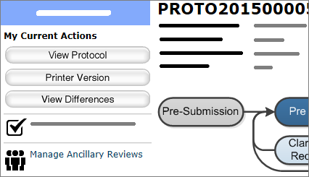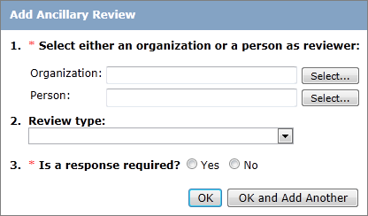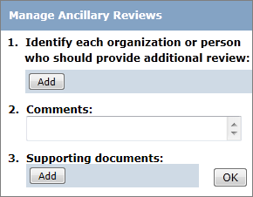  2  4  5  6  7  3  9  8 | Where do I start?
 | - From My Inbox or the In Review submissions tab, click the submission name.
 | Set up the review
- From the submission workspace, click Manage Ancillary Reviews. (Depending on the state of the submission, it may be farther down in the list.)
- Click Add.
- Optionally type comments and upload supporting documents
- Select reviewers by organization or by person.
- Optionally select the type of review.
- Select whether a review is optional or required for the specified reviewers.
- In Add Ancillary Review, click OK or Ok and Add Another.
- When you finish adding reviewers, Click OK in Manage Ancillary Reviews.
The newly added reviewers receive notifications, and if they are required reviewers, the submission appears in their Inboxes.

Submit an Ancillary Review
If you are assigned as an ancillary reviewer for a submission, you will receive an email notification. If your review is required for approval, the submission appears in your Inbox and remains there until you accept or reject the submission.
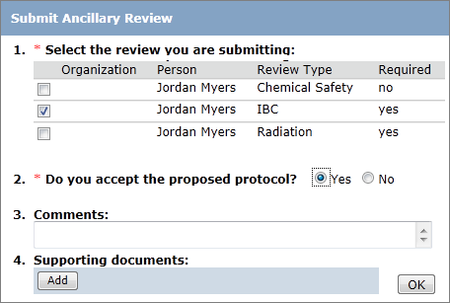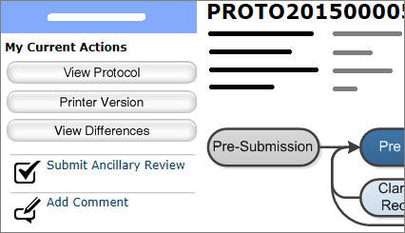  2  4  3  5  6 | Where do I start?
 | - From My Inbox or the In Review submissions tab, click the submission name.
 | Submit the review.
- Click Submit Ancillary Review.
- Select the review you want to submit.
- Accept or reject the submission.
- Optionally type a comment and add supporting documents.
- Click OK.

Suspend a Protocol
In some circumstances, for example a safety violation, the committee might vote to suspend all activity on a project until the problem is resolved. In such cases, a specialist or the Safety administrator suspends the approved submission.
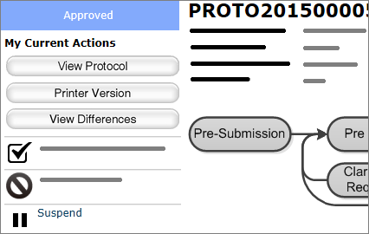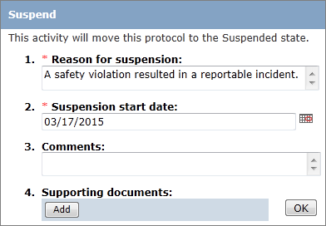  3  4  5  2  6 | Where do I start?:
 | - From My Inbox or the Active submissions tabs, click the name of the submission that you want to suspend.
 | Suspend the protocol.
- From the submission workspace, click Suspend.
- Type the reason for the suspension.
- Select the effective date of the suspension (must be the present date or a date in the past).
- Optionally type additional comments or upload supporting documents.
- Click OK.
The submission changes to the Suspended state. (See Lift Suspension from a Protocol on page 20.)

Lift Suspension from a Protocol
When the situation that warranted suspending a protocol has been addressed sufficiently to resume the project, the specialist or Safety administrator can lift the suspension.
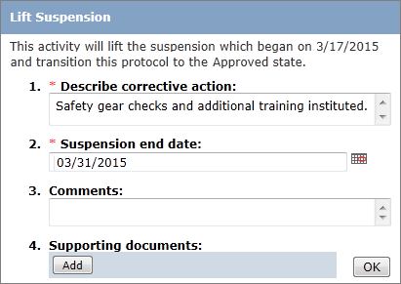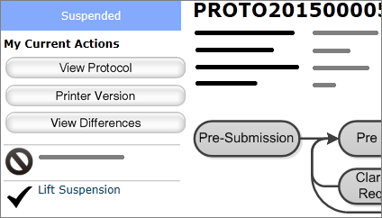  3  5  2  6  4 | Where do I start?
 | - From My Inbox or the Suspended or Lapsed tab, click the name of the submission whose suspension you want to lift.
 | Lift the suspension.
- From the submission workspace, click Lift Suspension.
- Type a description of the corrective action taken that justifies lifting the suspension.
- Select the date the suspension ended (must be the present date or a date in the past).
- Optionally type additional comments or upload supporting documents.
- Click OK.
The protocol returns to the Approved state.
Note: If a submission passes the last day of the continuing review period while suspended, when you lift the suspension, the submission enters the Lapsed state instead of Approved.

Manage Committee Meetings
If you are a committee administrator or oversee committee meetings, you will perform the following activities.
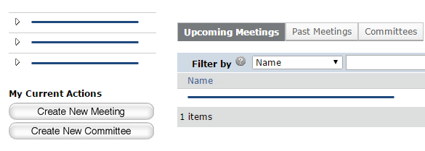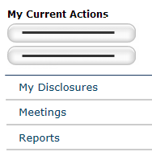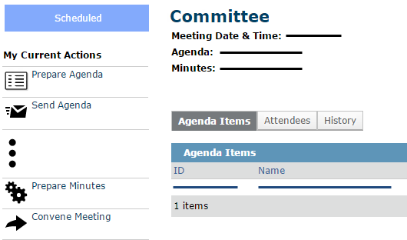  1  4  6a  6b  5  7  2  3 | Open a Meeting
- From My Inbox, click Meetings.
- On the Upcoming Meetings tab, click the name of the meeting to open it.
 | Create a New Meeting
- From the meetings workspace, click Create New Meeting.
- Complete the form and click OK.
The meeting workspace appears.
 | Run a Meeting
From the meetings workspace, open the meeting. See Open a Meeting above.

Before the Meeting:
- To remove an agenda item, click the agenda item name and then Remove from Agenda on the left of the workspace.
- When ready to send out the agenda to committee members:
  - Click Prepare Agenda and generate an agenda or add one to the meeting.
  - Click Send Agenda to e-mail the agenda to committee members.
- To create a minutes document to update during the meeting, click Prepare Minutes and generate the minutes from a template. Save the document and update it during the meeting.
Tip: Use Track Changes in Word so later you can copy your notes into the final minutes document.

