Clarification Requested and/or Modifications Required

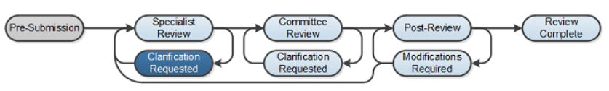

At several points during the review process, the Safety review team may request clarifications or require modifications from the research team prior to making a determination.

Work Instructions

- Log into Click Portal and click on the Safety tab on the top navigation bar which will then display only Safety protocols which is the same as clicking on your “My Inbox”.

- Find the submission requiring clarifications or modifications in which the state is defined as Clarification Requested (Specialist Review) and click on the submission name to navigate to the protocol workspace.
  - Investigators can also navigate directly to the protocol workspace by clicking on the link in the email notification and logging into the system

- Review the requested information by clicking on the Clarification Requested activity in the history log.

- To provide a response, return to the protocol workspace and click on Submit Response under My Current Actions. Write your response in the box provided and/or add any additional supporting documentation and click OK.

- The response submitted will display in the history log and state of the protocol will return back to Pre-Review.

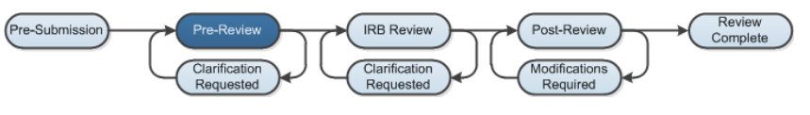

- The Safety review team may also add a note and ask for additional information by adding a Reviewer Note which is available in each SmartForm. At that time, the reviewer can determine if a response is required.

- Find the submission requiring clarifications or modifications in which the state is defined as Clarification Requested (Specialist Review) and click on the submission name to navigate to the protocol workspace.

  - Investigators can also navigate directly to the protocol workspace by clicking on the link in the email notification and logging into the system

- To edit the protocol in response to the reviewer’s note, click on the Reviewer’s Notes tab and then click on the Jump To link within the protocol which will direct you to the SmartForm that has the reviewer’s note.

Note: The Reviewers’ Note tab will only be present if there are notes made by the reviewer.

- From the protocol smart form pages or the Reviewer’s Note tab, click the Click here to respond link

- Select a response from the list and explain your response in the box. Click OK. Exit the protocol and navigate to the protocol workspace

- Click on Submit Response

- In the Comments box, explain your response to the reviewer and Click OK.

The activity is documented under the History tab and the state goes back to Specialist Review.

