Create and Submit a Follow-On Submission

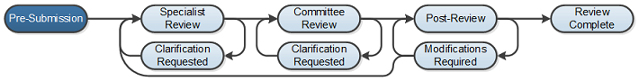

Work Instructions:
- Log into Click Portal and click on the Safety tab on the top navigation bar which will then display only Safety protocols which is the same as clicking on your “My Inbox”.

- Find the protocol in the Approved state that you would like to submit a continuing review for.
  - Users click on the Active tab to find the protocols that are in the Approved state and can click on the name of the protocol to begin their submission.

  - Users can also navigate directly to the protocol by clicking on the link provided in the Continuing Review Reminder email notification that are sent to the PI and Primary Contact 90, 60, 30, and 15 days prior to the protocol’s expiration and then logging into the system.

- From the protocol workspace, Under My Current Actions, select the Create Continuing Review button to create and submit a Follow-On Submission.

- Entering the required information on the first page of the SmartForm and clicking Continue in the top or bottom of the page will create the record.
  - Note that an approved protocol can have only one outstanding amendment or continuing review open at a time.

- Prior to submission to the Safety Specialist, all required fields will need to be completed.
  - Click the Hide/Show Errors link in the header of the SmartForm page to display any unanswered questions throughout the SmartForm at the bottom of the page.
    - Use the Jump To link to navigate directly to SmartForm pages that are missing information.
  - Submissions with any incomplete information will be redirected to the research team for updates.

- When all of the required fields have been completed, click Exit in the header or Finish in the footer of the last SmartForm page to be redirected to the protocol workspace.

- Once all of the above steps have been completed, the PI (or PI Proxy, if identified) must log into the protocol and click the Submit activity. This activity will remind the PI of their responsibilities and the system will check the submission for any missing fields. The PI will need to check that they agree with the statement and then click the OK button to submit the protocol.

- If the submission is successful, the page will refresh and the protocol will transition from the Pre-Submission state to the Specialist Review state.

