IRB Study Work Flow

Study States:
The diagram located in the study workspace will show the state of your study within the IRB review process.
Pre-Submission: During Pre-Submission, the PI will create the study.
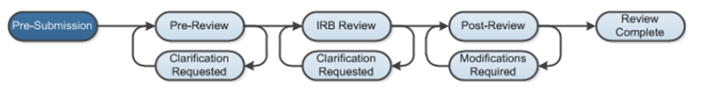
Pre-Review: In the Pre-Review state, the study has been submitted and the IRB coordinator reviews the study.
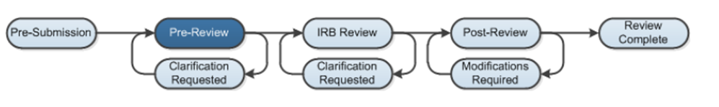
Pre-Review/Clarification Requested: The IRB pre-review staff can send the study back to the study team for more information or clarifications if needed, which lets the study team change the study.
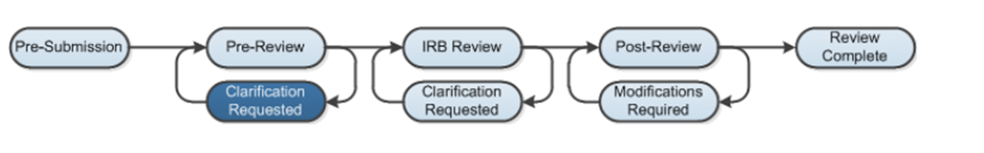
IRB Review: IRB review is where the IRB staff will review the study for completeness.
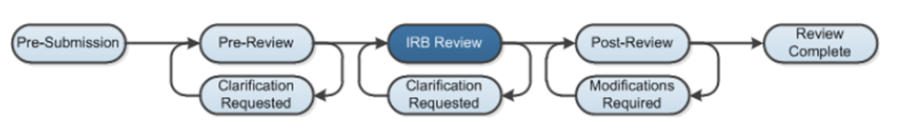

IRB Review / Clarification Requested: The IRB review staff can send the study back to the study team for more information or clarifications if needed, which lets the study team change the study.
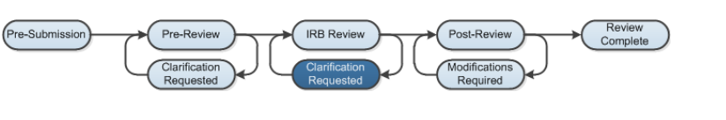
Post-Review / Modifications Required: The Post-Review state gives the IRB staff the opportunity to:
  - Approve documents that were attached to a submission
  - Prepare a letter to inform the study team about the IRB's decision
  - Send the letter
  - Request modifications
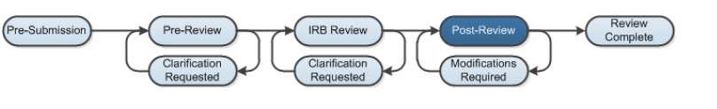
Review Complete: When the study team submits modifications that are acceptable, the submission returns to the Post-Review state. The submission will reach its final determination, Review Complete, after the letter is sent.

