

Huron IRB Staff Quick Reference

Introduction 3
Overview of IRB 3
Submission Types in IRB 3
Roles in IRB 3
Common Rule Requirements 5
Overview of the Submission Review Process 6
Ancillary Review Process 7
Continuing Review (CR) and Modification Process 7
External IRB Process for a Single-Site Study 8
Study, Modification, and CR States and Transitions 9
Reportable New Information Process 11
Reportable New Information States and Transitions 13
Complete a Pre-Review 15
Request Clarification on a Submission 16
Compare 17
Submit a Pre-Review 18
Confirm Reliance with the External IRB 19
Record the sIRB Decision for an External Study 19
Update an Approved, Single-Site External Study 20
Report Continuing Review Data for an External Study 21
Assign a Designated Reviewer 22
Assign to Committee Review 24
Submit a Committee Review 25
Post-Review Activities 25
Navigation and Basic Tasks 26

Introduction
Note that this guide covers information and tasks relevant to single-site studies, including initial single-site study submissions, external single-site study submissions, and single-site follow-on submissions (modifications, continuing reviews, and reportable new information).
For information related to multi-site studies under single IRB of record review, please see the Multi-Site Submission Quick Reference, found in the Help Center of your IRB system.

Overview of IRB
The IRB system provides a mechanism for creating and tracking studies that require IRB overview. IRB supports the following submission types:

Submission Types in IRB
Type | Description
Initial Submissions
Study | Documents the details of a study that require oversight by an Institutional Review Board. Studies include external studies, single-site studies, and multi-site or collaborative studies.
Site | Documents the study details specific to a particular institution, such as local team members and institution-specific consent forms.
Follow-on Submissions
Modification | Changes or updates to approved studies. The modification submission consists of a form that lists modification details along with the updated study pages.
Continuing Review (CR) | A review of an approved study. The continuing review submission consists of a form on which the researcher records any changes, accidents or other problems that have occurred since the study was approved, or since the previous continuing review.
Reportable New Information (RNI) | A report of new information about an approved study or active research.

Access to a study is based on the role a user is assigned in the IRB system and the role a user plays in relation to a particular study. For example, “Study Staff” is a system-wide role, whereas “PI” is a role in relation to a study; a user with the Study Staff role must be explicitly assigned the role of “PI.” For additional information on roles, see the IRB Deployment Guide.

Roles in IRB
Position | Typical Activities
Registered User | Users authorized to create submissions.
PI | The Principal Investigator (PI) listed on the submission. While others assist the PI in developing and editing the submission, only the PI (or designated PI proxies) can submit the study or follow-on submissions to start the review process.
Study Staff | Individuals involved in developing the study and listed on the submission as study team members. The study team always includes a PI but can also include a PI proxy, other co-investigators, science contributors, and administrative staff.
IRB Coordinator | Individuals who guide submissions through the review process. The coordinator reviews a newly submitted study for completeness, determines the level of review it needs, and ensures correspondence with the PI is completed in a timely manner.
IRB Director | An individual with IRB oversight responsibilities. Can perform the same actions as coordinators, but is typically less involved with the day-to-day processing of submissions.
Committee Member | Individuals on an IRB committee that are responsible for reviewing submissions.
Committee Chair | An IRB committee member assigned to chair the committee.
Committee Administrator | An individual responsible for managing committee meetings. See the Meeting Management Quick Reference for tasks this person performs.
Site Manager | An individual who has system-wide access. This includes full access to security and system settings, and all data, workspaces, activities, and actions in the system.

Common Rule Requirements
Studies in the IRB system may fall under the Pre-2018 or 2018 Common Rule requirements, based on the dates they were created and reviewed, the agencies providing regulatory oversight, and other factors. Institutions can evaluate which Common Rule requirements are applied to a study. There are several ways to do this:
- For new studies, the Common Rule effective date listed in the IRB settings page determines which rule is applied to the study, based on the study’s Pre-Review submission date. For example, if the effective date in the settings is January 19, 2018, studies with a Pre-Review submission date before that date will fall under the Pre-2018 requirements, and studies with a Pre-Review submission date on or after the effective date will fall under the 2018 requirements. For more information on editing this setting, see the IRB Deployment Guide.
- For new external studies, the study team can record which Common Rule requirements are applied during creation of the study.
Note: the decision of which Common Rule requirements the study falls under is made by the external IRB and the local study team should record the requirements communicated to them by the external IRB.
- For existing studies created before the effective date of the 2018 Common Rule requirements, all studies in a draft state or a state past Pre-Review will automatically have the Pre-2018 requirements applied. IRB coordinators and directors can move the study from the Pre-2018 rule to the 2018 rule as part of the continuing review process. When a Pre-Review for a CR is submitted, the IRB coordinator can specify whether the study should remain under the Pre-2018 requirements or be moved under the 2018 requirements.
- In the case of an error or discrepancy, the IRB Director or the Site Administrator can revert a study in a post-approval state from under the 2018 rule to under the Pre-2018 rule. If the study has any active follow-on submissions, they must be completed or discarded before the study can be reverted.
Note: The Common Rule requirements (Pre-2018 or 2018) applied to a study are also applied to any sites related to the study (in the case of external or multi-site studies) and to any follow-on submissions for which it is the parent study.
The Common Rule requirements applied to a study are displayed on the study workspace:
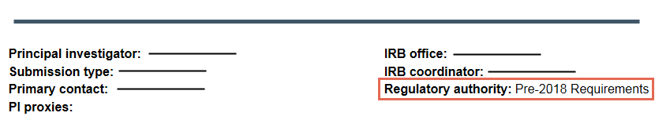

Agency Oversight
If the FDA or DOJ is selected in the Pre-Review form as an oversight agency for a study, the study will automatically fall under the Pre-2018 Common Rule requirements, even if the date of the study falls after the effective date setting of the 2018 requirements. This remains true even if other oversight agencies are selected in addition to the FDA or DOJ.
If, during a continuing review, you edit the Pre-Review form and change the study to fall under the 2018 requirements, the system will not allow the change if the FDA or DOJ remains selected. You must deselect these options in order to move the study under the 2018 requirements.

Exempt Categories
Some exempt categories are only available for studies under the Pre-2018 requirements, and some exempt categories are only available for studies under the 2018 requirements.
When you change a study under the Pre-2018 requirements to fall under the 2018 requirements, a Pre-2018 exempt category may still be displayed, but you will not be able to proceed with the change until it is deselected.

Overview of the Submission Review Process
The basic process for a study—or initial submission—is shown in the following diagram.
- The PI (and study team) creates a study, entering study information on a series of user-friendly pages in the IRB system. While the team is working on the study, it is in the Pre-Submission state, and when they finish working on it, the PI submits the study to the IRB for review.
- The study first goes through Pre-Review, in which an assigned IRB coordinator reviews the study for completeness, ensuring it includes all the necessary information and documentation for the IRB committee member reviewers. At any point during Pre-Review, the IRB coordinator may request clarification or changes from the PI resulting in a back-and-forth exchange between the PI and IRB coordinator. The IRB coordinator also determines if the study should be reviewed by a designated reviewer or the full committee.
- During IRB Review, the designated reviewer or the full committee will review the study.
  - If it is being reviewed by a designated reviewer, that reviewer makes a determination about the study and submits the decision in the IRB system. Before making a decision, however, the reviewer may request clarification or changes from the PI, resulting in a back-and-forth exchange between the PI and designated reviewer.
  - If a full committee reviews the study, a committee meeting occurs in which the committee makes a determination about the study. The committee may also request clarification before making a decision, but they can choose to make a determination without receiving a response. The IRB coordinator submits the decision in the IRB system on behalf of the committee. Submitting a determination in the system moves the study to Post-Review.
- During Post-Review, the IRB coordinator prepares and sends the determination letter to the PI. If the study was approved, the IRB coordinator also creates a final, PDF version of the study documents and the review process is complete (Review Complete). If the committee determines modifications are needed for the study to be approved, the PI can make changes to the study. The IRB coordinator reviews the changes and decides if the study can be approved or must go back through an IRB review (by a designated member or the full committee).
The following diagram illustrates the submission review process, including the roles and states involved in the review, as well as the decision points that govern whether a submission undergoes committee or designated review.
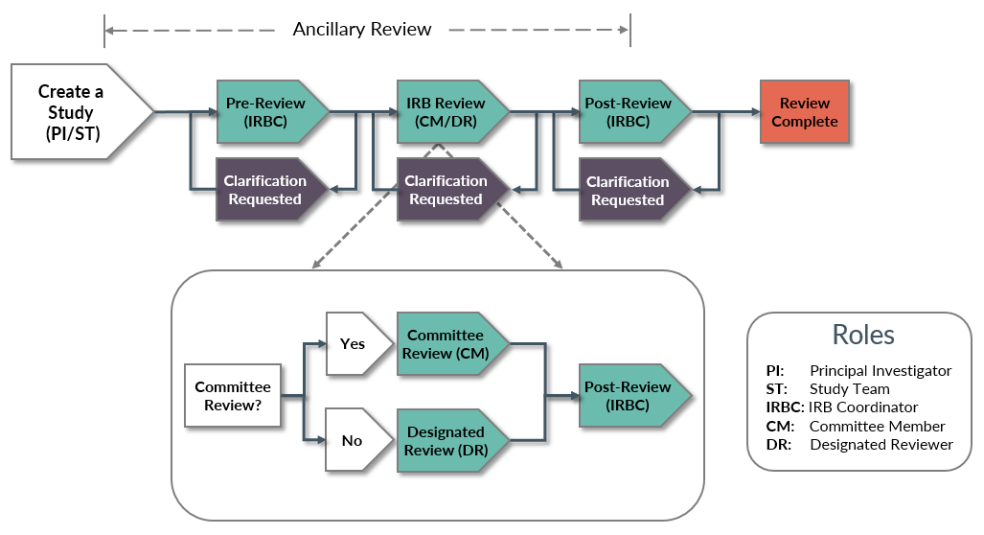

Ancillary Review Process
Ancillary reviews allow individuals, departments, and other organizations to give feedback on the submission in parallel with the IRB review. Both study team members and the IRB staff can add optional or required ancillary reviewers, however, the system does not prevent a submission from being reviewed or approved by the IRB if an ancillary review is outstanding. Refer to your IRB policies about how, when, and whether to interrupt the IRB review process to wait for ancillary reviews.
Ancillary reviews can occur at any time from Pre-Submission to Post-Review, as illustrated below. Study team members can add ancillary reviewers to a submission while it is in Pre-Submission and the IRB staff can add ancillary reviewers at any time before the study transitions from Post-Review to its final state, such as Approved. (Final states fall under the general state of Review Complete in the diagram.)
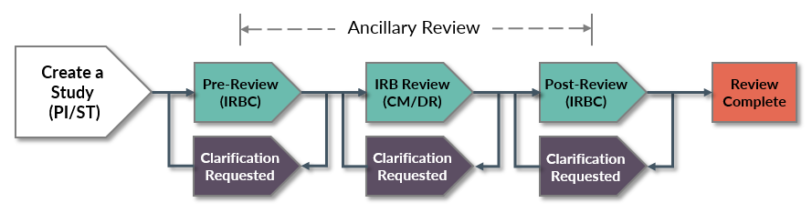

Continuing Review (CR) and Modification Process
Continuing reviews are submitted to close a study or extend the approval period. The IRB periodically reviews all approved studies involving human research. To start the review process, the study team submits a CR for the approved study in the IRB system. After that, the CR follows a similar review process to an IRB study and can also include ancillary reviews that are conducted concurrently with IRB reviews.
Note: Before closing a study via a CR, make sure to discard or approve any active modifications related to the study.
Modifications fall into the following categories: those that affect the study team membership, those that affect other parts of the study, or both. The study team submits a modification for any changes to the approved study; for example, to change the study team membership or update a consent form. Then, the modification follows a similar review process to an IRB study and can also include ancillary reviews that are conducted concurrently with IRB reviews.
If a modification is approved, the changes made in the modification are applied to all active submissions. If an approved modification changes the determination of the parent study, the parent study’s state will be updated according to the new determination.
Note: If multiple follow-on submissions are in progress for the same parent study, while one follow-on submission is being edited, all others are locked.
A modification that is disapproved remains active until the modification is either approved (which applies the modifications to the study) or discarded (in which case, no modifications are applied to the study). No new mods of the same type can be created until the disapproved mod is approved or discarded.

External IRB Process for a Single-Site Study
For a single-site study, when the local IRB cedes authority to an external IRB (or single IRB of record), the local IRB system tracks less information about the study throughout its life cycle. The basic process for reviewing and tracking a single-site external IRB study locally is shown below. Note that single-site external IRB studies do not use Huron’s IRB Exchange. Rather, the local IRB communicates with the external IRB, then records the external IRB’s determination using the Record sIRB Decision activity.
Note: For information on multi-site studies reviewed by an external IRB, see the Multi-Site Study Quick Reference.
- During Pre-Submission when the study team is creating the study, they will indicate that they are using an external IRB. This causes subsequent pages to require less information for the local IRB to review and require information about the external IRB.
- During Pre-Review, the assigned coordinator reviews the study, including the external IRB information, and can send the study back to the study team for more information or clarification as needed. When all the information has been supplied, the coordinator uses the Confirm Reliance activity to confirm that the external IRB is indeed overseeing the review process.
- The study will move to the Pending sIRB Review state. If the study needs to be revised while in the Pending sIRB state, the assigned IRB coordinator or study staff can directly edit the study.
- Once the external IRB communicates their decision, the local IRB coordinator records the decision using the Record sIRB Decision activity. The Record sIRB Decision activity is where you will record which Common Rule regulatory requirements apply to the study – Pre-2018 or 2018. Depending on the decision, and whether the coordinator needs to finalize documents and send an acknowledgement letter, the study moves to the Post-Review, Modifications Required, or Review Complete state:
  - In the Modifications Required state, the coordinator or PI can respond to the external IRB.
  - During Post-Review, the IRB coordinator can prepare and send the acknowledgement letter.
  - Once the study is in the Review Complete state, the local IRB process is complete.
- Note that all submissions reviewed by an external IRB are found on the External IRB tab.
The diagram below illustrates the review process for a single-site external submission.
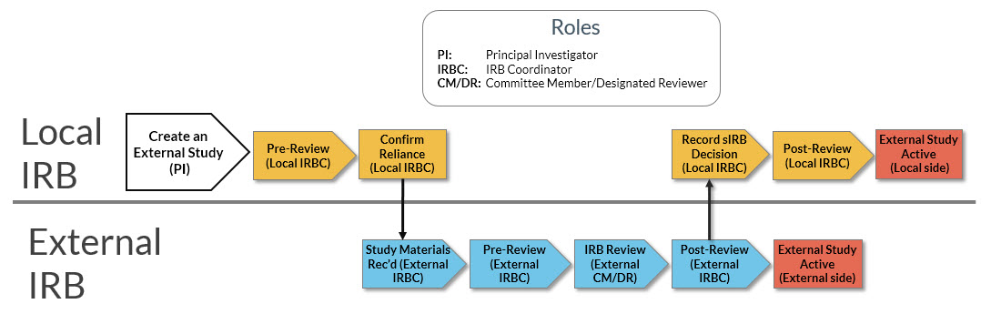

Study, Modification, and CR States and Transitions
This table contains information on key transitions in the IRB Review process that cause a submission to move from one state to another. The table lists the original state, the action required to change the state, the users that can perform this action, and the resulting state of the submission.
Note: To view the states and transitions available for a site connected to an externally-reviewed study, refer to the “pSite System Site States and Transitions” in the Multi-Site Study Quick Reference.
In this state… | These roles… | Can perform these actions… | Changing the state to…
Pre-Submission | Investigator, PI Proxy | Submit | Pre-Review
Pre-Review | IRB Coordinator, IRB Director | Submit Pre-Review | Pre-Review Completed
Pre-Review | IRB Coordinator, IRB Director | Request Pre-Review Clarification | Clarification Requested (Pre-Review)
Pre-Review Completed | IRB Coordinator, IRB Director | Assign Designated Reviewer | Non-Committee Review
Pre-Review Completed | IRB Coordinator, IRB Director | Assign to Meeting | Committee Review
Clarification Requested  (Pre-Review) | Investigator, PI Proxy | Submit Response | Pre-Review
Committee Review | IRB Coordinator, IRB Director | Assign to Non-Committee Review | Non-Committee Review
Committee Review | Committee Chair, Committee Administrator, IRB Coordinator, IRB Director | Submit Committee Review | Post-Review
Committee Review | Committee Member, IRB Coordinator, IRB Director | Request Clarification by Committee Member | Clarification Requested (Committee Review)
Clarification Requested (Committee Review) | Investigator, PI Proxy | Submit Response | Committee Review
Clarification Requested (Committee Review) | IRB Coordinator, IRB Director | Assign to Non-Committee Review | Non-Committee Review
Non-Committee Review | Designated Reviewer, IRB Coordinator, IRB Director | Assign to Committee Review | Committee Review
Non-Committee Review | Designated Reviewer, IRB Coordinator, IRB Director | Submit Designated Review | Post-Review
Non-Committee Review | Designated Reviewer | Request Clarification by Designated Reviewer | Clarification Requested (Designated Review)
Clarification Requested (Designated Review) | Investigator, PI Proxy | Submit Response | Non-Committee Review
Post-Review | IRB Coordinator, IRB Director | Send Letter | Approved
Post-Review | IRB Coordinator, IRB Director | Send Letter | Modifications Required
Post-Review | IRB Coordinator, IRB Director | Send Letter | Deferred
Post-Review | IRB Coordinator, IRB Director | Send Letter | Human Research, Not Engaged
Post-Review | IRB Coordinator, IRB Director | Send Letter | Not Human Research
Post-Review | IRB Coordinator, IRB Director | Send Letter | Disapproved
Approved | IRB Coordinator, IRB Director | Close Study (Admin) | Closed
Approved | IRB Coordinator, IRB Director | Submit Committee Review | Post-Review
Approved | IRB Coordinator, IRB Director | Submit Designated Review | Post-Review
Approved | IRB Director | Terminate | Terminated
Approved | IRB Director | Suspend | Suspended
Suspended | IRB Coordinator, IRB Director | Close Study (Admin) | Closed
Suspended | IRB Director | Terminate | Terminated
Suspended | Registered User | Continuing Review Closed | Approved
Deferred | Investigator, PI Proxy | Submit Response | Pre-Review
Deferred | Committee Chair, Committee Administrator, IRB Coordinator, IRB Director | Submit Committee Review | Post-Review
Disapproved | Investigator, PI Proxy | Submit Response | Pre-Review
Disapproved | IRB Coordinator, IRB Director | Submit Committee Review | Post-Review
Disapproved | IRB Coordinator, IRB Director | Submit Designated Review | Post-Review
Modifications Required | Investigator, PI Proxy | Submit Response | Modifications Submitted
Modifications Submitted | IRB Coordinator, IRB Director | Assign Designated Reviewer | Non-Committee Review
Modifications Submitted | Designated Reviewer, IRB Coordinator, IRB Director | Assign to Committee Review | Committee Review
Modifications Submitted | Committee Chair, Coordinator, IRB Director | Review Required Modifications | Post-Review
Modifications Submitted | Committee Chair, Coordinator, IRB Director | Review Required Modifications | Modifications Required
Lapsed | IRB Director | Suspend | Suspended
Lapsed | IRB Director | Terminate | Terminated
Lapsed | IRB Coordinator, IRB Director | Close Study (Admin) | Closed
Lapsed | Registered User | Continuing Review Closed | Approved
Terminated | IRB Coordinator, IRB Director | Submit Committee Review | Post-Review
Terminated | IRB Coordinator, IRB Director | Submit Designated Review | Post-Review
External IRB | IRB Coordinator, IRB Director | Close Study (Admin) | Closed
All states prior to Post-Review | Study Staff | Withdraw | Pre-Submission
All states prior to Post-Review | Study Staff | Discard | Discarded

Reportable New Information Process
The RNI workflow uses similar states to a study, but the IRB review process routes the submission differently depending on the significance of the determinations selected. For an RNI submission to be considered a serious issue, the determinations selected must include an unanticipated problem involving risks, serious or continuing non-compliance, or suspension or termination of IRB approval. This reduces the IRB's time spent handling insignificant issues.
- The review process starts with a pre-review that enables the coordinator to make the final determinations regarding any RNI submission that is not considered serious.
  - If the RNI submission is not considered a serious issue and is not marked as "Additional review required," the submission transitions directly to Acknowledged.
  - Otherwise, the coordinator can assign the submission to a designated reviewer or to committee review.
- The RNI designated reviewer starts from the determinations selected in pre-review and can modify them as needed.
  - If the RNI submission is not considered a serious issue, the submission transitions directly to Acknowledged.
  - Otherwise, the submission transitions to Committee Review so it can be assigned to a meeting.
- The committee review starts from the determinations selected in the previous review and can modify them as needed.
  - If the RNI submission is not considered a serious issue, and no further action is required, the submission transitions directly to Acknowledged.
  - If the RNI submission is not considered a serious issue, but further action is required, the submission transitions to Post-Review.
  - If the RNI submission is considered a serious issue, or if additional information is required before making a determination, the submission transitions to Post-Review regardless of whether further action is required.
- If further action is required to resolve the reported issue, the committee can specify an action plan and assign a responsible party for carrying out the plan. If action is required, the submission transitions from Post-Review to Action Required when the letter is sent. The responsible party can respond using the Submit Action Response activity when the action has been completed. Then the completed action can be reviewed and verified in the Action Submitted state. Alternatively, the submission can be assigned to a designated reviewer or to committee review to verify the completed action.
- When there is no further action required, and a letter is sent, the submission transitions to Complete.
The following diagram illustrates the review process for an RNI.
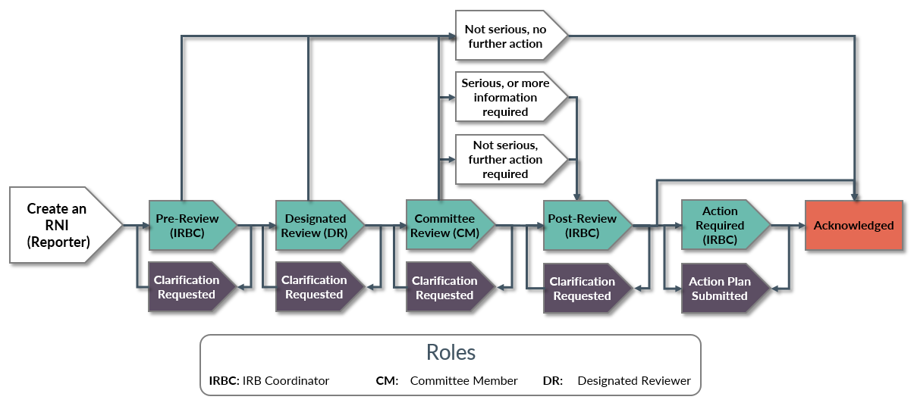

- Depending on how your IRB solution is configured, an RNI for a single-site external study may follow the workflow described above, or it may be routed directly to Pending sIRB Review. Once the external IRB communicates their decision, the local IRB coordinator uses the Record sIRB RNI Decision activity to record the decision.
Note: If the external IRB decision is to recommend local review, select the sIRB recommends local IRB Review determination in the Record sIRB RNI Decision activity.

Reportable New Information States and Transitions
This table contains information on key transitions in the RNI Review process that cause an RNI to move from one state to another. The table lists the original state, the action required to change the state, the users that can perform this action, and the resulting state of the RNI.
Note: The starred actions and states apply to RNI’s related to externally-reviewed studies only.
In this state… | These roles… | Can perform these actions… | Changing the state to…
Pre-Submission | Reporter | Submit RNI | Pending sIRB Review*
Pre-Submission | Reporter | Submit RNI | Pre-Review
Pre-Review | IRB Coordinator, IRB Director | Submit RNI Pre-Review | Acknowledged
Pre-Review | IRB Coordinator, IRB Director | Submit RNI Pre-Review | pSite Review*
Pre-Review | IRB Coordinator, IRB Director | Submit RNI Pre-Review | Pre-Review Completed
Pre-Review | IRB Coordinator, IRB Director | Route for sIRB Review* | Pending sIRB Review*
Pre-Review | IRB Coordinator, IRB Director | Request Pre-Review Clarification | Clarification Requested (Pre-Review)
Clarification Requested  (Pre-Review) | Reporter | Submit Response | Pre-Review
Pre-Review Completed | IRB Coordinator, IRB Director | Assign Designated Reviewer | Non-Committee Review
Pre-Review Completed | IRB Coordinator, IRB Director | Assign to Meeting | Committee Review
Committee Review | IRB Coordinator, IRB Director | Assign to Non-Committee Review | Non-Committee Review
Committee Review | Committee Chair, Committee Administrator, IRB Coordinator, IRB Director | Submit RNI Committee Review | Post-Review
Committee Review |  | Submit RNI Committee Review | Acknowledged
Committee Review |  | Review Required Actions | Post-Review
Committee Review |  | Review Required Actions | Action Required
Committee Review | Committee Member, IRB Coordinator, IRB Director | Request Clarification by Committee Member | Clarification Requested (Committee Review)
Clarification Requested (Committee Review) | Reporter | Submit Response | Committee Review
Non-Committee Review | Designated Reviewer, IRB Coordinator, IRB Director | Assign to Committee Review | Committee Review
Non-Committee Review | Designated Reviewer, Committee Chair, Committee Administrator, IRB Coordinator, IRB Director | Review Required Actions | Post-Review
Non-Committee Review |  | Review Required Actions | Action Required
Non-Committee Review | Designated Reviewer | Submit RNI Designated Review | Acknowledged
Non-Committee Review | Designated Reviewer | Submit RNI Designated Review | Committee Review
Non-Committee Review | Designated Reviewer | Request Clarification by Designated Reviewer | Clarification Requested (Designated Review)
Clarification Requested (Designated Review) | Reporter | Submit Response | Non-Committee Review
Pending sIRB Review* | IRB Coordinator, IRB Director | Record sIRB Decision* | Pre-Review
Pending sIRB Review* | IRB Coordinator, IRB Director | Record sIRB Decision* | Action Required
Pending sIRB Review* | IRB Coordinator, IRB Director | Record sIRB Decision* | Complete
Action Required | IRB Director | Submit Action Response | Action Submitted
Action Required | IRB Director | Submit Action Response | Action Submitted (sIRB Review)*
Action Submitted | Committee Chair, Committee Administrator, IRB Coordinator, IRB Director | Review Required Actions | Post-Review
Action Submitted |  | Review Required Actions | Action Required
Action Submitted | IRB Coordinator, IRB Director | Assign to Committee Review | Committee Review
Action Submitted | IRB Coordinator, IRB Director | Assign Designated Reviewer | Non-Committee Review
Action Submitted  (sIRB Review)* | IRB Coordinator, IRB Director | Record sIRB Decision* | Complete
Action Submitted  (sIRB Review)* | IRB Coordinator, IRB Director | Record sIRB Decision* | Action Required
Post-Review | IRB Coordinator, IRB Director | Send Letter | Action Required
Post-Review | IRB Coordinator, IRB Director | Send Letter | Complete
Post-Review | Committee Chair, Committee Administrator, IRB Coordinator, IRB Director | Submit RNI Committee Review | Acknowledged
Complete | Committee Chair, Committee Administrator, IRB Coordinator, IRB Director | Submit RNI Committee Review | Post-Review
Complete |  | Submit RNI Committee Review | Acknowledged
Acknowledged | IRB Coordinator, IRB Director | Submit RNI Pre-Review | Pre-Review Completed
Acknowledged | Committee Chair, Committee Administrator, IRB Coordinator, IRB Director | Submit RNI Committee Review | Post-Review
Acknowledged | Designated Reviewer, IRB Coordinator, IRB Director | Submit RNI Designated Review | Committee Review
All states prior to Post-Review | Study Staff | Withdraw | Pre-Submission
All states prior to Post-Review | Study Staff | Discard | Discarded

Complete a Pre-Review
When a study is submitted to the IRB for review, it will appear in all coordinators’ inboxes. The first step is to assign it to a specific coordinator to oversee through the review process. Next, the assigned IRB coordinator will check the study for completeness, ensuring all the information is there for the reviewers.
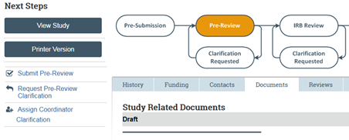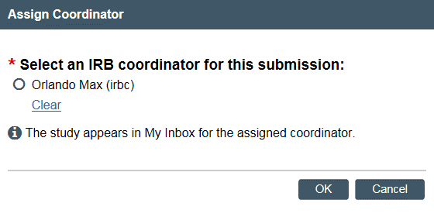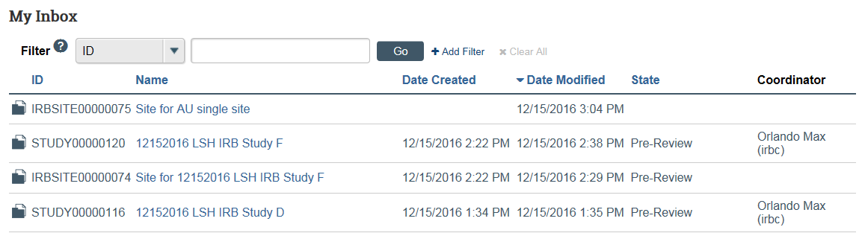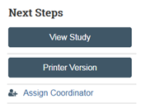  1  2  3  4  5  7  6 | Assign a Coordinator
- In your inbox, open the submission that does not have an assigned coordinator.
- From the study workspace, click Assign Coordinator.
- Select a coordinator to take ownership of the study.
- Click OK. The submission will appear only in the assigned coordinator’s inbox.
Note: If you assign a coordinator that is not yourself, the assigned coordinator will receive a notification.
 | Perform a Pre-Review
Review the submission and its documents. From the workspace, click the following:
- View Study: Opens the study. Click Continue to move through the pages.
- Printer Version: Shows the study in one scrollable page.
- Documents tab: Shows all attached study documents.
Note: You can also access these documents from the study pages and printer version.
 | Next Steps
- If you have questions or change requests for the PI, see Request Clarification on a Submission.
- If you are finished reviewing the submission, see Submit a Pre-Review.

Request Clarification on a Submission
If you have questions for the study team or require they make changes to the study, use the request clarification feature to communicate back and forth with the team. When all questions have been answered or changes made, submit your pre-review.
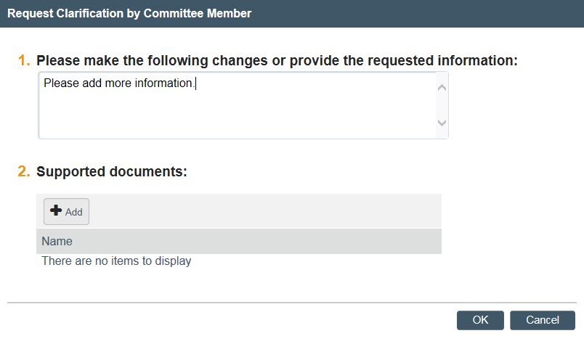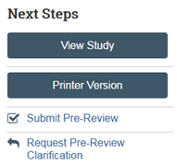  1  2  3 | Request Clarification
- From the submission workspace, click Request Pre-Review Clarification.
- Type your request.
Note: If you require more space for your request, add a document with the details in the Supporting documents area. In the Notes text box, instruct the PI to refer to the document.
- Click OK.
The PI will receive an email about your request. Once the PI responds to your request, you will receive an email and the submission will return to your IRB inbox so you can continue your review.

Compare
After the study team submits their response to the clarification request at Pre-Review or Designated Review, you can compare versions to see the changes that were made.
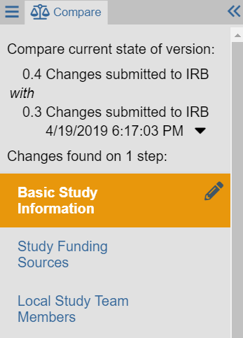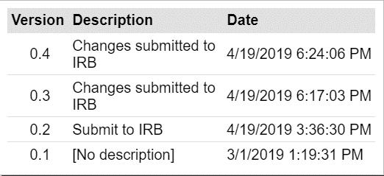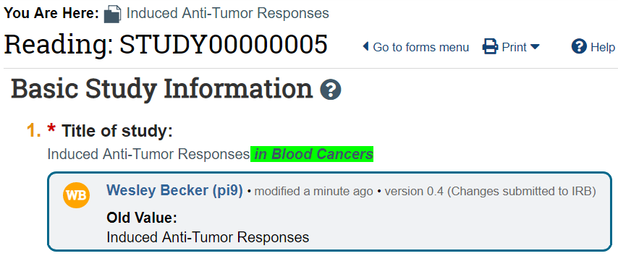  2  3  4  1  3  3a  5 | Compare
- From the study Left Navigator, click Compare.
- The Compare section of the Left Navigator shows the versions you are comparing.
- Click the down arrow to show the versions that you can compare against.
  - Select a version to compare against the current version.
- The pencil icon in the Left Navigator indicates that a change was made to the Basic Study Information page.
- The change is shown within the SmartForm. The new information is highlighted in green.

Submit a Pre-Review
After you have finished reviewing a submission for completeness, move it forward in the review process by submitting a pre-review.
Note: The Pre-Review form is editable in all states, including during a follow-on submission. However, if more than one follow-on submission is in progress for the parent study, the Pre-Review form is locked when a change is made to it.
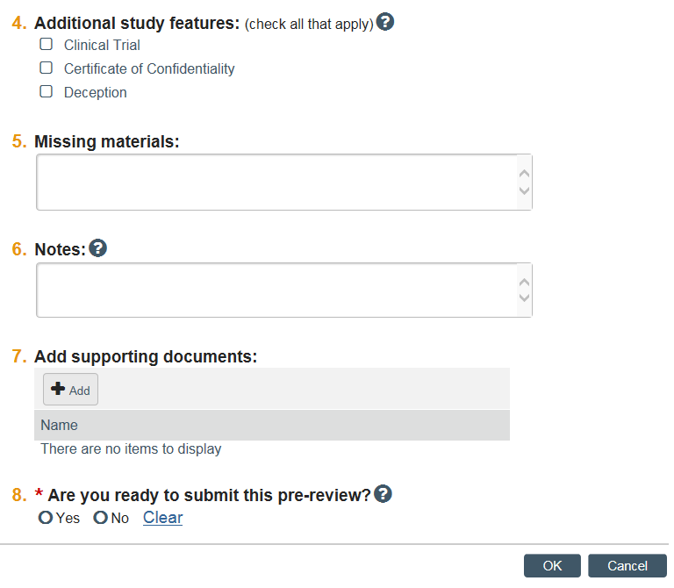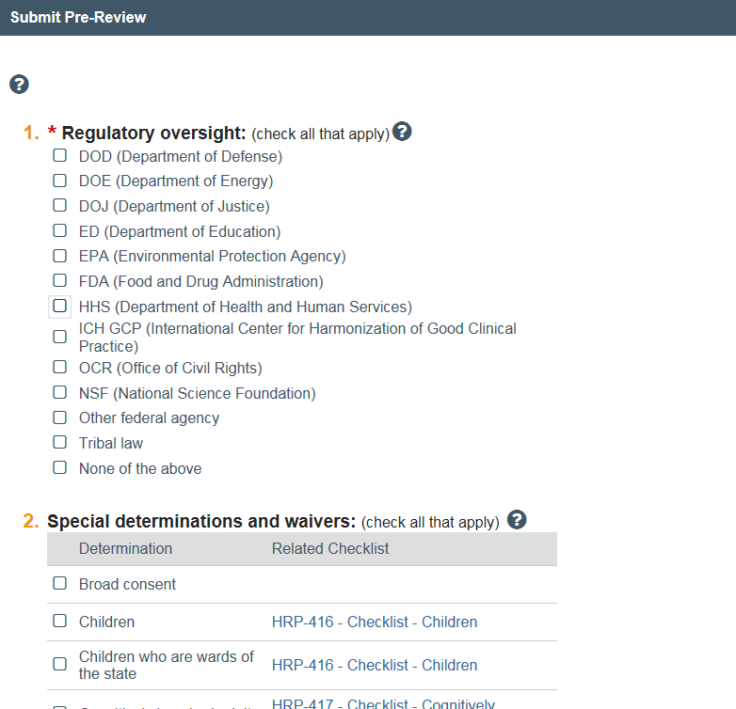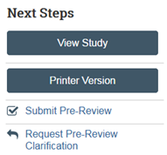  2  3  4  5  6  1 | Submit a Pre-Review
- From the submission workspace, click Submit Pre-Review.
- Complete the Submit Pre-Review page. Click the links to open and use a checklist.
Note: If you select FDA or DOJ in the Regulatory Oversight section, the study will automatically fall under the Pre-2018 Common Rule requirements, even if it falls after the effective date setting of the 2018 requirements. The Regulatory Authority label on the study workspace will read: 2018 Requirements +FDA +DOJ, depending on your selection.
Note: Broad consent is not a valid selection for studies falling under the Pre-2018 Common Rule requirements.
- Indicate whether the study has any additional features.
- Under Supporting documents, upload appropriate checklists based on the special determination and waivers selected in Question 2.
- Click Yes if you are ready to submit your review. If not, click No and you can return to this page later to submit.
- When finished, click OK.
Note: To correct a pre-review after you submit it, you can click Submit Pre-Review once more, make corrections, and click OK to resubmit.
From here, you must decide whether to assign the study to a designated reviewer (non-committee review) or the committee to review.

Confirm Reliance with the External IRB
For a single-site external IRB study, you must confirm reliance on the external IRB before the submission can move forward in the review process. From the Submissions link, click the External IRB tab, then open the study.
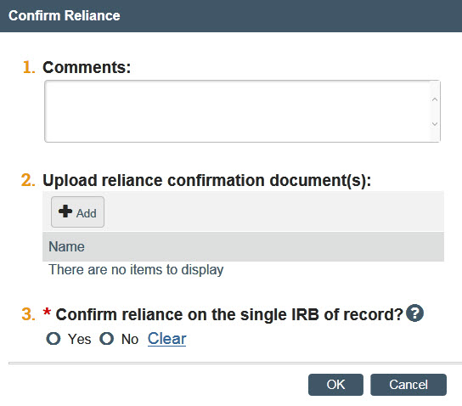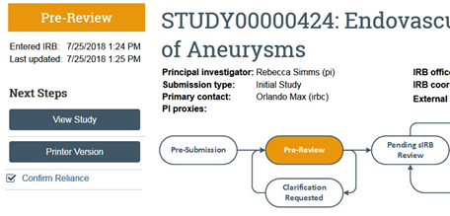  1 | Confirm Reliance
- From the study workspace, click Confirm Reliance.
- Complete the form.
- Click OK to finish.
If reliance is confirmed, the site enters a Pending sIRB Review state.

Record the sIRB Decision for an External Study
IRB staff record and edit the sIRB decision for an externally reviewed study.
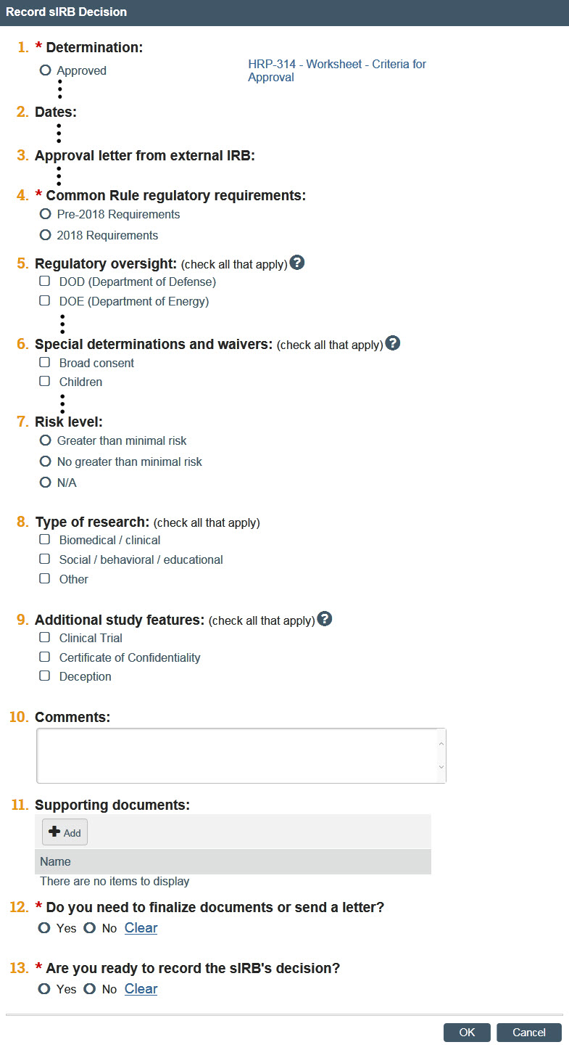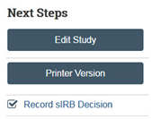  2a  2b  3  4  5  6  1 | Record sIRB Decision
- From the study workspace, click Record sIRB Decision.
- Complete the form. Pay attention to the following questions:
2a. Note: If you select FDA or DOJ in the Regulatory Oversight section, the study will automatically fall under the Pre-2018 Common Rule requirements, even if it falls after the effective date setting of the 2018 requirements.
2b. Note: Broad consent is not a valid selection for studies falling under the Pre-2018 Common Rule requirements.
- Indicate whether the study has any additional features.
- Under Supporting documents, upload appropriate checklists based on the special determination and waivers selected in Question 6.
- For Do you need to finalize documents or send a letter? Selecting Yes will send the item to Post-Review, and selecting No will send the item to Review Complete.
- Are you ready to record the sIRB’s decision? To note the sIRB determination without recording it, you can select No and your selections will be saved.
- Click OK to finish.

Update an Approved, Single-Site External Study
This section covers 2 scenarios when making an update to an approved, single-site study. Either the update originates with the local study, or the update originates with the external IRB, for example, when approval dates change. Both the local PI and local IRB coordinator can make updates to the external study.
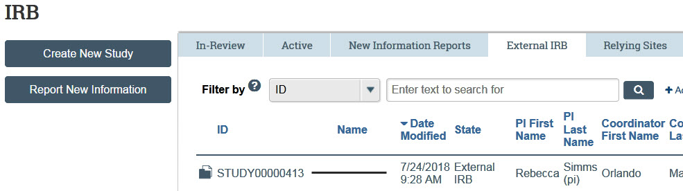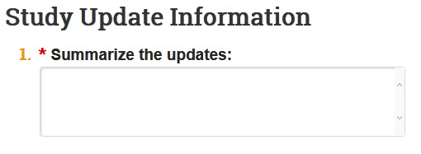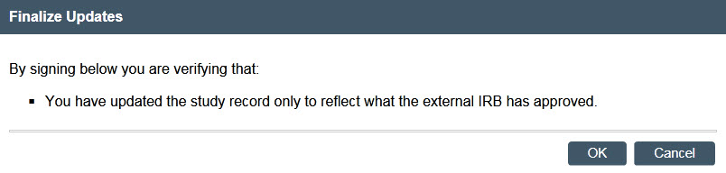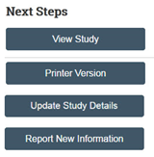  3  2  6  5  4  9  10 | Updates that Originate with the Local Study
- From your inbox, click the Submissions shortcut.
- Click the External IRB tab and open the study. Note that active external studies are in the External IRB state.
- Click the Update Study Details button.
- Summarize the updates, click Continue, then make changes to the study.
- From the study workspace, click Finalize Updates.
- Click OK to agree to the terms.
- Type your login credentials and click Submit.
- To review the local PI’s updates, from the study workspace, click View Differences and reference the Snapshot. If there is an error, the IRB coordinator can send a comment to the PI asking them to submit another update with corrected information. Alternatively, the IRB coordinator can make another update with the correct information.

Updates that Originate with the External IRB
- After the external IRB notifies the local IRB of a change to the study, the local IRB coordinator runs the Return to Post-Review activity from the study workspace.
- In Post Review, click the Edit sIRB Decision activity, then make the necessary changes. The activity presents the option to finalize documents, send a letter, or send the submission directly to Review Complete.

Report Continuing Review Data for an External Study
Both the local PI and local IRB coordinator can report continuing review data for a single-site external study.
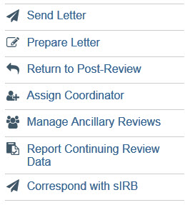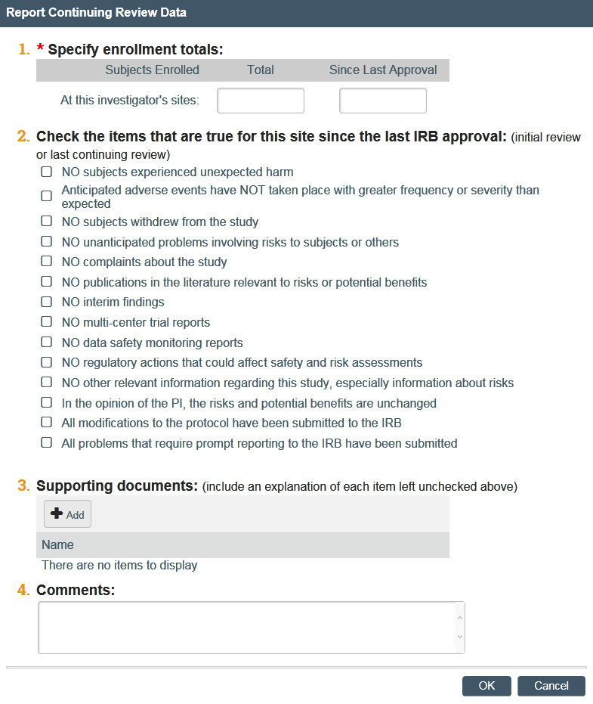  3  2  4  5 | To Report Continuing Review Data for an External Study
- From your inbox, click the Submissions shortcut.
- Click the External IRB tab and open the study. Note that active external IRB studies are in the External IRB state.
- Click Report Continuing Review Data.
- Complete the Report Continuing Review Data activity.
- In Supporting Documents, be sure to include an explanation for each item left unchecked in question 2 above.
- Click OK.

Assign a Designated Reviewer
You can assign a study to one committee member to review or to a committee meeting for all committee members to review.
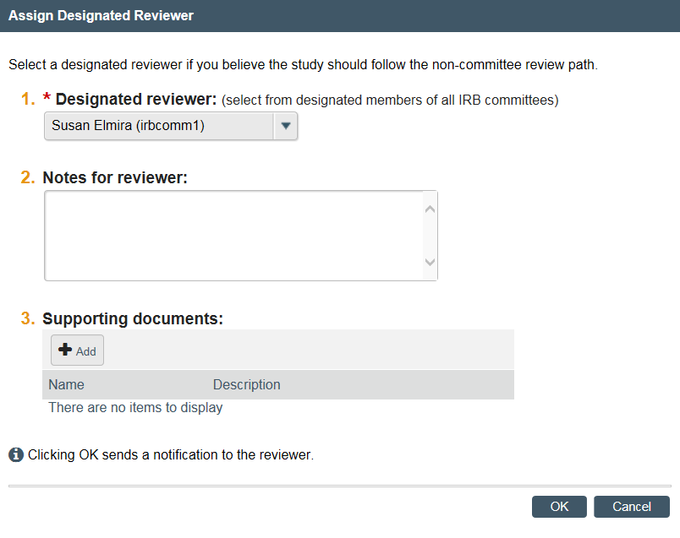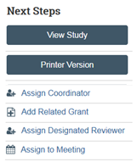  2  3  4  1 | Assign to a Designated Reviewer
- From the study workspace, click Assign Designated Reviewer.
- Select a committee member from the list.
- To help the reviewer, you can add checklists or review documentation along with a note indicating this. This way, the reviewer doesn’t have to search for them in the library.
- Click OK.
The reviewer will receive an email about the review and the study will appear in the reviewer’s IRB inbox.
Note: You can correct mistakes in an already-submitted designated review by clicking Submit Designated Review, making corrections, and clicking OK to resubmit.

Assign to Committee Review
You can assign a study to one committee member to review or to a committee meeting for all committee members to review.
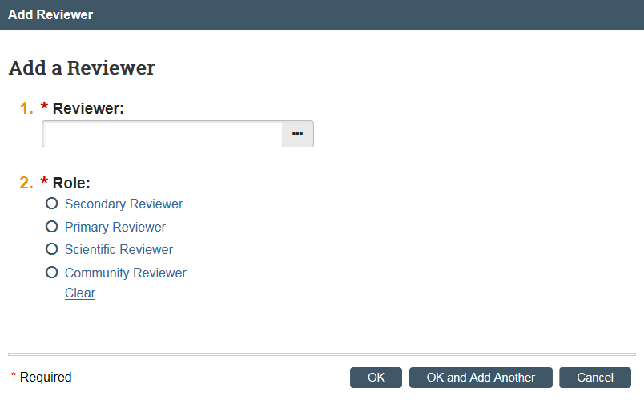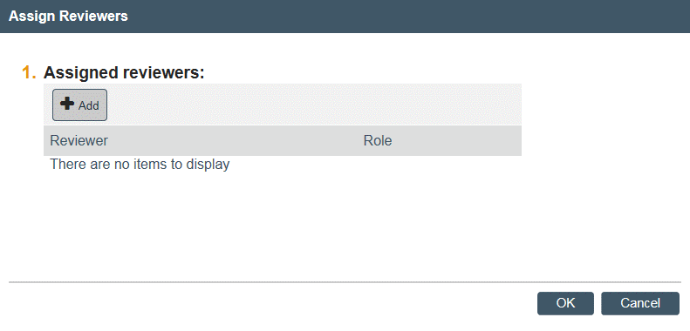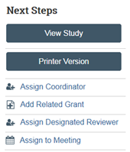  6  4  5  7  8  1 | Assign to a Committee Meeting
- From the study workspace, click Assign to Meeting.
- Select the upcoming IRB meeting for the office the study belongs to.
- Click OK.
The details will appear on the IRB Assignment Details tab.
 | Assign Committee Reviewers
After you assign a submission to a committee meeting, you can assign specific committee reviewers
- Click Assign Reviewers.
- Click Add.
- Click the ellipses to select a reviewer, then click OK.
- Select the reviewer’s role.
- Click OK to finish, or OK and Add Another to select an additional reviewer.

Submit a Committee Review
If the submission went through a committee review, the next step is to record the committee’s determination for that submission. You may do this during or after the committee meeting. An IRB staff member, committee admin, or committee chair can submit the committee review.
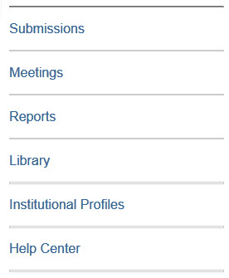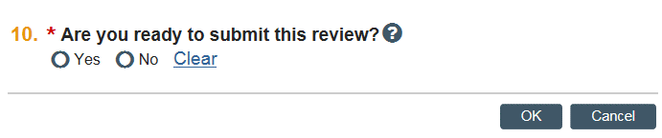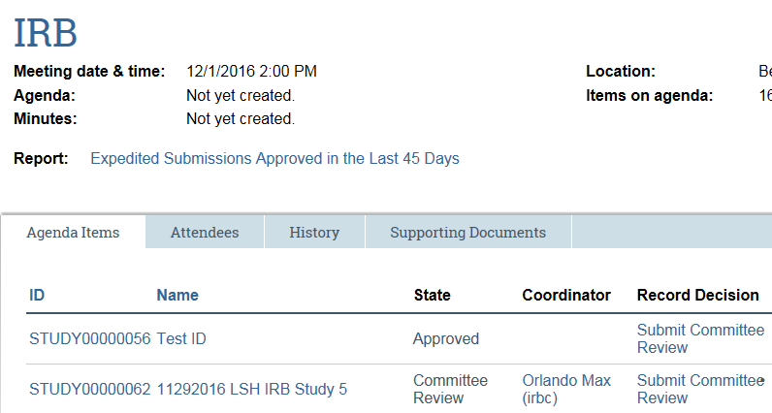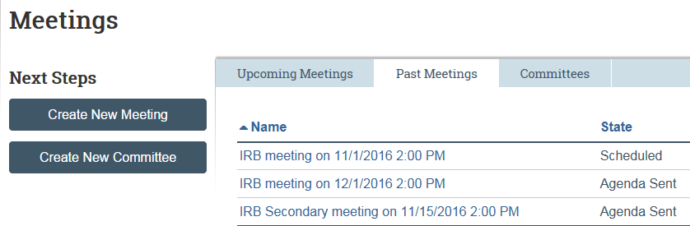  2  3  5  1 | Find the Study
- From My Inbox, click the Meetings shortcut.
- Click the Past Meetings tab and then the meeting name to open it.
 | Record Decision for a Submission
- From the meeting workspace, in the Record Decision column, click the Submit Committee Review link.
- On the Submit Committee Review page, pay attention to the following sections:
  - Determination: Select the determination
  - Risk level
  - Votes: fill in all votes regarding the determination.
  - Supporting Documents: include the final version of any relevant checklists.
  - Are you ready to submit this review: Clicking Yes moves the submission to Post-Review, and clicking No allows you to return and finish the review at another time.
- Click OK when done.
Note: To correct a committee review after you submit it, you can click Submit Committee Review once more, make corrections, and click OK to resubmit.

Post-Review Activities
After the designated member or committee review decision has been submitted for a submission, the next steps are to finalize the documents and prepare and send the determination letter to PI.
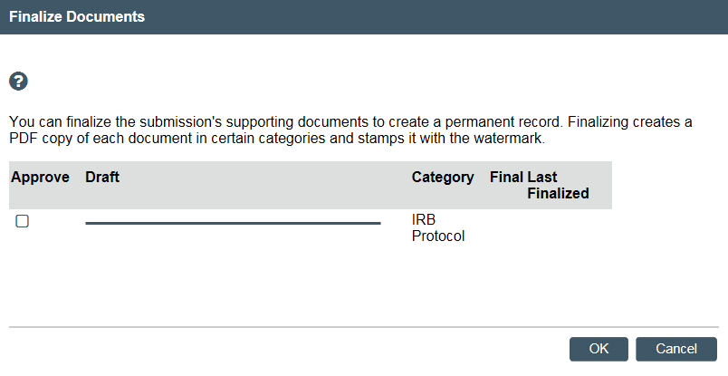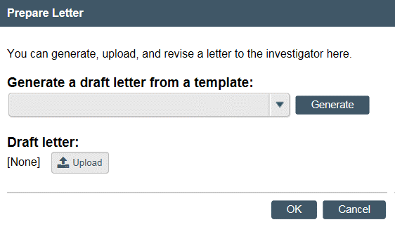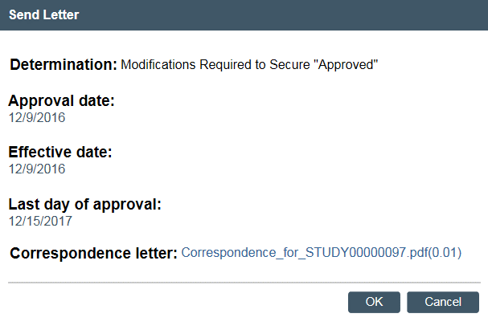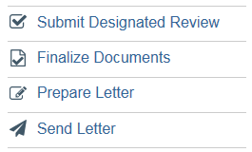  4  5a  5b  6  1  2  3  7  8 | Finalize Documents
- From the study workspace, click Finalize Documents.
- Select the documents to change to PDF and watermark.
- Click OK.
The Documents tab on the study workspace will include links to the final versions of the documents.
 | Prepare Determination Letter
- From the study workspace, click Prepare Letter.
- You have two options:
  - To create a letter from a template, select the template from the list and click Generate.
Note: You can open the draft letter, change it as needed, and then add the revised document.
  - To add a letter, click Upload and then browse for the letter.
- When done, click OK.
Until you send the letter, you can use the Prepare Letter activity to regenerate the letter again or upload revisions.
 | Send Determination Letter
- From the study workspace, click Send Letter.
- Review the determination and letter and then click OK.
Note: You may want to verify the acuracy of the dates listed on the Send Letter page before clicking OK.
The letter is sent to the PI, PI proxy, and primary contact.

Navigation and Basic Tasks
When you first log in, you will be on the My Inbox page. This topic lists where to find submissions and the basic tasks you will perform.
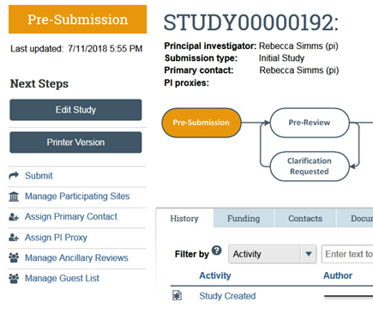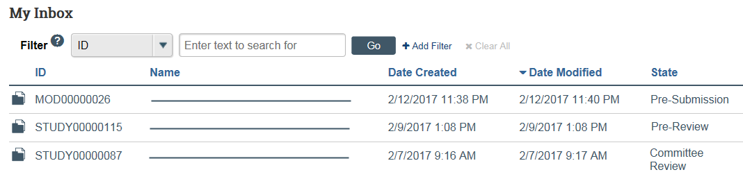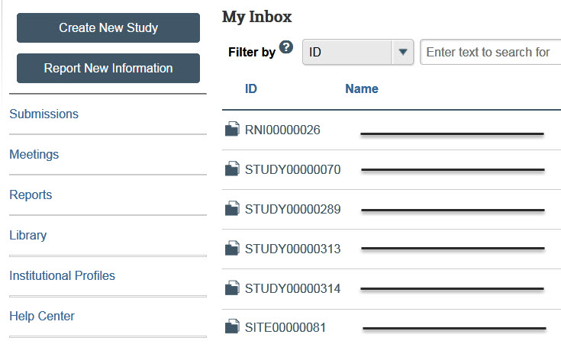  4  7  8  5  6  1  2  3 | Where do I find?
From the My Inbox page, you
will find:
- Submissions that require you to take action.
- Actions you can perform, such as create a new study.
- Shortcuts that provide access to other items such as all the submissions you can view.
 | What do I do?
 | - Review the state of submissions in your inbox. The state gives a clue as to what to do next. For example, “Pre-Submission” means you haven’t submitted the study. You can finish and submit it for review.
 | Open a Submission
- From your inbox, click the submission name.
- The submission
workspace opens.
 | View History
- From the submission workspace, click the History tab.
- The history tab lists the activity taken on a submission including any comments, attachments, or correspondence added.

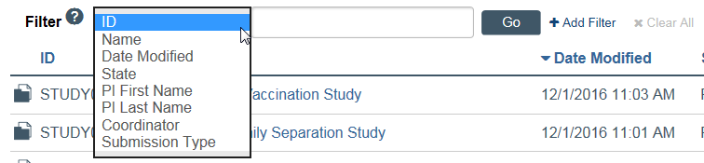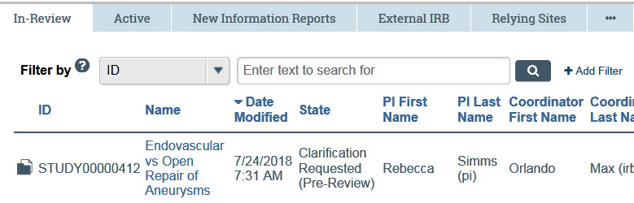  9  11  12  13  15  14  10 | Find Previous Submissions
- Click the Submissions shortcut.
- Click the tab to see submissions you can access:
- In-Review: Submissions undergoing IRB review.
- Active: All approved submissions as well external IRB, non-human research, human research not engaged, lapsed, and suspended submissions.
- New Information Reports: All Reportable New Information (RNI) submissions, in any state.
- External IRB: All studies managed by an external IRB.
- Relying Sites: All participating sites relying on the local IRB as the single IRB of record.
Click the ellipsis to see:
- All Submissions: All submissions, in any state.
- Archived: All closed, disapproved, discarded, and terminated submissions.
 | Filter Data
Many pages contain tables that you can filter to show specific data.
- Select the column to filter by.
- Type the beginning characters for the items you want to find. You can also type a % symbol as a wildcard before the characters. Examples:
- 71 shows all items
beginning with 71
- %71 shows all items containing 71
- Click Help for operators you can type in the text box.
- Click Go to apply the filter.
- To combine multiple filter criteria, click Add Filter.

© 2012-2019 Huron Consulting Group Inc. and affiliates. All rights reserved. Use and distribution without a current software license from Huron are prohibited.

All trademarks, registered trademarks, service marks, and trade names are the property of their respective owners.

Information in this document is subject to change without notice.

Published by Huron Consulting Group Inc.
9170 NE Turing Court
Suite 100
Hillsboro, OR 97006

