Reportable New Information (RNI)
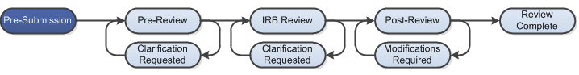

Work Instructions
- Log into Click Portal and find the study
  - You can log in and click on the “IRB” tab on the top navigation bar, and find the active studies in the Active tab
  - You can also create an RNI from a study workspace by clicking on the Report New Information button under the My Current Actions heading.

- Enter the required information on the first page of the SmartForm and click Continue in either the top or bottom of the page

- Prior to submission to the IRB, all required fields will need to be completed.
  - Click the Hide/Show Errors link in the header of the SmartForm page to display any unanswered questions throughout the SmartForm
    - Use the Jump To: link to navigate directly to SmartForm pages that are missing information
  - Submissions with any incomplete information will be redirected to the research team for updates.

- When all of the required fields have been completed, click Finish in the footer of the last SmartForm page to be redirected to the study workspace

- Use the Add Related Submission activity to notify the IRB if you are also submitting a modification to the approved study as a result of the RNI
  - Use this same activity to link multiple studies to one RNI submission, when appropriate.

- In order to submit to the IRB, log into the study and click the Submit activity. This activity will check the submission for any missing fields
  - If the submission is successful, the page will refresh and the study will transition from the Pre-Submission state to the Pre-Review state as identified by the workflow diagram at the top of the workspace.

