

Huron Committee Meeting

Meeting Management Guide

December 2019
Table of Contents
Create a Meeting 4
Prepare for Committee Meetings 4
Conduct Committee Meetings 6
Submit Committee Reviews 8
Wrap Up Committee Meetings 9
Checklists 12
Checklist for Preparing for Committee Meetings 12
Checklist for Conducting Committee Meetings 13
Checklist for Wrapping up Committee Meetings 14

Create a Meeting
Typically, the committee’s administrators or chairs create the meetings.
Tip: For best results in handling meetings, make sure the committee administrator also has one of these user roles, as appropriate: COI Administrator, IACUC Coordinator, IRB Coordinator, or Safety Specialist.
To create a meeting
- From the Sub-Navigator, or from My Inbox, click Meetings.
- From the meetings page, click Create New Meeting.
- Complete the SmartForm.
- When you’re done, click OK.
The meeting workspace appears.
To find/open a meeting
- From the Meetings page, under the Upcoming Meetings tab, click the name of the meeting to open it.
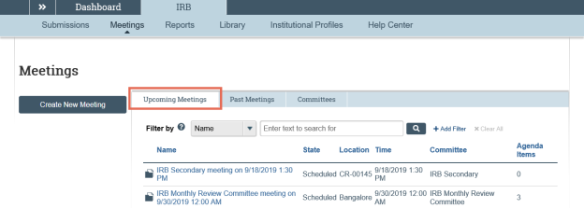
Prepare for Committee Meetings
From the committee meeting page, users designated as committee administrators can manage meetings, agendas, and minutes for that committee's meetings.
Note: Multiple users can be simultaneously designated as committee administrators.
To assign submissions to meeting
- From the submission workspace, click Assign to Meeting.
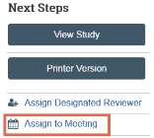
- Complete the form and click OK.
To assign reviewers
Once you assign an agenda item to a meeting, the Assign Reviewers activity is available.
- From the submission or meeting workspace, click Assign Reviewers.
Note for COI and non-submission agenda items: Click Assign Reviewers from the meeting workspace.
- Complete the forms and click OK.
To add documents
- From the meeting workspace, click Update Documents to add any supporting documents to the meeting.
- Complete the forms and click OK.
The documents are displayed in the Supporting Documents tab.
To add other items to the agenda
You can add text-based items and links to related projects to the agenda.
- From the meeting workspace, click Update Other Agenda Items.
- Click Add.
- Complete the forms, add a related project if desired, and click OK.
- When done adding items, click OK.
The items you added are displayed in the Other Agenda Items section below the list of submissions
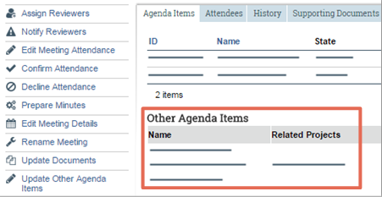
- (Optional) Assign Reviewers to the new items from the meeting workspace. (See To assign reviewers on page 4.)
To prepare and send the agenda
You can prepare the agenda from the meeting workspace.
- Click Prepare Agenda and generate an agenda or upload your own agenda document.
- Click Send Agenda to e-mail the agenda to committee members.
To remove an agenda item
You can remove a submission or other item from the agenda.
- To remove a submission, click the submission name and then click Remove from Agenda in the submission workspace.
- To remove a non-submission (other) agenda item:
  - Click Update Other Agenda Items.
  - Click X (delete button) on the right of the item.
Conduct Committee Meetings
During committee meetings, the committee administrator typically prepares minutes, records submission and non-submission information, and displays submissions to aid the committee’s discussion.
To prepare minutes
- (Optional) To create a meeting minutes document to update during the meeting, from the meeting workspace click Prepare Minutes and generate the minutes from a template. Save the document to your local system and update it during the meeting.
Tip: Use Track Changes in Word so later you can copy your notes into the final minutes document.
To start the meeting
- To start the meeting, click Convene Meeting.
To approve previous meeting minutes
- (Optional) From the meeting workspace on the Agenda Items tab, under Previous meetings with minutes for approval, click a previous meeting to go to its workspace. Then you can display its minutes, approve them, and return to the current meeting.
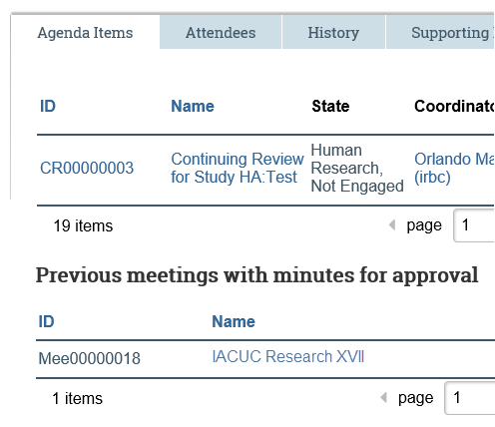
To display submission details
It may be helpful to display submission information and reviewer comments during the meeting.
- From the meeting workspace:
  - To view submission information, click the submission ID or name on the Agenda Items tab.
- From the submission workspace:
  - To show detailed contents of the forms, use the View Study button.
  - To show attached documents, use the Documents tab.
  - To show information recorded during previous reviews, as well as committee, meeting, and reviewer assignments, use the Reviews tab.
Submit Committee Reviews
Once the committee has reviewed a submission or other agenda item and determined how to handle it, a coordinator, committee admin, or committee chair typically records the committee’s decisions.
To submit a review
For each submission, you must record the committee decision, which will appear in the generated letter and meeting minutes.
- From the meeting workspace, on the Agenda Items tab under Record Decision, click Submit Committee Review.
Note (COI only): Click Record Committee Decision.
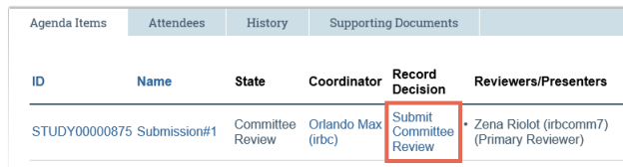
Tips:
  - You can also click the name of the submission, and submit the review from the submission workspace.
  - From the meeting workspace, check the Record Decision column next to the submissions. The column will show a link to an activity for any submission that has not yet had a decision recorded.
- Complete the resulting form.
- Click OK to submit the committee review.
The submission enters the Post-Review state, which enables you to notify the researcher of the review decision.
Important: Do not miss the Submit Committee Review step. Letters cannot be prepared and sent to researchers until this step has been completed.
To update other agenda items
You can record decisions about non-submission agenda items, which will appear in the generated meeting minutes.
- From the meeting workspace, click Update Other Agenda Items.
- Click Update next to the item.
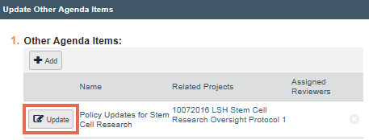
- Add notes reflecting the decision, and click OK.
Both the description and notes will appear in the meeting minutes.
Wrap Up Committee Meetings
At the end of a committee meeting, committee administrators can prepare the final minutes, close the meeting, and prepare and send correspondence.
To prepare minutes
- From the meeting workspace, click Prepare Minutes to generate new minutes containing committee decisions.
- Save the meeting minutes document on your local system, and revise the document.
  - Add meeting times and other non-submission information.
  - Cut and paste your notes from the document used during the meeting to this new document and save it.
- Click Prepare Minutes again to upload the final meeting minutes.
- Follow your internal processes for obtaining approvals of meeting minutes and sending them to committee members.
To close a meeting
- From the meeting workspace, click Close Meeting to complete the meeting.
- Inform coordinators and specialists that they can prepare and send letters to researchers notifying them of the committee’s decisions.
To approve minutes
Once approvals for meeting minutes have been collected, you can approve minutes in the meeting workspace.
- From the meeting workspace, click Approve Meeting Minutes.
- In the resulting dialog, select the checkbox to confirm approval.
- Click OK.
Checklists
Checklist for Preparing for Committee Meetings
Well in advance of the meeting:

 | Assign submissions to the meeting agenda (from the submission workspace).
 | If needed, assign reviewers to the agenda items (from the meeting or submission workspace). Reviewers must be committee members
 | (Optional) Add any relevant documents to the agenda.
 | (Optional) Add any other agenda items, such as text-based items or links to other projects in the system.
 | Prepare the agenda.
 | Send the agenda to committee members and any additional recipients.
  Tip: If you assign new items to the meeting or remove items after you have sent the agenda, make sure to prepare and send out the updated agenda.

Just before the meeting:

 | Edit the meeting attendance if you know who is planning to attend.
 | Remove any submissions in the Clarification Requested (Committee Review) state from the agenda, especially if the missing clarification requires delaying the committee decision. Reassign them to a later meeting.  Note (IACUC and IRB only): You can submit the committee review for any submissions in the Clarification Requested (Committee Review) state. Keep them on the agenda if there is sufficient information to make the decision.

Checklist for Conducting Committee Meetings

 | (Optional) Prepare the minutes.
  Tip: You may wish to record non-submission information such as meeting start and end times using the generated meeting minutes document during the meeting. To do so, prepare the meeting minutes, save the generated document to your local system, and then use it to record the information. After the meeting, copy and paste the items recorded during the meeting into the final version of the minutes. You can then upload the revised final version of the minutes.
 | Convene the meeting in the system.
 | Record meeting times, attendance, and other non-submission items (in the generated minutes document or elsewhere). We recommend dedicating one person to submit the committee reviews and record the non-submission information.
 | (Optional) Approve the minutes from previous meetings.
 | For IRB only: Click the Expedited Submissions Approved link to display a report of recently approved submissions.
 | Record decisions, events, and notes.
  Tip: If there is not enough time to completely fill out the committee review form during the meeting, finish it as soon as possible after the meeting.

 |  | For IRB only: From the individual reviewer checklists, reviewer comments, and committee discussion, fill out all relevant checklists to reflect the final committee opinion and reasoning. Then attach these final checklists in the Submit Committee Review activity.
  Tip: For IRB, you have the option to save your incomplete information in the Submit Committee Review form by saying no to Are you ready to submit this review? and then clicking OK.

Checklist for Wrapping up Committee Meetings

 | Make sure the final committee review has been recorded for each submission on the agenda. This is critical before you prepare the minutes and notify the researchers.
 | Update the non-submission (other) agenda items to record the committee decision in the notes field.
 | Prepare the minutes. The generated minutes document will contain the committee decisions for each agenda item, including the description and notes for the non-submission (other) agenda items.
 |  | Open and save the minutes on your local system. Add the meeting times, attendance, and any other non-submission items to the minutes.
  Tip: If you used the minutes template to record information during the meeting, simply cut and paste the information from that document into this version of the minutes.
 |  | Perform Prepare Minutes again to upload the revised minutes.
 |  | Send the minutes to the committee members.
 |  | Follow your internal processes to obtain the appropriate approvals of the meeting minutes.
 | Close the meeting.
 | Inform the coordinator(s) that they can send letters to the researchers.
  Tip: Minutes show the most recent determination for an item, not the one at the time of the meeting. If this is a concern, make sure to generate meeting minutes before sending letters, particularly for Modifications Required to Secure Approval items.
 | After the period for receiving comments from committee members has passed, perform Approve Meeting Minutes activity.  Note: Until you perform this activity, the minutes are listed in the next meeting's workspace with the approve activity available there as well.

© 2019 Huron Consulting Group Inc. and affiliates. All rights reserved. Use and distribution without a current software license from Huron are prohibited.

All trademarks, registered trademarks, service marks, and trade names are the property of their respective owners.

Information in this document is subject to change without notice.

Published by Huron Consulting Group Inc.
9170 NE Turing Court
Suite 100
Hillsboro, OR 97006

