

Huron IRB

Reviewer's Guide

December 2019
Table of Contents
Find Important Documents 4
Open the Submission 5
Review a Submission 6
Request Clarification on a Submission 7
Prepare Review Comments for a Committee Meeting 7
Submit a Designated Review 8
Submit an Ancillary Review 9
Navigation and Basic Tasks 9

Find Important Documents
If you are an IRB committee member or reviewer, you may want to access meeting agendas, worksheets, or checklists.
To locate meeting agendas
As a committee member, you can access a meeting agenda from the agenda notification email or by navigating to it in the IRB system.
- In the Top Navigator, click IRB and then Meetings.
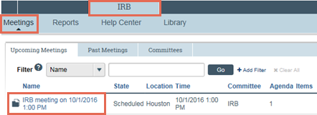
- From the list of meetings, click the name of the meeting.
The meeting workspace displays the list of agenda items.
- Click the agenda link for a printable agenda document.
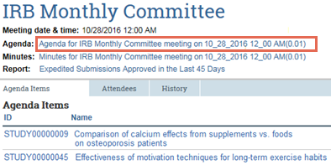
To locate reviewer checklists and worksheets
Several worksheets and checklists are provided in the system.
Note: Worksheets are for the reviewer’s benefit only, but checklists must be completed and attached when submitting review comments.
Checklists uploaded by an IRB coordinator will be most relevant to your review. To find these:
- In the study workspace, click the Reviews tab.
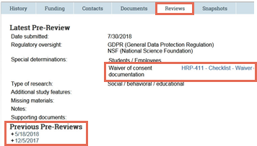
- Under Latest Pre-Review, click the link to download checklists relevant to your review.
- Click to see previous reviews.
You can also find a list of all worksheets and checklists in the IRB Library.
- In the top navigator, click IRB and then Library.
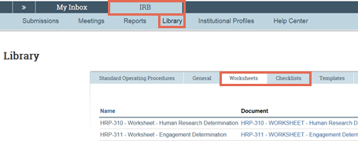
- Click the Worksheets or Checklists tab, depending on the document you want to view.
- Click a link to open or save the applicable document, which is in Microsoft Word format.
Open the Submission
You will receive an email when a study, site, or follow-on submission has been assigned to you to review and the submission will appear in your IRB inbox. As part of your review, you will want to access the necessary review checklists and worksheets, and the submission pages. Review comments and related files are not visible to study team members.
To open the submission (committee reviewer)
As a committee member, you can access a meeting agenda from the agenda notification email or by navigating to it in the IRB system.
- Click the meeting link in your email to open it.
You can also log into the site and click the Meetings link from your Inbox to see a list of upcoming meetings.
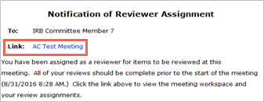
- In the meeting workspace, you will see a list of all the protocols that are on the meeting agenda.
- Click the agenda link for a printable agenda document.
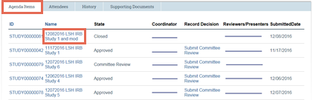
To open the submission (designated reviewer)
- Click the submission ID link in your email to open it.
If you no longer have the email, see Open a Submission and then View History.
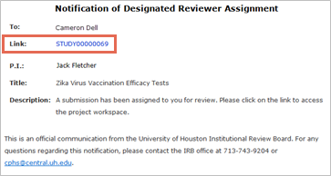
- On the History tab, read any Assigned to Designated Reviewer comments.
Review a Submission
You will receive an email when a study, site, or follow-on submission has been assigned to you to review and the submission will appear in your IRB inbox. As part of your review, you will want to access the necessary review checklists and worksheets, and the submission pages. Review comments and related files are not visible to study team members.
To review the submission pages
Review the submission and attached documents using the following tools:
- Click Review Study and review each section. You can scroll through the submission or use the Left Navigator to jump to specific sections of the form.
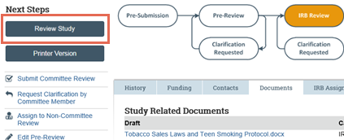
- To see what changed between this and a previous version, look in the Compare section of the Left Navigator.
- After reviewing each section, select the check-box at the bottom to indicate you have reviewed it.
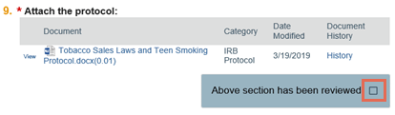
- The section turns green, and a green check mark appears in the Left Navigator.
- If the submission is edited later, the green check mark is removed and a pencil icon is added, indicating to review that section again.
Note: This Review Tracker feature does not stop a submission from moving forward in the review process.
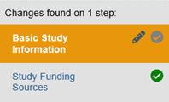
- Click the Reviews tab to access reviews completed by other committee members or reviewers.
Request Clarification on a Submission
If you have questions for the study team or require they make a change to the submission, use the request clarification feature to communicate back and forth with the team. When all questions have been answered or changes made, you can submit your review.
To request clarification
- From the submission workspace, click Request Clarification by…
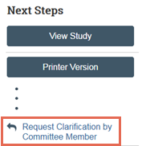
- Type your clarification request.
- Click OK.
The PI will receive an email about your request.
Prepare Review Comments for a Committee Meeting
If the committee plans to review a study, site, or follow-on submission, then you may want to record your review comments in the IRB system for other committee members to view before and during the meeting. Review comments and related files are not visible to study team members and are purged from the system when the approval letter is sent.
To add review comments
- From the submission workspace, click Add Review Comments.
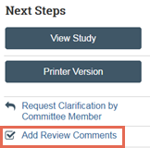
- Type your notes for other committee members.
- Add any checklists or documents you want to share with other committee members.
Note: You can access the appropriate checklist to upload by clicking the Library link and downloading the document from the Checklists tab.
- Click OK.
The review comments and attachments will appear on the Reviews tab of the submission workspace.
Submit a Designated Review
You may be assigned to perform a designated review, a process which doesn’t involve other committee members. After reviewing the assigned submission, you must record your decision in the IRB system. Recording your decision completes the designated review and moves the submission forward in the review process. (For committee meeting decisions, an IRB staff member will record the decision on behalf of the committee.)
To submit designated review
- From the submission workspace, click Submit Designated Review.
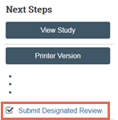
- Complete the Submit Designated Review page. Use the worksheets to support your determination and selections.
Note: Different determinations and exempt categories are available based on whether the study falls under the Pre-2018 or 2018 Common Rule requirements.
- For a study that falls under the 2018 Common Rule requirements, indicate whether continuing review is required.
- Under Supporting documents, add any documents related to your review such as a completed checklist.
- Select the check-box in question 7 affirming that you do not have a conflict of interest.
- Click Yes if you are ready to submit your review. If not, click No, and the information you entered will be saved. You can submit your review later.
- When finished, click OK.
If you said Yes, the submission moves to the IRB coordinator’s inbox so the coordinator can send a determination letter to the PI.
Submit an Ancillary Review
You may be assigned to review a submission as an ancillary reviewer. After reviewing the submission, you must record your decision in the IRB system. This step completes the ancillary review but does not change the state of a submission.
To submit ancillary review
- From the submission workspace, click Submit Ancillary Review.
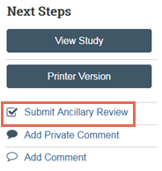
- Complete the Submit Ancillary Review page.
- Indicate whether you accept or do not accept the proposed study.
- Under Supporting documents, add any documents related to your review.
- When finished, click OK.
Your ancillary review responsibilities are complete.
Navigation and Basic Tasks
When you first log in, you will be on your Dashboard, which is the starting point for finding items and performing many basic tasks.
To find key items
From your Dashboard, you will see:
- My Inbox: Items that require you to take action.
- My Reviews: Items assigned to you to review. These are a subset of the items in My Inbox.
- Create menu and buttons: Actions you can perform. The menu will not show if you do not have access to any buttons.
- Recently Viewed: The last several items you viewed. Look here for an item you worked on recently.
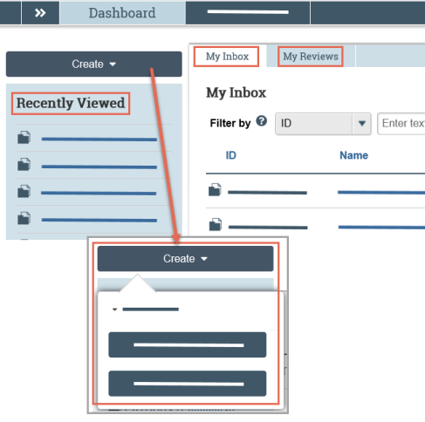
To identify what action is needed
- Review the state of submissions in My Inbox.
The state gives a clue as to what to do next. For example, Committee Review means a study is scheduled or in-review by an IRB committee.
To open a submission
- From My Inbox, or from the Submissions page, click the submission name.
- The submission workspace opens.
To view history
- From the submission workspace, click the History tab.
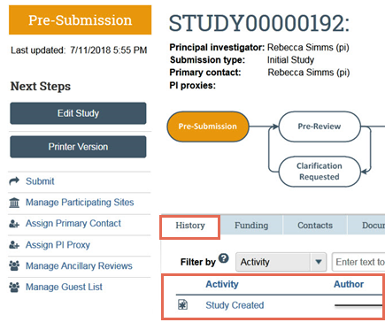
- The history tab lists the activity taken on a submission including any comments, attachments, or correspondence added.
To find previous submissions
- In the Top Navigator, click IRB and then Submissions.
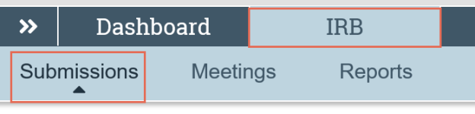
- Click the tab to see submissions you can access:
  - In-Review: Submissions undergoing IRB review.
  - Active: All approved submissions as well external IRB, non-human research, human research not engaged, lapsed, and suspended submissions.
  - New Information Reports: All Reportable New Information (RNI) submissions, in any state.
  - External IRB: All studies managed by an external IRB.
  - Relying Sites: All participating sites relying on the local IRB as the single IRB of record.
Click the ellipsis to see:
  - All Submissions: All submissions, in any state.
  - Archived: All closed, disapproved, discarded, and terminated submissions.
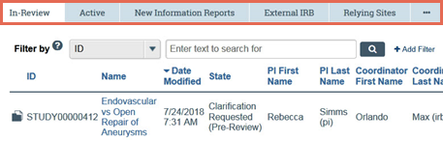
To filter data
Many pages contain tables that you can filter to show specific data.
- Select the column to filter by.
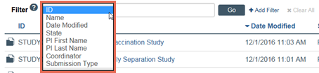
- Type the beginning characters for the items you want to find. You can also type a % symbol as a wildcard before the characters. Examples:
  - 71 shows all items beginning with 71
  - %71 shows all items containing 71
- Click Help for operators you can type in the text box.
- Click Go to apply the filter.
- To combine multiple filter criteria, click Add Filter.

© 2019 Huron Consulting Group Inc. and affiliates. All rights reserved. Use and distribution without a current software license from Huron are prohibited.

All trademarks, registered trademarks, service marks, and trade names are the property of their respective owners.

Information in this document is subject to change without notice.

Published by Huron Consulting Group Inc.
9170 NE Turing Court
Suite 100
Hillsboro, OR 97006

