

Huron IRB

Researcher's Guide

December 2019
Table of Contents
Create and Submit a Study 4
Create and Submit a New Single-Site External Study 5
Change Study Documents 6
Respond to Reviewer Requests 7
Create and Submit a Continuing Review or Modification 8
Update Study Details for a Single-Site External Study 9
Report CR Data for a Single-Site External Study 9
Create and Submit Reportable New Information 10
Navigation and Basic Tasks 11
Checklist of Information to Attach 14

Create and Submit a Study
Before you begin, gather files and information about your study. For more details on documents you may want to attach to a study, see the Checklist of Information to Attach.
To create a study
- From the Dashboard, click the Create menu and then select Create New Study.
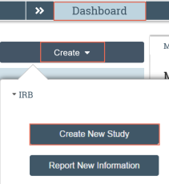
- Complete the pages. Click Continue to move to the next page.
- Pay attention to the following pages:
  - Basic Study Information: use the following questions to indicate whether the study is a single - or multiple-site study or will be locally or externally reviewed.
What kind of study is this?
Will an external IRB act as the IRB of record for this study?
  - Attach the protocol: the study protocol is the only mandatory document to include.
  - Local Site Documents: add consent forms, recruitment materials and other documents specific to your study.
  - Study-Related Documents: if the study is a multi-site study for which you are serving as the sIRB, use this page to add templates for consent forms, recruitment materials, and other that participating sites will need to access.
- On the final page, click Finish.
You are taken to the study workspace. You can continue to edit the study (Edit Study button) until you submit it.
To submit a study for review
- From the study workspace, click Submit.
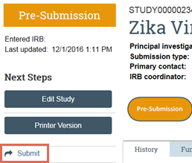
- Click OK to agree to the terms.
- Type your login credentials and click Submit.
You can log off the system. Your study has been submitted.
Create and Submit a New Single-Site External Study
External IRB study forms require less information than normal, but do require information about the external IRB.
To create an external single-site study
- From the Dashboard, click the Create menu and then select Create New Study.
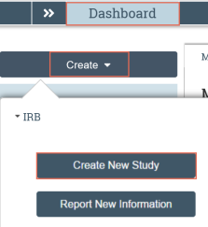
- Complete the pages. Click Continue to move to the next page.
- Pay attention to the following pages:
  - Basic Study Information: use the following questions to indicate whether the study is a single-site and that an external IRB will act as the IRB of record (Externally reviewed MSS are covered in the IRB Multi-Site Study Guide.)
What kind of study is this?
Will an external IRB act as the IRB of record for this study?
  - External IRB: Specify which institution will serve as the external IRB.
- On the final page, click Finish.
You are taken to the study workspace. You can continue to edit the study (Edit Study button) until you submit it.
To submit the external study for review
- From the study workspace, click Submit.
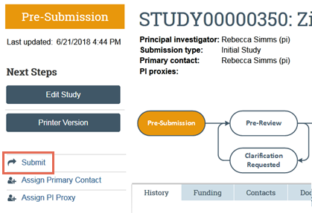
- Click OK to agree to the terms.
- Type your login credentials and click Submit.
You can log off the system. Your study has been submitted.
Change Study Documents
You can update your study documents any time prior to submitting the study to the IRB for review. Once it is in the review process, you can only update documents if the IRB coordinator or a committee member requests clarification, or if you are submitting a modification to the study.
To change study documents
- From My Inbox, open the study you want to edit.
If the study is not in your inbox, contact the IRB coordinator assigned to your study.
- From the submission workspace, click Edit Study.
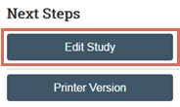
- Add and update documents on study pages as needed and exit the study when done.
  - When updating a document previously submitted to the IRB, revise it using Word’s Track Changes feature and then replace the original document with the tracked-changes version. When the IRB finalizes documents on approved studies, all tracked changes will be accepted and comments removed.
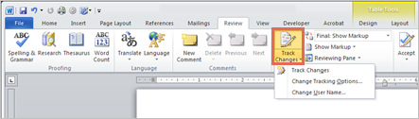
If responding to a clarification request, see Respond to Clarification Requests to submit the changes back to the IRB.
Respond to Reviewer Requests
If a reviewer has questions or requires you to change your submission, you will receive an email indicating this.
Review the request details and then respond to the request.
To review the request details
- Click the submission ID link in the email to open it.
If you no longer have the email, see Open a Submission and then View History to see reviewer comments.
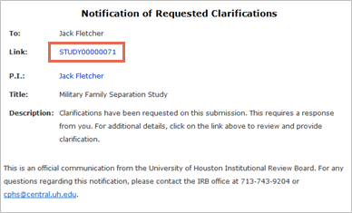
- Click the History tab and review the Clarification Requested activity.
Note: If the reviewer attached a document, a link to open it appears on the History tab.
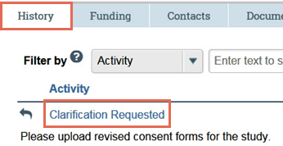
To submit response
- On the submission workspace, click Submit Response.
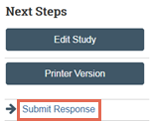
- In the Notes box, explain your response to the reviewer.
Note: If you responded to the reviewer’s request in a document, you can add the document in the Supporting documents area.
- Click OK.
- Type your login credentials and click Submit.
You can log off the system. The study has moved back to the reviewer’s inbox to continue the review.
Create and Submit a Continuing Review or Modification
You can submit a Continuing Review (CR), a modification, or both combined:
- To close a study or extend your approval period, submit a CR.
- To change an approved study or the study team’s members, submit a modification.
To create a CR or modification
- In the Top Navigator, click IRB and then Submissions.
- On the IRB page, click the Active tab and open the approved study.
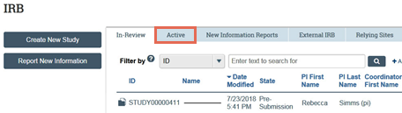
- Click the Create Modification/CR button.
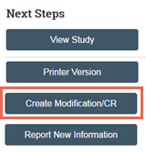
- Select whether the submission is a CR, a modification, or a combination.
- Pay attention to the following question:
Modification scope: To make changes to any part of the study except for study team members, select Other parts of the study.
- Complete the pages. Click Continue to move through the pages and Finish on the last page.
- From the workspace, click Submit.
- Click OK to agree to the terms.
- Type your login credentials and click Submit.
You can log off the system. Your modification or CR has been submitted.
To find your modifications and CRs, go to the Submissions page (In the Top Navigator, click IRB and then Submissions), and then the Follow-On Submissions tab.
Update Study Details for a Single-Site External Study
Use Update Study Details to make changes to an approved, single-site external study. The resulting External Update will be found in the study’s Follow-on Submissions tab.
To update study details for an external study
- In the Top Navigator, click IRB and then Submissions.
- Click the External IRB tab and open the study.
Note: The active external studies are in the External IRB state.
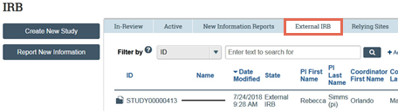
- Click the Update Study Details button.
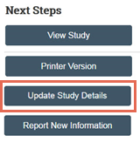
- Summarize the updates, click Continue, then make changes to the study.
- From the study workspace, click Finalize Updates.
- Click OK to agree to the terms.
- Type your login credentials and click Submit.
You can log off the system. Your updated study details have been submitted.
To find your External Update, go to the Submissions page (In the Top Navigator, click IRB and then Submissions), and then click the External IRB tab. You can also find the External Update by clicking the Follow-on Submissions tab in the study’s workspace.
Report CR Data for a Single-Site External Study
Both the local PI and local IRB coordinator can report continuing review data for a single-site external study, so ask the IRB coordinator for help if the need arises.
To report continuing review data for an external study
- In the Top Navigator, click IRB and then Submissions.
- Click the External IRB tab and open the study.
Note: The active external studies are in the External IRB state.
- Click Report Continuing Review Data.
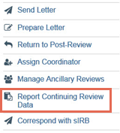
- Complete the Report Continuing Review Data activity.
- In Supporting Documents, be sure to include an explanation for each item left unchecked in question 2 of the Report Continuing Review Data page.
- Click OK.
You can log off the system. Your information has been saved.
Create and Submit Reportable New Information
You can report any adverse events or new information about a study as soon as you become aware of it.
To create a reportable new information (RNI)
- In the Top Navigator, click IRB and then Submissions.
- Click the Report New Information button.
Note: You can also open an active study and report new information from the study workspace.
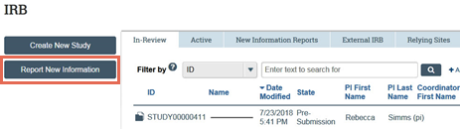
- Complete the Reportable New Information page. Pay attention to the following question:
  - Related studies and modifications: Select any studies or modifications that the RNI applies to.
Note: You cannot relate sites, external studies (unless the external study is part of a multi-site study), or follow-on submissions (except for modifications, which can be added by adding the parent study) to an RNI.
- Click Continue.
- If applicable, select the IRB office and then click Finish.
To submit an RNI
- From the RNI workspace, click Submit RNI.
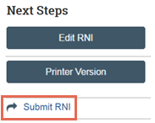
- Click OK to agree to the terms.
- Type your login credentials and click Submit.
You can log off the system. The RNI has been submitted to the IRB. After reviewing the RNI, the IRB may require specific actions be taken and assign a responsible party to do so.
Navigation and Basic Tasks
When you first log in, you will be on on your Dashboard, which is the starting point for finding items and performing many basic tasks.
To find key items
From your Dashboard, you will see:
- My Inbox: Items that require you to take action.
- My Reviews: Items assigned to you to review. These are a subset of the items in My Inbox.
- Create menu and buttons: Actions you can perform. The menu will not show if you do not have access to any buttons.
- Recently Viewed: The last several items you viewed. Look here for an item you worked on recently.
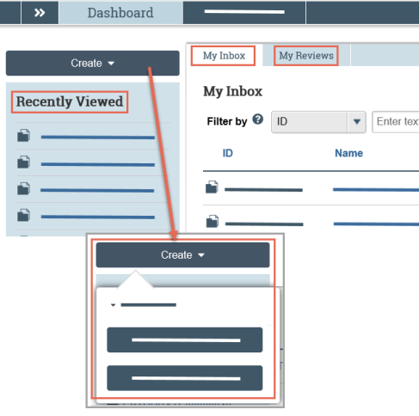
To identify what action is needed
- Review the state of submissions in My Inbox.
The state gives a clue as to what to do next. For example, “Pre-Submission” means you haven’t submitted the study. You can open it, and then finish and submit it for review.
To open a submission
- From My Inbox, or from the Submissions page, click the submission name.
- The submission workspace opens.
To view history
- From the submission workspace, click the History tab.
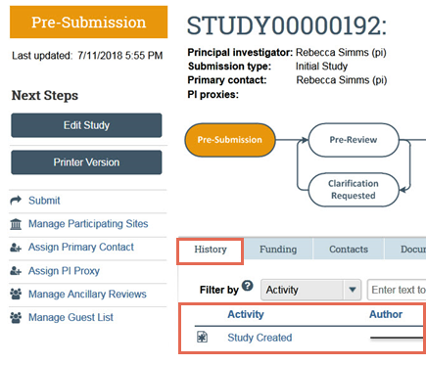
- The history tab lists the activity taken on a submission including any comments, attachments, or correspondence added.
To find previous submissions
- In the Top Navigator, click IRB and then Submissions.
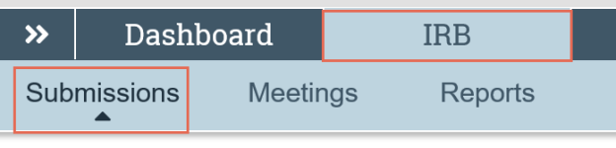
- Click the tab to see submissions you can access:
  - In-Review: Submissions undergoing IRB review.
  - Active: All approved submissions as well external IRB, non-human research, human research not engaged, lapsed, and suspended submissions.
  - New Information Reports: All Reportable New Information (RNI) submissions, in any state.
  - External IRB: All studies managed by an external IRB.
  - Relying Sites: All participating sites relying on the local IRB as the single IRB of record.
Click the ellipsis to see:
  - All Submissions: All submissions, in any state.
  - Archived: All closed, disapproved, discarded, and terminated submissions.
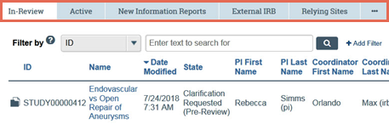
To filter data
Many pages contain tables that you can filter to show specific data.
- Select the column to filter by.
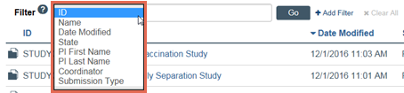
- Type the beginning characters for the items you want to find. You can also type a % symbol as a wildcard before the characters. Examples:
  - 71 shows all items beginning with 71
  - %71 shows all items containing 71
- Click Help for operators you can type in the text box.
- Click Go to apply the filter.
- To combine multiple filter criteria, click Add Filter.
Checklist of Information to Attach
While editing the study, several forms provide places to attach related files. In some cases, a template file is provided directly on the form for download, such as the protocol.
When attaching each file, name it as you want it to appear on the IRB approval letter.
Attach the information listed below (if relevant to your study) to the location identified.
Protocol: (Basic Information page)
- Investigator protocol
- Complete sponsor protocol
- Site supplement to sponsor protocol
- HHS (Department of Health and Human Services) protocol
Funding information: (Funding Sources page, with each source)
- Grant applications
Drug details: (Drugs page, with each drug, or on main Drugs page if not specific to one drug)
- Package insert
- Investigator brochure
- Verification of each IND number (one of these):
  - Sponsor protocol with the IND number
  - Communication from the FDA or sponsor with the IND number
Device details: (Devices page, with each device, or on main Devices page if not specific to one device)
- Product labeling/device instructions
- Investigator brochure
- Verification of each IDE or HDE number (one of these):
  - Sponsor protocol with the IDE / HDE number
  - Communication from the FDA or sponsor with the IDE / HDE number
Recruitment and consent details: (Local Site Documents page)
- Consent documents:
  - Consent forms
  - HHS-approved consent document
  - For non-written consent, a script of the information provided orally to the subjects
- All material to be seen or heard by subjects, such as:
  - Evaluation instruments and surveys
  - Advertisements, including printed, audio, and video
  - Recruitment materials and scripts
- Foreign-language versions of materials for subjects
- Supporting document and other attachments:
  - Conflict of Interest Committee's determination for each financial interest related to the research
  - Completed checklist of meeting Department of Energy requirements
All other relevant documents: (Study-Related Documents page)
- Consent document templates for use by participating sites
- Recruitment materials templates for use by participating sites
- Other supporting documents needed by participating sites

© 2019 Huron Consulting Group Inc. and affiliates. All rights reserved. Use and distribution without a current software license from Huron are prohibited.

All trademarks, registered trademarks, service marks, and trade names are the property of their respective owners.

Information in this document is subject to change without notice.

Published by Huron Consulting Group Inc.
9170 NE Turing Court
Suite 100
Hillsboro, OR 97006

