

Huron IRB

Multi-Site Study Guide

December 2019
Table of Contents
About this Document 5
Multi-Site Study Process Overview 5
Elements of a Multi-Site Study 5
Study Review Process 5
Site Review Process 6
Site Review Workflow 7
Site Modification Process 9
Reportable New Information Process 10
Continuing Review Process 11
External IRB Process for a Multi-Site Study 13
Reportable New Information for Multi-Site External Studies 14
Modification of Multi-Site External Studies 14
sIRB System Site States and Transitions 14
pSite System Site States and Transitions 17
sIRB Researchers 19
Create a Study 19
Manage Participating Sites 20
Submit a Study 22
Create and Submit a Continuing Review for a Multi-Site Study 22
Create and Submit a New Multi-Site External Study 25
Report CR Data for a Multi-Site External Study 26
Create Site Modification for a Multi-Site External Study 27
Update Study Details for a Multi-Site External Study 28
sIRB Coordinators 29
Create an Institutional Profile 29
Correspond with a Site 30
Submit an Invitation Decision to a pSite 31
Mark Site Materials as Received 32
Update a Site from the IRB Exchange 33
Download a Site Modification from the IRB Exchange 33
Download Reportable New Information from the IRB Exchange 34
Confirm Reliance on the External IRB 35
Record the sIRB Decision for an External Study 36
Accept Site Updates for a Multi-Site External Study 36
Update Study Details for a Multi-Site External Study 37
pSite Researchers 38
Manually Create a Site 38
Edit a Site 39
Submit a Site to the sIRB 40
Report Continuing Review Data for a Site 41
Create and Submit a Site Modification 42
Create and Submit Reportable New Information 43
pSite Coordinators 44
Download a Study from the IRB Exchange 44
Confirm Reliance with the sIRB 45
Correspond with the sIRB 45
Record the sIRB Decision 46
Approve a Site Modification 47
Close a Site 48

About this Document
This document covers tasks related to multi-site studies (MSS) under single Institutional Review Board (IRB) of record review. Tasks common to single and MSS can be found in the IRB Researcher Guide, IRB Reviewer Guide, and IRB Staff Guide.
Multi-Site Study Process Overview
Elements of a Multi-Site Study
A multi-site study (MSS) involves research from a single protocol carried out at multiple institutions. For a multi-site study, one institution serves as the single IRB of record (sIRB), and the other institutions serve as participating sites. The sIRB assumes review responsibility for the study at all sites, including the institution where the sIRB is located and any other participating institutions.
Note: The institution’s role depends on the particular multi-site study. For example, an institution that serves as the single IRB of record for one MSS can act as a participating site for another MSS.
A multi-site study includes several parts:
- A study submission that describes the research and the study-related details of the institution serving as the single IRB of record (sIRB).
- Site submissions that represent the study-related details of each participating site (pSite).
The multi-site study will appear differently based on whether you are in the IRB system of the sIRB institution or the IRB system of a pSite institution.
- The sIRB system is where the main multi-site study submission is housed. This includes a study submission, and all the site submissions for every pSite participating in the study. For example, if a multi-site study involves 3 pSites, the sIRB system will have 4 separate submissions: 1 study submission, and 3 site submissions (1 for each pSite). Each of these submissions has its own workspace and their own review process. Each site submission is also linked from the study workspace.
- The pSite system only includes an abbreviated version of the multi-site study, including 1 study submission and 1 site submission, which is the pSite’s own site submission. The site submission is editable in the pSite system, but the study submission is read-only. A multi-site study may have more than one pSite associated with the study, but an institution that is serving as a pSite will only see the site submission for their institution.
Study Review Process
The Principal Investigator (PI) at the sIRB institution initiates the study, specifying that the study is multi-site and that their local institution will serve as the single IRB of record for participating institutions. This is when the study submission is created.
Once the study submission is created, the PI, study team, and IRB staff can add participating sites to the study. Site submissions are created after the study reaches the Pre-Review Complete state; each newly created site corresponds to each participating site added to the study submission. The PI and study staff can continue to add participating sites after the study is in the Pre-Review Complete state. New site submissions are created immediately in the sIRB’s system when participating sites are added in Pre-Review Complete and later states.
The study submission moves through the standard review process in the same manner as a single-site study. For more details on the study review process, see the IRB Staff Guide.
Site Review Process
However, the site submissions require review from both the sIRB institution and the participating site institution. The review workflow differs depending on whether the sIRB and pSite institutions are connected to the IRB Exchange. The IRB Exchange is a cloud-based service that facilitates the sharing of information between the sIRB institution’s IRB system and the pSite institutions IRB system.
If the institutions are not connected to the IRB Exchange, users on both the sIRB and pSite systems manually enter and update site data on their respective systems. In this scenario, the submission in the pSite system resembles an externally-reviewed study with an associated site submission. In some cases, with prior agreement, the pSite PI, primary contact, and PI proxies may be granted account access to the sIRB system so that they can edit the site submission directly in the sIRB system.
If they are connected to the IRB Exchange, the sIRB institution initiates the site submission in their system and submits an invitation to the participating site. The pSite downloads the data and creates a local copy of the study and site submission in their system. The pSite institution fills in the site submission with details about the conduct of the study at their site, sends the site submission back to the sIRB for review, and confirms their reliance on the sIRB for IRB review. Then the sIRB reviews it and makes a determination.
The following diagram illustrates the study and site review processes for a multi-site study when both the sIRB and pSite institutions are connected to the IRB Exchange.
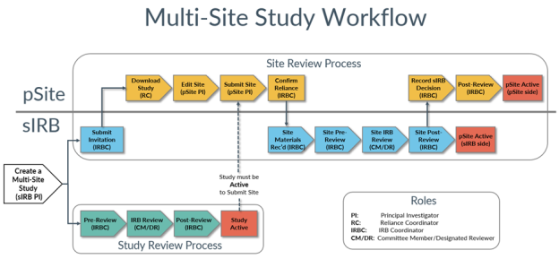
For a more detailed explanation of the site review workflow for institutions connected to the IRB Exchange, see the Site Review Workflow on page 6.
Site Review Workflow

Sl. No | Step | Description
Creation of Site Submissions:
1. | Create a Multi-Site Study | After a PI and study team create a multi-site study submission, the study team and IRB staff add participating institutions to the study using the Manage Participating Sites activity. This activity relies upon Institutional Profiles (IPs) already created in the system to represent the pSite institutions. IPs include authorization agreements and pSite contact information.
2. | Submit Study | The PI submits the study to the IRB for review, thus starting the Study Review Process. Upon reaching the Pre-Review Complete state, site submissions are created in the sIRB system for all pSites associated with the study.  Note: After Pre-Review Complete, the study team and IRB staff can add additional pSites.
Site Submission Workflow
3. | Submit Invitation | A site submission in the sIRB system begins in the Invitation Pending state. For each site, the assigned coordinator uses the Submit Invitation Decision activity to invite a pSite to join the study (or to disapprove the pSite’s participation, thereby deactivating that site). When a site is invited, the pSite PI and institutional contacts are notified.  The site submission moves to the Awaiting Site Materials state and remains in that state until the site submission information is completed by the pSite.
4. | Download Study | When the pSite receives an invitation to participate, the reliance coordinator downloads a read-only copy of the study from the IRB Exchange onto their own system. A site submission is automatically created in their system during the download, in the Pre-Submission state.
5. | Edit and Submit Site | The study team enters their local site information on a series of pages, including information about the local study team, research locations and local consent forms. They send their completed site submission back to the pSite’s IRB for Pre-Review.
  Important! The pSite PI cannot submit the site submission until the study has been approved.
6. | Confirm Reliance | When the assigned coordinator is satisfied that the site submission is complete and the necessary agreements and communication plans with the sIRB are in place, they use the Confirm Reliance activity to confirm that they accept review by a sIRB of record. This transfers portions of the site submission to the IRB Exchange and notifies the sIRB institutional contact of the pSite’s acceptance.  Now, the site submission is in a Pending sIRB Review state on the pSite system. It will remain in this state until the sIRB completes their review of the site submission.
7. | sIRB Reviews the Site Submission | In the sIRB system, the assigned coordinator updates the site information from the IRB Exchange and then uses the Site Materials Received activity to confirm receipt. The site is now in the Pre-Review state in the sIRB system.  The site first undergoes Pre-Review, in which an assigned IRB coordinator reviews the site submission, ensures it includes all the necessary information, and assigns it to a committee meeting or a designated reviewer.  During IRB Review, a designated committee member or the full committee reviews the site. Once a determination is submitted, the system moves the site to Post-Review.  During Post-Review, the IRB coordinator sends the determination letter and the site information is posted to the IRB Exchange.  If the site is approved, it moves to the Active state in the sIRB system. If the site submission requires changes, it moves to Modifications Required.
  Important! If the associated study is not yet approved, IRB staff cannot submit designated or committee reviews. Once the study is approved, the site workflow can resume.
8. | Record sIRB Decision | The assigned coordinator in the pSite updates the site information from the IRB Exchange and uses the Record sIRB Decision activity. The coordinator can choose to proceed to Post-Review to send a letter or to skip to the next appropriate state.  If the site is approved, it moves to the Active state in the pSite system. If it requires changes, it moves to the Modifications Required state.  From Modifications Required, the pSite PI can modify the site submission.
  Important! If the associated study is not yet approved, the pSite will not be able to record the sIRB decision for the site.

Site Modification Process
Modifications to active sites require additional review. Modifications fall into the following categories:
- Changes that affect the study team membership and research locations. These modifications only require local review by IRB staff.
- Changes that affect other parts of the site submission. These modifications require review by the sIRB of record.
- Changes that affect both categories. These modifications also require review by the sIRB of record.
Note: Modifications to a multi-site study submission (as opposed to a site submission) follow the regular study modification process. For more information on study modifications in the IRB Staff Guide.
Site modifications to the study team membership or to research locations follow an abbreviated local review process:
- The pSite PI creates and submits the site modification, moving it into the Pre-Review state.
- A pSite IRB staff member reviews the modification and either requests clarifications or approves the modification using the Accept Site Updates activity.
- If the pSite staff decides that finalized documents or a letter are required, the modification is sent to Post-Review, then to Review Complete.
Note: If no documents or letters are required, the modification is directly sent to Review Complete.
The following diagram illustrates the tasks, roles, and states involved in the creation and review of a site modification that only requires local review:
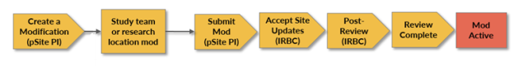
Site modifications to other parts of the site require sIRB review:
- After the pSite PI or study team member submits the modification, pSite IRB staff approves the modification on the pSite system using the Accept Site Updates activity. The modification is then uploaded to the IRB Exchange so the sIRB can access it.
- On the sIRB side, sIRB staff take the modification through the review process. While this happens, the modification remains in the Pending sIRB Review state on the pSite system.
- Once the sIRB review is completed, pSite IRB staff record the sIRB decision, moving the modification to either Post Review (if a letter is required) or Review Complete on the pSite system.
Note: If modifications are required for approval, the modification submission moves to Modifications Required. The pSite PI can then submit a response to the sIRB, which moves the modification submission back to Pending sIRB Review until a new determination is received by the pSite and recorded in the pSite system.
The following diagram illustrates the tasks, roles, and states involved in the creation and review of a modification that requires sIRB review, including the interaction between the sIRB and pSite systems if they are connected to the IRB Exchange.
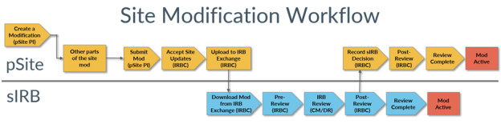
Note: A modification (of any category) that is disapproved remains active until the modification is either approved (which applies the modifications to the study) or discarded (in which case, no modifications are applied to the study).
Reportable New Information Process
The review process for reportable new information (RNI) associated with a multi-site study differs depending on whether the RNI originates from the sIRB or the pSite system, and on where the RNI is routed for review. An RNI originating from the sIRB system follows a review process like that of single-site study RNIs, as described in the IRB Staff Guide.
For an RNI originating from the pSite system:
- The study team on the pSite system creates an RNI submission. When the study team or IRB staff relates a multi-site study to the RNI, the system automatically captures which site is reporting the information.
- Depending on the institutional profile (IP) settings applied to the sIRB institution, the RNI may be routed to either local or sIRB review on submission:
  - If the IP for the sIRB institution specifies that all RNIs should be routed to the sIRB for review, then the RNI is uploaded to the IRB Exchange (if connected) and a notification is sent to the sIRB.
  - If not, the RNI is routed for local review.
Note: After submission, an IRB coordinator in the system the RNI has been routed to can change this selection and route the RNI to the other system (for example, the sIRB coordinator can choose to route the RNI for local review) by using the Route for… activities in the RNI workspace. A notification is sent when the RNI is re-routed.
- If the RNI is sent for sIRB review:
  - On the sIRB system, the Reliance Coordinator downloads the RNI from the IRB Exchange (if connected to the IRB Exchange). The RNI begins in the Pre-Review state.
Note: The sIRB cannot request clarification on RNI’s created by a pSite.
  - The RNI moves through the IRB Review process (which may include local review by a designated reviewer, full committee review, or both) and is sent to Post-Review, where further actions may be required, and eventually to Review Complete.
Note: If the sIRB determines that action is required, the sIRB coordinator uploads an action plan to the IRB Exchange, where it is automatically downloaded on the pSite system. The pSite responsible party can then submit an action response via the IRB Exchange once the sIRB’s concerns have been addressed.
  - On the pSite system, a staff member can record the sIRB decision and move the RNI to the Post-Review or Review Complete states.
- If the RNI is sent to local review:
  - A pSite IRB staff member reviews the RNI and either requests clarifications or submits a pre-review.
  - Depending on the staff member’s pre-review determination, the RNI remains in Pre-Review pending assignment for further review, or goes straight to Review Complete if the reported issue is neither serious nor continuing.
  - RNI’s that require further review are sent through the local IRB review process, which may include local review by a designated reviewer, full committee review, or both.
  - Next, the RNI is sent to Post-Review, where further actions may be required, and eventually to Review Complete.
The following diagram illustrates the tasks, roles, and states involved in the creation and review of a RNI, including the interaction between the sIRB and pSite systems if they are connected to the IRB Exchange.
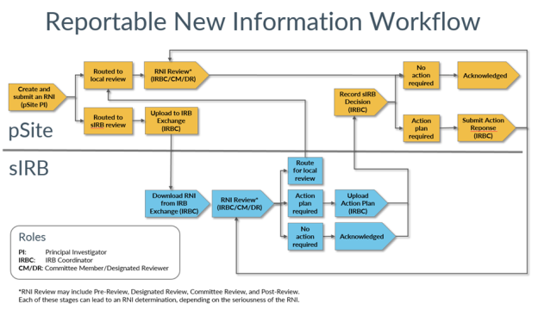
Continuing Review Process
A continuing review (CR) for a multi-site study requires data from the sIRB institution and from all pSites associated with the study. While the pSite is responsible for reporting CR data from their site, the sIRB PI is responsible for creating and submitting a CR that encompasses the entire multi-site study.
For a pSite, the process is simple:
- The PI on the pSite system receives reminders beginning 90 days before a continuing review is due and reports CR data from the site workspace using the Report Continuing Review Data activity.
  - If the pSite is connected to the IRB Exchange, the reported information is automatically made available to the sIRB.
  - If not, the pSite PI must manually send their CR data to the sIRB so the sIRB PI can manually enter the data into a continuing review submission.
- After the pSite PI reports the data, the CR is in the hands of the sIRB PI.
The sIRB system is where the bulk of the CR process takes place. Here, the process differs based on whether you are using the IRB Exchange or not. In an sIRB system connected to the IRB Exchange, the process looks like this:
- The sIRB PI creates a CR from the study workspace and begins to complete the form. Because a CR for an MSS requires data from the sIRB institution and all pSites, it’s likely that the PI may not have all the information they need at hand. In this case, the PI can exit the CR form and return to it later.
- When a pSite PI reports continuing review data for their site, the data is automatically transferred to the sIRB system via the IRB Exchange and the sIRB PI is notified. The data from the pSite PI is available in the workspace of the CR that sIRB PI previously created. In order to access it, the sIRB PI navigates to the CR workspace and opens the Report Continuing Review Data activity. The Report Continuing Review Data form is automatically populated with the pSite data, and the sIRB PI clicks OK to submit the activity.
- The site data is then displayed in the Sites tab. Next to the data, the sIRB PI must select the check-box next to Report Completed to indicate that the CR data from that site has been reported. Once this checkbox is selected, the data that was reported complete automatically populates the CR form. When the sIRB PI next opens the CR form to edit it, the PI can see that the form has been automatically populated with the site CR data in the appropriate fields.
Note: the sIRB PI can complete the above activities as they receive CR data from various sites, or they can wait until they have received CR data from all site associated with the MSS and complete the activities for multiple sites at once.
- When the sIRB PI has received and reported CR data from all the pSites associated with the MSS, the PI can complete the CR form and submit the CR. Once the CR is submitted, it follows the same review process as a continuing review for a single-site study.
Note: Before a CR can be closed, the sites linked in the Sites tab of the CR workspace must be closed.
If the sIRB system is not connected to the IRB Exchange, the sIRB must use another means of communication to receive CR data from pSites. When the sIRB PI is ready to complete a continuing review, they have a few options:
- The sIRB PI can complete steps 4-5 above in the CR workspace, except that they must manually enter the CR data from a site into the Report Continuing Review Data activity.
- The sIRB PI can manually enter data into the CR form as they receive it from pSites.
The following diagram illustrates the tasks, roles, and states involved in the creation and review of a continuing review, including the interaction between the sIRB and pSite systems if they are connected to the IRB Exchange.
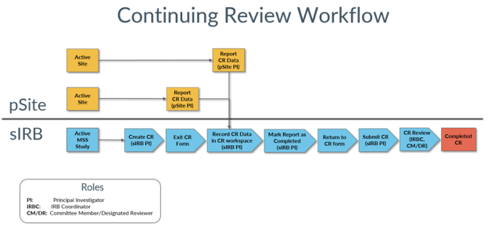
External IRB Process for a Multi-Site Study
The workflow for a multi-site study and a single-site study where the local IRB cedes authority to an external IRB are similar. The difference is in the amount of information collected: A multi-site study collects both study and site information, so the SmartForm is considerably longer.
Note: Neither single-site nor multi-site external IRB studies use Huron’s IRB Exchange. Rather, the local IRB communicates with the external IRB, then records the external IRB’s determination using the Record sIRB Decision activity.
- During Pre-Submission when the study team is creating the study, they will indicate that they are using an external IRB. For a multi-site study, the study team records both study information (Study SmartForm pages include: Basic Study Information, External IRB, Study Funding Sources, Study Scope, and Study Related Documents) and site information (Site SmartForm pages include: Basic Site Information, Additional Local Funding Sources, Local Study Team Members, Research Locations, and Local Site Documents).
- During Pre-Review, the assigned coordinator conducts their administrative review of the study, including the external IRB information, and can send the study back to the study team for more information or clarification as needed. When all the information has been supplied, the coordinator uses the Confirm Reliance activity to confirm that an external IRB is able to oversee the review process.
- The study will move to the Pending sIRB Review state. If the study needs to be revised while in the Pending sIRB state, the assigned IRB coordinator or study staff can directly edit the study.
- Once the external IRB communicates their decision, the local IRB coordinator records the decision using the Record sIRB Decision activity. The Record sIRB Decision activity is where you will record which Common Rule regulatory requirements apply to the study – Pre-2018 or 2018. Depending on the decision, and whether the coordinator needs to finalize documents and send an acknowledgement letter, the study moves to the Post-Review, Modifications Required, or Review Complete state:
  - In the Modifications Required state, the coordinator or PI can respond to the external IRB.
  - During Post-Review, the IRB coordinator can prepare and send the acknowledgement letter and finalize documents.
  - Once the study is in the Review Complete state, the local IRB process is complete.
Note: All submissions reviewed by an external IRB are always found on the External IRB tab.
The following diagram illustrates the review process for a multi-site study external submission.
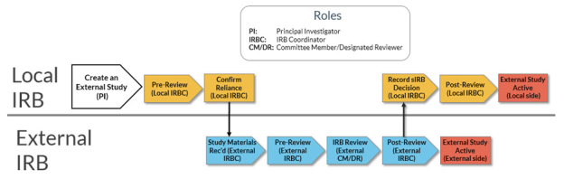
Reportable New Information for Multi-Site External Studies
The RNI workflow for multi-site studies that cede review to an external IRB follows the same workflow as that for single-site studies. Depending on how your IRB solution is configured, an RNI for a multi-site external study may follow the workflow in the workflow map below, or it may be routed directly to Pending sIRB Review. Once the external IRB communicates their decision, the local IRB coordinator uses the Record sIRB RNI Decision activity to record the decision. The sIRB has the option to route the RNI back to the local IRB.
See the Reportable New Information Process section in the IRB Staff Guide for more details on the workflow.
The following diagram illustrates the review process for an RNI for both single-site and multi-site external studies, if your solution is configured to send the RNI to your local IRB. Alternatively, the RNI may be routed to the Pending sIRB Review state.
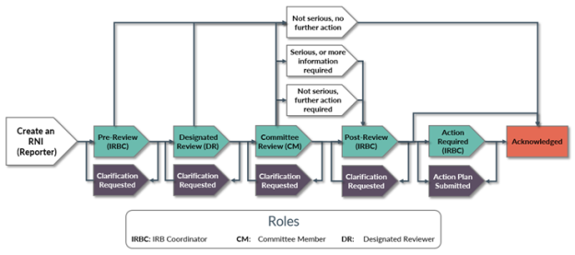
Modification of Multi-Site External Studies
There are two activities that can be used to modify a multi-site external review study: (1) Create Site Modification; and (2) Update Study Details. Create Site Modification allows the PI to edit only site information, and Update Study Details allows the PI to edit only study information. For all 3 activities, the local IRB is notified after the submission. What happens after that depends on the type
- For Create Site Modification, the PI can select to modify either Study Team Members, or Other Parts of the Study.
  - If Study Team Members is selected – The local IRB either accepts the site updates, or requests a pre-review clarification. The site update does not go through sIRB review.
  - If Other Parts of the Study selected – The local IRB either accepts the site updates, or request a pre-review clarification. The site update will go through sIRB Review.
- For Update Study Details – The local IRB is only notified. The study update does not go through sIRB Review.
sIRB System Site States and Transitions
The table below outlines the possible states for a site submission in the sIRB system. For the study submission states and transitions, see the IRB Staff Guide.

In this state… | These roles… | Can perform these actions… | Changing the state to…
Invitation Pending | IRB Coordinator, IRB Director | Submit Invitation Decision | Inactive
Invitation Pending | IRB Coordinator, IRB Director | Submit Invitation Decision | Awaiting Site Materials
Awaiting Site Materials | IRB Coordinator, IRB Director | Site Materials Received | Pre-Review
Pre-Review | IRB Coordinator, IRB Director | Assign Designated Reviewer | Non-Committee Review
Pre-Review | IRB Coordinator, IRB Director | Assign to Meeting | Committee Review
Non-Committee Review | Designated Reviewer, IRB Coordinator,  IRB Director | Assign to Committee Review | Committee Review
Non-Committee Review | Designated Reviewer, IRB Coordinator,  IRB Director | Submit Site Designated Review | Post-Review
Committee Review | IRB Coordinator, IRB Director | Assign to Non-Committee Review | Non-Committee Review
Committee Review | Committee Chair, Committee Administrator, IRB Coordinator, IRB Director | Submit Site Committee Review | Post-Review
Post-Review | IRB Coordinator, IRB Director | Send Letter | Deferred
Post-Review | IRB Coordinator, IRB Director | Send Letter | Modifications Required
Post-Review | IRB Coordinator, IRB Director | Send Letter | Active
Post-Review | IRB Coordinator, IRB Director | Send Letter | Inactive
Deferred | IRB Coordinator, IRB Director | Assign Designated Reviewer | Non-Committee Review
Deferred | IRB Coordinator, IRB Director | Assign to Meeting | Committee Review
Active | IRB Coordinator, IRB Director | Update Site Status | Inactive
Active | IRB Coordinator, IRB Director | Update Site Status | Suspended
Active | IRB Coordinator, IRB Director | Update Site Status | Terminated
Active | IRB Coordinator, IRB Director | Return to Post-Review | Post-Review
Active | IRB Coordinator, IRB Director | Close Site (Admin) | Closed
Modifications Required | IRB Coordinator, IRB Director | Site Materials Received | Modifications Submitted
Modifications Submitted | IRB Coordinator, IRB Director | Assign Designated Reviewer | Non-Committee Review
Modifications Submitted | IRB Coordinator, IRB Director | Assign to Meeting | Committee Review
Modifications Submitted | IRB Committee Chair, IRB Coordinator,  IRB Director | Review Required Modifications | Post-Review
Modifications Submitted | IRB Committee Chair, IRB Coordinator,  IRB Director | Review Required Modifications | Modifications Required
Inactive | IRB Coordinator, IRB Director | Record Response | Pre-Review
Inactive | IRB Coordinator, IRB Director | Record Response | Invitation Pending
Inactive | IRB Coordinator, IRB Director | Update Site Status | Suspended
Inactive | IRB Coordinator, IRB Director | Update Site Status | Terminated
Inactive | IRB Coordinator, IRB Director | Close Site (Admin) | Closed
Suspended | IRB Coordinator, IRB Director | Update Site Status | Suspended
Suspended | IRB Coordinator, IRB Director | Update Site Status | Terminated
Suspended | IRB Coordinator, IRB Director | Close Site | Closed

pSite System Site States and Transitions
The table below outlines the possible states for a site submission in the pSite system. For the study submission states and transitions, see the IRB Staff Guide.

In this state… | These roles… | Can perform these actions… | Changing the state to…
Pre-Submission | Investigator | Submit | Pre-Review
Pre-Review | IRB Coordinator, IRB Director | Confirm Reliance | Pending sIRB Review
Pre-Review | IRB Coordinator, IRB Director | Confirm Reliance | Inactive
Pre-Review | IRB Coordinator, IRB Director | Request Clarification | Clarification Requested (Pre-Review)
Pre-Review | IRB Coordinator, Reliance Coordinator, IRB Director | Accept Site Updates | Post-Review
Pre-Review | IRB Coordinator, Reliance Coordinator, IRB Director | Accept Site Updates | Approved
Pre-Review | IRB Coordinator, Reliance Coordinator, IRB Director | Accept Site Updates | Pending sIRB Review
Clarification Requested (Pre-Review) | Investigator | Submit Response | Pre-Review
Pending sIRB Review | IRB Coordinator, IRB Director | Record IRB Decision | Approved
Pending sIRB Review | IRB Coordinator, IRB Director | Record IRB Decision | Post-Review
Pending sIRB Review | IRB Coordinator, IRB Director | Record IRB Decision | Deferred
Pending sIRB Review | IRB Coordinator, IRB Director | Record IRB Decision | Modifications Required
Pending sIRB Review | IRB Coordinator, IRB Director | Record IRB Decision | Active
Pending sIRB Review | IRB Coordinator, IRB Director | Record IRB Decision | Inactive
Modifications Required | IRB Coordinator, IRB Director | Submit Response | Pending sIRB Review
Deferred | IRB Coordinator, IRB Director | Submit Response | Pending sIRB Review
Disapproved | IRB Coordinator, IRB Director | Submit Response | Pending sIRB Review
Post-Review | IRB Coordinator, IRB Director | Send Letter | Approved
Post-Review | IRB Coordinator, IRB Director | Send Letter | Disapproved
Post-Review | IRB Coordinator, IRB Director | Send Letter | Deferred
Post-Review | IRB Coordinator, IRB Director | Send Letter | Modifications Required
Post-Review | IRB Coordinator, IRB Director | Send Letter | Active
Post-Review | IRB Coordinator, IRB Director | Send Letter | Inactive
Post-Review | IRB Coordinator, IRB Director | Edit sIRB Decision | Approved
Post-Review | IRB Coordinator, IRB Director | Edit sIRB Decision | Disapproved
Post-Review | IRB Coordinator, IRB Director | Edit sIRB Decision | Deferred
Post-Review | IRB Coordinator, IRB Director | Edit sIRB Decision | Modifications Required
Post-Review | IRB Coordinator, IRB Director | Edit sIRB Decision | Active
Post-Review | IRB Coordinator, IRB Director | Edit sIRB Decision | Inactive
Active | IRB Coordinator, IRB Director | Deactivate Site | Inactive
Active | IRB Coordinator, IRB Director | Return to Post-Review | Post-Review
Active | IRB Coordinator, IRB Director | Close Site | Closed
Inactive | IRB Coordinator, IRB Director | Return to Post-Review | Post-Review
Inactive | IRB Coordinator, IRB Director | Close Site | Closed
Inactive | IRB Director | Activate Site | Active

sIRB Researchers
Create a Study
Before you begin, gather files and information about your study, such as supporting information (drug and device information, recruitment materials, etc.), financial interest status for each study team member, and consent forms and recruitment materials.

Who performs this activity? | When to perform this activity
- sIRB principal investigators | This is the first step in creating a multi-site study

To create a study
- From the Dashboard, click the Create menu and then select Create New Study.
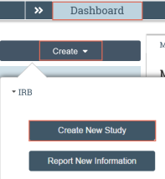
- Complete the form. Pay attention to the following pages:
  - Basic Study Information: use the following questions to indicate whether the study will be locally or externally reviewed, and whether it is a single- or multiple-site study:
What kind of study is this?
Will an external IRB act as the IRB of record for this study?
  - Study-Related Documents: add templates for consent forms, recruitment materials, and other documents that are required study-wide and that participating sites will need to access.
  - Local Site Documents: add consent forms, recruitment materials and other documents specific to your site.
- Click Continue to move to the next page. Complete the pages.
- On the final page, click Finish.
Manage Participating Sites
While a study is in the Pre-Submission or Pre-Review Clarification Requested states, you can add or delete participating sites. While a study is in the Pre-Review Completed state, you can continue to add sites, but you can no longer delete sites. Instead, you can deactivate sites that are no longer associated with the study.

Who performs this activity? | When to perform this activity
- sIRB principal investigators  - Study staff  - Reliance coordinators  - IRB coordinators and directors | After creating a multi-site study. You can manage sites (add and delete) before the study is in Pre-Review Completed, and add sites after Pre-Review is Completed.

To manage participating sites
- From the study workspace, click Manage Participating Sites.
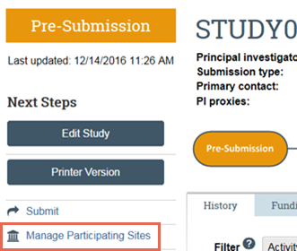
- Click Add.
Click the ellipses to add an institutional profile and a principal investigator. Repeat this process to add additional institutions.
Note: The pSite PI is matched according to email address, so make sure you have the correct PI email.
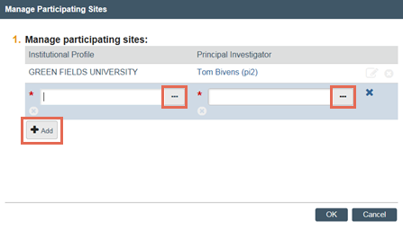
- Click OK when you are finished.
Sites are in a “pending creation” state until the study is submitted. Once the study is in Pre-Review Completed, the sites are automatically created.
- Click the Sites tab to view participating sites pending creation.
To add participating sites
- Click Add Participating Sites.

- Follow steps 2-4 in To manage participating sites on page 19 to add sites.
A site is automatically created for any institutions you add. In the Sites tab, click the name of a site to go to the site workspace.
Note: Once participating sites are added to a study, the study cannot be withdrawn until all associated sites are in an Inactive or Discarded state.

Submit a Study
Once you have finished creating an Multi-Site Study (MSS) and managing participating sites, you can submit the study for review.

Who performs this activity? | When to perform this activity
- sIRB Principal Investigators | After you have created a study and managed participating sites.  Once you submit a study, it moves to the Pre-Review state.

To submit a study
- From the study workspace, click Submit.
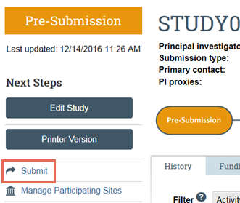
- Click OK to agree to the terms.
- Type your login credentials and click Submit.
Note: When you submit an MSS, the PIs and primary contacts of any invited pSites are notified.
You can log off the system. Your study has been submitted to the IRB.

Create and Submit a Continuing Review for a Multi-Site Study
A researcher at the sIRB institution can create and submit a continuing review (CR) that reports data for the sIRB institution and any pSites involved in the multi-site study.

Who performs this activity? | When to perform this activity
- sIRB principal investigators | When CR data for the study is required.

To create a continuing review
- From the study workspace, click Create Modification/CR.
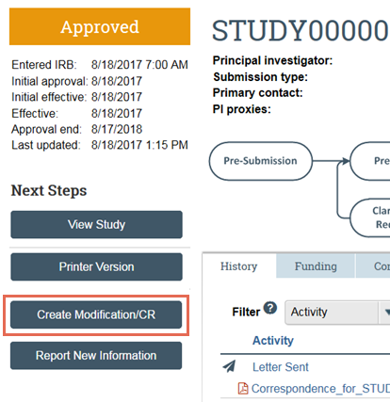
- Select Continuing Review as the purpose of the submission.
- Click Continue.
- On the Continuing Review / Study Closure page, pay attention to the Specify enrollment totals question.
You must specify the subjects enrolled at your local site as well as the combined enrollment totals for all sites (Study-wide).
  - If you are not connected to the IRB Exchange, and you have received all pSite CR data, you can manually enter the study-wide enrollment count.
  - If you have not yet received all pSite data, you can exit the Continuing Review form and return to the continuing review workspace. From the workspace, you can complete the To record site CR data on page 23 steps as site data becomes available.
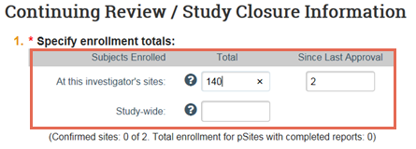
- Complete the other questions and click Continue. Click Finish on the last page.
Note: If you do not have all the information you need to complete the CR, you can save your information and then click Exit to leave the form. To return to the CR, click Edit Modification/CR from the CR workspace.
To record site CR data
As continuing review data from pSites becomes available, you can enter the site data directly from the continuing review workspace without having to edit the continuing review submission multiple times.
- From the continuing review workspace, click the Sites tab.
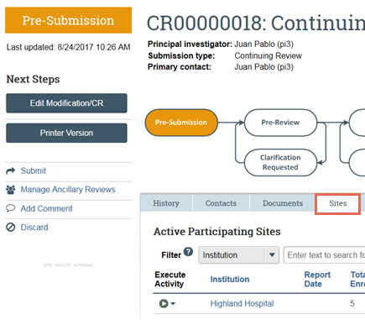
- Under Execute Activity, click the arrow.
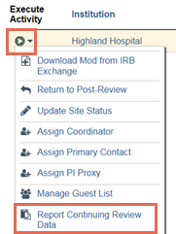
- Click Report Continuing Review Data.
  - If a site is connected to the IRB Exchange and has reported their CR data, the form is automatically populated with the data.
  - If not, you can manually enter the CR data.
- Click OK.
- If you have sufficient data to complete the site’s continuing review report, under Report Completed, select the check-box. You must select the check-box for the site’s enrollment totals to be confirmed and added to the Continuing Review form.
Note: If the CR is discarded, the Report Complete checkmarks for all sites are automatically cleared.
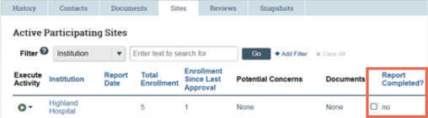
To submit a continuing review
- If necessary, from the study workspace, click Edit Modification/CR, update the CR, and click Finish.
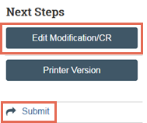
- From the study workspace, click Submit.
- Click OK to agree to the terms.
Type your login credentials and click Submit.

Create and Submit a New Multi-Site External Study
The process of creating and submitting a multi-site study for external review is similar to a single site study, but more information is required.
To create an external multi-site study
- From the Dashboard, click the Create menu and then select Create New Study.
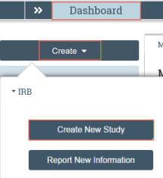
- Complete the pages. Click Continue to move to the next page.
- Pay attention to the following:
  - Basic Study Information page questions: use the questions pictured to the left to indicate the submission is a multiple-site study (MSS) and that an external IRB will act as the IRB of record.
  - Basic Site Information page: describe the activities this site will perform.
  - External IRB page: specify which institution will serve as the external IRB.
- On the final page, click Finish.
You are taken to the study workspace. You can continue to edit the study (Edit Study button) until you submit it.
To submit the external study for local review
- From the study workspace, click Submit.
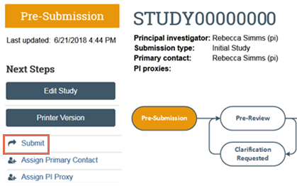
- Click OK to agree to the terms.
- Type your login credentials and click Submit.
You can log off the system. Once the IRB confirms reliance, you will receive further information on next steps (for example, submitting to the external IRB).
Note: This submission combines both study and site information. After the IRB coordinator confirms reliance, the interface refers to your submission as a site (for example, View Site), but your submission will still have the word Study in the title.
Report CR Data for a Multi-Site External Study
Both the local PI and local IRB coordinator can report continuing review data for a multi-site external study.
To report continuing review data for an external study
- In the Top Navigator, click IRB and then Submissions.
- Click the External IRB tab and open the study.
Note: Active multi-site external IRB studies are in the Active state.
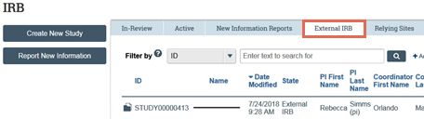
- Click Report Continuing Review Data.
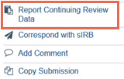
- Complete the Report Continuing Review Data activity.
- In Supporting Documents, be sure to include an explanation for each item that is not selected in question 2.
- Click OK.
Create Site Modification for a Multi-Site External Study
Create Site Modification only updates the site. There is also an option to Update Study Details which is covered in the next section.
To create a site modification for an external study
- In the Top Navigator, click IRB and then Submissions.
- Click the External IRB tab and open the study.
Note: Active multi-site external IRB studies are in the Active state.
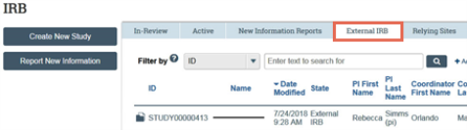
- Click Create Site Modification.
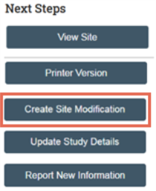
- After selecting Modification, the Modification Scope question appears. Select Study team and research location information to update them, or select Other parts of the study to update Basic Local Information (like the PI), Additional Funding Sources, or Local Site Documents, or you can select both options. Click Continue.
- On the Modification Information page, summarize the updates.
- Complete the rest of the Smartform.
- From the study workspace, click Submit.
- Click OK to agree to the terms.
- Type your login credentials and click Submit.
Both selections, whether study team and research location information or other parts of the site, go to your local IRB for review. Other parts of the site will also be reviewed by the external IRB.
Update Study Details for a Multi-Site External Study
Update Study Details only updates the study.
To update study details for an external study
- From the study workspace, click Update Study Details.
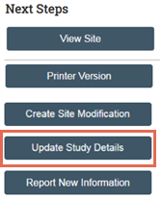
- On the Study Update Information page, summarize the updates.
- Click Create Site Modification.
- After selecting Modification, the Modification Scope question appears. Select Study team and research location information to update them, or select Other parts of the study to update Basic Local Information (like the PI), Additional Funding Sources, or Local Site Documents, or you can select both options. Click Continue.
- On the Modification Information page, summarize the updates.
- Complete the rest of the Smartform.
- From the study workspace, click Finalize Updates.
- Click OK to agree to the terms.
- Type your login credentials and click Submit.
The local IRB is notified about the updates.

sIRB Coordinators
Create an Institutional Profile
Institutional profiles contain a record of information about institutions with whom your institution collaborates on multi-site research. Researchers use institutional profiles to add participating sites to studies, but before they do so, you must create them in your system.

Who performs this activity? | When to perform this activity
- Reliance Coordinator on the sIRB side | The Reliance Coordinator must create Institutional Profiles before investigators can add participating sites to their multi-site studies.

To add an institutional profile
- In the Top Navigator, click IRB.
- In the Sub-Navigator, click Institutional Profiles.
- On the right side of the window, click Add.
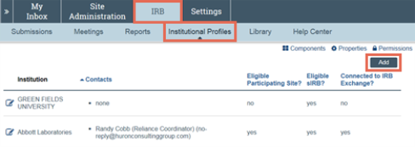
- Complete the form. Pay attention to the following question:
Route RNIs to this institution: This determines whether Reportable New Informations (RNIs) originating from a pSite are sent to local IRB review or if they are automatically sent to the sIRB institution for review.
- Add an IRB Exchange account:
  - Click the Search for Account button.
  - From the drop-down menu above the Search button, select the account.
Note: The selected account name should match the institution name at the top of the form.
The IRB Exchange account is created once you click OK on the IP form.
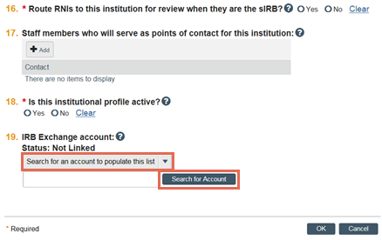
- Click OK.
The institutional profile is created.

Correspond with a Site
At any point during the review process, you can correspond with the researchers and coordinators at a Site.

Who performs this activity? | When to perform this activity
- sIRB Coordinators assigned to a submission  - IRB Reliance Coordinators  - IRB Directors | This activity is available before a site is submitted for review and while it is going through the review process.

To navigate to the site workspace
- In the Top Navigator, click IRB.
- In the Sub-Navigator, click Submissions.
- Click the Sites tab.
- Click the name of the site you want to open.
Note: To find sites related to a specific Multi-Site Study (MSS), navigate to the MSS workspace and click the Sites tab.
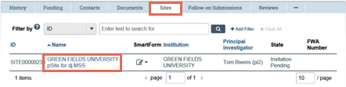
To correspond with a pSite
- From the site workspace, click Correspond with Site.
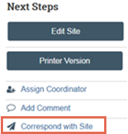
- Complete the form and click OK.
Your correspondence is sent to the designated receiver.
Submit an Invitation Decision to a pSite
Once a study has been submitted to the sIRB for review, you can submit an invitation decision to a pSite so that they can access the study from the IRB Exchange and update their site materials.

Who performs this activity? | When to perform this activity
- sIRB Coordinators assigned to a submission  - IRB Reliance Coordinators  - IRB Directors | After adding a participating site to a multi-site study, and after submitting the study, you can submit invitation decisions to participating sites.  Until you submit the invitation decision to a participating site, the site will not be able to access the study via the IRB Exchange or move forward in the review process.

To submit an invitation decision
- From the site workspace, click Submit Invitation Decision.
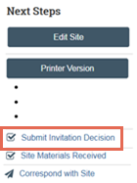
- Complete the form and click OK.
The pSite PI and institutional contacts are notified and the pSite reliance coordinator can download a local copy of the study from the IRB Exchange.

Mark Site Materials as Received
Once you receive site materials from a pSite, you can mark them as received in order to move to the next state of review.

Who performs this activity? | When to perform this activity
- sIRB Coordinators assigned to a submission  - IRB Reliance Coordinators  - IRB Directors | After you have received completed materials from a pSite.

To mark site materials received
- From the site workspace, click Site Materials Received.
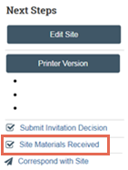
- Complete the form and click OK.

Update a Site from the IRB Exchange
The IRB Exchange automatically updates site data every 30 minutes when a site is in an editable state. If a pSite makes changes to the site in their system, these changes are uploaded to the sIRB system during the automatic update. Registered users with read permission to a site can also manually update their local copy of the site from the IRB Exchange.

Who performs this activity? | When to perform this activity
- Registered users with read permissions for a site | When the pSite has made changes to a site that have not already been uploaded during the automatic update.

To update an external submission
- From the site workspace, click Update from IRB Exchange.
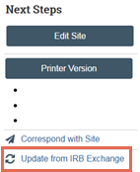
- Complete the form and click OK.
- In the History tab, click the link to open the item. You can now review the materials.
Download a Site Modification from the IRB Exchange
If a pSite submits a site modification to the sIRB, the sIRB can download the modification to the sIRB system via the IRB Exchange in order to review it.

Who performs this activity? | When to perform this activity
- sIRB Coordinators assigned to a submission  - IRB Reliance Coordinators  - IRB Directors | When the pSite has submitted a site modification to the sIRB.

To update an external submission
- From the site workspace, click Download Mod from IRB Exchange.
The modification is downloaded.
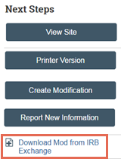
- In the History tab, click the link to open the modification. You can now review the materials.
Note: If a site modification is approved, the approved changes will automatically be applied to the site on the sIRB side.
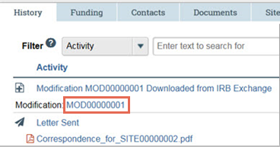

Download Reportable New Information from the IRB Exchange
Reliance coordinators can download RNIs created by a pSite from the IRB Exchange.
Note: To download a modification, see Download a Modification from the IRB Exchange. To download a site update, see Update a Site from the IRB Exchange .

Who performs this activity? | When to perform this activity
- Reliance Coordinator on the sIRB side | After a pSite coordinator uploads a site modification or RNI to the IRB Exchange, you receive a notification. You can then download the external submission to your local system.

To download a new external submission
- In the Top Navigator, click IRB.
- In the Sub-Navigator, click Submissions.
- Click the IRB Exchange tab.
Note: Only users assigned the role of reliance coordinator can see the IRB Exchange tab.
- Next to the external submission you wish to download, click Download.
Note: If you do not see the external submission you are looking for, click Refresh to refresh the list of items available for download.
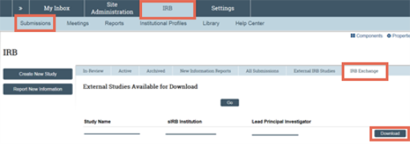
- A message appears when the item is successfully downloaded. Click the link to navigate to the item.
Note: You can also navigate to the item by clicking the External IRB Studies tab and clicking the name of the external submission you downloaded to open it.
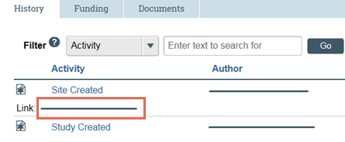

Confirm Reliance on the External IRB
For a multi-site external IRB study, you must confirm reliance on the external IRB before the submission can move forward in the review process. From the Submissions link, click the External IRB tab, then open the study.
To confirm reliance
- From the site workspace, click Confirm Reliance.
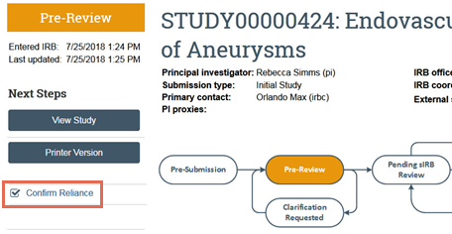
- Complete the form.
- Click OK to finish.
If reliance is confirmed, the site enters a Pending sIRB Review state.
Record the sIRB Decision for an External Study
IRB staff record and edit the sIRB decision for an external IRB study.
To record sIRB decision
- From the site workspace, click Record sIRB Decision.
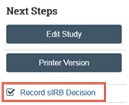
- Complete the form.
Note: If you select FDA or DOJ in the Regulatory Oversight section, the study will automatically fall under the Pre-2018 Common Rule requirements, even if it falls after the effective date setting of the 2018 requirements.
Note: Broad consent is not a valid selection for studies falling under the Pre-2018 Common Rule requirements.
- Indicate whether the study has any additional features.
- Under Supporting documents, upload appropriate checklists based on the special determination and waivers.
- For Do you need to finalize documents or send a letter?, select Yes to send the item to Post-Review, and select No to send the item to Review Complete.
- For Are you ready to record the sIRB’s decision?, select No to note the sIRB determination without recording it and your selections will be saved.
- Click OK to finish.
Accept Site Updates for a Multi-Site External Study
For a multi-site external IRB study, you must accept the site updates before the submission will move forward in the review process. If the modification scope is “Study team and research location information”, you will have the option to finalize documents or send a letter. If you pass on these options, the submission moves to Review Complete. If the modification scope is “Other parts of the site”, once you accept the updates, the submission moves to Pending sIRB Review (you do not have the option to finalize documents or send a letter at this point.)
To accept site updates
- From the site workspace, click Accept Site Updates.
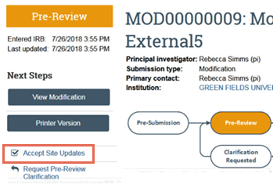
- Notice that you also have the option to Request a Pre-Review Clarification.
- Complete the form.
- Click OK to finish.

Update Study Details for a Multi-Site External Study
For a multi-site external IRB study, the local IRB is notified when the PI updates study details. Note that the IRB receives the update in the Updates Complete state, so the workflow is complete. But you can still review the update using the procedure described below.
To update study details
- From the site workspace, open the update.
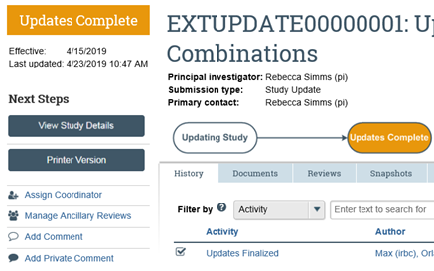
- Click View Differences so see the updates.
- Add a comment if there is an error that needs to be addressed asking the Principal Investigator (PI) to make the change with another update.

pSite Researchers
Manually Create a Site
If you do not participate in the IRB Exchange, you must manually create local copies of studies and sites involved in a multi-site study.
To create an external multi-site study
- From the Dashboard, click the Create menu and then select Create New Study.
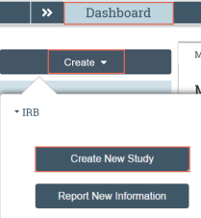
- Complete the pages. Click Continue to move to the next page.
- Pay attention to the following:
  - Basic Study Information page questions: use the following questions to indicate whether the submission is a multiple-site study (MSS) and that an external IRB will act as the IRB of record.
What kind of study is this?
Will an external IRB act as the IRB of record for this study?
  - Basic Site Information page: describe the activities this site will perform.
  - External IRB page: specify which institution will serve as the external IRB.
- On the final page, click Finish.
You are taken to the study workspace. You can continue to edit the study (Edit Study button) until you submit it.
To submit the external study for review
- From the study workspace, click Submit. Click OK to agree to the terms.
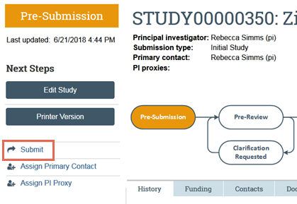
- Type your login credentials and click Submit.
You can log off the system. Once an IRB coordinator confirms reliance on the external IRB, your study will be submitted.
Note: This submission combines both study and site information.
Edit a Site
You can edit site information before submitting the site to the sIRB for review.

Who performs this activity? | When to perform this activity
- pSite Principal Investigators | You must edit the site before submitting it to the sIRB for review.  If you are connected to the IRB Exchange, you will edit the site after the reliance coordinator downloads a local copy of the multi-site study to your system and confirms reliance on the sIRB.  If you are not connected to the IRB Exchange, you can edit the site after you create it, but before you submit it for review.  Note: The “Edit Study” button becomes “Edit Site” after the submission is in the Pending sIRB Review state.  Note: In some cases, the pSite Principal Investigator (PI), primary contact, and any PI proxies can also edit a site directly from the sIRB system. This requires prior arrangement with the sIRB institution.

To edit the site
- From the site workspace, click Edit Site.
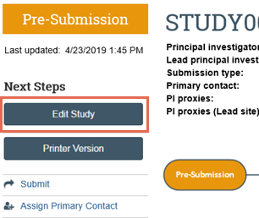
- Complete the form. Pay attention to the following pages:
Local Site-Specific Documents: add consent forms, recruitment materials and other documents specific to your research site.
- On the final page, click Finish.
You can now submit the site to the sIRB for review.

Submit a Site to the sIRB
Once a multi-site study has been approved, and you have updated the site information, you can submit the site to the sIRB in order to move it to the next stage of review.

Who performs this activity? | When to perform this activity
- pSite Principal Investigators | After the associated Multi-Site Study (MSS) has been approved, you can submit a site whenever it is ready for review by the sIRB.  Note: If you are connected to the IRB Exchange, the site information, including the site’s primary contact, will also be uploaded to the IRB Exchange for the sIRB to access.

To submit the site
- From the site workspace, click Submit.
Note: The associated MSS must be approved before you can submit the site to the sIRB.
Note: The Edit Study button becomes Edit Site after the submission is in the Pending sIRB Review state.
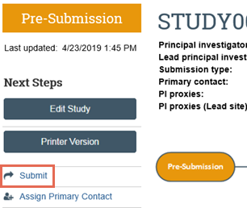
- Click OK to agree to the terms.
- Type your login credentials and click Submit.
You can log off the system. Your study has been submitted to the IRB.

Report Continuing Review Data for a Site
Researchers can submit enrollment and other data about their local site to the sIRB for continuing review purposes.

Who performs this activity? | When to perform this activity
- pSite Principal Investigators | When you need to report data from your site for continuing review purposes.

To report continuing review data
- From the site workspace, click Report Continuing Review Data.
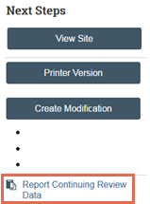
- Complete the page. Click OK to finish.
The data is reported.
Create and Submit a Site Modification
There are two types of site modifications:
- study team and research location modifications require local approval
- modifications to other parts of a site (including basic site information, additional local funding sources, and local site documents) require review by the sIRB.

Who performs this activity? | When to perform this activity
- pSite Principal Investigators and study team members | When you need to make changes to an already-approved site.

To report continuing review data for a site
- From the site workspace, click Create Modification.
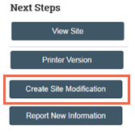
- Select the modification scope.
  - Study team and research location information can be modified without an sIRB review.
  - Modifications to other parts of the site require sIRB review.
- Complete the pages. Click Finish on the last page.
To submit a modification
- From the site workspace, click Submit.
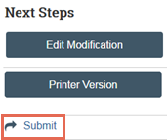
- Click OK to agree to the terms.
- Type your login credentials and click Submit.
You can log off the system. Your modification or continuing review (CR) has been submitted to the local IRB.
To find your modifications, from the site workspace, click the Follow-On Submissions tab.

Create and Submit Reportable New Information
You can report any adverse events or new information about a study as soon as you become aware of it.

Who performs this activity? | When to perform this activity
- Any registered user that has at minimum read-only access to existing submissions. | When you need to report new information about a study or modification.

To create an reportable new information (RNI)
- In the Top Navigator, click IRB.
- On the IRB page, click Report New Information.
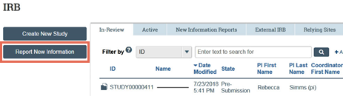
- Complete the page. Pay attention to the following question:
  - Related studies and modifications: If you relate a study for which you are a participating site, the system automatically captures that you are the reporting site.
Note: You can also create an RNI directly from the site workspace in order to automatically relate the appropriate Multi-Site Study (MSS).
To submit an RNI
- From the RNI workspace, click Submit RNI.
Depending on the IP settings for the sIRB institution, the RNI is either routed to local review or sIRB review.
Note: You can change the routing of an RNI after submitting by using the Route for… activities on the RNI workspace.
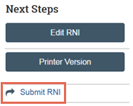
- Click OK to agree to the terms.
- Type your login credentials and click Submit.
The RNI is submitted to the IRB in either your local system or the sIRB system.
pSite Coordinators
Download a Study from the IRB Exchange
If an sIRB determines that an institution meets the criteria to participate in a multi-site study, they will invite the institution to join the study. The reliance coordinator can then access the study from the IRB Exchange and download a local copy.

Who performs this activity? | When to perform this activity
- Reliance Coordinator on the pSite side | After the sIRB submits an invitation to a pSite to participate in an MSS, the study is uploaded to the IRB Exchange, and you receive a notification. You can then download the study to your local system.

To download a study from the IRB Exchange
- In the Top Navigator, click IRB.
- From the Submissions workspace, click the IRB Exchange tab.
Note: Only users assigned the role of Reliance Coordinator can see the IRB Exchange tab.
- Next to the study you wish to download, click Download.
Note: If you do not see the study you are looking for, click Refresh to refresh the list of studies available for download.
- In the window, select an IRB office and click Download.
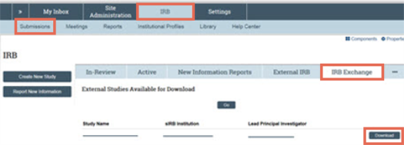
- A message appears when the study is successfully downloaded. Click the link to navigate to the study.
Note: You can also navigate to the study by clicking the External IRB Studies tab and clicking the name of the study you downloaded to open it.
- In the study workspace, click the link to open the associated site.
The site PI can now edit the site and submit it to the sIRB.
Note: If the email address for the PI is incorrect, it will not be connected to the PI’s account, and the PI will be unable to edit or submit the site.

Confirm Reliance with the sIRB
If an sIRB determines that you meet the criteria to participate in a multi-site study, they will invite you to join the study. You can then download the study from the IRB Exchange and confirm reliance on the sIRB of record.

Who performs this activity? | When to perform this activity
- sIRB Coordinators assigned to a submission  - IRB Reliance Coordinators  - IRB Directors | After downloading a local copy of a multi-site study to your system.  You must confirm reliance on the sIRB before the PI can submit the site for sIRB review.

To confirm reliance
- From the site workspace, click Confirm Reliance.
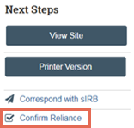
- Complete the form and click OK to finish.
- If reliance is confirmed, the site is uploaded to the IRB Exchange and enters a Pending sIRB Review state.

Correspond with the sIRB
At any point during the review process, you can correspond with sIRB researchers and coordinators.

Who performs this activity? | When to perform this activity
- sIRB Coordinators assigned to a submission  - IRB Reliance Coordinators  - IRB Directors | At any point during the review process.

To correspond with a pSite
- From the site workspace, click Correspond with sIRB.
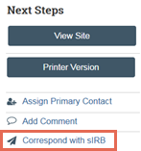
- Complete the form and click OK to finish.
Your correspondence is sent.
Record the sIRB Decision
pSite IRB staff can record and edit sIRB determinations for a site, site modification, or reportable new information.

Who performs this activity? | When to perform this activity
- sIRB coordinators assigned to a submission  - IRB Reliance Coordinators  - IRB Directors | After you have been notified of the sIRB’s review decision.

To record sIRB decision
- From the site workspace, click Record sIRB Decision.
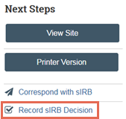
- Complete the form. For sites and site modifications, pay attention to the following questions:
  - Do you need to finalize documents or send a letter?, select Yes to send the item to Post-Review, and select No to send the item to Review Complete.
  - Are you ready to record the sIRB’s decision?, select No to note the sIRB determination without recording it, and your selections will be saved.
- Click OK to finish.
To edit sIRB decision
Note: You can only edit the sIRB decision for Approved sites in the Post-Review state.
- From the site workspace, click Edit sIRB Decision.
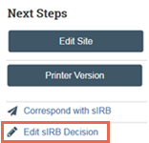
- Edit the form and click OK.
To submit a response to the sIRB
For sites that are deferred, disapproved, or require modifications, you can submit a response to the sIRB.
- From the site workspace, click Submit Response.
- Complete the form and click OK.
- Type your login credentials and click Submit.

Approve a Site Modification
IRB staff can approve site modifications submitted by investigators. Modifications that concern other parts of the site (including basic information, funding, and local site-specific documents) require sIRB review in addition to local approval.

Who performs this activity? | When to perform this activity
- sIRB Coordinators assigned to a submission  - IRB Reliance Coordinators  - IRB Directors | After a site modification has been submitted by a PI.

To approve a site modification
- From My Inbox, click the link to open the modification.
Note: You can also find the modification by clicking IRB and then Submissions in the Top Navigator and search for the modification in the In-Review tab.
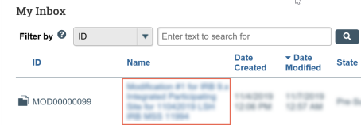
- From the modification workspace, click Accept Site Updates.
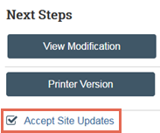
- Complete the form. Depending on the type of modification, the submission enters different states:
  - For a modification to the study team or research locations, pay attention to the following question:
Do you need to finalize documents or send a letter? Selecting Yes will send the modification to Post-Review, where you will have a chance to complete these activities. Selecting No will send the modification to Review Complete.
  - For a modification to other parts of the study (including basic information, funding, or local site-specific documents), the modification will be uploaded to the IRB Exchange for the sIRB to review. While in review, the modification will remain in the Pending sIRB Review state.
- Click OK to finish.
Close a Site
If a site is in the Review Complete state, IRB coordinators and directors can close the site at any time.

Who performs this activity? | When to perform this activity
- sIRB Coordinators assigned to a submission  - IRB Reliance Coordinators  - IRB Directors | You can close Active or Inactive sites in the Review Complete state.  Note: If you close a site, the associated external study will also be closed.

To close the site
- From the site workspace, click Close Site.
The site is closed.
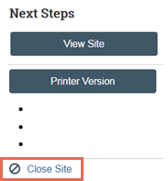

© 2019 Huron Consulting Group Inc. and affiliates. All rights reserved. Use and distribution without a current software license from Huron are prohibited.

All trademarks, registered trademarks, service marks, and trade names are the property of their respective owners.

Information in this document is subject to change without notice.

Published by Huron Consulting Group Inc.
9170 NE Turing Court
Suite 100
Hillsboro, OR 97006

