

Huron IRB

Advanced Reports Guide

December 2019
Table of Contents
About Advanced Reports 4
Open and Generate Advanced Reports 4
Filter Data on Reports 6
Export and Print Reports 7
Days in State Report 9
IRB Turnaround Times Report 11
Submission Volume Report 14

About Advanced Reports
IRB includes several ready-to-use advanced reports to help you monitor the performance and effectiveness of your operations.
IRB staff (IRB coordinators and directors) and committee members can generate the following advanced reports:

Report | Description
Days in State Report on page 8 | The total and average number of days that approved submissions were in a particular state for a specified date range.
IRB Turnaround Times Report on page 10 | The average number of days it took for approved submissions (studies, continuing reviews, modifications, and/or Reportable New Information (RNI)) to go through an IRB review.
Submission Volume Report on page 13 | The total number of all submissions in the IRB system, per IRB office (as applicable).

Open and Generate Advanced Reports
IRB staff (coordinators and directors) and committee members can access IRB advanced reports.
To open an advanced report
- In the top navigator, click IRB.
- Click Reports.
- Click the Advanced Reports tab.
The list of advanced reports appear.
- Click the report name link to open it.
Tip: Expand the report window to see the filtering options and the whole report. To view all pages of the report, use the page navigation features in the report toolbar (beneath the filtering options). 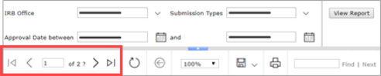
To generate an advanced report
- Open the applicable advanced report.
- Filter the data as required.
- On the right, click View Report.
Filter Data on Reports
At the top of the report are filtering options so you can view a subset of data on the report.
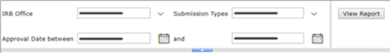
To filter data on a report
- Specify criteria for data you want to see on the report:
  - From a drop-down list, click the down arrow and select from the available options.
  - For a date field, type the date in MM/DD/YYYY format or click the calendar icon and select the date.
- Click the View Report button.
Export and Print Reports
From the report toolbar, you can export an advanced report to a variety of file formats, such as PDF or Excel, and print the report.
Tip: Some browsers may not support the printing function. Use Internet Explorer for best results.
To export a report
- In the report toolbar, click the export icon down arrow.
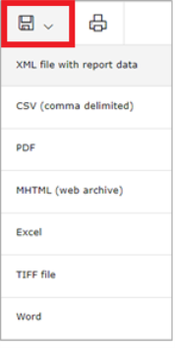
- Select a file format from the list.
- Click Open to open the file or click Save to save the file to a location on your computer or network.
To print a report
- In the report toolbar, click the print icon.
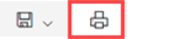
Tip: Your version of Internet Explorer may require certain SQL Server Reporting Services add-on software be installed before you can print a report. If so, follow the browser instructions to install the required software.
- In the print window, select the appropriate print options and click Print.

Days in State Report
This report shows the total and average number of days that approved submissions were in a particular state for a specified date range. Use this report to assess workflow efficiency and identify bottlenecks in the review process.
Note: This report shows data for multi-site studies, including site data.
Report filters
You can filter approved submissions by specifying:
- Approval Date: The approval date is the date selected on the Approval Date field when a committee or designated review is submitted for a submission.
- Submission Types: Includes study, modification/continuing review, and/or RNI.
- Submission States: The current state of the submission at the time of generating the report.
Note: If you filter submissions by state, the resulting list shows only those states in which there is at least one submission.
Sample report
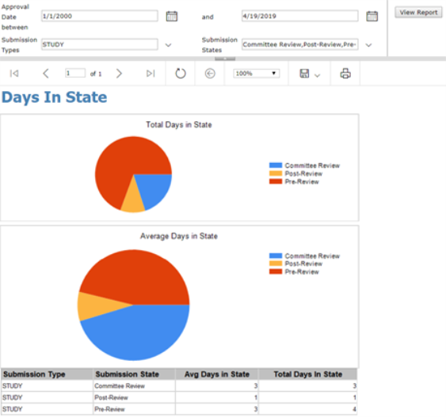
Chart description
Two pie charts show the filtered data:
- Total Days in State: The total number of days submissions were in each state
- Average Days in State: The average number of days submissions were in each state
The legend and chart show only those states selected in the Submission States filter.
Table description
Several table rows showing total and average days may appear for each selected state. State data is first separated into rows by IRB office, then by submission type, and then by state.
IRB Turnaround Times Report
This report shows the average number of days it took for approved submissions (studies, continuing reviews, modifications, and/or Reportable New Information (RNI)) to go through an IRB review.
Note: This report shows data for multi-site studies, including site data. However, data for externally-reviewed studies is not included.
Report filters
You can filter approved submissions by specifying:
- IRB Office: The administrative office assigned to the submission.
- Submission Types: The type of submission such as study or modification.
- Approval Date Range: The approval date is the date selected on the Approval Date field when a committee or designated review is submitted for a submission.
Report definitions

Data | Description
Chart Legend
Submission to Review Assignment | From: The date the PI first sent (submitted) the submission to the IRB office.  To: The date the IRB coordinator assigned the submission to a designated reviewer or a meeting for full committee review.
Submission to Initial Review | From: The date the PI first sent (submitted) the submission to the IRB office.  To: The date the first IRB determination letter was sent to the PI, regardless of the determination.
Submission to Approval | From: The date the PI first sent (submitted) the submission to the IRB office.  To: The date the final determination letter was sent to the PI.  Final determinations include (not a complete list):  - Approved  - Not Human Research  - Human Research, Not Engaged  - Disapproved  - Deferred  Note: The approval date may be the same as the initial review date if the first and only review resulted in a final IRB determination.
Review Type
Committee | Full committee review of a non-RNI submission.
Exempt | Non-committee review of an exempt submission.
Expedited | Non-committee review of an expedited submission.
RNI Committee | Full committee review of an RNI submission.
RNI Non-Committee | Non-committee review as the final review of an RNI submission.
RNI Pre-Review | Pre-review as the final review of an RNI submission.

Sample report
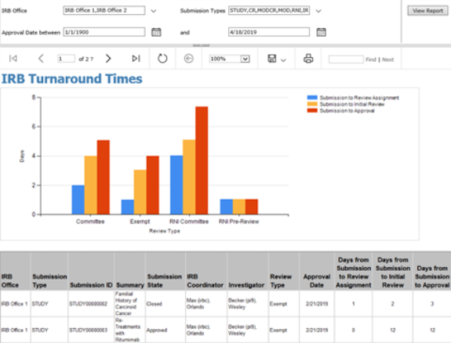
Chart and legend description
For each review type (determined by the last review performed), the chart shows the average number of days for a submission to move between milestones.
The height of the bar shows the total days from submission to approval. The numbers on each bar indicate the days to complete these milestone intervals.
Submission Volume Report
This report shows the total number of all submissions in the IRB system, per IRB office (as applicable).
Note: This report shows data for multi-site studies, including site data.
Report filters
You can filter submissions by specifying:
- Submission States: The current state of the submission at the time of generating the report.
Note: If you filter submissions by state, the resulting list shows only those states that have at least one submission.
- Submission Types: Such as study, continuing review, modification, and/or RNI.
Report definitions
The data table includes several dates related to the submission:

Column | Description
Date Entered IRB | The date the PI first sent (submitted) the submission to the IRB office.
Approval Date | The date the IRB decision was made.
Effective Date | The date the IRB decision takes effect.
Last Day of Approval | The last day of the approval period as recorded on the submission.

Sample report
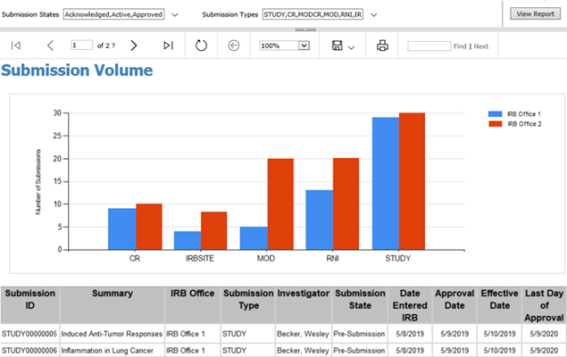
Chart and legend description
The chart shows the number of submissions for each submission type, and includes a bar for each IRB office.
The legend shows the IRB office responsible for the submissions.

© 2019 Huron Consulting Group Inc. and affiliates. All rights reserved. Use and distribution without a current software license from Huron are prohibited.

All trademarks, registered trademarks, service marks, and trade names are the property of their respective owners.

Information in this document is subject to change without notice.

Published by Huron Consulting Group Inc.
9170 NE Turing Court
Suite 100
Hillsboro, OR 97006

