Continuing Review and Modification
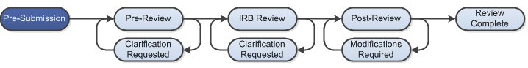

Work Instructions:
- Log into Click Portal and click on the IRB tab and find the study in the Approved or Lapsed state that you would like to submit a continuing review for.
  - Users can log in and click on the IRB tab on the top navigation bar, and find the active studies in the Active tab.
  - Users can navigate directly to the submission by clicking on the link provided in the Continuing Review Reminder email notification (sent to the PI and Primary Contact 90, 60, 30, and 15 days prior to study expiration) and logging into the system.

- From the study workspace, Under My Current Actions, select the Create Modification/CR button to create a Continuing Review, Modification, or CR/Modification combination SmartForm.

- Entering the required information on the first page of the SmartForm and clicking Continue in the top or bottom of the page will create the record.
  - Note that only one continuing review and one modification of each type (study personnel or other parts of the study) can be open at a time. The system will inform you on this page if another continuing review or modification is already open and in progress, and provide you with a link to that workspace.

- Prior to submission to the IRB, all required fields will need to be completed.
  - Click the Hide/Show Errors link in the header of the SmartForm page to display any unanswered questions throughout the SmartForm at the bottom of the page.
    - Use the Jump To link to navigate directly to SmartForm pages that are missing information.
  - Submissions with any incomplete information will be redirected to the research team for updates.

- When all of the required fields have been completed, click Exit in the header or Finish in the footer of the last SmartForm page to be redirected to the study workspace.

- Once all of the above steps have been completed, the PI (or PI Proxy, if identified) must log into the study and click the Submit activity. This activity will remind the PI of their responsibilities and the system will check the submission for any missing fields. The PI will need to re-authenticate into the system to click the OK button to submit the study to the IRB.

- If the submission is successful, the page will refresh and the study will transition from the Pre-Submission state to the Pre-Review state.

