Clarification Requested and/or Modifications Required

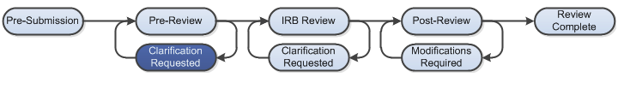

At several points during the review process, the IRB may request clarifications or require modifications from the research team prior to making a determination.

Work Instructions
- Log into Click Portal and navigate to My Inbox

- Find the submission requiring clarifications or modifications and click on the submission name to navigate to the submission workspace
  - Investigators can also navigate directly to the submission workspace by clicking on the link in the email notification and logging into the system

- Review the requested information by clicking on the Clarification Requested activity in the history log, or by reviewing the determination letter

- Edit the submission by navigating to the SmartForm - click on the Edit Study, Edit Modification/CR, or Edit RNI button under My Current Actions

- When the changes have been made, the study PI must execute the Submit Response activity to send the submission back to the IRB for review
  - Anyone listed on the study can execute the Submit Response activity for RNI submissions

