Administrative Review: Manage Departures
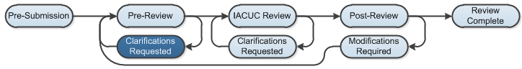

Work Instructions:
The IACUC coordinator and director manage departures from the Guide for Care and Use of Laboratory Animals.
Departures from the Guide for Care and Use of Laboratory Animals are reported on approved protocols. Departures are found in the Institutional Official report and the Protocols with Departures from the Guide report. Both reports are located by clicking the Reports link.
- Log into the Click Portal and click on the IACUC tab in the top navigation menu.
- From the In-Review tab, click the submission’s Name.
- From the workspace, click Manage Departures under My Current Actions.
- Complete the page, paying special attention to Question 1 - Add any departures from the Guide.
  - Click the Add button.
  - This opens a SmartForm. Complete the fields, and then click OK.
- Add any Comments or Supporting Documents, if needed. Click OK.
Note: Manage Departures is not available for Annual Reviews.

