Concern Review Process

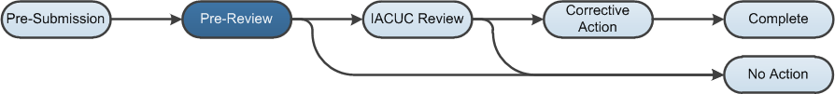

Work Instructions: Pre-Review State
- Log into the Click Portal and click on the IACUC tab in the top navigation menu.
- Open the concern from My Inbox, by clicking on its Name. Alternatively, click the Concern link on the left, and then open the Concern.
- An IACUC Coordinator can be assigned to the Concern to see it through the workflow (optional).
- Click Assign Coordinator, and then click the Select button to assign the appropriate Coordinator. Click OK.
- Add Comments and/or Supporting Documents, if necessary, and then click OK.
- Click the Edit Concern button to review the concern. Use the Continue button to move through the SmartForm pages, and then click Exit or Finish to return to the workspace.
- The coordinator may request clarification from any user in the system and continue editing the concern with further information (optional). Click Manage Clarification Requests, and complete the SmartForm. Click OK.
- The IACUC Coordinator may determine that no further action is required based on his or her review, or assign it to a Committee Meeting for review.
- If no further action is required: Click Report as No Action. Complete the SmartForm and click OK. Concerns that do not require a committee review will still appear on the committee’s next meeting agenda to inform Committee Members of the Coordinator’s determination. The concern moves to the No Action state.
- If further action is required: Click Assign to Meeting. Complete the SmartForm and click OK. The concern moves to the IACUC Review state.

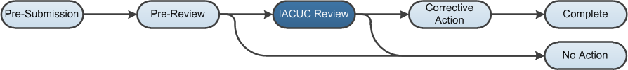

Work Instructions: IACUC Review State
During Committee Review, the Committee Members determine if further action is required and whether the Concern is a Deficiency. The IACUC Coordinator enters the committee determination, and if applicable, the corrective action instructions or plan, the corrective action due date, and those responsible for performing the corrective action plan.
- Log into the Click Portal and click on the IACUC tab in the top navigation menu.
- Click the Meetings link. Select the appropriate Meeting by clicking on its Name.
- On the Agenda Items tab, select the appropriate Concern by clicking on its Name.
- Click Submit Committee Determination.
- Complete the SmartForm, paying special attention to the fields explained below.
Note: Required fields are marked with an asterisk (*).
- Question 1 - Select the determination
Select either Corrective Action Required or No Action.
- Question 3 - Describe the corrective action plan
Describe the corrective action plan with enough detail so that it can be carried out. You also have the option to add a document in Question 4, if necessary.
- Question 5 - Assign responsible parties
Click the Add button to search for and assign responsible parties. You can also assign responsible parties within the workspace by clicking Assign Responsible Parties.
- Complete the rest of the SmartForm. Click OK.
  - If the determination was No Action: The concern moves to the No Action state.
  - If the determination was Corrective Action Required: The concern moves to the Corrective Action state.

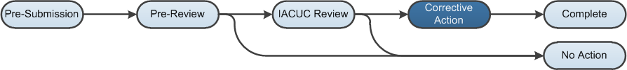

Work Instructions: Corrective Action State
During Corrective Action, the responsible parties perform the Corrective Action and when completed, notify the IACUC that the action was completed. During this state, IACUC staff (Coordinators and Directors) or the Committee Chairperson can update the corrective action plan and the system will notify the responsible parties of the updated plan.
Responsible parties will also get a Corrective Action Plan reminder notification prior to the due date, as well as after the due date has passed. Once the responsible parties have completed the corrective action, the IACUC staff or Chairperson can confirm the action plan was indeed completed.
- Log into the Click Portal and click on the IACUC tab in the top navigation menu.
- Click the Meetings link. Select the appropriate Meeting by clicking on its Name.
- On the Agenda Items tab, select the appropriate Concern by clicking on its Name.
- Click Complete Corrective Action. Complete the SmartForm, and then click OK.
- Click Submit Confirmation. Complete the SmartForm, and then click OK.
- The concern moves to the Complete state.

