Administrative Review: IACUC Review – Committee Review
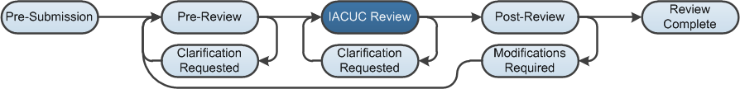

Work Instructions: Assign to Meeting
When undergoing a full committee review, a submission is assigned to an IACUC Meeting. The results of the meeting are recorded in the Submit Committee Review activity.
- Log into the Click Portal and click on the IACUC tab in the top navigation menu.

- Locate the appropriate protocol from the In-Review tab, and click on its Name.

- Under My Current Actions, click Assign to Meeting.
- Select the appropriate Meeting.
- Add any Comments and/or Supporting Documents as needed, and then click OK.
Note: If you must reassign the protocol to a different Meeting, click Remove from Agenda, then repeat the Assign to Meeting process.

Work Instructions: Assign Reviewers
- Click the IACUC tab in the top navigation menu, and then click the Meetings link.
- Click on the Name of the appropriate meeting from the Upcoming Meetings tab.
- You have the option to assign the submission to a reviewer who will lead the discussion regarding the submission at the Meeting. Click Assign Reviewers, then complete the SmartForm:
- Click the Update button to the left of the submission.
- Click the Add button, and then click Select to locate the desired Reviewer. Click the OK button.
- Select the appropriate Role and then click the OK button.
- Click the Add button again to add additional Reviewers, or click the OK button to return to the Assign Reviewers window.
- Click Update to repeat the process for additional submissions.
- Indicate whether you wish to notify the Reviewers via a system-generated email. Click OK when you are finished.
Note: The Assign to Meeting and Assign Reviewers activities are not available if the assigned IACUC Meeting has convened.

Work Instructions: Request Clarification
- Click the View Protocol button to review the submission; use the Continue button to move through the SmartForm pages.
- Click Add in the Reviewer Notes bar to add notes on any of the SmartForm pages.
- Click the Exit or Finish button to return to the workspace.
- A Committee Member may request a clarification that he or she wants the Principal Investigator (PI) to address prior to the IACUC Meeting.
- Under My Current Actions, click Request Clarification by Committee Member.
- Complete the page, making note of the change or additional information required. At this stage in the review process, the submission is not editable for the PI, so the Committee Member would ask if the investigator is willing to make changes to secure a determination of Modifications Required to Secure Approval.
- Click OK. The submission moves to the Clarification Requested state.
Note: If the PI does not respond to the clarification request, the Committee can still submit the Committee Review.
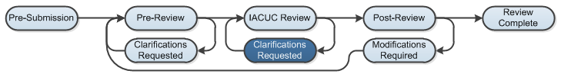

Work Instructions: Submitting the Committee Review
- To record the results of the IACUC Meeting for this submission, click Submit Committee Review.
- Complete the page, paying special attention to the fields listed below:
Note: Required fields are marked with an asterisk (*).
- Question 1 – Determination
Select from Approved, Approval Withheld, and Modifications Required to Secure Approval.
- Question 2 - Last day of annual review period
The system enters this date, but it can be changed. Specify the last day of the annual review period; typically, this is: (Date of Approval) + (1 year) – (1 Day).
- Question 3 - Last day of triennial approval period
The system enters this date but it can be changed. Specify the last day of the triennial approval period; typically, this is: (Date of Approval) + (3 years) – (1 Day).
- Question 5 - Approval date
Specify the date the IACUC decision was made. Select the date the IACUC Committee made the decision, not the date that you are submitting the Committee Review.
- Question 6 - Identify the modifications required or reasons for withholding approval
This field becomes required if the determination is either Approval Withheld or Modifications Required to Secure Approval.
- Click OK. The submission moves to the Post-Review state.
Note: If the determination of Modifications Required to Secure Approval is selected, the submission moves to the Modifications Required state.

