Click® IACUC 7.2
IACUC Staff Guide

December 2014

Table of Contents
Introduction 6
IACUC Submission Process Overview 6
Ancillary Review Process Overview 7
Initiating Ancillary Reviews 8
Notifications and Ancillary Review Feedback 8
Decisions Regarding Ancillary Review Feedback 8
Multiple IACUC Office Overview 8
Meeting Workflow 9
Assigning Submissions to Meetings 9
Preparing for a Meeting 9
Starting a Meeting 10
Wrapping Up After a Meeting 10
Concern and Deficiency Process Overview 10
Inspection and PAM Audit Process Overview 12
Creating Inspections 12
Filing Concerns from an Inspection 12
Completing Inspections 12
Semiannual Evaluation Process Overview 13
IACUC Submission Types 14
Access to Submissions by Role 15
Performing Basic Administration Tasks 16
Locating Your Assignments 16
Understanding My Inbox 17
Accessing a Submission 19
Assigning Ownership of a Submission 20
Viewing the Submission Details 20
Editing a Submission as IACUC Staff 22
Viewing Changes to a Submission 23
Requesting Clarifications to a Submission 25
Submitting a Review Decision 27
Suspending a Protocol 28
Closing a Protocol 29
Administratively Approving a Follow-On Submission 29
Checklist of Committee Meeting Tasks 30
Preparing for Each Meeting 30
Conducting the Meeting 30
Wrapping Up After the Meeting 32
Scheduling Meetings 33
Setting Up Committees 34
Setting Up Ancillary Reviews 36
Tagging Submissions for Reporting 37
Transferring a Protocol between IACUC Offices 38
Filtering and Sorting Data 38
Handling Concerns and Deficiencies 40
Submitting a Concern 41
Requesting Clarifications about a Concern 42
Submitting a Concern Review Determination 42
Handling Inspections and PAM Audits 43
Creating an Inspection or PAM Audit 43
Completing an Inspection or PAM Audit 44
Tracking and Managing Inspections 45
Conducting Semiannual Program Reviews 46
Getting Started for Training Coordinators 47
Adding a Training Course 47
Recording Course Completion 48
Inactivating a Course 48
Identifying Training Deadlines 49
Generating Reports 49
Generating Concern and Deficiency Reports 50
Generating Inspection Reports 50
Generating an Institutional Official (IO) Report 51
Generating an AAALAC Report 53
Finding More Information 55
Workflow Diagrams Overview 56
Pre-Submission Workflow 57
Pre-Review Workflow 57
IACUC Review Workflow 58
Designated Review 59
Committee Review 59
Request Clarifications 60
Post-Review Workflow 61
Preparing Correspondence 61
Reviewing and Sending Determination Letters 61
Responding to Required Modifications 61
Review Complete and Final States 62
Final States 62
Meeting Workflow 62
Assigning Submissions to Meetings 63
Preparing for a Meeting 63
Starting a Meeting 63
Wrapping Up After a Meeting 63

Introduction
Welcome to the Click IACUC system, which automates IACUC protocol submission and review as well as all other federally mandated IACUC functions (facility inspections, program reviews, concern and deficiency management, etc.)
- To get started using the system, see Performing Basic Administration Tasks on page 16
- For high level overviews of how items move through the system, see:
- IACUC Submission Process Overview on page 6
- Concern and Deficiency Process Overview on page 10
- Inspection and PAM Audit Process Overview on page 12
- Semiannual Evaluation Process Overview on page 13
See also Finding More Information on page 55 for a listing other guides and resources available.

IACUC Submission Process Overview
At the highest level, the Click IACUC system enables protocol teams to submit protocols and follow-on submissions (amendments, annual reviews, and triennial reviews) to the IACUC for review.
All submissions follow a similar workflow, moving through various states, until the IACUC review is complete. Institutions can also conduct ancillary reviews (with other experts, faculty, safety, etc.) concurrently with IACUC reviews. For more information, see Ancillary Review Process Overview on page 7.
When you view a submission in the system, a diagram (like the one below) appears in the submission workspace with the current state shown in dark blue, for example, Pre-Submission. In each state, different users can access the submission and perform certain activities. Streamlined approval processes are available for follow-on submissions, which can be applied based on your institution's policies.
Note: Some key states represent a collection of states that are not reflected in the diagram.
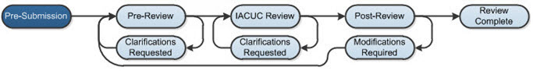
A submission goes through the following key states. See Appendix A for more detail on each state.
- Pre-Submission: The protocol team enters a new protocol or follow-on submission into the system and then the PI or PI proxy submits it to the IACUC.
- Pre-Review: An IACUC staff member (typically the coordinator) reviews the submission and requests clarification from the protocol team or a vet consult with a veterinarian, if necessary. When all questions and clarifications have been addressed, the coordinator forwards the submission to IACUC Review (either a committee or designated member review). If the institution's policies allow for a streamlined review process for follow-on submissions, see Administratively Approving a Follow-On Submission on page 29.
- IACUC Review: During IACUC Review, submissions not sent directly to a committee review by the IACUC staff will move to a Grace Period state in which committee members can decide if the submission should be reviewed by the committee. If no committee member forwards the submission to a committee review during the grace period, the IACUC chair will assign it to a specific member for designated review. The committee or designated member reviews the submission and requests clarification from the protocol team as necessary before submitting a decision.
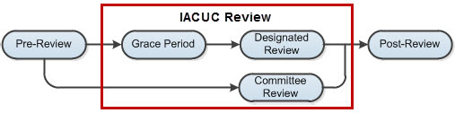
- Post-Review: The coordinator prepares the decision letter and the IACUC chair reviews and sends it to the protocol team. If the IACUC determination was Approval Withheld or Modifications Required to Secure Approval, upon sending the letter, the submission moves to the Approval Withheld or Modifications Required state, respectively. These two states fall under the Modifications Required key state in the diagram. In the Modifications Required key state, the protocol team can edit the submission as needed and then submit a response back to the IACUC. Upon doing so, the submission will move back to the Pre-Review state to go through the review process again.
- Review Complete: The submission is approved. The protocol team can submit amendments, annual reviews, and triennial reviews for the approved protocol.

Ancillary Review Process Overview
The submission review process may include ancillary reviews. Ancillary reviews allow individuals, departments, and other organizations to give feedback on a submission in parallel with the IACUC review. The system does not prevent the IACUC from reviewing or approving a submission with outstanding ancillary reviews. Decisions about how, when, and whether to interrupt the IACUC review process to wait for ancillary reviews are left to your IACUC policies and staff.
Ancillary reviewers can be assigned to a submission at any point from Pre-Submission through Post-Review. Ancillary reviewers assigned during Pre-Submission are notified once the protocol is submitted to the IACUC for review. Ancillary reviewers assigned after Pre-Submission are notified immediately.
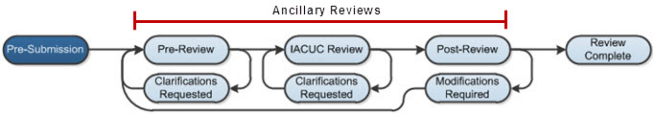

Initiating Ancillary Reviews
Both protocol team members and IACUC staff can add ancillary reviewers to a submission as follows:
- Protocol team members can add ancillary reviewers to a submission whenever the submission is in an editable state, for example, Pre-Submission or Clarifications Requested (by pre-reviewer).
- IACUC staff can add ancillary reviewers to a submission up until Post-Review when the determination letter is sent to the IACUC chair for review.
- Both can add individuals and organizations as reviewers.
Organizations must be set up in advance with specific ancillary reviewers; otherwise, no one will receive ancillary review notifications for the organization. For instructions, see the online help.

Notifications and Ancillary Review Feedback
Ancillary reviewers are identified as required or optional by the person adding them to the submission. A required ancillary reviewer receives the submission in My Inbox, where it remains until the reviewer accepts or rejects the submission. An optional reviewer does not see the submission in My Inbox. Both required and optional reviewers receive a notification and can use the Submit Ancillary Review activity to provide feedback.
If any reviewer, required or optional, contacts the IACUC with feedback, the IACUC staff can add the reviewer's comments into the system using the Manage Ancillary Reviews activity. IACUC staff can also modify the optional/required setting of a reviewer on the submission.
Ancillary review feedback is visible on the Reviews tab to everyone who can access the submission. For details, see the online help.

Decisions Regarding Ancillary Review Feedback
Depending on your IACUC policies, IACUC staff may choose to use ancillary reviews in many different ways. For example:
- Treating all ancillary reviewers as optional and not waiting for responses.
- Allowing IACUC review and approval without the response of a required ancillary reviewer.
- Allowing IACUC review but waiting for a required ancillary reviewer response before approving the submission.
- Delaying IACUC review at any point until the required ancillary reviewers respond. This may involve requesting clarifications or modifications from the protocol team (to officially put the submission back in the protocol team members' inboxes).

Multiple IACUC Office Overview
If your institution has multiple IACUC admin offices that operate separately, the IACUC system can separate submissions by the assigned admin office so IACUC staff members see only submissions assigned to their IACUC. Your institution's decisions determine how submissions are assigned to a specific IACUC admin office. For details about the possibilities, see the IACUC Deployment Guide.
With multiple IACUC admin offices, IACUC staff see only the submissions assigned to their office. PIs and protocol team members can see all of their own submissions. IACUC committee members see all submissions assigned to their committee for review. Site Managers see all IACUC submissions.
The assigned IACUC admin office appears in the submission workspace, as shown here. Note: If you have only one IACUC admin office, all submissions are automatically assigned to that office.
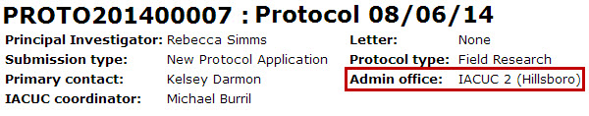
Follow-on submissions are automatically assigned to the same IACUC admin office as the initial protocol.
Certain users may need permission to view all IACUC submissions regardless of IACUC office. For example, a grants office staff member may need to see all IACUC submissions. To meet this need, add the Global IACUC Viewer role to the user's profile. For details about the Global IACUC Viewer role, see the IACUC Deployment Guide.

Meeting Workflow
From the IACUC Meeting workspace, the person designated as the administrator for a committee can manage meetings, agendas, and minutes for that committee's meetings. Note: The committee administrator is a designated member of a committee and not an actual user role in the software. Refer to the workflow diagrams provided with the software to see other roles that can perform the activities listed below.
For a recommended order to perform meeting tasks, see Checklist of Committee Meeting Tasks on page 30.

Assigning Submissions to Meetings
The IACUC coordinator will first assign a submission to a meeting from the submission workspace. Also from the submission workspace, the coordinator can remove it from a meeting agenda and reassign it to a different meeting.

Preparing for a Meeting
The committee administrator, as well as IACUC staff and the chair, can assign reviewers to submissions that are assigned to meetings and notify reviewers of the scheduled meeting.
The committee administrator can prepare an agenda from a template using the Prepare Agenda activity. A standard template is included in the software that supports automatic agenda generation that fills in the time and place of the meeting and several details about each submission on the agenda. Your institution can add to or replace the provided template as described in the IACUC Deployment Guide.
The committee administrator can generate an agenda, download it, edit it as necessary, and upload it again. When the agenda is ready, the committee administrator can use the Send Agenda activity to send an e-mail notification to the invitees.
The invitees can confirm or decline attendance using the provided activities. The committee administrator can also use the Edit Meeting Attendance activity to fill in attendance details for those who do not use the provided activities to respond.
Tip: The committee administrator should remove any submissions in the Clarifications Requested state from the agenda if the clarifications are required for the committee to make a decision. Submissions left in Clarifications Requested will be moved to the Committee Review state when the Convene Meeting activity is used.
The Prepare Minutes activity lets the committee administrator (or chair) generate meeting minutes from a selected template or upload minutes. Generating the minutes shortly before the meeting from the provided standard template creates a framework to record meeting activities and details about each submission as well as fill in committee decisions and notes. The filled-in minutes document can be uploaded later using Prepare Minutes again.

Starting a Meeting
To start the meeting, the committee administrator can use the Convene Meeting activity. Convene Meeting moves any submissions in the Clarifications Requested state back to Committee Review so a decision can be recorded.

Wrapping Up After a Meeting
During or shortly after the meeting, the IACUC coordinator will submit the committee review for each submission, which includes recording the committee decision for that submission. This is done from each submission's workspace. Additionally, the coordinator will prepare the decision letter and forward it to the chair to approve and send to the protocol team.
Meanwhile, the committee administrator can upload the completed meeting minutes using Prepare Minutes on the meeting workspace and then the Close Meeting activity to conclude the meeting in the system.
The chair (or committee administrator) will use the Approve Meeting Minutes activity to record approval of the minutes.

Concern and Deficiency Process Overview
Any Click IACUC user role (Study staff, IACUC coordinators, directors, committee members, etc.) can enter a concern or report of non-compliance about the research facilities or personnel involved in the care and use of animals. Concerns can arise as a result of facility inspections, IACUC program reviews, or audits of approved protocols. Additionally, a user can submit a concern at any time that is not related to a specific IACUC event (ad hoc).
During IACUC review, the IACUC committee will decide if a concern is actually a deficiency and whether it requires corrective action. The institutional official will report certain deficiencies to the regulatory bodies depending on PHS and USDA policies.
The workflow starts with a Click IACUC user entering a concern into the system. The user will either complete a short or long version of the concern form depending on their role.
- Short form: For PIs, ancillary reviewers, veterinarians, and any other user that is not part of the IACUC to enter basic concern information.
- Long form: For IACUC staff (coordinators and directors), committee members, inspection officers, and Post-Approval Monitoring (PAM) coordinators to enter additional information such as the source of the concern (facility inspection, program review, etc.) and any deficiency details.
Only IACUC staff and committee members can submit a newly created concern to move it from Pre-Submission to Pre-Review. Once submitted, committee members cannot edit the concern; IACUC staff, however, can edit any concern for their administrative office regardless of state, and inspection officers and PAM coordinators can edit any concern they create.
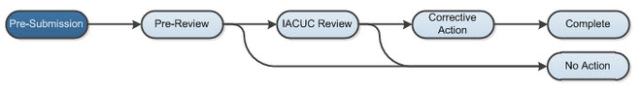
The concern goes through the following states:
- Pre-Submission: An IACUC staff member (typically the IACUC coordinator) reviews the concern and adds any missing information to it. The long version of the form appears regardless of whether the submitter completed the short form. When finished editing it, the coordinator submits it for pre-review. One coordinator may be assigned to the concern to see it through the workflow.
- Pre-Review: The coordinator may request clarification from any user in the system and continue editing the concern with further information. The coordinator may determine that no further action is required based on their review or assign it to a committee meeting for review. Concerns that don't require a committee review will still appear on the committee's next meeting agenda to inform committee members of the coordinator's determination.
- IACUC Review: During committee review, the committee determines if further action is required and whether the concern is a deficiency. The coordinator enters the committee's determination, and if applicable, the corrective action instructions or plan, corrective action due date, and those responsible for performing the corrective action. Upon submitting the determination, the system sends a notification to the responsible parties. If the concern is an administrative issue, the system will also send a notification to the IACUC chair and institutional official.
- Corrective Action: The responsible parties perform the corrective action and when completed, notify the IACUC that the action was completed. During this state, IACUC staff or the committee chair can update the corrective action plan and the system will notify the responsible parties of the updated plan. Responsible parties will also get a corrective action plan reminder notification prior to the due date as well as after the due date has passed. Once the responsible parties have completed the corrective action, the IACUC staff or chair can confirm the action plan was indeed completed.
- Complete: The corrective action plan for the concern or deficiency has been completed. The completed concern is added to the committee's next meeting agenda for acknowledgment.
- No Action: The IACUC coordinator, director, or chair can, at any time, assign it to a meeting to be reviewed by the IACUC committee.

Inspection and PAM Audit Process Overview
Click IACUC provides the ability to schedule and track different types of inspections such as semiannual facility inspections and Post-Approval Monitoring (PAM) audits of investigators, protocols, and procedures. All inspection types follow the same workflow involving two states—Pending Inspection and Inspection Complete. Upon creation, an inspection is in the Pending Inspection state and remains in that state until the inspection is completed.
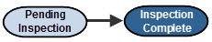

Creating Inspections
Inspection officers and PAM coordinators create inspections and PAM audits (routine, for cause, or follow-up audits) in the Click IACUC system. For facility inspections, the inspection officer selects committee members to do the inspection (for PAM audits the inspector is the PAM coordinator, which appears by default on the form). When the inspection or PAM audit is actually created in the system, the system sends e-mail notifications to the inspectors informing them of their assignments. If a due date was entered for the inspection or PAM audit, the inspection or PAM audit is added to the inspection calendar for tracking. See Creating an Inspection or PAM Audit on page 43. Assigned inspectors also get a reminder notification prior to the due date.
Inspection officers, PAM coordinators, and assigned inspectors can edit inspections in the Pending Inspection state. IACUC staff and committee members can review inspections for their administrative office, while Institutional Officials (IOs) and veterinarians can review inspections for any office.

Filing Concerns from an Inspection
If an inspector identifies an issue during the inspection or PAM audit, the inspector can create a concern (or deficiency) right from the inspection workspace to associate the concern to the inspection. See Submitting a Concern on page 41. The concern follows the workflow described in the Concern and Deficiency Process Overview on page 10.
Anyone who can access the inspection can see a list of related concerns on the Concerns tab.
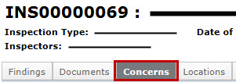

Completing Inspections
Assigned inspectors record their findings and complete the inspection. Upon completion in the IACUC system, the inspection appears on the agenda of a future committee meeting to inform committee members of the completed inspection. The inspection moves to the Inspection Complete state. See Completing an Inspection or PAM Audit on page 44.
In the Inspection Complete state, inspection officers, PAM coordinators, and the IO can continue to update inspection findings.

Semiannual Evaluation Process Overview
The IACUC must perform certain activities at least every six months—facility inspections, program reviews, and reports to the Institutional Official (IO). The IACUC software can help you accomplish these activities:
- Semiannual Facility Inspections: Create and track inspections of animal facilities and report any issues discovered in the Click IACUC system. See Inspection and PAM Audit Process Overview on page 12.
- Semiannual Program Reviews: Generate reports on facility inspections and reported deficiencies as well as review corrective action taken on concerns reported during inspections. See Conducting Semiannual Program Reviews on page 46. Also, report any issues discovered during the program review in the Click IACUC system.
- IO Report: Generate a report to the IO report that details any changes to the animal care and use program since the last review, departures from the Guide for the Care and Use of Laboratory Animals reported in protocols, deficiencies from program reviews and facility inspections, minority views expressed by committee members, and AAALAC accreditation status. See Generating an Institutional Official (IO) Report on page 51.
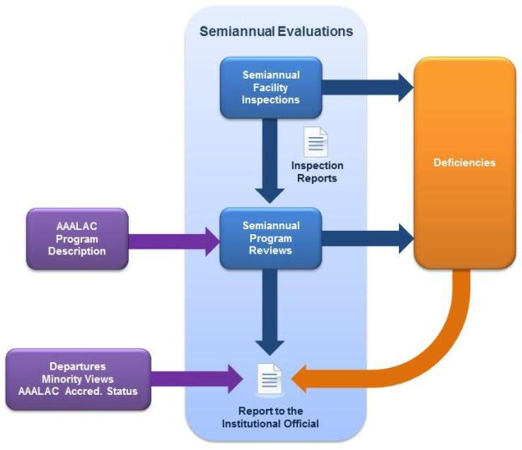

IACUC Submission Types
The IACUC system accepts these types of submissions:

Submission Type | Description
Initial Submission
Protocol | A brand new protocol. The protocol submission consists of a number of forms, and attachments, that contain the research and experiment details.
Follow-on Submissions
Amendment | Changes to an approved protocol. The amendment submission consists of a form that lists amendment details along with the updated protocol pages.
Annual Review | A review of an approved protocol that is typically conducted every year. Protocols involving USDA-covered species must go through an annual review by the IACUC; however, your institution may require all protocols, regardless of USDA-covered species, to go through an annual review.  The annual review submission consists of a form that lists the number of animals used during the prior year and held for future use.
Triennial Review | A review of an approved protocol that is conducted every three years (also referred to as a "de novo" review).  The triennial review submission consists of a form that identifies the progress made on the protocol along with the updated protocol (all pages).
Other Submissions
Concern | A concern about any aspect of the animal care and use program. Depending on the user's role, the user will receive either a short or long form to complete. The long form is for IACUC staff and other IACUC roles to add more details about the concern such as deficiency details, if appropriate.

Access to Submissions by Role
Your role in the system affects your access to protocols and follow-on submissions and the activities you can perform in different submission states. The following table summarizes the policies controlling access to submissions (both protocols and follow-on submissions).
Note: Any Click IACUC user role (Study staff, IACUC coordinators, directors, committee members, etc.) can enter a concern or report of non-compliance about the research facilities or personnel involved in the care and use of animals.

User Role | Access to Submissions
Study Staff | You can view and edit all submissions that include you on the protocol team. Note: After a protocol or follow-on submission is submitted to the IACUC, it is only editable at certain points during the IACUC review process.  You cannot view the committee members assigned to review the submission or their private comments. However, you can view reviewer notes added to the submission.
Veterinarian | You can view all submissions.  You can add reviewer notes to submissions assigned to you to review and view reviewer notes added by other reviewers. You can also add and view all private comments added to the submission.
IACUC Coordinator, IACUC Director | You can view all submissions.  You can add reviewer notes to submissions assigned to you to review and view reviewer notes added by other reviewers. You can also add and view all private comments added to the submission.
IACUC Committee Members | You can view all submissions assigned to you to review or assigned to a committee of which you are a member.  You can add reviewer notes to submissions assigned to you and view any reviewer notes added by other reviewers. You can also add and view all private comments added to the submission.
Registered User (Guest or Ancillary Reviewer) | You can view submissions that include you on the guest list or assigned to you to review. Guests and ancillary reviewers can view reviewer notes added by reviewers, but not any private comments added.  You can also view and edit all submissions that include you on the protocol team. Note: After a protocol or follow-on submission is submitted to the IACUC, it is only editable at certain points during the IACUC review process.
Site Manager | You can view and edit all submissions.  You can add reviewer notes to submissions assigned to you to review and view reviewer notes added by other reviewers. You can also add and view all private comments added to the submission.

Performing Basic Administration Tasks
IACUC staff members play a key role in preparing for reviews, moving submissions through IACUC review, and communicating the results to the protocol team.
Your inbox provides a list of items that need your attention. For details, see Locating Your Assignments on page 16 and Understanding My Inbox on page 17.
Some basic activities include:
- (Optional) Assign a specific coordinator to a submission to oversee the submission through the review process. See Assigning Ownership of a Submission on page 20. If no one coordinator is assigned, all coordinators will see the submission in My Inbox and can take action on the submission.
- Prepare for full committee review meetings. Refer to the Checklist of Committee Meeting Tasks on page 30 for activities to perform before, during, and after committee meetings.

Locating Your Assignments
IACUC protocols and follow-on submissions that are assigned to you for action will appear in My Inbox. You may also receive an e-mail with a link to the submission. The e-mail indicates that you must take action or informs you of important information.
To access submissions assigned to you:
- When you log into the IACUC system, you will be on the My Inbox page. If not, click the My Inbox link in the top right navigation header.
- Identify the reason the submission appears in My Inbox by looking at the State column. For an explanation of the action required of you, see Understanding My Inbox on page 17.
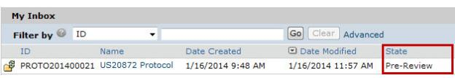
- Click the name of the submission to open it.
To view the details of the protocol, click View Protocol on the left. (See Viewing the Submission Details on page 20.)

Understanding My Inbox
My Inbox lists the submissions that require your attention and action to move them to the next step in the workflow. See the table below for examples of submissions that will appear in My Inbox. To find a submission that is not in My Inbox, see Accessing a Submission on page 19.

Your Role | In My Inbox
 | State | Action Required
Protocol Team
PI  PI proxy  Protocol team member | Pre-Submission | Complete the submission pages and submit it to the IACUC for review.  Note: Any protocol team member can make changes to a submission, but the PI or PI proxy must submit the submission to the IACUC.
 | Clarification Requested | Edit the submission to address any questions or comments made by reviewers (IACUC staff, veterinarian, committee members) and provide an explanation of the changes when submitting it back to the IACUC.
 | Modifications Required | Edit the submission as needed, and respond to each reviewer note. Submit the changes back to the IACUC. When you do so, the submission will move back to the Pre-Review state to go through the review process again.
Reviewers and Committee Members
Veterinarian | Vet Consult | The IACUC staff has requested a veterinarian consultation. Review the submission and submit your response back to the IACUC. You can also add reviewer notes to protocol pages, which the IACUC staff can pass onto the protocol team.  You can also request clarification from the protocol team. When the protocol team responds to your request for clarification, review their response and submit your decision to the IACUC about whether you accept the submission.
Ancillary reviewer | From Pre-Review through Post-Review | You have been selected as a reviewer (either by name or representing a specific organization) by the protocol team or IACUC staff. Review the submission and submit your decision.  The IACUC may begin its review before you submit your review. The IACUC may or may not wait for your input before completing its review of the submission.
IACUC committee member | Designated Review | The IACUC chair has designated you as the sole reviewer of this submission. Review the submission and submit your final review decision to the IACUC. If you request clarification from the protocol team, the submission will return to you (My Inbox) after the team has responded to your request so you can finish your review.
 | Committee Review | The IACUC coordinator has assigned you as a committee reviewer. Review the submission details before the IACUC committee meeting. If you request clarification from the protocol team, the submission will return to you (My Inbox) after the team has responded to your request so you can finish your review.
IACUC Administrative Staff
IACUC coordinator  IACUC director  Note: Submissions will appear in all coordinator and director inboxes unless a specific coordinator is assigned to them. | Pre-Review | Review the submission and submit a pre-review form indicating if the submission should go to a full committee review.
 | Meeting Assignment | Assign the submission to a committee meeting for review.
 | Committee Review | Before the committee meeting occurs, you can remove the submission from the meeting agenda, assign it to another meeting, and/or assign specific reviewers to the submission.  After the meeting has occurred, submit the committee's review decision.
 | Post-Review | Prepare or update the IACUC decision letter and forward it to the IACUC chair to review and send to the protocol team.
IACUC chair | Assign Designated Reviewer | Assign the submission to a particular committee member to review it.
 | Chair Letter Review | Review the IACUC decision letter prepared by the IACUC coordinator. If changes are required to the letter, you can request changes to it or prepare a new letter yourself, otherwise, send the letter to the protocol team.

Accessing a Submission
You may want to view a submission, submit it for review, or take other action on it.
Note: Your role in the system affects your access to protocols and follow-on submissions and the activities you can perform in different submission states.
To open a submission: Click the name of the submission to open it.
To find a submission: Try the following suggestions.

For... | Check... | How to find this list
Submissions assigned to you, for example:  - For PI and team members: A submission you are currently working on  - For reviewers: A submission assigned to you to review | My Inbox | When you log into the IACUC system, you will be on the My Inbox page. If not, click the My Inbox link in the top right navigation header.
Submissions that are:  - In Grace Period state  - Awaiting meeting or reviewer assignments  - Undergoing review and clarification (pre-review by IACUC staff, veterinarian consult, IACUC full committee or designated member reviews, etc.)  Submissions for which an IACUC decision has been made but not yet communicated to the protocol team | IACUC Submissions In-Review tab | Click IACUC in the top left navigation area and select the In-Review tab.  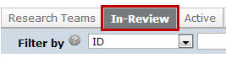
Approved submissions | IACUC Submissions Active tab | Click IACUC in the top left navigation area and select the Active tab.
Discarded or closed submissions | IACUC Submissions Archived tab | Click IACUC in the top left navigation area and select the Archived tab.
All submissions that you have permission to view | IACUC Submissions All Submissions tab | Click IACUC in the top left navigation area and select the All Submissions tab.  Tip: Try filtering this list by the protocol name:  - Next to Filter by, select Name.  - Type the beginning of the name.  - Click Go.

Assigning Ownership of a Submission
Any IACUC staff member (coordinators or director, for example) can take ownership of a submission to ensure it moves through the review process in a timely manner. Any staff member can also reassign it to another staff member at any time (e.g., to balance workloads).
To assign a coordinator:
- Open the submission.
- Click Assign Coordinator on the left.
- Select yourself or another coordinator.
- Click OK.
The coordinator will see the submission in My Inbox whenever action is required and can perform activities reserved for the assigned coordinator to move the submission through the IACUC process.

Viewing the Submission Details
As an IACUC staff member, you will need to look at all information related to the submission, including the submission pages and attached documents. You can review the submission online or print it out to review.
To begin, first open the submission you want to review. See Accessing a Submission on page 19.
To view submission pages:
- Click View... (View Protocol, View Amendment, etc.) on the left.
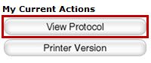
- Use the Continue and Back buttons in the top bar (and the Jump To navigation option if needed) to move through all of the submission pages.
See section below on viewing experiment details.

To view experiment details:
There are several ways to view a protocol's experiments:
- On the Experiments page of the protocol, click the experiment name to drill down to the details. You can also click any procedure name to see its details. Note: The procedure name indicates if it is a standard or team procedure so you can easily identify the institution-approved procedures (standard) from those created by the protocol team.
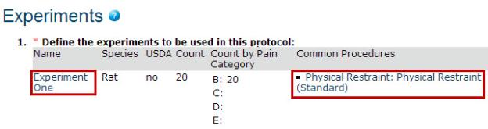
- On the submission workspace, click the Experiments tab to see a list of experiments along with the procedures and substances included in the protocol. Click a procedure or substance to open it.
To view documents attached in the submission:
There are several ways to view documents included in a submission:
- As you look through the submission pages (using the steps in the previous section), when you come across an attached document, click the name of a document to open it.
- On the submission workspace, click the Documents tab to see a list of all the documents attached in the submission. Click the name of a document to open it.
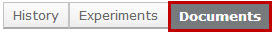
Tip: Microsoft® Word documents open differently in different web browsers. If the document does not open promptly:
- Click the Word icon if it is flashing at the bottom of your screen, and then click one of your open Word documents.
- Check the bottom of the browser window to see if the document icon and name is shown there. If so, click the name to open it.
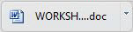

To print submission pages:
- On the submission workspace, click Printer Version on the left.
Tip: With the printer version displayed, you can search it by pressing CTRL+F or Command+F (Windows and Macintosh, respectively) and typing your search term. You can also view a particular section, by clicking a link in the Table of Contents (top right) to jump to that section.
- Click Print at the top.
An abbreviated version of the protocol prints to your default printer. The printer version shows each page in the submission followed by appendices that list the procedures, substances, and experiments.
Tip: In the appendix, you can identify each new procedure, substance, and experiment as follows:
- Procedures: The prefix "Procedure Identification", for example, Procedure Identification: Blood Draw
- Substances: The prefix "Substance Information", for example, Substance Information: Acetone
- Experiments: The experiment name, for example, Control
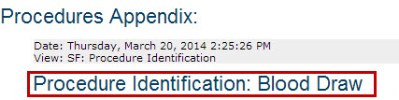

Editing a Submission as IACUC Staff
Depending on your institution's policy, IACUC staff (coordinators and directors) for an administrative office may be allowed to edit protocols and follow-on submissions (amendments and triennial reviews) on behalf of the protocol team. A system-wide setting, as described in the IACUC Deployment Guide, must be enabled to allow this.
If the setting is enabled, IACUC staff members can make any change to protocols submitted to their administrative office in any state up until it is approved. For example, suppose you (an IACUC coordinator) are completing the pre-review process and notice a small inconsistency in the submission. From talking with the PI, you know what needs to be changed, and the PI prefers that you make the change directly. You open the protocol and edit it. Next, to inform others of the changes, you add a comment to the submission history detailing the changes and notify the protocol team members. Protocol team members and other reviewers can look at the Change Log tab to see the changes you made and when.
Important: Use caution when editing protocols as some changes, such as adding new procedures, may require additional animals or change the science. Also, when editing a protocol, ensure all required fields are updated. It is possible that validation that occurs in one state may not occur in other states. For example, if you add a new procedure to a protocol after Pre-Submission, the system will not validate that appropriate personnel have been assigned to that procedure.
To edit a submission on behalf of the protocol team:
- Log in as the IACUC coordinator or director for the submission.
- Navigate to the submission workspace. Note: If you can't find the submission, see Accessing a Submission on page 19.
- Click Edit Protocol (or Edit Amendment or Edit Triennial Review) on the left and make the changes.
- Notify the PI and protocol team as follows:
  - Click Add Comment on the left and describe the change you made in the Comments box.
  - Select the roles to be notified of the change.
  - Click OK to add the comment and send the notification.

Viewing Changes to a Submission
If the protocol team made changes to their submission in response to your clarification request, you will want to determine what changed since you last reviewed it. To figure out what changed, review the clarification request comments (and responses to your reviewer notes). You can also view the Change Log to see all changes made to the submission by person and date or compare two versions of the submission to see what changed on specific pages.
Tip: If the institution allows IACUC staff to edit protocols in addition to protocol team members, you may want to identify who made each change. See the steps below to view the Change Log.
To view responses to a clarification request:
- From My Inbox, click the name of the submission to open it.
- Click the History tab. In the Activity column, look for Response Submitted and any comments the PI may have added.
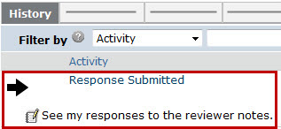
- If you added reviewer notes to the submission, click the Reviewer Notes tab on the submission workspace and review the PI's responses to your notes.
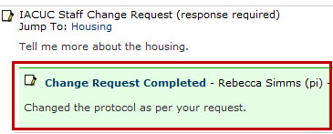
- To view the submission page related to the reviewer note, click the Jump To link. Exit the submission when done.
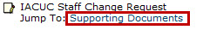
Tip: From within the submission, you can click Previous and Next on the Reviewer Note bar to move through the reviewer notes. You can also hide the reviewer notes to make it easier to view the protocol by clicking the arrow on the left of the Reviewer Note bar.

Important! You have not submitted your review yet. When you are ready to submit it, see Submitting a Review Decision on page 27.
To view the Change Log:
The Change Log only shows changes after the submission has entered Pre-Review state. For approved protocols, the Change Log shows only the changes made on the initial submission; changes from amendments show on the Change Log for the amendment.
- From My Inbox, click the name of the submission to open it.
- In the submission workspace, click the Change Log tab. The tab lists the protocol page, the item on the page that changed, the original and new values, who made the change, and when.
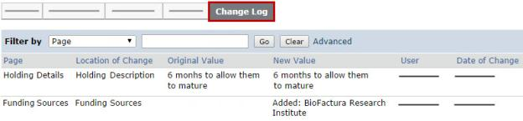
Tip: Use the Filter By feature to find specific data. See Filtering and Sorting Data on page 38.
To view changes between two versions of a submission:
- From My Inbox, click the name of the submission to open it.
- Click View Differences on the left.
- Next to "Show Changes made...", select the version to compare to the current version.
- Look for red and green changes in the current form.
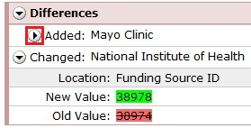
Click the arrow to show the details and new and old values. The changes since the previous version appear as follows:
- Added text is highlighted in green.
- Deleted text is highlighted in red with a line through it.

- Next to Changed Steps, click the arrow (or use the drop-down list) to view each of the other forms that have changed.
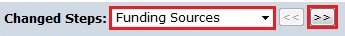
- Exit the View Differences screen by clicking Close on the right.

Requesting Clarifications to a Submission
As an IACUC staff member, you can ask the protocol team to clarify or change information in the submission by adding reviewer notes to specific pages of the submission. Note: Veterinarians and committee members can also add reviewer notes, while ancillary reviewers cannot. Instead, ancillary reviewers can add comments about the submission when they submit their review.
Using reviewer notes will enable the protocol team to address any issues with the submission quickly and appropriately. There are two types of reviewer notes—one that requires a response from the PI and one that doesn't. The PI must respond to all notes requiring a response to move the submission forward in the workflow. As you review a submission, you may see notes added by other reviewers. Notes added by committee members are always anonymous.
To request clarification of specific submission pages:
Follow these steps to add notes to specific pages of the submission:
- From My Inbox, click the name of the submission to open it.
- Click View... (View Protocol, View Amendment, etc.) on the left.
- Navigate to the page where you want to add a note. Note: You cannot add reviewer notes to a specific procedure or substance in a submission. Instead, add a note on the Experiments page with your comments about the experiment's procedure or the substances used in the procedure.
Tip: Use the Continue and Back buttons in the top bar (and the Jump To navigation option if needed) to move through all of the submission pages.
- Click Add in the Reviewer Note bar at the top of the page.
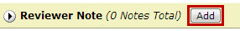
- From the Type list, choose a note type. You can choose a note that requires a response from the PI or one that doesn't. If the note requires a response from the PI, the PI must respond to it before the PI can move the submission forward in the workflow.
Note: The note is considered "draft" until you submit the request for clarification or approve the submission with modifications required. Once submitted, you won't be able to edit your reviewer notes, but you can view them.
- Type your submission comments in the Note box and click OK.
Tip: If you need to update or change what you just wrote, use the options in the Reviewer Note bar at the top of the page:
- To delete the note, click Delete.
- To edit the note text, click the link under the Type column.
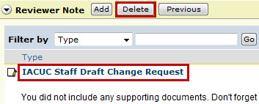
- When done adding notes, click the Exit navigation option at the top.
- Click the Request Clarification... activity on the left.
- Review the notes that you added (at the bottom of the page). To let the protocol team know you added reviewer notes, type a comment in the text box such as "See reviewer notes." This text will appear in the submission's history and the protocol team will see it upon opening the submission. When ready to submit the notes, click OK.
The notes appear in the submission history, however, they will be removed when the submission is approved, discarded, or withdrawn.
You will receive an e-mail notification when the protocol team submits their response to your clarification request (unless the submission is in full committee review).
To request a general clarification about the submission:
Follow these steps to provide general comments about the submission. Where possible, use reviewer notes so the protocol team can respond quickly and appropriately to your requests. See the steps in the section above for adding reviewer notes.
- From My Inbox, click the name of the submission to open it.
- Click Request Clarification... on the left.
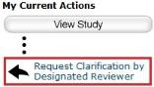
- In the Request Clarification form, type your question or request for changes to the submission.
Note: You can also attach documents that explain your comments, show examples or screen captures of problematic areas, or provide suggestions for resolving the problems.
- Click OK to submit your feedback.
You will receive an e-mail notification when the protocol team submits their response to your clarification request (unless the submission is in Full Committee Review).

Submitting a Review Decision
After reviewing a submission, you must submit your review decision in the system. This step completes the review and moves the submission forward in the IACUC process.
For committee reviews: An IACUC staff member must submit the decision on behalf of the committee.
Tip: You can include comments when you record your decision. If you need the research team to answer a question before you can record a decision, request clarifications as described in Requesting Clarifications to a Submission on page 25.
Procedures for the following reviews are identified below:
- Pre-review
- Committee review
Note: The procedures below assume that the protocol team has completed any requested clarifications and responded to all reviewer notes that require responses.
To open the protocol:
- From My Inbox, click the name of the submission to open it.
- Choose the appropriate action below.
To complete a pre-review:
- Click Submit Pre-Review on the left.
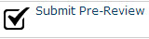
- Answer the required questions marked with a red asterisk (*):
  - Select the committee from which a member or all members will review the submission.
  - Select Yes or No depending on whether the submission should go right to a full committee review.
  - Implications of this choice:
- Yes: Moves the submission to the Meeting Assignment state so the IACUC coordinator can assign it to an IACUC meeting for review.
- No: If the submission will not be forwarded directly to a full committee review, it will move to the Grace Period state so IACUC committee members can review it and determine whether it should go to full committee review.
- (Optional) Add any comments and attach documents related to the review.
- Click Yes to the last question to move the protocol to the next stage of IACUC review. Clicking No will allow you to return to the pre-review form later to edit and submit it.
- Click OK.
If this submission is going to a full committee review, the IACUC coordinator can now assign it to a committee meeting. If it is not going to a full committee review, once the grace period has expired, the IACUC chair will select someone from the committee to review the submission.
To complete a committee review:
Important! An IACUC staff member must submit the decision on behalf of the committee.
Tip: If the information entered for pre-review is inaccurate, contact the IACUC coordinator to request a change. The coordinator can change some of the pre-review information until the decision from designated or committee review is submitted.

- Click Submit Committee Review on the left.
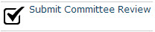
- Select your determination.
- If the committee approved the submission, select the approval date (this will most likely be the committee meeting date), otherwise leave it blank.
- If the committee is withholding approval or requires changes to the submission to approve it, type those details in the "Identify the modifications required..." text box.
- (Optional) Type the number of votes for each determination.
- (Optional) Add any comments and attach documents related to the review.
- Click OK.
The IACUC can now officially communicate the decision to the protocol team.

Suspending a Protocol
During a committee meeting, committee members may determine that a protocol should be suspended if animal welfare is in danger or the research team is conducting activities involving animals that are not in accordance with the approved protocol. When this happens, the IACUC coordinator, director, or chair can suspend the protocol in the IACUC system.
Follow your institution's policies with regards to suspending protocols.
To suspend a protocol:
- Click IACUC in the top navigator.
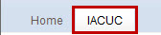
- Click the Active tab. Note: You can only suspend approved protocols (state is "Approved").
- Click the name of the submission to open it.
- Click Suspend on the left.
The protocol is suspended; however, IACUC staff can lift the suspension using the Lift Suspension activity if corrective action has been taken or the issue resolved.

Closing a Protocol
You can close an approved protocol or any protocol that is inactive (in the Lapsed or Suspended states). This feature is especially useful if the PI has left your institution. You may also receive closure requests from PIs to close an approved protocol, for example, if the research is completed or the PI ran out of funding.
To close a submission:
- Open the protocol. See Accessing a Submission on page 19.
- Click Close Protocol (Admin) on the left.
The form identifies any open follow-on submissions for the protocol.
- Verify that it makes sense to close the protocol. When you close a protocol, the system will discard any open follow-on submissions.
- Click OK to close the protocol and discard the follow-on submissions.
The protocol moves to the Closed state and appears on the Archived tab of the IACUC Submissions workspace.
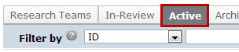

Administratively Approving a Follow-On Submission
During pre-review, you can approve amendments, annual reviews, or triennial reviews if the institution's polices allow for a streamlined approval process. To keep committee members informed, administratively approved follow-on submissions will appear on the next meeting agenda for the committee associated with the submission.
Approve a follow-on submission:
- From My Inbox, click the name of the submission to open it.
- Click Approve Submission (Admin) on the left.
- Review the committee associated with the submission and select a different one if appropriate.
- Select the approval date for the submission.
- (Optional) In the Explanation box, type your rationale for approving the submission instead of forwarding it to IACUC review.
The submission moves to the Post-Review state and IACUC staff can now prepare the decision letter that will be sent to the PI.

Checklist of Committee Meeting Tasks
Below are suggested checklists for preparing for, conducting, and completing a committee meeting. Actual meeting activities may vary based on institutional policy. The checklists assume you have already created the committee and the meeting.
Important! Most steps are performed by the committee administrator in the meeting's workspace, unless otherwise specified. The administrator for a committee can be any user that has a role of Committee Member, IACUC Coordinator, or IACUC Director.

Preparing for Each Meeting
Well in advance of the meeting:
- Assign submissions to a meeting (from the submission workspace).
- Assign reviewers to the submissions assigned to the meeting (from the meeting or submission workspace). Reviewers will be notified when you send out the agenda.
- Prepare the agenda.
- Send the agenda to committee members and any additional recipients. Note: If you change the agenda after you have sent it out, use the Notify Reviewers activity to inform reviewers of the change.
Just before the meeting:
- Edit the meeting attendance if you know who is planning to attend.
- Remove any submissions in the Clarification Requested (Committee Review) state from the agenda if the missing clarifications require delaying the committee decision. Reassign them to a later meeting.
Tip: Any submissions left on the agenda in the Clarification Requested (Committee Review) state will move to the Committee Review state when the meeting is convened.

Conducting the Meeting
We recommend dedicating one person to fill out the Submit Committee Review forms and record the non-submission information such as meeting start and end times.
During the meeting, it may be helpful to display protocol information in the course of discussion. See tips for navigating to protocol information below.
Meeting administration:
Record meeting times, attendance, and other non-submission items.
Tip: You may wish to record this information using the meeting minutes template. To do so, prepare the meeting minutes, save the generated document to your computer, and then use it to record the information. When you prepare the final minutes (as instructed below), copy and paste the items recorded during the meeting into the final version of the minutes. You can then upload the revised final version of the minutes.
- Convene the meeting. Note: Convene Meeting moves agenda items in the Clarifications Requested (Committee Review) state to Committee Review.
- (Optional) Under "Previous meetings with minutes for approval," click a previous meeting to go to its workspace. Then you can display its minutes, approve them, and return to the current meeting.
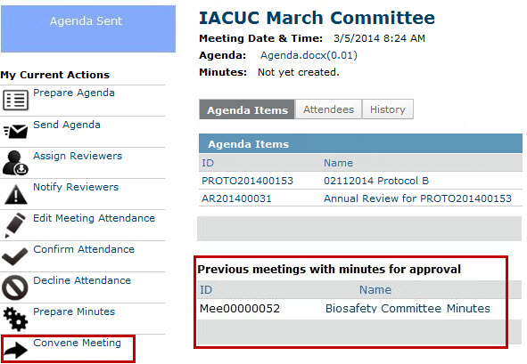
Tips for navigating to protocol information:
From the meeting workspace:
- To show protocol information, click the submission ID or protocol name in the Agenda Items list.
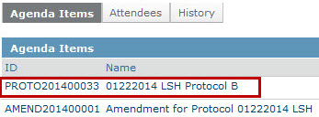
From the protocol workspace:
- To show protocol details in the forms, use the View button (View Protocol, View Amendment, etc.) on the left.
- To show attached documents, use the Documents tab.
- To show information recorded during pre-review and comments from individual committee members, use the Reviews tab.
Recording decisions, events, and notes:
- Perform Submit Committee Review to record decisions and information for each submission reviewed. Attach any relevant documents. Note: The IACUC coordinator can also submit the committee review.
Important! Don't miss the Submit Committee Review step. Correspondence cannot be prepared and sent to the investigator for a protocol until this step has been completed.

Wrapping Up After the Meeting
- If you haven't yet submitted the final committee review for each submission, do so now to move to the next steps.
Tip: From the meeting workspace, look at the Record Decision column for the agenda items to see which submissions have not yet had a decision recorded. The column will show Submit Committee Review if the activity has not yet been completed.
- Prepare the minutes. The minutes will contain the committee decisions for each protocol.
- Open and save the minutes on your computer. Add the meeting times, attendance, and any other non-submission items to the minutes. Note: If you used the minutes template to record information during the meeting, simply cut and paste the information from that document into this version of the minutes.
- Perform Prepare Minutes again to upload the revised minutes.
- Follow your internal processes to obtain the appropriate approvals of the meeting minutes.
- Inform the IACUC coordinator(s) that they can send correspondence to the investigators. For each protocol, the assigned coordinators:
- Prepare a letter to inform the PI about the IACUC's decision.
- Forward the letter to the IACUC chair to review and send it to the PI.
- Send the minutes to the committee members.
- Close the meeting.
- After the period for receiving comments from committee members has passed, perform Approve Meeting Minutes.
Tip: Until you perform this activity, the minutes are listed in the next meeting's workspace with the approve activity available there as well.

Scheduling Meetings
After committees are set up, IACUC meetings can be scheduled for committees to review submissions. Meetings may already have been set up as part of your initial system deployment, however, you may need to add new meetings or reschedule existing ones.
To create a meeting:
To perform these steps, you must be a chair, administrator, or member of this committee, or have site administrator privileges.
- Click the Meetings link on the left.
- Click Create New Meeting on the left.
- Select a committee for the meeting.
- Select a date and time for the meeting.
Tip: You can easily type over the meeting time after exiting the calendar control.
- Type a location for the meeting.
- Click OK.
The meeting is created.
To reschedule a meeting:
Note: To perform these steps, you must be the committee administrator or have site administrator privileges.
- Click the Meetings link on the left.
- Click the Upcoming Meetings tab.
- Click the meeting name to open it.
- Click Reschedule Meeting on the left.
- Change the meeting date and start time or location as appropriate.
- Click OK.

Setting Up Committees
Before the IACUC can review submissions, you must set up each of the IACUC committees in the system. If you already set up committees as part of your initial system deployment, occasionally you may need to add and edit committee information or change committee membership.
Important! Before you can assign a person to a committee, the person's user account must include the IACUC Committee Member role.
To create a committee:
To perform these steps, you must be the IACUC director or have site administrator privileges.
- Click the Meetings link on the left.
- Click Create New Committee on the left.
- Click the Committee type arrow and select IACUC.
- In the Name box, type a name for the committee.
- (Optional) In the Description box, type a description for this committee.
- Click Continue.
- If your institution has multiple IACUC offices, click the Administrative office arrow and select the appropriate office. If your institution has only one IACUC office enabled, this option will not appear.
- Select a committee administrator using one of the following methods:
- In the appropriate role box, start typing the name of the user. Select the user from the list of results.
- Click the Add button, select the members from the list and click OK. You can also use the filtering tools to search for a person.
- Assign members to the committee by selecting the member and filling in the relevant details. Then click OK at the bottom. Note: Only the questions preceded by red asterisks (*) are required. However, some of the optional information may be important to include here so it can later be included in the committee membership report.
- After adding all committee members, click Finish.
The committee is created.

To edit the committee name or description:
Note: To perform these steps, you must be the IACUC director or an administrator for this committee, or have site administrator privileges.
- Click the Meetings link on the left.
- Click the Committees tab.
- Click the committee name to open it.
- Click Edit Committee Info on the left.
- Change the committee office, name, or description as appropriate.
- Click OK.
To change the committee roster:
Note: To perform these steps, you must be the IACUC director or an administrator for this committee, or have site administrator privileges.
- Click the Meetings link on the left.
- Click the Committees tab.
- Click the committee name to open it.
- Click Edit Members on the left.
- Add or remove committee administrators or members as appropriate:
- To add people to the committee, click the Add button. See "To create a committee" above for more details about adding committee members.
- To remove people from the committee, click the Remove or Delete button to the right of the person.
- Click OK.
To change facilities for a committee:
Note: To perform these steps, you must be the administrator or chair for this committee, a coordinator or director, or have site administrator privileges.
- Click the Meetings link on the left.
- Click the Committees tab.
- Click the committee name to open it.
- Click Select Facilities for Committee on the left.
- Add or remove buildings as appropriate:
- To add buildings to the committee, click the Add button and select the buildings.
- To remove buildings from the committee, click the Remove button to the right of the building.
- Click OK.

Setting Up Ancillary Reviews
If you are including department review or review by other non-IACUC organizations as part of your standard process, you need to set up ancillary reviewers in advance. Ancillary reviewers get a chance to review a protocol without delaying the IACUC review of the protocol. The IACUC staff determines whether the IACUC review process needs to wait for results from ancillary reviewers.
For an explanation of the ancillary review workflow, see Ancillary Review Process Overview on page 7.
You can configure your system to support automatic ancillary reviews by:
- Adding a department or other organization as an ancillary reviewer to each researcher's profile or asking the researcher to include an organization in the ancillary reviewers on a protocol. For instructions, see the IACUC Deployment Guide.
- Identifying ancillary reviewers for each organization. (For instructions, see below.)
Important! The organization must have one or more ancillary reviewers defined. Otherwise, specifying the organization to perform an ancillary review has no effect.
Notes:
- You may have already set up ancillary reviewers as part of your initial system deployment. However, you may need to add or remove ancillary reviewers at a later date.
- You can instead use bulk import to add this information for multiple users as described in the IACUC Deployment Guide.
To assign ancillary reviewers to an organization:
- Log in with an account with administrator privileges.
- In the top right corner of the site, click the Projects link.
- Click the Fast Find tab on the left-hand side of the page.
- Click the Find arrow and select Organizations.
- In the Organization Name box, type the name of the department or other organization and click Find Now.
- From the list of results, click the name of the organization where you want to assign reviewers.
- Click the Properties tab.
- Click the Select View arrow and select the Detail view.
- Under Ancillary Reviewers, use the empty box to type the name of the person who you want to be included in the ancillary review. Select the matching user.
- As you type, the system searches for a user matching your criteria. You can also click Add and search for a person using more sophisticated filtering tools.
- If necessary, add additional reviewers using the same procedure.
- Click Apply.

Tagging Submissions for Reporting
As an IACUC staff member, you can add tags, or keywords, to protocols and follow-on submissions so that you can later report on those submissions. For example, you could tag submissions with "follow-up inspection" to identify submissions that require additional action. Once tagged, run a Submissions with Tags standard report and use the Change Parameters feature to filter the report to show only specific tags.
You can associate tags to submissions in any state.
Note: You must have site administrator privileges to create or update the list of tags that can be associated with submissions.
To tag a submission:
- From My Inbox, click the name of the submission to open it.
- Click Manage Tags.
- 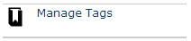
- Click Add to associate tags to the submission.
- Select tags from the list and click OK. If you want to use a tag that is not in the list, contact your site administrator to add it.
- Click OK again to associate the tags with the submission.
Generate a report of submissions that have certain tags:
- Click the Reports link on the left.
- On the Standard Reports tab, click the Submissions with Tags report link.
- On the right of the Filter by area, click Change Parameters.
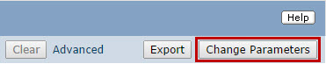
- Change the Tag.ID value to the tag you want to see on the report. Use the % to show all tagged submissions regardless of tag. See Filtering and Sorting Data on page 38 for more detail on changing report parameters.
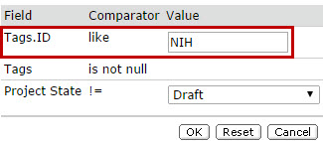
- Click OK.

Transferring a Protocol between IACUC Offices
If your institution has multiple IACUC admin offices and a protocol is assigned to the wrong one, the PI or IACUC coordinator can reassign the protocol, depending on the system configuration settings. The system may be configured for one or both of these options:
- To let the PI select the admin office on the first page of the protocol during Pre-Submission
- To let the IACUC coordinator assign the admin office during pre-review
Important! You can use the procedure below to reassign a protocol before the IACUC completes its pre-review of the protocol. After the pre-review, the PI can withdraw and resubmit the protocol with the correct IACUC admin office.
To transfer a protocol between IACUC offices:
Choose from these options:
- Click Assign Admin Office and select the correct admin office.
- Click Request Clarification by Pre-Reviewer and ask the PI to change the admin office. Note: This option takes longer but is more informative for the PI.

Filtering and Sorting Data
Many pages contain tables you can filter and sort to help you find the data you want.
- Filtering reduces the list to only the data that meets the criteria. The advanced filter lets you combine multiple filter criteria together.
- Sorting displays the data in ascending or descending order by a particular column
For some reports, you can change the criteria used to create the report before you apply additional filters or change the sort order.
Note: For details on using Advanced Reports, see the Advanced Reports Quick Reference guide.
To filter data:
- Select the column to filter by from the drop-down menu. The menu lists only the columns you can filter by. Note: To combine multiple filter criteria, such as, ID, name, and Date Created, use the advanced filters.
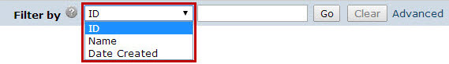
- In the next box, type the beginning characters for the items you want to find. If you do not know the beginning characters, type a % symbol as a wildcard before the characters. Examples:
- 71 shows all items beginning with 71
- %71 shows all items containing 71 in any position
Tip: For examples and a list of operators you can use, click the Help icon. 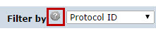
- Click Go to apply the filter.
The table shows only those rows that are an exact match.
Tip: If you do not see the expected items in the list, click Clear in the Filter By area to remove the filter.
To use advanced filters:
- In the Filter By area, click Advanced.
- Enter filter criteria as explained in the previous section. To add criteria, click Add Another Row.
- Click Go to apply the filter.
The table shows only those rows that match all the filter criteria.
To sort data:
Click the column header you want to sort by. Click it a second time to reverse the sort order. The arrow indicates the column by which the data is sorted and the sort order, either ascending (up arrow) or descending (down arrow). Note: If the column header is not a link, you cannot sort by that column.
To change the criteria of the report:
- On the right of the Filter by area, click Change Parameters.
- Change the report criteria field values as needed. Typically, multiple criteria rows (see example 2) are treated with an "and" between them. That is, the report will show items that meet criteria 1 and criteria 2.
- Example 1: Shows all projects that are not archived (!= means the field is not the specified value).
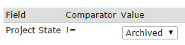
- Example 2: Shows projects that will expire in the next 90 days, that is, the expiry date must be before or on "today plus 90 days" and the expiry date must be today or later. For these fields, you can select different dates using the calendar.
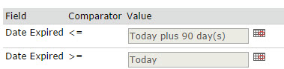
Tip: For a list of the operators you can use in the parameter criteria, click the Help icon.

- Click OK.

Handling Concerns and Deficiencies
As an IACUC staff member or PAM coordinator, you may create or receive concerns about the care and use of animals from the public, research facility staff, or employees. Upon creating or seeing a new concern in your Click IACUC inbox, click the concern name to open it.
To handle the concern, you will perform various tasks at different times in the workflow using activities on the left of the concern workspace. At any time during the concern review process, you may need to update concern details. IACUC coordinators and directors can edit a concern (assigned to their admin office) in any state. You may also wish to run reports on concerns and deficiencies in the system. See Generating Concern and Deficiency Reports on page 50 for details.
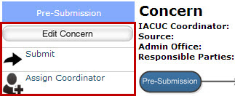
During Pre-Submission
- Submit the concern to move it to the Pre-Review state. During this step, you will select the committee (and corresponding administrative office) that will review and handle this concern.
During Pre-Review
- Assign a coordinator to oversee the concern. See Assigning Ownership of a Submission on page 20.
- Request clarifications about the concern from any user in the system. See Requesting Clarifications about a Concern on page 42.
- Give view access to other IACUC users by adding them to the concern's guest list (Manage Guest List activity). By default only the IACUC staff and responsible parties can view a concern. Anyone you request clarification from is also added to the guest list. Note: Use the Manage Clarification Requests activity to make specific requests to which people must respond.
- Assign the people responsible for addressing or correcting the concern.
- Based on your research and review of the concern, perform one of the following:
- Report the concern as no action if no further action is required. The concern will appear on the committee's next meeting agenda to inform committee members of your determination.
OR
- Assign the concern to a meeting to be reviewed by the IACUC.
During IACUC Review
- After the IACUC meeting, submit the IACUC's determination. See Submitting a Concern Review Determination on page 42.
- If corrective action is required, assign responsible parties and add a corrective action plan if this wasn't done previously (Update Corrective Action Plan activity).
During Corrective Action
- When responsible parties have completed the corrective action, confirm it was indeed completed. Use the Submit Confirmation activity to confirm it was completed or request clarification from the responsible parties if there are questions or outstanding items.
- Update the corrective action plan, if necessary (Update Corrective Action Plan activity).

Submitting a Concern
Any Click IACUC user role (Study staff, IACUC coordinators, directors, committee members, etc.) can enter a concern or report of non-compliance about the research facilities or personnel involved in the care and use of animals.
To submit a concern:
- From the My Inbox workspace, click Create Concern on the left. Note: If the concern is related to an inspection (or PAM audit), create the concern from the inspection workspace so the concern is associated with the inspection. To do so:
  - Click the Inspections link on the left
  - Click the name of the inspection to open.
  - Click Create Concern.
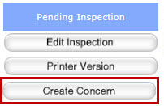
- Complete the required questions marked with a red asterisk (*). Click Continue to move to the next page.
- When done, click Finish.
The concern has not yet been submitted for IACUC review. IACUC staff or a committee member must submit the concern to move it from Pre-Submission to Pre-Review.

Requesting Clarifications about a Concern
As an IACUC staff member, you can request clarifications about a concern (or deficiency) from any user in the system. When you do so, the concern moves into that person's Click IACUC inbox and that person must respond to the request to move the concern forward in the review process.
People from whom you request clarifications are automatically added to the concern's guest list, which in turn gives them view access to the concern. Note: If you want to give a person view access to a concern without requiring a response, you can simply use the Manage Guest List activity to add them to the guest list.
To request clarification from other users:
- Click Manage Clarification Requests on the left.
- Click Add and then Select to choose the person from whom you want clarification. Click OK.
- In the Request clarifications box, type your questions for that person. Click OK (or OK and Add Another to add more people).
- Click OK.
The people from whom you requested clarifications will receive an e-mail to respond to your request.

Submitting a Concern Review Determination
After the committee has reviewed a concern or deficiency, you must submit the review decision in the system. This step moves the submission forward in the concern process.
To submit a committee determination for a concern:
- Click Submit Committee Determination on the left.
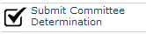
- Select the determination for the concern. If corrective action is required:
  - Indicate if the incident is reportable.
  - Attach corrective action plan documents, assign the parties responsible for performing the corrective action, and select the correction due date. Note: If this information is not available at the time of submitting the determination, you can add it later using the Assign Responsible Parties and Update Corrective Action Plan actions.
- Review the deficiency information entered previously. Update it if appropriate.
- When finished, click OK.

Handling Inspections and PAM Audits
The IACUC system can help you track and manage different types of inspections such as semiannual facility inspections and Post-Approval Monitoring (PAM) audits of investigators and protocols. You must have either the user role of Inspection Officer or PAM Coordinator to perform the following activities. Committee members assigned to complete inspections can record findings and complete inspections.
- Create inspections and PAM Audits in the IACUC system. See Creating an Inspection or PAM Audit on page 43.
- Perform the inspection, record your inspection findings, and complete the inspection. See Completing an Inspection or PAM Audit on page 44.
- Track scheduled inspections and audits. See Tracking and Managing Inspections on page 45.

Creating an Inspection or PAM Audit
Inspection officers and PAM coordinators create inspections and PAM audits (routine, for cause, or follow-up audits) in the Click IACUC system.
To create an inspection or PAM audit:
- From the My Inbox workspace, click Inspections on the left.
- From the Inspections workspace, click Create Inspection.
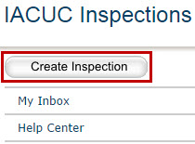
- Complete the required questions marked with a red asterisk (*).
- Click Continue. Depending on the inspection type selected, you may have another page to complete. Complete it and click Finish.
The inspection is created and inspectors are notified via e-mail of the inspection assignment and date. The inspection is also added to the inspection calendar. For details about the inspection calendar, see Tracking and Managing Inspections on page 45.

Completing an Inspection or PAM Audit
If you are assigned to do an inspection or PAM audit, you will receive an e-mail notification with a link to the inspection. If you no longer have the e-mail, you can find the inspection on the IACUC Inspections workspace (see steps to open an inspection).
Open the inspection and perform the following tasks:
- Download inspection checklists to use during the inspection (steps below).
Note: The OLAW Semiannual Program Review and Facility Inspection Checklist is included in the software. Your institution can add to or replace this checklist as described in the IACUC Deployment Guide.
- Log any concerns that you find during the inspection. See Submitting a Concern on page 41.
- Update the inspection audit with your findings and attach any completed checklists (steps below).
- Complete the inspection (steps below).
To open an inspection:
- From an e-mail: Click the inspection link.
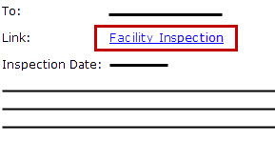
- From My Inbox:
- Click the Inspections link on the left.
From the IACUC Inspections workspace, click the name of the inspection to open it.
To find inspection checklists:
Inspection checklists, if available, will appear at the top of the inspection form.
- On the inspection workspace, click Edit inspection on the left.
- At the top of the page, click the link to save the checklist to your computer.
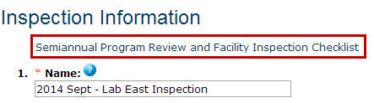

To record inspection findings:
- Click Record Findings on the left.
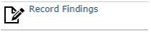
- Complete the form. In the inspection documents area, add any completed checklists.
- Click OK.
You can use Record Findings as often as needed to add to or change what you previously typed.
To complete an inspection:
- Click Complete Inspection.
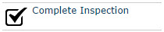
- Select the committee meeting on whose agenda this completed inspection will appear. This will inform committee members of the completed inspection.
- Update the findings you previously entered as necessary.
- Click OK.

Tracking and Managing Inspections
When an inspection is created, if it has an inspection date, it is added to the inspection calendar. Each inspection type is a different color for easy identification and the inspection name is a link to that inspection's workspace. Use the calendar to see scheduled inspections and adjust inspection dates as necessary.
To view the inspection calendar:
- Click the Inspections link on the left.
- Click the Calendar tab.
Tip: To change an inspection date, click the inspection name and then click Edit Inspection on the left of the inspection workspace.
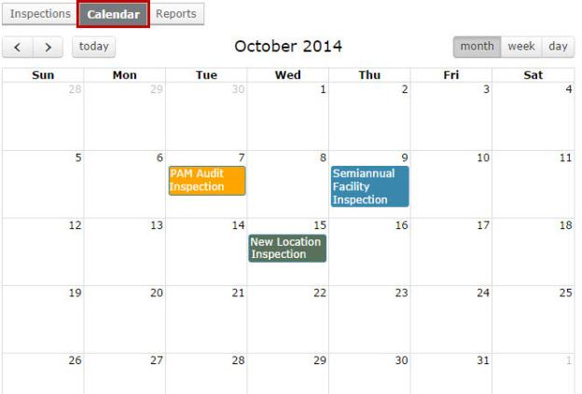

Conducting Semiannual Program Reviews
In the IACUC system, a semiannual program review is done via a meeting in which the committee typically reviews the Institutional Official (IO) Report (generated from the IACUC system) in addition to the animal care and use program. This report includes departures from the Guide for the Care and Use of Laboratory Animals on approved protocols and deficiencies reported from program reviews and facility inspections.
Generally, the committee administrator sets up the program review meeting and the IACUC coordinator runs the meeting.
To conduct a program review:
- Generate the IO report. See Generating an Institutional Official (IO) Report on page 51. In a later step, you will attach this report to the meeting agenda.
- Create a meeting for the program review. See Scheduling Meetings on page 33.
- Copy and paste the contents of the IO report into your meeting agenda so it can be reviewed.
- Upload your agenda and send it to committee members:
  - Click the Meetings link on the left
  - On the Upcoming Meetings tab, select the program review meeting name.
  - Click Prepare Agenda and then Add to upload the agenda. Choose the agenda file that contains the IO Report details. When done, click OK to exit all the windows and return to the meeting workspace.
  - Click Send Agenda on the left to send the agenda to committee members.
- During the meeting:
  - In the meeting workspace, click Prepare Minutes and generate the minutes.
  - At the top of the meeting workspace, click the minutes link to download and save the document.
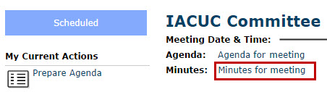
  - Copy and paste the contents of the IO report into the saved minutes and add any additional information to it as needed.
  - In the meeting workspace, click Prepare Minutes and then Upload Revision to upload the updated minutes.

Getting Started for Training Coordinators
The IACUC is charged with ensuring that all IACUC members (including non-affiliated community members) have been adequately trained and the research team has the required training to conduct protocol activities. Follow your institution's policies for designing, developing, and delivering training programs.
The IACUC system can help you track and manage training. You must have the user role of Training Coordinator to perform the following activities:
- Add training courses into the IACUC system. See Adding a Training Course on page 47.
- Upon course completion, update the course with the list of attendees that took the course. See Recording Course Completion on page 48.
- Inactivate courses that are no longer active or valid. See Inactivating a Course on page 48.
- Track training deadlines. See Identifying Training Deadlines on page 49.

Adding a Training Course
You can add new training courses to the IACUC system at any time.
To add a training course:
- Click the Training link on the left.
- Click the Create Course button on the left.
- Answer the required questions marked with a red asterisk (*) and click Continue to move to the next page.
- (Optional) Enter any other course details and information.
- On the final page, click Finish on the right.

Recording Course Completion
When researchers or IACUC members have completed a course, you can update the course information to indicate who took it. You can also remove anyone who didn't actually take the course.
To open a course:
- Click the Training link on the left.
- On the Courses tab, click the name of the course to open it.
To record course completion:
- Open the course. See steps above.
- Click Record Course Completion on the left.
- Click Add and select the people who completed the course. Click OK.
- (Optional) Add any other course completion details.
- Click OK.
To remove a person from a course:
- Open the course. See steps above.
- Click Remove Course Completion on the left.
- Click Add and select the person you want to remove from the course completion.
- Click OK.

Inactivating a Course
If a course is no longer active or valid, you can inactivate it. Once inactivated, you can no longer record researchers and IACUC members as having completed the course.
To inactivate a training course:
- Click the Training link on the left.
- Click the course name to open it.
- Click Discontinue Course on the left.
- (Optional) In the Comments box, type your reasons for inactivating the course. You can also attach supporting documents, if appropriate.
- Click OK.

Identifying Training Deadlines
The IACUC system comes with standard training reports that show training courses that have expired and training courses due to expire in 90 days. To generate a standard report, see Generating Reports on page 49.
Both reports list the course, name of the researcher or IACUC member, and other details about the course including the expiration date. Follow your institution's standard operating procedures for dealing with expired training and deadlines.
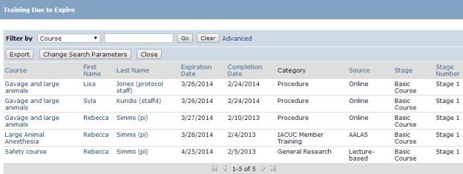

Generating Reports
The IACUC system includes many standard reports to keep you informed about important aspects of submissions and IACUC activities. In addition, your institution may create custom reports. The reports provide links to the individual submissions.
Any user can access the reports; however, only those reports and data to which they have permission will appear. For example, the Protocols Due to Expire report generated by a PI will include only protocols that the PI can view. IACUC coordinators and directors have access to most reports and data.
For specific IACUC reports, see the following:
- Concern and Deficiency Reports
- Inspection Reports
- Institutional Official (IO) Report
- AAALAC Report
To generate a report:
- Click the Reports link on the left.
The list of standard reports appears.
Tip: To find a custom report, click the Custom Reports tab.
- Click the name of the report to view it.
The report appears listing the relevant submissions.
Tip: Use the Filter By feature to find specific data. See Filtering and Sorting Data on page 38.

Generating Concern and Deficiency Reports
IACUC staff, committee members, and the institutional official can view a listing of all concerns entered into the system as well as those converted into deficiencies by the IACUC.
To generate concern and deficiency reports:
- Click the Concerns link on the left.
- Click the Reports tab.
- Click the name of the report to view it.
Tip: These reports are also available from the Advanced Reports tab on the IACUC Reports workspace. See the Advanced Reports Quick Reference guide for details on these reports and steps for using advanced report features.
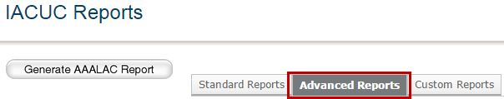

Generating Inspection Reports
IACUC staff, inspection officers, committee members, PAM coordinators, and the institutional official can view a report of all inspections including semiannual inspections and PAM audits.
To generate a report of all inspections:
- Click the Inspections link on the left.
- Click the Reports tab.
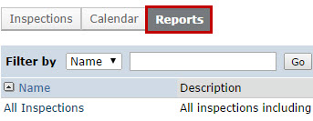
- Click the report name "All Inspections" to view the report.
Tip: Use the Filter By feature to find specific data. See Filtering and Sorting Data on page 38.
For example, filter inspections by inspection type, such as semiannual facility inspection, to view only those inspections.
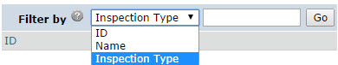
To see all inspections for a particular building or room within a building:
- In the top navigator, click Facilities.
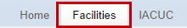
- Select the Buildings or Rooms tab.
- Click the building or room name link.
- On the workspace, click the Inspections tab.

Generating an Institutional Official (IO) Report
The IACUC must prepare a semiannual report of the program reviews and facility inspections for the IO. In the Click IACUC system, the IO, IACUC staff members, or committee members can generate an IO Report for a specific committee and date range.
The report uses the same format as the Office of Laboratory Animal Welfare (OLAW) sample IO Report and automatically populates the report with the following data:
- Departures from the Guide for the Care and Use of Laboratory Animals reported on:
- Approved protocols created during the date range
- Protocols that have reached the Approved state during the date range
- Deficiencies for program reviews and facility inspections for which the IACUC has submitted a deficiency determination in the date range (the Submit Determination date is in the date range)
The IO report includes sections for you to manually add program changes since the last review, minority views expressed by committee members, and AAALAC accreditation status.
To generate an IO Report:
- Click the Reports link on the left.
- Click Generate IO Report.
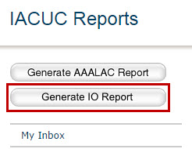
- In the window, select the committee for the IO Report.
- Select a date range for the data to include in the report.
- Select the PDF check box to generate a PDF. If not selected, a Word document is generated. Generate a Word document if you will add program changes, minority views, or AAALAC accreditation status information to the report.
- Click Generate. When finished, click the generated report link to save the report.
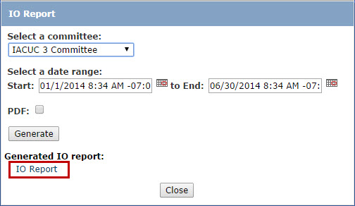
Tip: Microsoft® Word documents open differently in different web browsers. If the document does not open promptly:
  - Click the Word icon if it is flashing at the bottom of your screen, and then click one of your open Word documents.
  - Check the bottom of the browser window to see if the document icon and name is shown there. If so, click the name to open it.

- If applicable, open the saved Word version and add any program changes, minority views, or AAALAC accreditation status details to it.
- Follow your internal processes to obtain the appropriate signatures on the report.

Generating an AAALAC Report
If you are applying for AAALAC (Association for Assessment and Accreditation of Laboratory Animal Care) accreditation or renewing an existing accreditation, you can generate the Animal Usage Form B from the IACUC system and insert it into the appendix of your Program Description document.
The AAALAC Report uses the same format as the Animal Usage Form B and is populated with data from the IACUC system.
To generate an AAALAC Report:
- Click the Reports link on the left.
- Click Generate AAALAC Report.
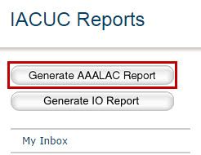
- In the window, select the administrative office and click Generate. The report is generated in Microsoft Word format.
- Click the generated AAALAC report link to save and open the report.
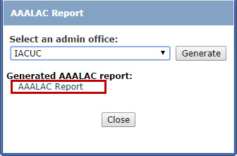
Tip: Microsoft® Word documents open differently in different web browsers. If the document does not open promptly:
- Click the Word icon if it is flashing at the bottom of your screen, and then click one of your open Word documents.
- Check the bottom of the browser window to see if the document icon and name is shown there. If so, click the name to open it.

AAALAC Report Example:
Below is an example of the AAALAC report generated from the IACUC system.
Tip: In Word, if the table goes beyond the width of the page, simply adjust the columns or table properties to make it fit.
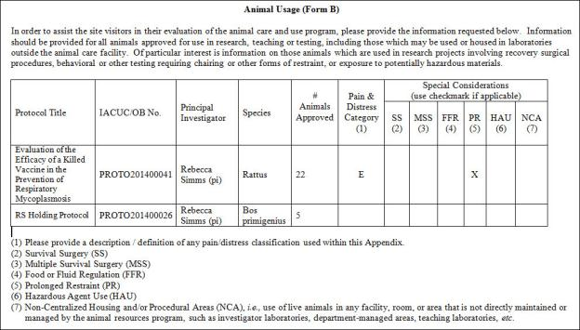

Finding More Information

Resource | Description | Location
Help for a field or page | More information about a question or form. | Click next to the question or page title.
IACUC Researcher's Quick Reference | A quick reference guide for PIs and research teams  with steps for creating and submitting protocols and follow-on submissions. | - Click the Help Center link on the left.  - On the Guides tab, click the name of the guide to open it.
IACUC  Reviewer's  Guide | A guide for reviewers with steps for reviewing a submission and submitting a decision.
IACUC Staff  Guide | A guide for IACUC staff, inspection officers, PAM coordinators, and training coordinators that includes process overviews, basic administration activities, and tasks for managing and handling inspections, concerns, and training.
IACUC Videos | Conceptual videos to help you understand and use the IACUC software. | - Click the Help Center link on the left.  - Click the Videos tab.  - Click the name of the video to run it.

Workflow Diagrams Overview
Workflow diagrams provided with the IACUC software show all the states a submission can go through, user roles that can take actions during that state, and when e-mail notifications are generated by the system for the next users in the process. See the product release page to download the workflow diagrams.
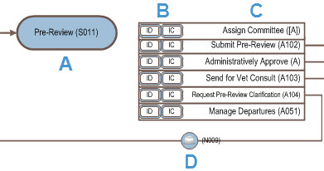
The example above shows a protocol in Pre-Review state. A protocol moves into the Pre-Review state after a PI submits it to the IACUC. In this state, only the IACUC director or IACUC coordinators can access it and perform actions on it. For example, an IACUC coordinator might send it to a veterinarian to review (Send for Vet Consult). Workflow diagrams show the following information:
- A. States that an IACUC submission transitions through during its life cycle
- B. User roles that can perform each activity, for example, the IACUC Director (ID)
- C. Activities that can be performed in that state
- D. E-mail notifications that are triggered at specific points of the process
For protocols and follow-on submissions, workflow diagrams are available for the following key states. Concerns and deficiencies and inspections and PAM audits follow different workflows.
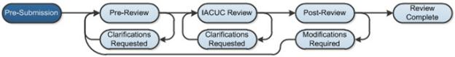
For more detail on each state, refer to the following topics:
- Pre-Submission Workflow on page 57
- Pre-Review Workflow on page 57
- IACUC Review Workflow on page 58
- Post-Review Workflow on page 61
- Review Complete and Final States on page 62

Pre-Submission Workflow
To prepare a protocol or follow-on submission for review, the protocol team fills out a series of dynamic forms and attaches all applicable information. Only the PI can submit the protocol to the IACUC, however, any of the protocol team members (including the PI) can edit the submission during Pre-Submission. Additionally, a person designated as the primary contact can edit the submission without being part of the protocol team.
During pre-submission, the protocol team can also assign ancillary reviewers to their submission. For details about ancillary reviews, see Ancillary Review Process Overview on page 7.
Note: Depending on your institution's policy, IACUC staff (coordinators and directors) for an administrative office may be allowed to edit protocols and follow-on submissions (amendments and triennial reviews) on behalf of the protocol team. A system-wide setting, as described in the IACUC Deployment Guide, must be enabled to allow this.

Pre-Review Workflow
After the PI submits the protocol or follow-on submission to the IACUC, it moves to the Pre-Review state.
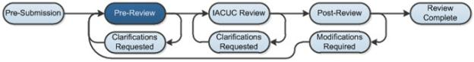
Generally, during Pre-Review, the IACUC coordinator will review the protocol to ensure it has all the necessary information for IACUC review. Other activities may also occur during this state:
- Assign a specific coordinator to a submission: The IACUC director and anyone with the IACUC coordinator role can assign the submission to a specific coordinator to handle. The assigned coordinator will receive an e-mail and the submission will appear in My Inbox whenever the assigned coordinator needs to take action on it. If the submission is not assigned to a coordinator, all coordinators can still access it from the IACUC submission workspace, however, it will not appear in My Inbox as an indication to take action.
- Consult a veterinarian: The IACUC coordinator can send the submission to a vet for consultation and review. The submission will stay in Pre-Review, however, will have a Vet Consult state. In the Vet Consult state, the vet can respond to the consultation request and submit it back to the coordinator. The vet can also request clarification from the protocol team, in which case the submission will move to the Clarifications Requested state (shown below).
- Request clarifications from the protocol team: If the coordinator requires the protocol team make changes or answer questions about the submission, the coordinator can add reviewer notes to specific pages of the submission and then use the "Request Clarification..." activity to return the submission to the protocol team. The submission will move to the Clarifications Requested state. When the protocol team submits their response to the request, the submission will return back to the previous state.
- Approve a follow-on submission: The system allows for a shortened review process for follow-on submissions. If the institution's policies support this, the IACUC director or coordinator can administratively approve certain follow-on submissions. Upon approval, the submission will move to the Post-Review state, bypassing an IACUC review.
When the submission is finally ready for IACUC review, the coordinator will complete and submit a Submit Pre-Review form along with the submission. The Submit Pre-Review form identifies:
- The IACUC committee to review the submission and whether the submission should move directly to a full committee review
- Any missing materials
- Comments and/or supporting documents
The coordinator can return to add and update some of the information in the Submit Pre-Review form before finally submitting it for IACUC Review. Also, IACUC staff members can change some of the pre-review information during the review process.
IACUC staff can add or update ancillary reviewers at any time until Post-Review is completed. For details about ancillary reviews, see Ancillary Review Process Overview on page 7.

IACUC Review Workflow
After the coordinator completes and submits the Submit Pre-Review form, the submission moves into IACUC Review. During this workflow, the submission will either go to a full committee review or a designated member review.
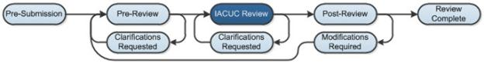

When the coordinator filled out the Submit Pre-Review form, the coordinator indicated if the submission should be forwarded directly to a Full Committee Review. If so, the submission state will change to Meeting Assignment until the IACUC coordinator assigns it to a specific IACUC committee meeting for review. Once assigned to a meeting, the submission state will change to Committee Review.
If the submission will not be forwarded directly to a full committee review, it will move to the Grace Period state so IACUC committee members can review it and determine whether it should go to full committee review. If the grace period passes and it wasn't assigned to a committee review, the submission moves to a Designated Reviewer Assignment state and the IACUC chair will assign it to a committee member to review. The submission will move to the Designated Review state.
Note: Various settings affect how long the grace period is and when it starts or ends. Further, your system may send a weekly e-mail to committee members of protocols in grace period so they can review them to determine if a committee review is required. For details on grace period settings, see the IACUC Deployment Guide.

Designated Review
The designated reviewer's most likely actions are:
- View the protocol details
- Ask the IACUC coordinator to edit the pre-review information if it is inaccurate
- Request clarifications from the protocol team if needed (see Request Clarifications on page 60)
- Submit the review
After the reviewer has made a decision about the protocol, the reviewer submits the determination and other details. In particular, if modifications are required, the reviewer describes them in the activity form. The reviewer can return multiple times to add and update information in the Submit Designated Review form before finally submitting it as a final decision. Once submitted, the state transitions to Post-Review.

Committee Review
During the Committee Review state, two types of activities occur:
- Meeting-related activities, such as scheduling the meeting and creating an agenda and minutes. These are handled in the meeting workspace. (For more description, see Meeting Workflow on page 9.)
- Review-related activities, such as assigning specific reviewers, viewing the protocol, adding review comments, and submitting the review determination. These are handled in the protocol workspace. The review-related workflow is described below.
An IACUC coordinator can assign specific reviewers to a submission in either the meeting or protocol workspace.
Before the meeting, reviewers will most likely:
- View the protocol details
- Add review comments
- Ask the IACUC coordinator to edit the pre-review information if it is inaccurate
- Request clarifications from the protocol team if needed (see Request Clarifications on page 60)
- View comments from other reviewers
After the committee has made a decision about a protocol, the IACUC coordinator submits the review decision with all the details, including a description of any modifications required. Once submitted, the state transitions to Post-Review.

Request Clarifications
If committee members require the protocol team make changes or answer questions about the submission, they can add reviewer notes to specific pages of the submission and then use the "Request Clarification..." activity to return the submission to the protocol team. The submission will move to the Clarifications Requested state. When the protocol team submits their response to the request, the submission will return back to the previous state.
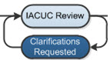
Requests for clarifications are handled differently during committee review than during other types of review in that:
- Protocol team members cannot edit the protocol when it is in Clarifications Requested (Committee Review) state, but they can submit changes back to the committee.
- The IACUC coordinator can remove the submission from the agenda before the meeting and reassign it to a later meeting.
- The committee can record a decision for the submission when it is still in Clarifications Requested (Committee Review) state.

Post-Review Workflow
During Post-Review, the correspondence is prepared, reviewed, and sent to the PI.
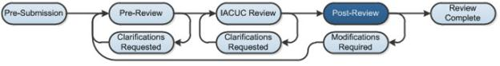

Preparing Correspondence
Using the Prepare Letter activity, the coordinator can generate a letter from a selected template. Standard templates support automatic letter generation that fills in many details about the submission, such as the protocol title, PI, and approval expiration date (if applicable). Standard templates are provided to match each IACUC determination, and your institution can add to or replace the provided templates. The template selection list in Prepare Letter is filtered to show only templates matching the IACUC's determination for the submission.
Prepare Letter also lets the coordinator upload a letter. The coordinator can generate a letter, download it, edit it as necessary, and upload it again.

Reviewing and Sending Determination Letters
After the letter is created, the coordinator can use Forward Letter for Review activity to move the submission to the Chair Letter Review state and into the committee chair's My Inbox. The chair can request changes to the letter using the Request Changes to Letter activity and the submission will move back to the coordinator to make changes and send it back to the chair.
When the letter is ready to send to the PI (and the primary contact), the chair can use the Send Letter activity to send the letter to the PI and primary contact using an e-mail notification. Note: Your institution may not require the chair to review determination letters prior to sending. In this case, your system may be set up to allow the IACUC coordinator, director, or chair to send the letter using the Send Letter activity during Post-Review. For detail on the setting, see the IACUC Deployment Guide.
When the letter is sent, the submission transitions to a state that reflects the IACUC's determination, such as Approved or Approval Withheld. The letter is visible to the IACUC staff and all members of the protocol team when they access the submission in the system.

Responding to Required Modifications
For submissions receiving an Approval Withheld or a Modifications Required to Secure Approval determination, sending the letter places the submission in the Approval Withheld or Modifications Required state, respectively. These two states fall under the Modifications Required key state in the diagram. In this key state, the protocol team can edit the submission and submit a response back to the IACUC. When the protocol team does so, the submission moves back to the Pre-Review state to go through the review process again.

Review Complete and Final States
After the correspondence is sent to the PI, the submission moves to Review Complete.
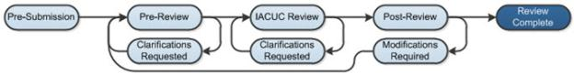
While in Review Complete, the submission can have the following states:
- Approved: The protocol is active and the protocol team is conducting their research. When a protocol is approved, the system copies the approved protocol to create a draft protocol. When an amendment or triennial review is created, the draft protocol is updated with the proposed changes, while the approved protocol remains unchanged. When the amendment or triennial review is approved, the changes are published into the approved protocol.
- Lapsed: An active protocol moves to the Lapsed state if the protocol team does not submit an annual review or triennial review to the IACUC in the required time frame.
- Suspended
- Closure Requested

Final States
Final states for a protocol are Closed or Discarded.
- Closed: The IACUC director or coordinator can close approved, lapsed, or suspended protocols using the Close Protocol (Admin) activity. Additionally, a PI may request the IACUC to close an approved, lapsed, or suspended protocol, using the Request Closure activity, if it is no longer active, for example, the protocol team has finished their research or is no longer performing the research due to lack of funding or other reasons. When the IACUC closes a protocol, the state changes to the final state of Closed.
- Discarded: The protocol team can discard a protocol using the Discard activity, for example, to completely start over, as long as the IACUC hasn't yet submitted its review decision (prior Post-Review).
Closed and discarded protocols appear on the Archived tab of the IACUC Submissions workspace and are read-only; however, protocol team members can copy it and use the copy as a starting point for new submissions.

Meeting Workflow
From the IACUC Meeting workspace, the person designated as the administrator for a committee can manage meetings, agendas, and minutes for that committee's meetings. Note: The committee administrator is a designated member of a committee and not an actual user role in the software. Refer to the workflow diagrams provided with the software to see other roles that can perform the activities listed below.
For a recommended order to perform meeting tasks, see Checklist of Committee Meeting Tasks on page 30.

Assigning Submissions to Meetings
The IACUC coordinator will first assign a submission to a meeting from the submission workspace. Also from the submission workspace, the coordinator can remove it from a meeting agenda and reassign it to a different meeting.

Preparing for a Meeting
The committee administrator, as well as IACUC staff and the chair, can assign reviewers to submissions that are assigned to meetings and notify reviewers of the scheduled meeting.
The committee administrator can prepare an agenda from a template using the Prepare Agenda activity. A standard template is included in the software that supports automatic agenda generation that fills in the time and place of the meeting and several details about each submission on the agenda. Your institution can add to or replace the provided template as described in the IACUC Deployment Guide.
The committee administrator can generate an agenda, download it, edit it as necessary, and upload it again. When the agenda is ready, the committee administrator can use the Send Agenda activity to send an e-mail notification to the invitees.
The invitees can confirm or decline attendance using the provided activities. The committee administrator can also use the Edit Meeting Attendance activity to fill in attendance details for those who do not use the provided activities to respond.
Tip: The committee administrator should remove any submissions in the Clarifications Requested state from the agenda if the clarifications are required for the committee to make a decision. Submissions left in Clarifications Requested will be moved to the Committee Review state when the Convene Meeting activity is used.
The Prepare Minutes activity lets the committee administrator (or chair) generate meeting minutes from a selected template or upload minutes. Generating the minutes shortly before the meeting from the provided standard template creates a framework to record meeting activities and details about each submission as well as fill in committee decisions and notes. The filled-in minutes document can be uploaded later using Prepare Minutes again.

Starting a Meeting
To start the meeting, the committee administrator can use the Convene Meeting activity. Convene Meeting moves any submissions in the Clarifications Requested state back to Committee Review so a decision can be recorded.

Wrapping Up After a Meeting
During or shortly after the meeting, the IACUC coordinator will submit the committee review for each submission, which includes recording the committee decision for that submission. This is done from each submission's workspace. Additionally, the coordinator will prepare the decision letter and forward it to the chair to approve and send to the protocol team.
Meanwhile, the committee administrator can upload the completed meeting minutes using Prepare Minutes on the meeting workspace and then the Close Meeting activity to conclude the meeting in the system.
The chair (or committee administrator) will use the Approve Meeting Minutes activity to record approval of the minutes.

© 2012-2014 Huron Technologies Inc. All rights reserved. Use and distribution prohibited except through written agreement with Huron.

Click is a registered service mark of Huron Consulting Group, Inc. All other trademarks, registered trademarks, service marks, and trade names are the property of their respective owners.

Information in this document is subject to change without notice.

Published by Huron Technologies Inc.
1925 NW AmberGlen Pkwy
Suite 400
Beaverton, OR 97006

