Respond to Clarification Requests

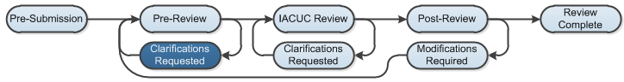

Work Instructions:
If a reviewer has questions or requires you to change your submission, you will receive an e-mail indicating this. Review the request details and then respond to the request.
- Click the e-mail link to open the submission. Alternatively, log in to Click Portal, then open the submission from My Inbox.
- On the History tab, find the “Clarification by…Requested” activity and read the comments.
- Check to see if the reviewer added notes to the submission: Click the Reviewer Notes tab (in the Resource tabs).
  - For each reviewer note, you can either:
    - (a) Click the link Click here to respond…. Select a response from the drop down list that appears (Change Request Completed; Change Request Not Completed; or Reviewer Information Only). Elaborate on what you did in the text box, then click OK.
    - (b) Alternatively, click the Jump To: link to go directly to the page with the reviewer note so that you can see the note in context, and then respond.
  - If there are no notes, proceed to step (4).
- Click Submit Response. In the Comments section, explain your response to the reviewer. Add supporting documents if that is appropriate, then click OK. The state moves to Pre-Review.

