Click® IACUC Researcher’s Quick Reference

Before You Create a Protocol 2
Create a Research Team 3
Check for Existing Building Blocks 3
Create Building Blocks 4
Create and Submit a Protocol 5
Respond to Reviewer Requests 6
Create and Submit a Follow-On Submission 7
Navigation and Basic Tasks 8

Before You Create a Protocol

Plan out your protocol:
- Summarize the research (science), reasons for performing the research, and benefits from it.
- Determine the experiments and the number of animals required.
- Determine the procedures you will perform and the substances required for your experiments.
- Identify any supporting documents to include in your protocol, such as, flowcharts, explanations of the science, grant applications, and other information explaining or justifying your research.

Set up building blocks:
The diagram below shows the concept of building blocks. Once they are set up, you can create your protocol.
- Create a research team for the substances, procedures, and protocols you create.
- Check the IACUC standard library for the procedures and substances required for your protocol experiments (see Check for Building Blocks). If not in the library:
Create the missing substances
Create the missing procedures
Create protocols with experiments*

*Experiments can have one or more team or standard procedures
Create procedures*

*Team procedures can have one or more team or standard substances

Substances & Procedures Library
Substances
Procedures

Substances
Research Team
Procedures
Protocols

Create substances

Substance
Substance
Substance
Procedure
Substance
Substance

Protocol Experiment
Procedure
Substance
Substance
Procedure
Substance

Create a Research Team
As a member of a research team, you can create substances, procedures, and protocols for your research team. When you create a protocol, your research team members appear on the protocol by default.
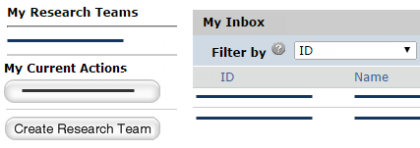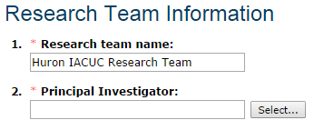  2  3  1 | Create Research Team
- From My Inbox, click Create Research Team.
- Type a name for the research team and select the team’s PI.
Note: If you are not the PI, add yourself as a team member if you will create team procedures
and substances.
- Complete the rest of the page and click OK.
You are taken to the research team workspace page.

Check for Existing Building Blocks
Check the system to see if there are IACUC standard building blocks that you can use in your protocols.
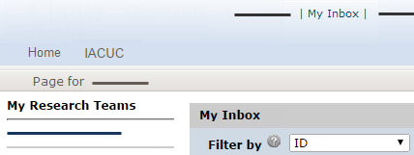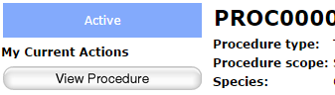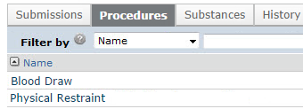  1  3b  2  3a  3 | Check for Building Blocks
- From My Inbox, click your research team on the left.
- In the research team workspace, click the Procedures tab and check for the procedures you need. Do the same for substances (on Substances tab). If missing, see Create Building Blocks.
- If the building block exists, review its details:
  - On the Procedures or Substances tab, click
the item name.
  - In the item’s workspace,
click View Procedure or View Substance.

Create Building Blocks
After you have checked the system for IACUC standard building blocks, create any that are required for your protocols.
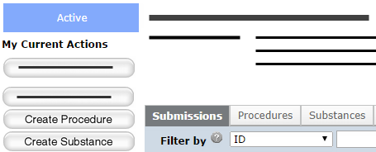  2  3  1 | Create a Substance or Procedure
- From the research team workspace, click Create Substance or Create Procedure.
Note: Create the substances you
will use in your procedures before creating the procedures.
- Complete the pages. If more than one page, click Continue to move to the next page.
- When done, click Finish.
You are taken to the research team’s substance or procedure
workspace page.

Create and Submit a Protocol
Once all the building blocks are set up, you are ready to create your protocol.
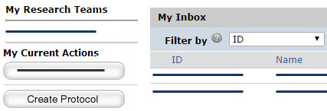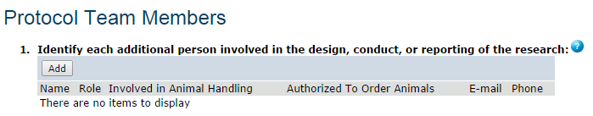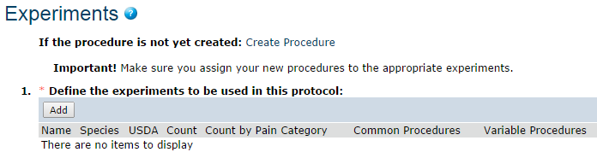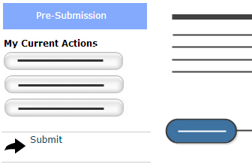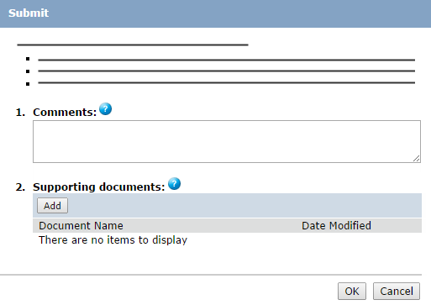  2  4  3a  3b  1  5  6 | Create a Protocol
- From the research team workspace or My Inbox page, click Create Protocol.
- Complete the pages. Click Continue to move to the
next page.
- Pay attention to the
following pages:
  - Protocol Team Members: Add each person who will edit the protocol. Do not add the PI here.
  - Experiments: When you add an experiment, select the procedures that apply to all animals (common procedures) and those that apply to some animals or
are used differently across animals (variable procedures).
- On the final page, click Finish.
You are taken to the protocol workspace page. You can continue to edit the protocol (Edit Protocol button) until you submit it for review.
 | Submit a Protocol for Review
- From the protocol workspace,
click Submit.
- Click OK to agree to the statement and submit the protocol for review.
You can log off the system (top right).

Respond to Reviewer Requests
If a reviewer has questions or requires you to change your submission, you will receive an e-mail indicating this.
Review the request details and then respond to the request.
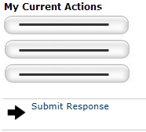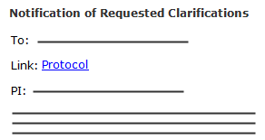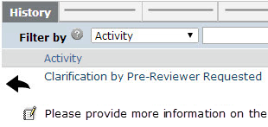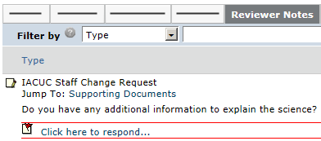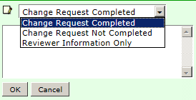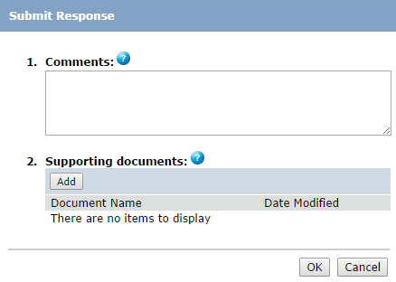  1  8  2  3  4  6  5  9  10  7 |  | Review the Request Details
- Click the e-mail link to open
the submission.
If you no longer have the e-mail,
see Open a Submission and then View History to see reviewer comments.
- On the History tab, find the “Clarification by…Requested” activity and read the comments.
- If the reviewer added reviewer notes, click the Reviewer Notes tab and go to Respond to Reviewer Notes. If not, go to Submit Response.
 |  | Respond to Reviewer Notes
For each reviewer note that requires
a response:
- To edit the protocol in response to the reviewer note, click the Jump To link.
- From the protocol page or the Reviewer Notes tab, click the Click here to respond link.
- Select a response and explain your response in the text box.
- Click OK. If on a protocol page, exit the protocol when done.
Go to Submit Response.
 |  | Submit Response
- On the protocol workspace, click Submit Response.
- In the Comments box, explain your response to the reviewer.
- Click OK.
You can log off the system (top right).

Create and Submit a Follow-On Submission
If you need to make changes to an approved protocol or submit an annual review, follow these steps.
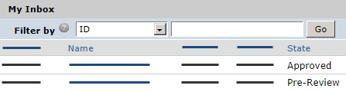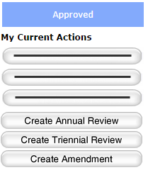  2  1  4  5  7  6  3 | Create a Follow-On Submission
- From My Inbox, click the research team on the left.
- Select the name of the
approved protocol.
- On the left, click the
“Create…” button.
- Complete the pages. Click Continue to move to the
next page.
- When done, click Exit and save changes or Finish on the
final page.
You are taken to the submission’s workspace page. You can continue to edit the submission (“Edit…” button) until you submit it for review.

Submit Follow-On Submission
for Review
- From the follow-on submission’s workspace, click Submit.
- Click OK to agree to the statement and submit it for review.
You can log off the system (top right).

Navigation and Basic Tasks
When you first log in, you will be on the My Inbox page. This topic lists where to find submissions and the basic tasks you will perform.
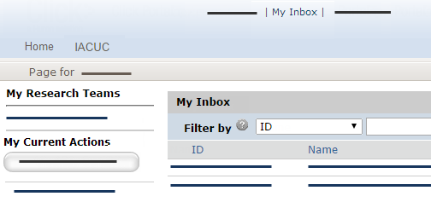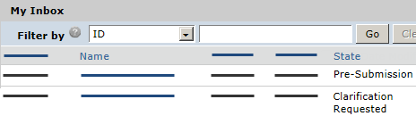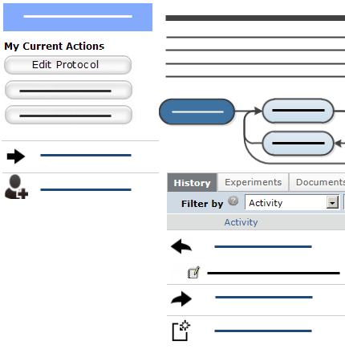  1  2  3  5  4  6  7  8 | Where do I find?
From My Inbox, you can find:
- Submissions that require you to take action.
- Your research teams.
- Actions you can perform such as create a protocol.
 | What do I do?
 | - Review the state of submissions in My Inbox. The state gives a clue as to what to do next. For example, “Pre-Submission” means you haven’t submitted the protocol. You can finish and submit it for review.
 | Open a Submission
- From My Inbox, click the submission name.
- The submission
workspace opens.
 | View History
- From the submission workspace, click the History tab.
- The history lists the activity taken on a submission including any comments, attachments, or correspondence added.

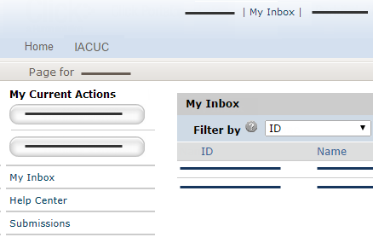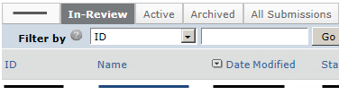  9  10  11  12  13  15  14 | Find Previous Submissions
- On the left, click Submissions.
- Click the appropriate tab to see your submissions:
      - In-Review: All submissions undergoing IACUC review
      - Active: All approved submissions
      - Archived: All discarded and closed submissions
      - All Submissions: All submissions, in any state
To find specific data, see
Filter Data.
 | Filter Data
Many pages contain tables that you can filter to show specific data.
- Select the column to filter by.
- Type the beginning characters for the items you want to find. You can also type a % symbol as a wildcard before the characters. Examples:
      - 71 shows all items
beginning with 71
      - %71 shows all items containing 71
- For operators you can type in the text box, click the Help icon.
- Click Go to apply the filter.
- To combine multiple filter criteria, click Advanced and then click Add Another Row.

© 2014 Huron Technologies Inc. All rights reserved. Use and distribution prohibited except through written agreement with Huron.

Click is a registered service mark of Huron Consulting Group, Inc. All other trademarks, registered trademarks, service marks, and trade names are the property of their respective owners.

Information in this document is subject to change without notice.

Published by Huron Technologies Inc.
1925 NW AmberGlen Pkwy
Suite 400
Beaverton, OR 97006

