Submit Proposal to Sponsor (Non-Grants.Gov)

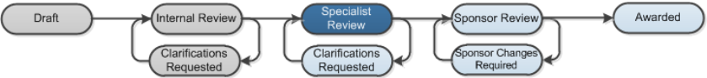

Work Instructions:
- Log into Click Portal.
- From your Inbox, on the SPO Tasks tab, open the proposal in Final SPO Review.
- From the proposal workspace, click the appropriate activity to indicate how the proposal will be sent to the sponsor.
- Submit to Sponsor: Applies if the Sponsored Programs Office will submit the proposal to the sponsor outside of the Grants system. Execute this activity only after the proposal has been submitted to the sponsor. The system sends an email to the proposal team and submitting department that the proposal has been submitted.
- Submit by PI: Applies after the proposal has been fully compiles and vetted by the Sponsored Programs Office. When executed, the system sends an email to the proposal team and submitting department that they are responsible for submitting the proposal to the sponsor.
The proposal moves to the Sponsor Review phase of the review process (proposal’s state is Pending Sponsor Review). The next step is to update the status of the grant when communication is received from the sponsor. If an award letter is received, then an award can be created for the proposal.
Note: Steps for creating an award are covered in other work instructions.

