Create an Award Modification

Work Instructions:
- Log into Click Portal.
- Click the Grants tab at the top and then the All Awards tab.
- Open the active award.
Note: To find an award, you can filter by “State” and then type “Active” in the search criteria box. Click Go. The system returns all awards in the Active state.
- From the award workspace, click the Create Award Modification button.
- Complete the first page, paying attention to the following fields. Click Continue in the Navigation Bar to move through the pages. Required fields are marked with an asterisk (*).
Note: Some fields were auto populated from the award; update any fields as needed.
- 1.0 Name: Update the name assigned by the system so it gives more information about the type of modification, for example, Modification #1 – PI Change.
- 4.0 Select Modification Type: Select the modification type. The system will adjust the SmartForm pages to be completed depending on the modification type.
Note: Steps for creating a revision modification type are covered in other work instructions.
- When finished answering all the required fields on the SmartForm pages, on the Completed Award page (last page), click Finish to be redirected to the award workspace.
The award modification is in the Draft state. The next steps are to approve it, decline and withdraw it from the process, or send it for sponsor approval.

Funding Award
- 9.0 Administrative Contact: Select a department contact that will have access to this award.
- 11.0 and 12.0 Start and End Dates: Update the start and end dates of the award if appropriate.
Award Setup Information
- 1.0 Cumulative Awarded Amount: Enter the total amount awarded by the funding agency for this award.
- 2.0 Funded amount…: Enter the total amount currently awarded.
Terms and Conditions
- Terms and Conditions: Select all the Terms and Conditions that apply.
- Special Terms and Conditions: If there are Terms and Conditions that do not appear in 1.0, click Add to add them manually.
Project Award Budgets
You can set up allocations and reconcile them to budget periods either while you are setting up an award or afterward. Once an award is activated, you will need to create an award modification to make changes to the award.
Note: Steps for creating an award modification are covered in other work instructions.
Click Add, Update, or Remove to adjust allocations to match the sponsor’s actual award allocations. By default, when an award is created, the system creates allocations to match the proposal budget periods.
When you click Add or Update, the Edit Funding Allocation page opens. Complete it and click OK.
  - 1.0 Name: The name defaults to “Award Period #
  - 2.0 Description: This is an optional field for additional information about the award allocation.
  - 8.0 Period Number: The period associated with the funding allocations.
Note: If there is a split in the award funds for a period (e.g., multiple departments splitting funds,) the allocations will be grouped by the period number.
  - 9.0 Indirect Rate: The indirect rate will be used for indirect rate calculations on the reconciliation page.
  - 10.0 Authorized:
- “No” means the amount is a future allocation that must be awarded.
- “Yes” means the sponsor has authorized spending of the allocation. Only allocations with “Yes” will be available to reconcile with a budget period.

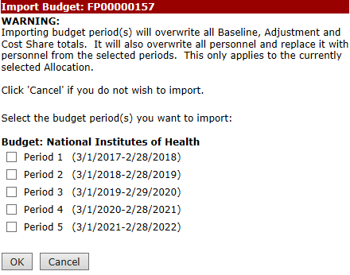
Award/Authorized Budget Reconciliation
C
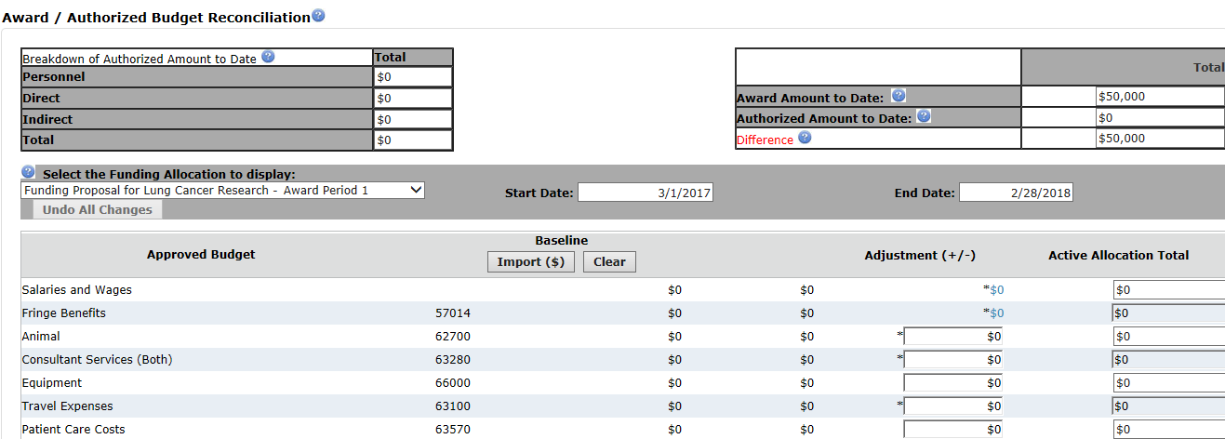
- Select the funding allocation period to reconcile.
A
B
D
E
Note: Only funding authorized allocations will be available for selection.
- Click Import to bring in amounts from the funding proposal budget.
Note: You can manually type costs into the Adjustment column rather than importing them.
- Select the budget period you want to bring in as a starting point for the award period and click OK. The budget categories are updated with amounts from the selected proposal budget period.
- In the Adjustment column, adjust the imported budgeted amounts so the difference between the awarded and authorized amounts, in the top-right corner, equals zero.
- To adjust salaries or fringe benefits, click the blue hyperlink and add, edit, or remove personnel details as needed.
Repeat the above steps to reconcile other budget period amounts to award allocations.

Deliverables
Deliverables are activities or work assignments that must be completed to remain in compliance with the award Terms and Conditions. Deliverables are assigned to owners and appear on the Deliverables tab of the award workspace.
Click Add to create a new deliverable.
- 1.0 Name: Type a name for the deliverable, for example, “Annual Progress Report.”
- 3.0 Set Number of Occurrences and 4.0 Frequency: The occurrences and frequency allow you to create multiple instances of the deliverable at one time. For example, if the number of occurrences is “3” and the frequency is “Annual”, the system will create 3 instances one year apart, starting with the defined due date.
- 6.0 Responsible Party: Select the primary person responsible for completing the deliverable.
- 7.0 Additional Staff…: Add all users who should receive a reminder email 60 and 30 days before the deadline date.
Compliance Information
This page defaults to values from the proposal. No updates are needed to this page during the initial award creation because most, if not all, compliance has been completed on the proposal.

