Create a Revision (Supplement)

Work Instructions:
- Log into Click Portal.
- Click the Grants tab at the top and then the All Awards tab.
- Open the active award.
Note: To find an award, you can filter by “State” and then type “Active” in the search criteria box. Click Go. The system returns all awards in the Active state.
- From the award workspace, click the Create Award Modification button.
- Complete the pages, paying attention to the fields explained below. Click Continue in the Navigation Bar to move through the pages. Required fields are marked with an asterisk (*).
- When finished answering all the required fields on the SmartForm pages, on the Completed Award Modification page (last page), click Finish to be redirected to the award modification workspace.
The award modification is in the Draft state. The next steps are to approve it, decline and withdraw it from the process, or send it for sponsor approval.

Award Modification
- 1.0 Name: Update the name assigned by the system so it gives more information about the type of modification, for example, Modification #1 – Revision.
- 4.0 Select Modification Type: Select Revision | Supplement.

Project Setup Information
- 1.0 Project Commitment
  - Current Total Project Period Commitment: The total amount the sponsor has committed to giving for the whole project (specified in the award letter).
  - Project Commitment Adjustment Amount: Type the amount by which the total project period commitment amount will change. For example, type “$10,000.00” or “-$10,000.00” to increase or decrease the current total by that amount.
- 2.0 Award Amount
  - Current Total Award Amount to Date: The total amount the sponsor has given to date, for example, the sponsor may send installments rather than all the money at once.
  - Award Adjustment Amount: Type the amount by which the total award amount to date will change. For example, type “$10,000.00” or “-$10,000.00” to increase or decrease the current total by that amount.

Project Award Budgets
You can add new funding actions to an existing allocation or add new award allocations.

Add a new funding action (change to an existing award period):
- Click [Add] in the Add Funding Action column for the award period.
- Complete the Add Funding Action window, paying attention to the following field:
  - 2.0 Name: Type a name indicating that the action is a revision to a period, for example, Revision to Period 1.
  - 6.0 Sponsor’s Action Documents: Add any documents not included with the associated funding proposal, for example, the award letter from the sponsor or information about the reallocation of funds
- Click OK when done. The action added will appear in section 2.0 below the award allocations. To update the action, click Update next to the action and make the changes.
- Repeat the steps above to add more funding actions.

Add a new award allocation:
- Click the Add button under Award Allocations.
- Complete the Create or Edit Funding Allocation window, paying attention to the following fields:
  - 1.0 Name: Type a name that indicates if the new allocation is for an existing or new award period, for example, Award Period 1 – Revision.
  - 8.0 Period Number: To tie the new allocation to an existing period, type that period number. Otherwise, type a period number that is one greater than the current period set, for example, if there are currently five periods, then the next period number is 6.
  - 9.0 Authorized:
    - “Yes” means the sponsor has authorized spending of the allocation. Only allocations with “Yes” will be available to reconcile with a budget period.
    - “No” means the amount is a future allocation that must be awarded.
- Click OK when done. The allocation will appear as a row in the Award Allocations area.
- Repeat the steps above to add more award allocations.

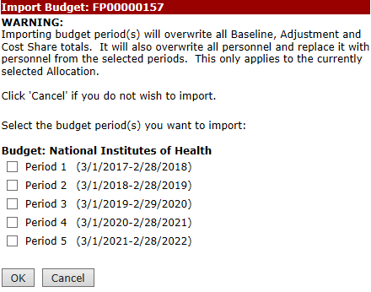
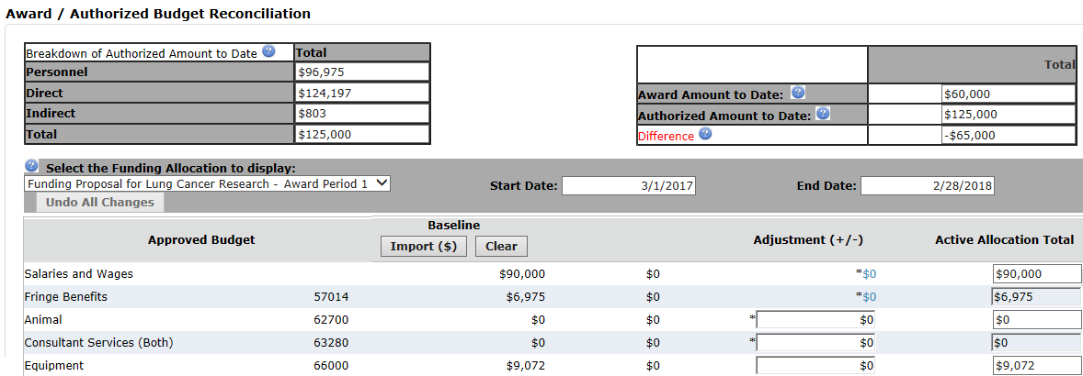
Award/Authorized Budget Reconciliation
C
A
B
D
E
- Select the allocation to reconcile. The list shows the authorized new and updated allocations (entered on the previous page).
- For new award allocations, you can import an approved budget that you can adjust. For a revision to an existing award period, import the budget for that award period.
- For an existing award allocation that you are updating, the system automatically brings in the amounts for that award period.
- To import an approved budget (new award allocation), click Import to bring in the budget amounts.
- Select the budget period and click OK. The budget categories are updated with amounts from the selected proposal budget period.
- In the Adjustment column, adjust the imported budgeted amounts so the difference between the awarded and authorized amounts, in the top-right corner, equals zero.
- To adjust salaries or fringe benefits, click the blue hyperlink and add, edit, or remove personnel details as needed.
Repeat the above steps to reconcile other budget period amounts to award allocations.

