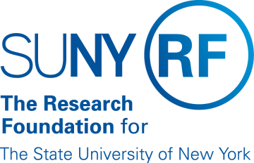
Research Foundation for SUNY
Test Plans for SUNY PACS Grants

Test Description: | 12. Specialist submits proposal to sponsor and notifies team
Tester Location:
Test Executed By:
Tester Email Address:

Test 12: Specialist submits proposal to sponsor and notifies team

Step | Test Steps | Test Data | Expected Results | Notes
1 | Open browser and navigate to https://pacsstg3.rfsuny.org/SponsoredPrograms/login |  | - The SUNY PACS website login page is presented.
2 | Log in grantsspecialist  (Test accounts have been provided) |  | - Log in is successful  - Inbox displays
3 | Click on Grants (tab on the Top), Prerequisite is to have a proposal in the state of Specialist Review: The proposal has already gone thru Department Review and approval. Click on the proposal name to Open the proposal up. | Use the proposal from Test 11 | - The proposal page will display  - Status is Specialist Review | NOTE: Save and Continue along the way as you proceed thru the below steps
4 | On the left hand side click on Edit Funding Proposal |  | - The Proposal details are now available for review.
5 | Specialist Final Review  On the left hand side select Final Review  Add any comments necessary.  Click OK | Enter comment, Specialist Final Review Completed. | - Final review form displays
6 | Specialist submits proposal to sponsor  On the left had side of the screen select Submit to Sponsor  Attach sponsor documents (Optional), Click add  Check the box I confirm that the included document has been read and signed  Click OK | Use attachment 14 | - Proposal is now in the state of Pending sponsor review
7 | Notify Team  On the left hand side click on Email Proposal Team Add comments to indicate the proposal has been submitted to the sponsor  Click OK | Proposal has been submitted to the sponsor, | - Email sent to proposal team
End of Test

