Research Foundation for SUNY
Test Plans for SUNY PACS Grants

Test Description: | 13. Test Ability for Specialist to Award Proposal and Create Funding Award
Tester Location:
Test Executed By:
Tester Email Address:

Test 13: Specialist Awards Proposal and Creates Funding Award

Step | Test Steps | Test Data | Expected Results | Notes
1 | Open browser and navigate to https://pacsstg3.rfsuny.org/SponsoredPrograms/login |  | - The SUNY PACS website login page is presented.
2 | Log in as grantsspecialist  (Test accounts have been provided) |  | - Log in is successful  - Inbox displays
3 | Click on Grants (tab on the Top), In the users Grants In Box user will see the Proposal with the state of Pending Sponsor Review. Click on the proposal name to Open the proposal up. | Use the proposal from Test 12 | - The proposal page will display  - Status is Pending Sponsor Review | NOTE: Save and Continue along the way as you proceed thru the below steps  PreReq – Proposal exists in the state Pending Sponsor Review.
4 | Award Letter Received  On the left hand side click on Award Letter Received  Enter Sponsor Award ID  Actual Date of Sponsor Decision, click on Calendar  Total Award Amount.  Add any comments or Notes (Optional)  Click Add, Attach any sponsor award documents  Click OK | 999999  Click on current date.  Enter same as proposal grand total.  Enter: Sponsor approved budget as submitted amount.  Attachment 15 | - The Award Letter received form displays  - Current state is Now Award Notification Received
5 | Create Funding Award  Click on Create Funding Award on the left.  On the Funding Award form fill out the below fields;  1.0 Award Title –defaults from Proposal but can be modified  2.0 Principal Investigator - defaults from Proposal but can be modified  3.0 Award Type  4.0 Select Instrument Type - defaults from Proposal but can be modified  5.0 Award Structure - defaults from Proposal but can be modified  6.0 Sponsor Award ID –Defaults from the Award letter received form  7.0 Direct Sponsor - defaults from Proposal but can be modified  8.0 Sponsor Award Date - defaults from Proposal but can be modified  9.0 Approving Dept. and Admin Contact - defaults from Proposal but can be modified  10.0 Date Notified of Award – Optionally Complete date  11.0 Start Date - defaults from Proposal but can be modified  12.0 End Date - defaults from Proposal but can be modified  13.0 Award Documents – Optionally add any award documents | All information defaults from the proposal for questions 1.0 – 9.0.  11.0-12.0.  Change this information only if different in award notice.  10.0 Enter date notified of award.  Click add, upload attachment 15 | - The Funding Award form will display  - Data is updated | Note: Some fields were auto populated from the proposal; you can update any fields as needed.
6 | Award Setup Information  Complete the below fields as needed;  1.0 Cumulative Awarded Amount –defaults from Award Notification but can be modified  2.0 Funded Amount to Date - defaults from Award Notification but can be modified  3.0 Indirect Cost Rate – Enter the rate from the Award Notification letter.  4.0 Salary Cap - defaults to $0 but can be modified  5.0 Does this Award include cost sharing – select yes or No | Enter No | - The Award Setup Information form is displayed  - Data is updated
7 | Award Funding Proposals  1.0 Proposals Funded by this Award –defaults from Award Notification. |  | - The Award Funding Proposals form is displayed
8 | Terms and Conditions  Optionally select any that apply  - Terms and Conditions –Select any that apply  - Special Terms and Conditions –Click Add, Another form to allow for Free form text to be added (Optional). |  | - The Terms and Conditions form is displayed  - Data is updated
9 | Project Award Budgets  Click either Add, Update or Remove existing Budget Periods. (Optional)  Click on UPDATE to open the Edit Funding Allocation Form |  | - The Edit Funding Allocations form displays | Note: You can set up allocations and reconcile them to budget periods either while you are setting up an award or afterward. Once an award is activated, you must create an award modification to change the award.
10 | Edit Funding Allocations  Click on Update for each award period.  On the Edit Funding Allocations form fill out the below fields;  1.0 Name –Award Period # -defaults from Proposal but can be modified  2.0 Description – This is an optional field for additional information about the award allocation.  3.0 Associated Funding Proposal – Defaults from proposal  4.0 Account - NOT USED BY RF  5.0 Start Date - defaults from Proposal but can be modified  6.0 End Date –Defaults from the Award letter received form  7.0 Sponsor award ID - defaults from Award letter received but can be modified  8.0 Period Number - defaults to 1 and then sequential for next period  9.0 Indirect Rate: The indirect rate will be used for indirect rate calculations on the reconciliation page.  10.0 Authorized – Select Yes for Year 1 and No for the rest.  Enter the awarded direct and Indirect amounts for the period.  Click Continue. | Use defaults.  Year 1 Select  Yes  Subsequent years Select No | - Data excepted | Note: If there is a split in the award funds for a period, for example, multiple departments splitting the funds, the allocations will be grouped by the period number.  Note: Yes” means the sponsor has authorized spending of the allocation. Only allocations with “Yes” will be available to reconcile with a budget period.  “No” means the amount is a future allocation that must be awarded.
11 | Award/Authorized Budget Reconciliation  Import the Funding Allocation Budgets for each period Created.  In the LOV Select the Funding Allocation to display select an award period. (The drop-down shows only allocations you’ve authorized in the edit funding allocation form.)  This will now display an additional budget form. Select IMPORT in the middle of the screen. Check the Periods to import.  In the Adjustment column, adjust the imported budgeted amounts so the difference between the awarded and authorized amounts, equals zero in the top-right corner.  Repeat the above steps to reconcile other budget period amounts to award allocations  Click OK and SAVE |  | - Budget form is now loaded and reconciled.
12 | Deliverables  Not used at the RF | Skip | - Skip this form
13 | Compliance Review  Optionally enter any compliance restrictions or select yes or no on Question 1.0 |  | - Data updated as needed
14 | Completed Award  In the toolbar, select "Hide / Show Errors" to validate that the form is complete. Update any errors or incomplete sections.  If no errors are found select Finish to complete the award setup. |  | - Award process is complete and user is returned to the main Award page.
15 | Activate the Award  On the left hand side click on ACTIVATE  Click OK |  | - Award state is now Active  - Click the Grants tab on the Tool bar to return to main Grants folder.
16 | Create the Subaward and Activate  On the award you just activated  click on the Subaward Tab.  On the left under My Current Actions, click the Create Subaward button  Complete Question 2, 5, 5, and 6 and click continue  Completed subaward personnel question 1 and 2 and click continue  Subaward Terms and Conditions leave blank and complete continue  Subaward documents leave blank and click contine  Subaward deliverables leave blank and click continue  Completed subaward and click finish  You are returned to the main subaward screen and under my current actions click the activate button. |  | 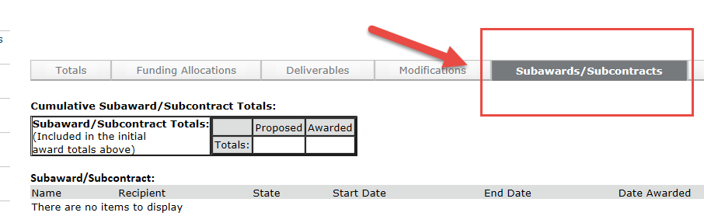  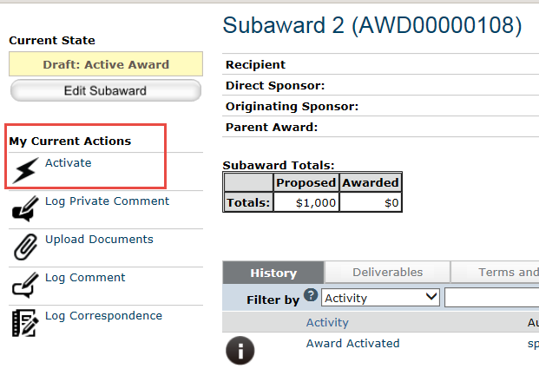
End of Test

