Research Foundation for SUNY
Test Plans for SUNY PACS Grants

Test Description: | 2. Test and validate to ensure that the PI are able to create a new budget without issues.
Tester Location:
Test Executed By:
Tester Email Address:

Test 2: Create Budget

Step | Test Steps | Data to Enter | Expected Results | Notes
1 | Open browser and paste in https://pacsstg3.rfsuny.org/SponsoredPrograms/login |  | - The SUNY PACS website login page is presented.
2 | Log in as PIgrants1  (Test accounts have been provided) |  | - Log in is successful  - Inbox displays
3 | Click the Grants tab at the top and then find the proposal you created in test plan 1 and click on the name | 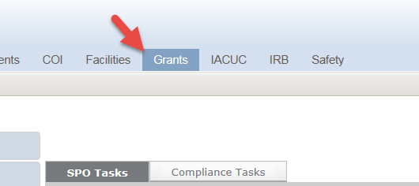 | - List of proposal display
4 | Click the Budgets Tab, next click the Funding Source Name on Working Budgets page for the Proposal you are adding a budget too. | 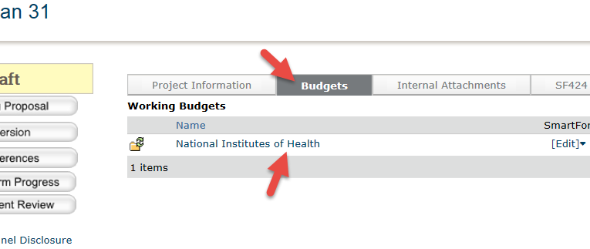 | - The Draft Budget page is displayed. | Note: The system automatically created a draft blank budget from the proposal
5 | Click Grid: Inflation and Indirect Rates on the left of the workspace to review the inflation and indirect rates. To change indirect rates if necessary and/or verify the rate you want for the proposal:  - The default cost base type and rate is based upon the proposal. To see the other cost base types available, click the down-arrow.  - To change the indirect cost rates, click in the rate field and type a new value.  - To copy a rate to subsequent periods, click the blue arrow to the right of the value. (since you have only one year you will not see this)  Click Apply and OK to save the changes and return to the budget workspace. | For testing purposes no changes needed, just verify the rate and base  Since one year budget you will not see this. | - Grid: Inflation and Indirect Rates are either verified or updated.
6 | Click the Edit Budget Button on the left. | 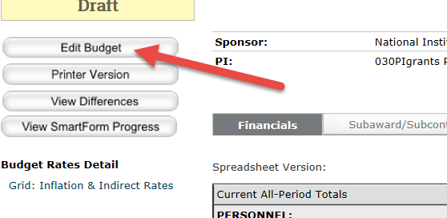 | - The General Budget Information page is presented.
7 | General Budget Information Page:  - Questions 1.0, 2.0  - Question 3.0 Budget Type: Select Project. (A program project cannot be sent to Grants.Gov.)  - Question 4.0 Is Modular Budget? Select “No”.  - Question 5 Sponsor Budget Detail Level: Select Full Details (A detailed budget is required for proposals submitted via Grants.Gov.)  Verify the information is correct. Click Save & Continue. | These fields auto populate.  ‘Project’  ‘No’  Full Details | - The General Budget Information is saved and the Budget Characteristics page is now displayed. | Note: Most of the fields on this page are auto populated from the proposal. In general, the principal investigator, funding source, and project sponsor should not require updates here; change them in the funding proposal, if needed.
8 | Budget Characteristics Page:  - Question 1.0 * Will this budget pay for participant/trainee costs? (Leave as no.)  - Question 2.0 Will this this Subaward/Subcontract research to another institution?  (You must enter ‘Yes’)  - Question 3.0 Will this budget have Cost Sharing? Answer No as cost sharing will be covered in another test.  Click Save and Continue. | ‘No’  ‘Yes’  ‘No’ | The Budget Characteristics are now saved and the Personnel Costs page is now displayed. | Note: By selecting ‘Yes’, the system will add a page for you to enter the subaward/subcontract organizations. The system will also create a subaward/subcontract budget for each organization that you must complete. Steps for completing subaward/subcontract budgets are covered in another test plan.
9 | Personnel Costs:,  - Enter the Salary Cap as defined in the application based on the sponsor.  - Salary Inflation Rate will default, change if necessary.  - Apply Infl. Per. 1: If this should be applied to Period 1, check the box. | 185,000
10 | Personnel Costs Grid:  - To add personnel to the grid: In the first column, click the “add row” down arrow, select the number of personnel rows to add, and then click the Add button.  - For each personnel row: Complete all the fields listed in the first column:  - Person: Select the Person from the list of values by clicking the down arrow to display the list of values.  - Appt: Select Appt: (Appointment Period) by clicking the down arrow to display the list of values.  - Role: Select the Role by clicking the down arrow to display the list of values.  - Key: Check the box if this person is a Key.  - F & A Type: will default.  - Apply Inflation Rate: Check the box to Apply Inflation Rate if applicable.  - Base Salary ( if inflation applied): Enter the Base Salary  - Fringe Category: Chose the Fringe Category from the list of values by clicking the down arrow to display the list of values.  In the Period Column Enter:  - Effort: Enter the Percentage of Effort  - SalReq: Salary Requested percentage.  - Base: enter the Base salary  - Req: Enter the salary amount requested.  - FB Rate: The fringe benefit rate will default.  - Click Save. | Chose the PI you are logged in as.  9 month  PI  This will default  This will default  Base Salary PI: 100,000  SUNY-IFR  20%  20%  102,000  20,400 | The Personnel Costs Grid information has now been saved. Go to Step 11 to Add additional people (for this test) or Click Continue and the General Costs Grid will be displayed and go to Step 12. | Note: The system auto populates each period’s FB rate based on the fringe category selected (based upon only entering one year you will only have one column)
11 | Add an additional row for CO-PD/PI and TBD to the budget repeating step 10 for each person. Click Save and Continue. | CO-PD/PI  Effort: 10%  Base: 102,00  SalReq: 10,200  TBD  Effort: 100% SalReq: 100%  Base: 20,000  Req: 20,000 | - The Personnel Costs Grid information has now been saved and the General Costs Information will be displayed.
12 | General Costs  Inf Rate: Lists the default inflation rate.  Apply Infl. Per. 1: Check if applying inflation rate to period 1, for the purpose of this test, leave the box unchecked.  General Costs Grid:  - To add a cost item to the grid: In the first column, click the “add row” down arrow, select the number of rows to add, and then click the Add button.  - For each row: Complete all the fields listed in the first column, for example, select the cost type, type a description, type the unit cost, etc. | Cost Type: Materials & Supplies  Desc: Lab Supplies  Unit Cost: 1.00 and number of units 10,000  Cost Type: Travel- Domestic  Desc: Travel in US.  Unit Cost: 1.00  # Units: 2500 | Click Continue and the Subaward-Subcontractor Sites page will now display.
13 | Subaward-Subcontractor Sites –  Question 1  - Click Add , Add Subcontractor form displays  - Name: Leave Blank for this test  - Organization: Type Cornell on the Organization line, Click Select, List of values displays, Chose Cornel University, Click Ok  - Question 2, leave blank.  - Click continue | Cornell University | - Note you have added the name of the subaward/subcontractor.
14 | SF424 Subaward Import  - Question 1, Ignore  - Question 2, Select Browse and select the document called ‘RR_Budget_1_3_A30-V1 3’.  - Click continue | Attachment: RR_Budget_1_3_A30-V13. | - Subaward pdf form is attached and imported. | Note: For testing, we are providing the budget attachment.
15 | On the Attachments for Internal Purposes screen (optional) Click Save and Finish. | Don’t load any attachments. | - You will be returned to the Financials Screen.
16 | Click the Subaward/Subcontract Tab, Click the Subaward/Subcontract Name, click Edit Budget |  | - The Subaward/Subcontract Budget Information will now display.
17 | - Questions 1.0 Defaults in information.  - Question 2, Defaults in information.  - Question 3.0 Budget Type, Select "Subaward”.  - Question 4,Leave PI default.  - Question 5.0 leave as 0.  - Question 6, select “PDF Import”,  - Click Continue. | Subaward  PDF Import | - The Subaward/Subcontract Information is now saved. | Note: Select PDF Import for all Grants.Gov submissions.
18 | Attachments for internal Purposes | Leave Blank and click continue | - Optional for additional attachments
19 | You will be returned a financial screen showing the direct cost total for the subaward you imported for year 1 only |  | - Shows the total imported
 | End of Test

