Research Foundation for SUNY
Test Plans for SUNY PACS Grants

Test Description: | 14. Test the ability to Create a Revision (Supplement)
Tester Location:
Test Executed By:
Tester Email Address:

Test 14: Create a Revision (Supplement) Funding Proposal

Step | Test Steps | Test Data | Expected Results | Notes
1 | Open browser and navigate to https://pacsstg3.rfsuny.org/SponsoredPrograms/login |  | - The SUNY PACS website login page is presented.
2 | Log in as Grantsspecialist  (Test accounts have been provided) |  | - Log in is successful  - Inbox displays | NOTE: Save and Continue along the way as you proceed thru the below steps
3 | Click on Grants (tab on the Top), Click on the All Awards tab. Prerequisite: Find an Award that is in a state of Active.  Click on the Award Name and Open up the Award | Use the Award from Test 13 |  | Note: To find an award, you can filter by “State” and then type “Active” in the search criteria box. Click Go. The system returns all awards in the Active state.
4 | Click on the Create Award Modification Button.on the left hand side of the screen.  Award Modification (Revision)  Q 1.0 Name – Update the name assigned by the system so it gives more information about the type of modification. (Optional)  Q 2.0 Description – Enter a description of what is being changed  Q 3.0 Sponsors Modification ID – Defaults but can be changed  Q 4.0 Modification Type – Select type of modification  Q 5.0 Will this Modification affect any subaward/subcontract? Select Yes or No  Click Continue | Enter Revision #1  Revision  Select Revision | Supplement  Select No | - Award Modification form displays to create medication type of Revision/Supplement or Revision/Supplement with Extension
5 | Project Setup Information  - 1.0 Project Commitment  - Current Total Project Period Commitment: The total amount the sponsor has committed to giving for the whole project (specified in the award letter). Defaults  - Project Commitment Adjustment Amount: Type the amount by which the total project period commitment amount will change. For example, type “$10,000.00” or “-$10,000.00” to increase or decrease the current total by that amount.  - 2.0 Award Amount  - Current Total Award Amount to Date: The total amount the sponsor has given to date, for example, the sponsor may send installments rather than all the money at once.  - Award Adjustment Amount: Type the amount by which the total award amount to date will change. For example, type “$10,000.00” or “-$10,000.00” to increase or decrease the current total by that amount.  - 3.0 Current Indirect Rate (%): Defaults  - Indirect Rate (%) , Enter Rate  Required.  - 4.0 Current Salary Cap: $ Defaults  - Salary Cap: Enter Salary Cap  - 5.0 Default Financial Account for Authorizations  Leave blank not used at the RF  Click Continue | Defaults in  Enter 10,000.00  Defaults in  Enter 10,000.00  Leave default  Leave default  Skip | - Data is updated
6 | Award Modification Funding Proposals Screen  - 1.0 Award Funding Proposal:  Name-Defaults  New Awarded Funding Proposals:  Click to add and new award funding proposal if applicable.  Click Continue | Leave blank
7 | Project Award Budgets  You can add new funding actions to an existing allocation or add new award allocations.  Q1 Award Allocations to add to existing period:  - Click the Add button under Award Funding Allocations to increase the existing. | Skip | 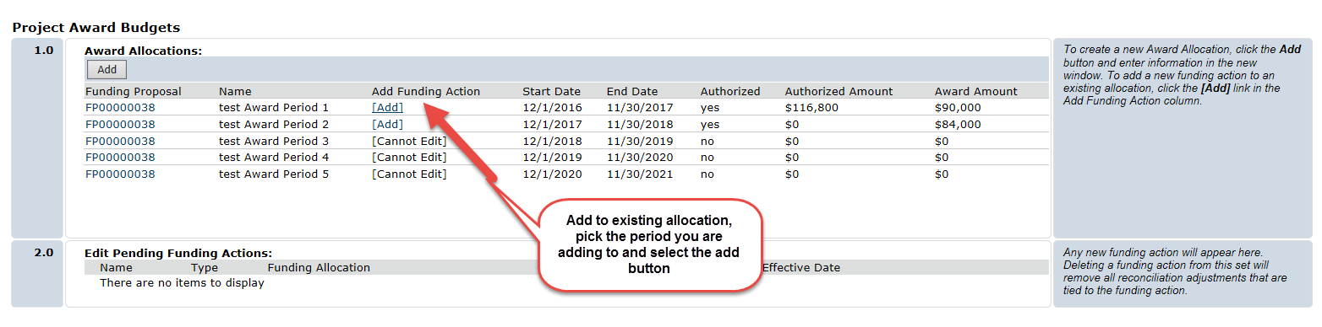
8 | Complete the Edit Funding Allocation window, paying attention to the following fields:  - Q2.0 Funding Action Type: defaults in  - Q2.0 Name: Type a name that indicates if the new allocation is for an existing or new award period, for example, Award Period 1 – Revision.  - Q3.0 Description (Optional)  - Q4.0 Funding Allocation to be adjusted: defaults in from the period you selected.  Q5.0 Award Issue Date:  Click on Calendar to add a date. Use 4/30/2017  - Q6.0 Sponsor’s Action Documents (Optional) leave blank  Click OK |  | 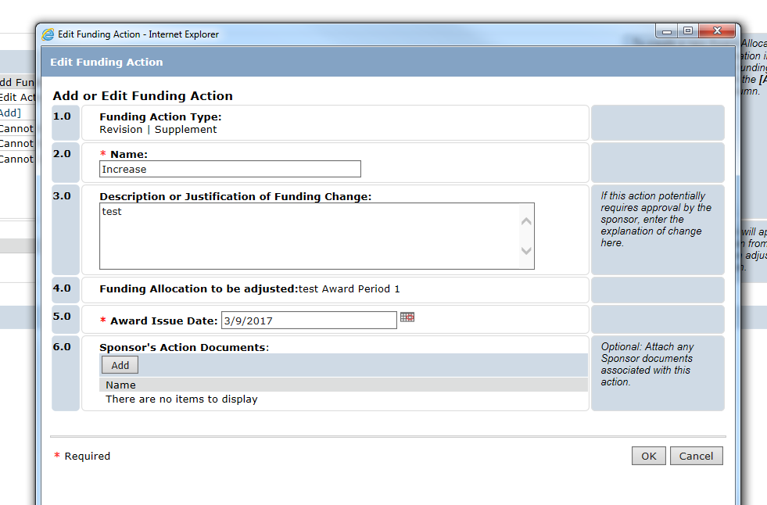
Award / Authorized Budget Reconciliation

9 | Award/Authorized Budget Reconciliation  - Select the funding allocation to display by selecting the period we are adjusting and the budget will default in.  - In the Adjustment column, adjust the imported budgeted amounts so the difference between the awarded and authorized amounts, in the top-right corner, equals zero.  - To adjust salaries or fringe benefits, click the blue hyperlink and add, edit, or remove personnel details as needed.  Repeat the above steps to reconcile other budget period amounts to award allocations if necessary. SKIP  Click Continue | Adjust and otps category like supplies | 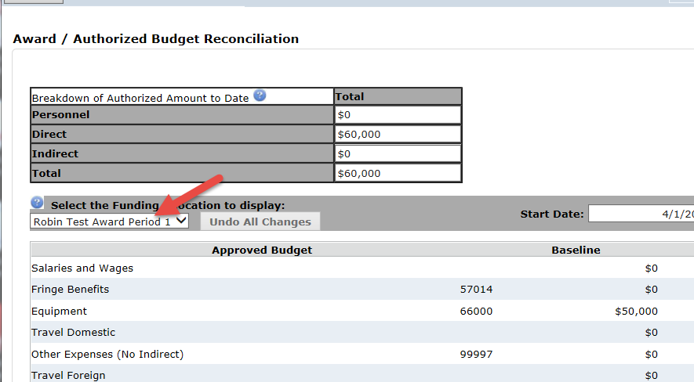  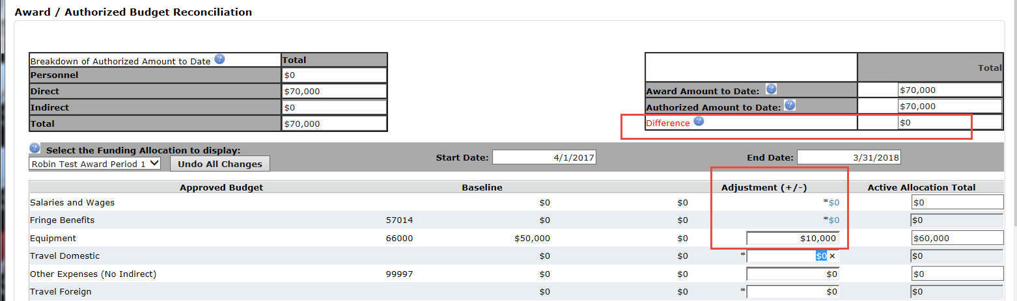
10 | Completed Award Modification  Click Hide/show errors to validate the completion of the form.  Fix each error. Click Refresh if fixing an error. If NO errors click Finish |  | - Information is now saved and No errors exist on the form and the Award Modification page will now be displayed  - The Revision will be in a draft state.
11 | On the left hand side click Sent for Sponsor Approval (if you need to wait for a response), otherwise skip to step 13.  Send for Sponsor Approval Window opens,  Add any comments and attachments. (Optional) | Skip this step for testing. | - Award Modification in in the Sent for Sponsor Approval State if this step performed
12 | On the left hand side click APPROVE.  The Approve Modification Window opens,  Add any comments and attachments (sponsor approval) Optional  Click OK |  | - Award Modification in in the Approved State if this step performed.
End of Test

Now back at the award screen if you view funding allocation you will see it.
