Complete Credit Distribution

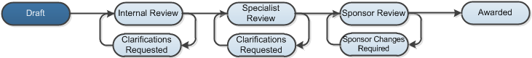

Work Instructions:
- Log into Click Portal.
- From your Inbox, on the SPO Tasks tab, open the proposal whose credit distribution you will complete.
- On the left of the proposal workspace, click Credit Distribution.
- In the Department/Center/Institute column:
- Click Add to add the key person’s departments that will be involved in the internal proposal review process.
- Click Select and then select the department name from the list. Click OK.
Note: You can also start typing the department name in the box and the system will return a list of all departments that meet the criteria. Select the department from the list.
Repeat the steps above to add another department.
- In the Proposal Credit column, type the percentage that represents the person’s contribution to the proposal. The total percentage across key people must total 100%. For example, if there is only one key person, the proposal credit will be 100%. If there are two key people, the total credit could be 75% for one person and 25% for the other.
Note: Validation doesn’t occur until the proposal is submitted for review. Therefore, check that the proposal credit total is 100% before leaving this page.
- In the Financial Credit column, type the percentage of the person’s budget that will be distributed to each department. For example, a PI may distribute 50% of their budget to one department and 50% to the other.
- In the Recognition Credit column, type the percentage of recognition that each department will receive for the person’s intellectual property (ideas, plans, etc.). For example, one department may receive 75% recognition for intellectual property and the other, 25%.
- Click OK to save the information and return to the proposal workspace.
Note: Clicking Apply saves the information, but does not exit the page.
Your proposal is still in the Draft state. The next step is to complete the budgets.
While the proposal is in the draft state, you can perform the following activities from the proposal workspace:
- Continue to update your proposal by clicking Edit Funding Proposal.
- Withdraw your proposal before you have submitted it for review by clicking Withdraw Proposal (Prior to submission to sponsor).
- Email the proposal team or specialist regarding your proposal by clicking Email Proposal Team or Email Specialist.

