April 2018
Discloser
Reference Guide
COI

Page left intentionally blank

Click COI – Discloser Quick Reference
Contents
Navigation and Basic Tasks 4
Where Do I Find? 4
What Do I Do? 4
Open a Certification 4
View Certification History 4
Find Previous Certifications 5
Before You Start 5
Submit an Annual Certification for Review 6
Start the Certification 6
Update Disclosures 6
Finish and Submit 6
Respond to Clarification or Change Requests 7
Review the Request Details 7
Respond to the Request 7
Respond to a Management Plan 8
Review the Management Plan 8
Submit Your Response 8
Update Your Certification 9
Update Your Certification 9

Page left intentionally blank

Navigation and Basic Tasks
When you first log in, you will be on the My Inbox page.
This topic lists where to find certifications and the basic tasks you will perform.
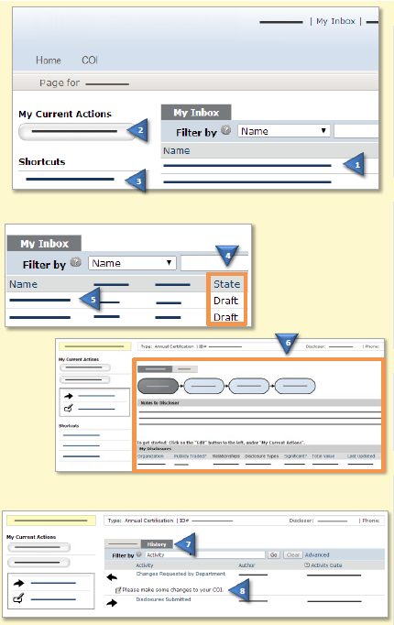 | Where Do I Find?
From My Inbox, you can find:

- Certifications that require you to take action.
- Actions that you can perform (e.g., Create or Update a Certification).
- Shortcuts that provide access to other items such as your disclosures or reports.
 | What Do I Do?
 | - Review the State of certifications in My Inbox. The state provides a clue as to what to do next. For example, Draft means you haven’t submitted the certification for review.
 | Open a Certification
- From My Inbox, click the certification’s Name.
- The certification’s Workspace will open.
 | View Certification History
- From the certification Workspace, click the History tab.
- The History lists the activity taken on a certification including any comments, attachments, or correspondence added.

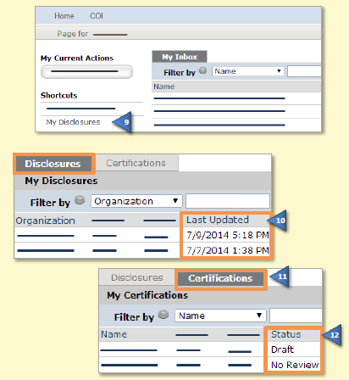 | Find Previous Certifications
- On the left, click Certifications.
- The Disclosures tab shows details for each disclosure, including when it was last updated.
- Click the Certifications tab.
- Sort or filter by Status to find certifications that have completed the review process.

Before You Start
Before you submit a certification, gather the following information. This will help you complete the forms.
- Any consulting agreements you have signed this year
- Receipts from travel paid by outside companies
- Any stock option agreements
- Your stock portfolio summary
- Your IRS 1040 and/or 1099 forms

Submit an Annual Certification for Review
You will receive an email to submit your certification. See Before You Start before performing the steps below.
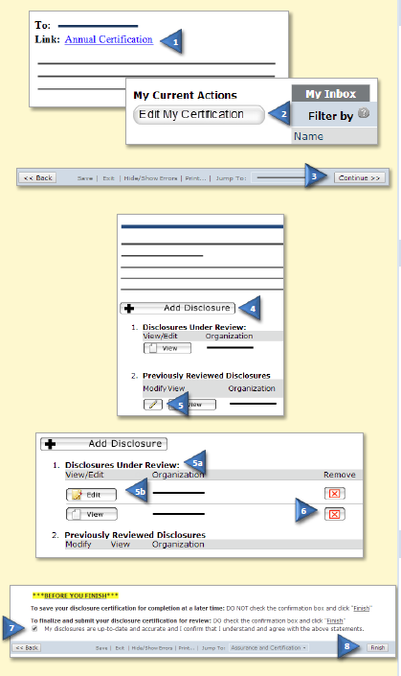 | Start the Certification
- Click the e-mail link to open the certification.
- If you no longer have the e-mail, from My Inbox, click Edit My Certification on the left.
- Complete the pages. Click Continue to move to the next page.

Note: If you have submitted a certification before, the forms will show your previous answers. Update them appropriately.
 | Update Disclosures
Depending on your answers, the Disclosure Details page may appear.

- To add a disclosure, click Add Disclosure. Complete the pages and click Finish on the last page.

- To edit a previously reviewed disclosure, click the pencil.
  - The disclosure moves under Disclosures Under Review.
  - Click Edit. Update the pages and then click Finish on the last page.
- To remove a disclosure, click the red X. Select Yes and click OK.
 | Finish and Submit
- On the last page, select the check box to submit the certification.

Note: To submit later, leave the check box blank. Use the Submit action on the certification workspace to submit.

Respond to Clarification or Change Requests
If a reviewer has questions or requires you to change your certification, you will receive an email notification alerting you.
Review the request details and then respond to the request.
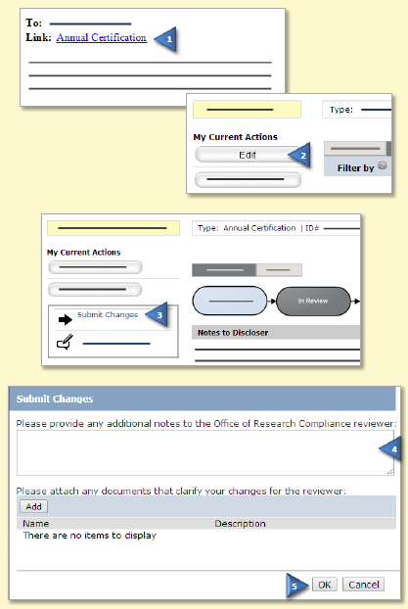 | Review the Request Details
- Read the email for details about the clarification or change request. Click the link within the email notification to open the submission.
If you no longer have the email, see Open a Certification and then View Certification History to see reviewer comments.
 | Respond to the Request
- To update the certification, click Edit on the left and make the requested changes. Otherwise got to the next step. You will be able to enter a response to the reviewer before submitting.
- Click Submit Changes.
- (Optional) In the Notes box, type your response to the reviewer.
- Click OK.

Respond to a Management Plan
As a result of reviewing your certification, the COI office may issue you a plan to manage your conflicts of interest.
Review the management plan and then submit your response to the plan.
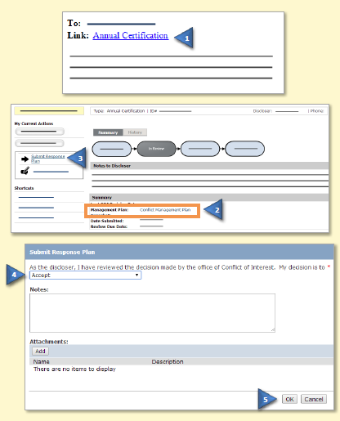 | Review the Management Plan
- Click the certification link in the e-mail.

If you no longer have the e-mail, see Open a Certification and then View Certification History. Review the correspondence letter.

- On the Disclosures workspace, click the management plan link to open the management plan and then review it.
 | Submit Your Response
- Click Submit Response Plan.
- Select Accept to accept the management plan.

If you have questions about the management plan, select Request Further Clarification and type your questions in the Notes box. The certification will move back to the COI administrator’s inbox to review.
- Click OK. You can logoff the system.

Update Your Certification
As a result of reviewing your certification, the COI office may issue you a plan to manage your conflicts of interest.
Review the management plan and then submit your response to the plan.

Update Your Certification
- From My Inbox, click Create My Certification.
- Type the reason for the update and then click OK.
- In the certification workspace, click Edit.
- Update the certification.

Tip: Click the Jump To: menu to go to the page you want to update.
See Update Disclosures to add, edit, or delete disclosure details.
- On the last certification page, select the check box to submit the updated certification.
- Click Finish. You can log off the system.

