Administrator
Reference Guide
April 2018
COI

Page left intentionally blank

Click COI – Administrator Quick Reference
Contents
Navigation and Basic Tasks 4
Where Do I Find? 4
What Do I Do? 4
Create a Certification for a Discloser to Complete 4
Open a Certification 4
View Certification History 5
Run a Report 5
Filter Data 5
Workflow States and Transitions 6
Actions and State Transitions 7
User Roles 10
Review the Certification 11
Review Certification Details 11
View Changes Between Disclosure Versions 11
Record and Complete Your Review 12
Record an Administrative Review 12
Complete the Review 12
Record Committee Decisions 13
Find the Certification 13
Record the Committee’s Decision 13
Create or Upload a Management or Mitigation Plan 14
Create or Upload a Plan 14
Prepare and Send Correspondence 14
Prepare Correspondence 14
Send Correspondence 14
Monitor Management Plans 15
Reassign a Plan Monitor 15
View Monitor Report Details 15
Indicate a Plan is Satisfied 15

Navigation and Basic Tasks
When you first log in, you will be on the My Inbox page.
This topic lists where to find certifications and the basic tasks you will perform.
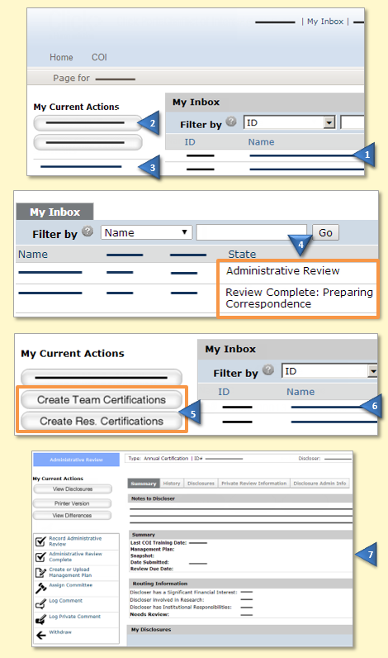 | Where Do I Find?
From My Inbox, you can find:
- Certifications that require you to take action.
- Actions you can perform, such as creating an annual certification for someone to complete.
- Shortcuts to other items, such as reports or documentation.
 | What Do I Do?
 | - Review the state of the certifications. The state tells you where the certification is in the review process and provides a clue as to what to do next. For example, a status of Administrative Review means that you need to review the certification.
 | Create a Certification for a Discloser to Complete
 | - From My Inbox, click the appropriate Create… button to create either a team member or research-initiated certification.
 | Open a Certification
- From My Inbox, click the certification’s Name.
- The certification Workspace appears.

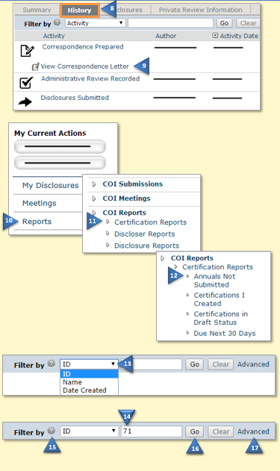 | View Certification History
- From the certification Workspace, click the History tab.
- The History lists the activity taken and any comments, attachments, or correspondence added.
 | Run a Report
- From My Inbox, click Reports.
- Under COI Reports, click the Reports link.
- Click the report name.
The data shows in a table. To find specific data, see Filter Data.
Tip: To export data for use in another application, such as Excel, click Export in the top right corner of the table.
 | Filter Data
Many pages contain tables that you can filter to show specific data.
- Select the column to Filter by.
- Type the beginning characters for the items you want to find. You can also type a % symbol as a wildcard before the characters. For example:
- 71 shows all items beginning with 71
- %71 shows all items containing 71
- For a list of operators that you can type in the text box, click the Help icon.
- Click the Go button to apply the filter.
- To combine multiple filter criteria, click Advanced and then click Add Another Row.

Workflow States and Transitions
The diagrams below show three basic workflows a certification may go through, each resulting in a different review determination—No Issues, Management or Mitigation Plan Required, or Changes Required. The table on the following page lists all activities roles can perform in each state and the activities that cause state changes (). See User Roles for a description of each role.
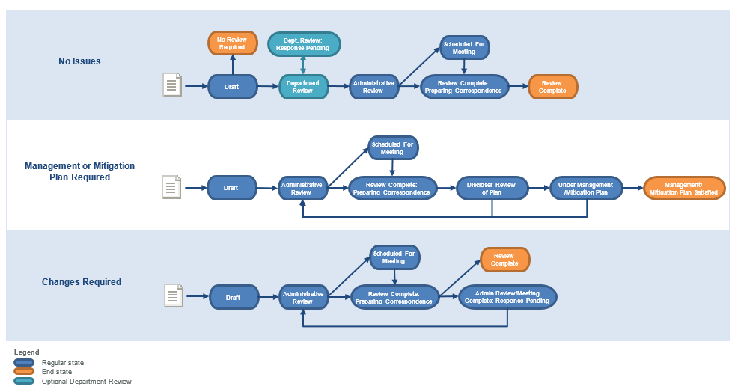

Actions and State Transitions
In this state… | These roles… | Can perform these actions… | Changing the submission state to…
(No State) | COI Discloser | Submit Disclosures (for review) | The system evaluations the certification based on the review criteria to determine if a review is required, and if so, which one. The certification moves to the appropriate state:  - No Review Required  - Department Review (optional)  - Administrative Review
 |  | Edit the Certification
 |  | Log Comment (available in all states)
Department Review | COI Department Reviewers | Department Review Complete | Administrative Review
 |  | Request Changes by Department | Department Review: Response Pending
 |  | Create or Upload Management Plan
 |  | Log Private Comment (available in all states)
Department Review: Response Pending | COI Discloser | Submit Changes | Department Review
Administrative Review  Administrative Review (cont.) | COI Administrator | Administrative Review Complete  When the COI Administrator performs this action, they select one of the following options, which moves the certification to the appropriate state:  - Send to Committee  - Administratively Disposition  Note: The Administrator must record an administrative review before selecting the Administratively Disposition option. | - Scheduled for Meeting  - Review Complete: Preparing Correspondence
 |  | Withdraw | Withdrawn
 |  | Assign Committee
 |  | Record Administrative Review
 |  | Create or Upload Management Plan
 |  | Log Comment (available in all states)
 |  | Log Private Comment (available in all states)
Scheduled for Meeting | COI Administrator | Record Committee Decision | Review Complete: Preparing Correspondence
 |  | Withdraw | Withdrawn
 |  | Remove From Agenda | Administrative Review
 |  | Create or Upload Management Plan
Review Complete: Preparing Correspondence | COI Administrator | Send Correspondence  Note: The COI Administrator must prepare correspondence before sending it.  If the Committee or Administrative Review decision was:  - No Issues Found  - Management Plan Required or Mitigation Plan Required  - Changes/Information Required | - Review Complete  - Discloser Review of Plan  - Administrative Review: Response Pending OR Meeting Complete: Response Pending
 |  | Prepare Correspondence
 |  | Record Committee Decision
 |  | Create or Upload Management Plan
Administrative Review: Response Pending  Meeting Complete: Response Pending | COI Discloser | Submit Changes | Administrative Review
Discloser Review of Plan | COI Discloser | Submit Response Plan  - Accept  - Request Further Clarification | - Under Management/Mitigation Plan  - Administrative Review
Under Management/Mitigation Plan | COI Administrator | Plan Satisfied | Management/Mitigation Plan Satisfied
 |  | Reassign Monitor
 |  | Log Sponsor Notification
 | COI Monitor | Complete Monitor Report  If report indicates:  - Compliance  - Non-Compliance | - Under Management/Mitigation Plan  - Administrative Review
 |  | Log Sponsor Notification
 | Site Manager | Monitor Reminder (Monitoring Interval)
 | COI System | Monitor Report Overdue (runs nightly) | Monitor Report Overdue
Monitor Report Overdue | COI Monitor | Complete Monitor Report  If report indicates:  - Compliance  - Non-Compliance | - Under Management/Mitigation Plan  - Administrative Review
 |  | Reassign Monitor

User Roles

User roles determine what appears in My Inbox as well as user access to
certifications (including disclosures), actions, and activities in the system.
Position | Typical Activities
COI Discloser | Individuals that must disclose their financial interest (and conflicts of commitment) in the COI system. This may include researchers, staff, faculty members, etc.
COI Department Reviewer | Individuals that review the certification on behalf of a department. Department reviews are optional.
COI Administrator | Individuals that perform an Administrative Review of a certification on behalf of an institution or organization. This role may make a review determination about the certification or determine that it should be reviewed by a COI Committee. This role can also create or upload management/mitigation plans to the certification, if required.
COI Committee Member | Individuals on the COI Committee that review certifications when the COI Administrator has determined that a Committee Review is required.
COI Monitor | Individuals that monitor whether a management or mitigation plan assigned to a COI Discloser is being followed or completed. The monitor logs regular reports indicating whether or not the COI Discloser is in compliance with the plan.
Site Manager | Individuals that have system-wide access. This includes complete access to security and system settings, and all data, workspaces, activities, and actions in the system.
COI System | System background tasks that run automatically (not a user role).

Review the Certification
This section explains where to look for information when performing a Department, Administrative, or Committee Review.
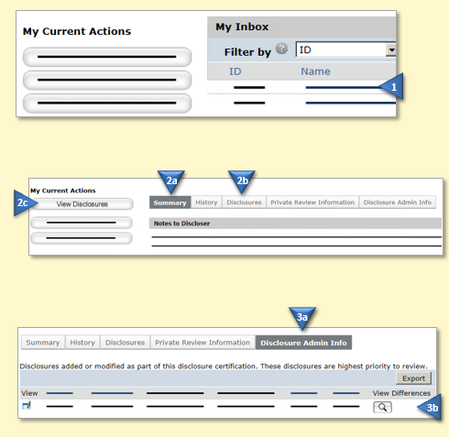 | Review Certification Details
- From My Inbox, click the certification Name.

- From the certification Workspace, review the following information:
  - Summary tab provides a summary of the certification and the amounts disclosed by the organization.
  - Disclosures tab shows the amounts disclosed for each organization by compensation type.
  - View Disclosures button shows all certification pages, including the disclosure pages.

 | View Changes Between Disclosure Versions
- Administrative and Committee reviewers can see what changed between current disclosures and previous versions.
  - Click the Disclosure Admin Info tab.
  - Click the View Differences button for a disclosure and then select the version to compare against.
Next Step: After reviewing the certification:

- Department Reviewers: See Complete the Review
- Administrative Reviewers: Go to Record an Administrative Review

Record and Complete Your Review
After you have reviewed the certification, complete your review in the system.
Administrative reviewers will record an Administrative Review prior to completing their review.
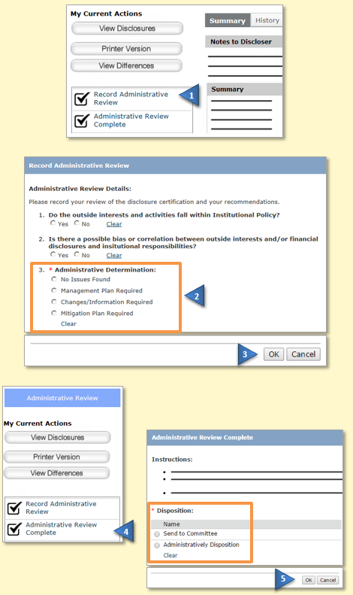 | Record an Administrative Review
If you are a Department Reviewer, go to Complete the Review.
- In the certification Workspace, click Record Administrative Review.
- Complete the form. Select the determination and include any management or mitigation plan details, if applicable.
- Click OK when done.
 | Complete the Review
- In the certification Workspace, click … Review Complete.
- Complete the form and click OK at the bottom when done.

- Department Reviewers: (optional) Add any notes or attachments to be included in the certification History.
- Administrative Reviewers: Determine if the certification should be reviewed by a committee. If so, select the Meeting to add the certification to the agenda.
Next Step (Administrative Reviewers):

- For Committee Reviews, see Record Committee Decisions.
- For administrative dispositions, see Prepare and Send Correspondence.

Record Committee Decisions
After a Committee Meeting, record the committee’s decision for each certification reviewed in the meeting.
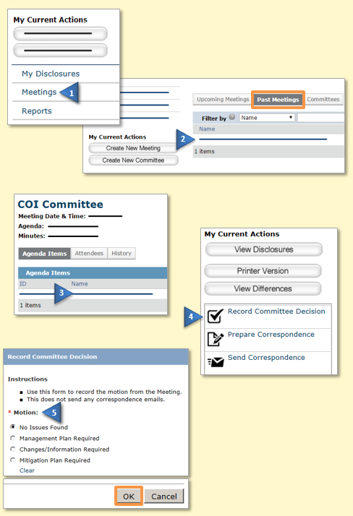 | Find the Certification
- From My Inbox, click Meetings.
- On the Past Meetings tab, click the Name of the Meeting to open it and see the list of agenda items.
 | Record the Committee’s Decision
- In the meeting Workspace, click an agenda item to open it in a new browser tab.
- Click Record Committee Decision.

- Select the motion and complete the remainder of the form. Click OK when done.
- For Management or Mitigation Plan Required: Select a plan monitor and review frequency. Go to Create or Upload a Management or Mitigation Plan.
- For Changes/Information Required: Type the change or information required in the Comments box.
 | Next Step: Prepare and Send Correspondence

Create or Upload a Management or Mitigation Plan
If a Management or Mitigation Plan is required, add a plan to the certification.
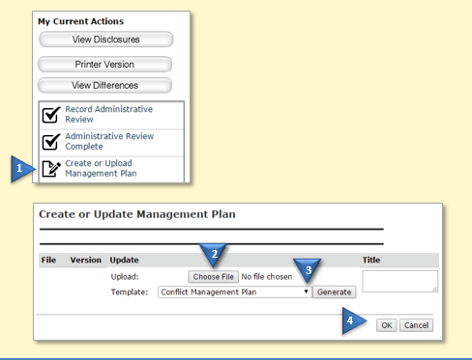 | Create or Upload a Plan
- In the certification Workspace, click Create or Upload Management Plan.

- To upload a plan, click Choose File, select the file, and then click Open.
- To create a plan from a template, select the plan from the list and then click Generate.

- Click OK when done.
 | Next Step: Prepare and Send Correspondence

Prepare and Send Correspondence
After a review determination is made, prepare and send the correspondence letter to the COI Discloser.
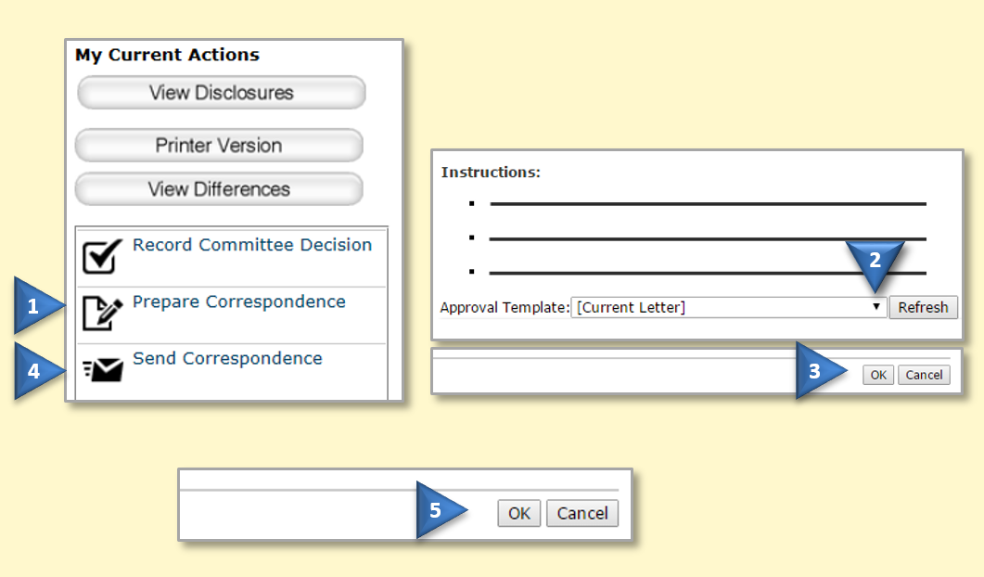 | Prepare Correspondence
- In the certification Workspace, click Prepare Correspondence.
- Select the letter template from the list.
- Click OK to create the letter.
 | Send Correspondence
- In the certification Workspace, click Send Correspondence.

- Click OK to send the letter.

Monitor Management Plans
To ensure management/mitigation plans are completed, monitors will complete a monitor report periodically.
If reports are not completed in a timely manner, you can reassign the certification to another monitor.
Once the management/mitigation plan is satisfied, you can indicate this to complete the review process.
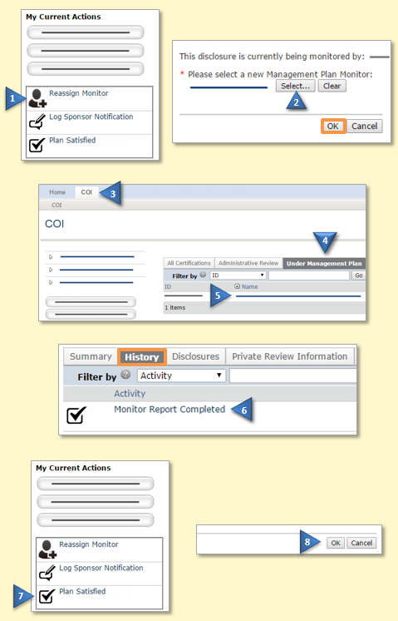 | Reassign a Plan Monitor
- In the certification Workspace, click Reassign Monitor.
- Select a different monitor for the management/mitigation plan and click OK.
 | View Monitor Report Details
- From My Inbox, click the COI tab.

- Click the Under Management Plan tab.
- Click the certification Name to open it.
- Click the History tab and then the Monitor Report Completed activity to see details.

 | Indicate a Plan is Satisfied
- In the certification Workspace, click Plan Satisfied.

- Add any comments, if appropriate, and then click OK.

