Track and Manage Reviews

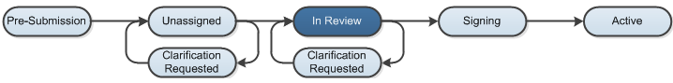

Work Instructions:
Change Agreement State to Internal or External Review

- Log into the Click Portal and click on the Agreements tab in the top navigation menu.

- Click the All Agreements tab, and then click on the agreement’s Name to open it.

- To shift the agreement between review states, click on Move to Internal Review or Move to External Review under My Current Actions.
- Agreements Managers and/or Reviewers can change the agreement state at any point to reflect who is reviewing the agreement.

Find Agreements in Review

- Log into the Click Portal and click on the Agreements tab in the top navigation menu.

- Click the In Progress tab.

- On the In Progress tab, see the following columns:

- Status to find agreements in Internal Review, External Review, and Ancillary Review.
- Modified Date to see when action was last taken on the agreement.

Use the Filter by option to show agreements in a certain status.

- Click on the Name of an agreement to open to the Agreements Workspace.

- Click the History tab to review the last action taken on the agreement.
Create and Update “To Do” Items

- Log into the Click Portal and click on the Agreements tab in the top navigation menu.

- Click the All Agreements tab, and then click on the agreement’s Name to open it.

- To create an action item or reminder, click on Log Correspondence under My Current Actions.

- Enter a Summary description for the item.

- To select an Owner for the item (you will be the default owner), click the Select button.

- Use the Filter by option to determine which search method you will use.
- Enter your search term in the box and click the Go button.
- Select the appropriate user.
- Click the OK button.

- Repeat the actions in step 5 to select a Person to complete the item.
- Complete the remaining items in the form and Add attachments, if needed.
- Click OK.
- The item will be added to the list on the Communication tab, and can be updated, marked complete, or deleted.

Edit or Revise the Agreement
- Log into the Click Portal and click on the Agreements tab in the top navigation menu.

- Click the All Agreements tab, and then click on the agreement’s Name to open it.

- To make changes to the agreement or SmartForm pages, click the Edit Agreement button.

- To upload a revised or final copy of the agreement document, click Revise Agreement under My Current Actions.

