Manage Ancillary Reviews

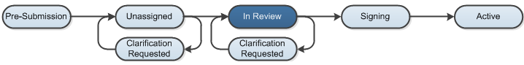

Work Instructions:
Add an Ancillary Reviewer

- Log into the Click Portal and click on the Agreements tab in the top navigation menu.

- Click the All Agreements tab, and then click on the agreement’s Name to open it.

- To request an ancillary review, click on Manage Ancillary Reviews under My Current Actions.
- Agreements Managers and/or Reviewers can request an ancillary review during the Unassigned and In Review states.

- Click the Add button.

- Click the Select button next to either Organization or Person.

- Select an organization or person, and then click OK.
- To remove a selected organization or person, click the Clear button

- Select a Review type from the list.

- Determine whether or not a Response is required.
- Any reviews marked as Required must be completed prior to approving the language of an agreement

- If you are finished adding reviewers, click the OK button. If you desire to add additional reviewers, click the OK and Add Another button, repeat steps 5-8, and then click the OK button.

- You will be returned to the Agreements Workspace.
- The list of all ancillary reviewers appears above the History tab in the Workspace

Remind Ancillary Reviewers

- Log into the Click Portal and click on the Agreements tab in the top navigation menu.

- Click the All Agreements tab, and then click on the agreement’s Name to open it.

- To remind an ancillary reviewer of their obligation, click on Submit Ancillary Review Reminder under My Current Actions.

- Select the Organization(s) or Person(s) you wish to send a reminder to.

- Type a Message and Add any Supporting Documents, if needed.

- Click the OK button, and your reminder will be sent.

Update an Ancillary Review

- Log into the Click Portal and click on the Agreements tab in the top navigation menu.

- Click the All Agreements tab, and then click on the agreement’s Name to open it.

- To update an ancillary review, click on Manage Ancillary Reviews under My Current Actions.

- Click the Update button next to the Organization or Person you wish to update information for.

- Complete the form, indicating if the reviewer accepted the submission and entering Comments as necessary. Then click OK.

