Create and Submit an Amendment

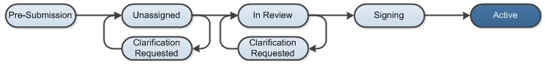

Work Instructions:
- Log into the Click Portal and click on the Agreements tab in the top navigation bar.

- Find the protocol in the Approved state that you would like to submit an amendment for.
  - Principal Investigators (or a PI Proxy, if identified) can click on the Active tab to find the agreements that are in the Approved state and can click on the name of the agreement to begin their submission.

- From the Agreements Workspace, select the Create Amendment button.

- Enter the updated information on the SmartForm pages.
  - Note that an approved protocol can have only one outstanding amendment or continuing review open at a time.

- Prior to submission to the Agreements Manager, all required fields will need to be completed.
  - Click the Hide/Show Errors link in the navigation bar to display any unanswered questions throughout the SmartForm at the bottom of the page.
    - Use the Jump To: link to navigate directly to SmartForm pages that are missing information.
  - Submissions with any incomplete information will be redirected to the study team for updates.

- When all of the required fields have been completed, click Exit in the navigation bar or the Finish button on the last SmartForm page to be redirected to the Agreements Workspace.

- The agreement will transition from the Active state to an amendment in the Pre-Submission state.

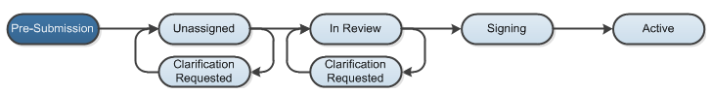

- Click the Submit activity. This activity will remind the PI of their responsibilities and the system will check the submission for any missing fields. Click the OK button to submit the amendment.

- If the submission is successful, the page will refresh and the agreement will transition from the Pre-Submission state, and then to the In Review state.

