Create and Submit an Agreement
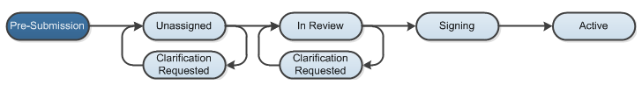

Work Instructions:
- Log into the Click Portal and click on the Agreements tab in the top navigation bar.

- Under My Current Actions, select the Create Agreement button to create a new agreement.

- Enter the required information on the first page of the SmartForms, Agreement Upload.
Required information fields are marks with an asterisks (*)

- Click the Choose File button to upload a draft copy of the agreement, if available.
- Enter a Title for the agreement, or enter an Internal Reference Number.
- Select the appropriate Agreement type.
- Enter a Purpose/Description for the agreement.
The SmartForms will branch to include additional SmartForms that are related to your Type selection.
- Click the Continue button at either the top or bottom-right of the form.

- Navigate through all of the SmartForms and complete all of the required fields
  - Click the Help icon ( ) for more information about a question or field

- Click the Hide/Show Errors link in the navigation bar at the top or bottom of the SmartForm page to display any unanswered questions
- Use the Jump To: link to navigate directly to SmartForm pages that are missing information
- Protocols with any incomplete information will be redirected to the protocol team for updates

- When all of the required fields have been completed, click the Finish button in the footer of the last SmartForm page to be redirected to the Agreements Workspace.
Your agreement has not yet been submitted for review.
- Assign any additional staff to the agreement, as necessary:

- Assign PI Proxy – assigns a user that will have the ability to act on behalf of the PI within the Agreements module. This individual will have the same access to the agreement as the PI, and will receive the same system-generated email notifications. The PI Proxy must be selected from the individuals that were added to the study team.

- Click the Submit activity located under My Current Actions on the left side of the Agreements Workspace. Read the statement, and then click OK to submit the agreement for review.

- The system will check the agreement to ensure that all required questions have been answered on the SmartForms. If any items have been missed, you will be prompted to answer them.

- If the submission is successful, the page will refresh and the agreement will transition from the Pre-Submission state to the Unassigned state.

