Agreements Work Flow

Agreement States:
The diagram located in the Agreements Workspace will show the state of your agreement within the Agreements workflow.
Pre-Submission: During Pre-Submission, the PI (or Agreements Manager) will create the agreement.
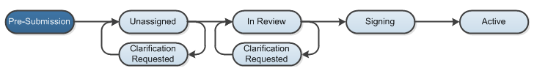
Unassigned/Clarification Requested: In the Unassigned state, the agreement has been submitted and is reviewed by the Agreements Manager, who can send the agreement back to the study team for more information or clarifications if needed. The Agreements Manager then assigns the agreement to an Agreements Reviewer.
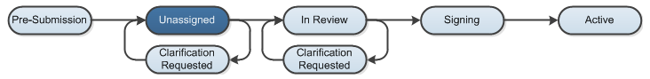
In Review / Clarification Requested: The Agreements Reviewer completes a thorough review of the agreement, and can send the agreement back to the study team for more information or clarifications if needed.
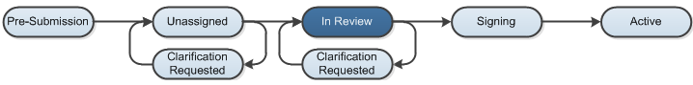
Signing: During Signing, the agreement is routed for internal and external signatures. Once that is complete, the agreement is activated.
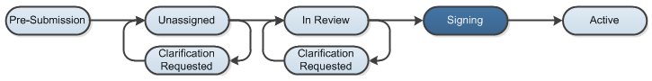
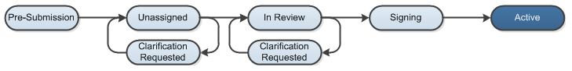
Active: The submission will reach its final determination, Active, after the final signed copy has been uploaded to the system.

