Quick Start Guide
Run an Analysis

The RF Report Center is linked to the RF internal website (See the Access the Report Center Quick Start Guide for both InCommon and “click-through” instructions).

Perform one of the following options to access an analysis:

- From the RF Report Center menu, select either Catalog. (Go to Step 3.)
OR

- Click on the analysis in the Others section of the Home page. This only applies to an Analysis that was recently accessed (Go to Step 4.)

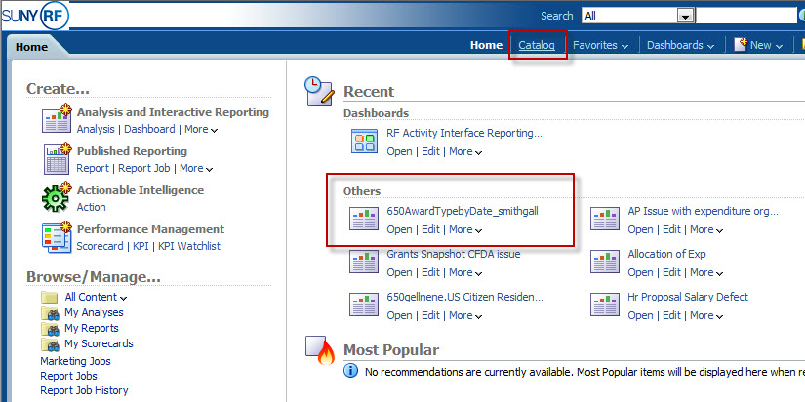

The “Overview” tab has all tab descriptions and links to appropriate support materials and training.
Catalog

Others

The “Overview” tab has summary tab descriptions to help you navigate the application and links to appropriate support materials and training.

Navigate to the Folders panel and click on either My Folders or Shared Folders. In this example, click on the 000 Public by CO Reporting then a subfolder, i.e. Grants, in order to retrieve your analysis.

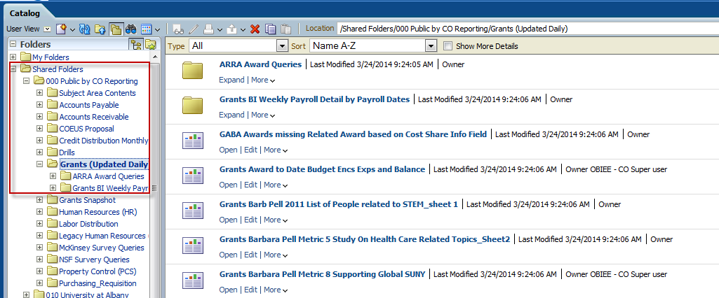
All your analyses are listed in the main window of the RF Report Center Catalog.

Click Open under the analysis’ name to execute the analysis. If report elements need updating, click on the Edit link first next to Open.
Refer to the Create an Analysis Quick Study Guide for instructions on editing.
PRINT AND EXPORT
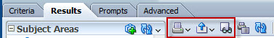

Print: Click Print, the icon on the left, to print as a printable PDF or a printable HTML.
Export: Click Export, the middle icon above, and to
- Download the analysis as it appears on the form, select PDF, Excel, PowerPoint, or Web Archive.
- Download the raw data set, select CSV, XML, or Tab Delimited.
View: To see how the results will look on a dashboard, click View, the icon on the right.

