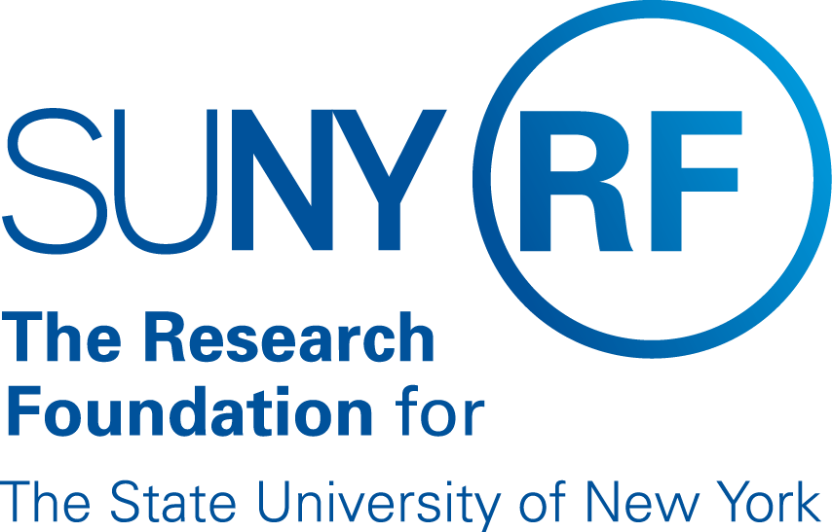

Chief Operating Officer
  - Leadership Profile
Summer 2026

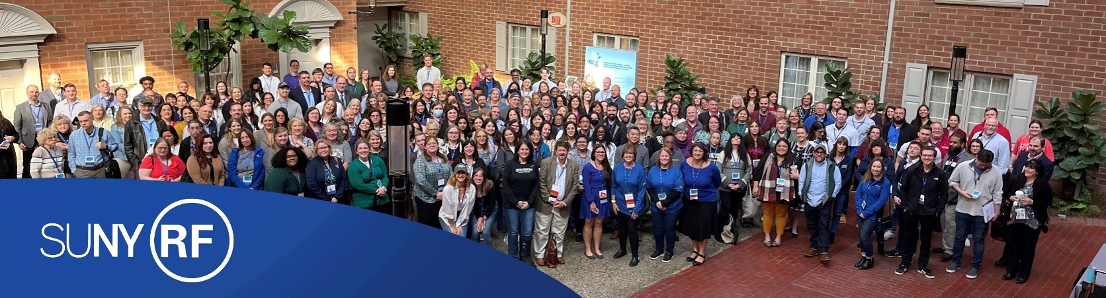

Executive Summary
The President and CEO of The Research Foundation for SUNY (RF) and its Board of Directors invite nominations and applications for an experienced, execution-oriented research administration leader to serve as RF Chief Operating Officer (RFCOO).
Driving social impact, enhancing human wellbeing, and stimulating economic growth, the RF provides SUNY's 30 state-operated campuses with an infrastructure of people, technology, and processes that enable faculty to write and submit grant proposals to agencies, foundations, and companies; establish contracts and manage funding awarded to run campus-based research projects; protect and commercialize intellectual property created within those projects; and establish enduring partnerships that shape the future. The RF operates with a singular focus: SUNY is its sole customer, and excellence in service to campuses is paramount.
In collaboration with System Provost and President of the Research Foundation, Dr. Melur "Ram" Ramasubramanian, the RFCOO will play a critical role on the RF leadership team, working to establish an environment that expertly and efficiently supports research and discovery across the SUNY System. The RFCOO will oversee the disciplined execution and continuous improvement of the core functions of the RF, including the efficient and transparent administration of sponsored programs and technology. This individual has day-to-day oversight of the strategic, operational, and financial goals of all areas within the RF, coordinating with elected officers and working with the leadership team members responsible for key functional areas.
At its core, this is an operational leadership role requiring a hands-on, service-oriented executive who ensures that strategy translates into consistent, high-quality delivery across a complex, distributed system. The RFCOO provides essential leadership in supporting the Presidents, Operations Managers, and other leaders at SUNY's campuses, building trusted relationships and credibility by listening closely, responding with urgency, and delivering solutions that meet campus needs. They ensure that initiatives and projects are executed effectively, with clear accountability, measurable outcomes, and a strong customer-service orientation. The RFCOO is a key strategic partner to the RF President and acts in the place of the President during the President's absence. The COO is the main liaison to the RF Board of Directors on all operational matters and attends all Board Committee meetings. The COO is also the staff liaison to the Executive Committee of the RF Board of Directors.
The RFCOO will evaluate the RF's current operating practices, ensuring that they are optimized to cultivate, support, and facilitate campuses' ability to establish and increase faculty scholarship, cutting edge research, and the recruitment and retention of strong faculty researchers across the System. This leader will bring a continuous-improvement mindset, strengthening processes, service delivery models, and performance management systems to ensure responsiveness and reliability for campuses. To that end, they will scale and optimize operations to support SUNY's efforts to elevate research expenditures, technology transfer, and cross-institutional research collaboration. The RFCOO will be responsible for leading and motivating a high-performing team, with a portfolio that includes Industry and External Affairs, Finance, Human Resources, Information Technology Services, and Sponsored Program Administration and Regulatory Affairs.
The successful candidate will embody a servant-leader ethos while empowering teams and fostering a culture of responsiveness, accountability, and partnership. The RFCOO will champion the RF's values of inclusion, equity, and belonging in its workforce for diversity of people, culture, thought, perspective, and background. They will ensure that operational procedures are communicated clearly, consistently, and transparently to manage and advance the business of serving SUNY.
The ideal candidate will be an experienced leader in one or more key operational areas, including research administration, grants and sponsored project administration, technology transfer, finance, legal affairs, or human resources, bringing deep familiarity with research compliance and commercialization. Demonstrated technical depth in sponsored programs administration including pre-award, post-award, compliance, and regulatory frameworks is preferred. The RFCOO will be a data-informed and execution-focused leader who will partner closely with the President of the RF to identify existing pain points in research administration across the System and optimize operations to better the experience of all faculty and research administrators of SUNY. Success in this role will be defined by the ability to translate institutional priorities into operational units and a consistently strong service experience for campuses.
To submit a nomination or express personal interest in this position, please see Procedure for Candidacy at the end of this document.

Role of the Chief Operating Officer
The Research Foundation Chief Operating Officer plans, organizes, and provides strategic direction to all the functions of the RF in providing outstanding services to The State University of New York (SUNY) research community in the core business areas of sponsored program administration and technology commercialization.
The RFCOO supports the President by taking responsibility for leadership, management, and direction of an integrated functional team supporting RF operations across thirty SUNY campuses. This includes providing vision and operational leadership for the administration of sponsored programs and industry and external affairs across SUNY; responsibility for supporting and overseeing Operations Managers (OMs); and working in partnership with campus leadership to address operational challenges and strengthen alignment across RF-supported activities. The RFCOO will ensure that all RF services provided to campus constituents are of high quality, responsive, and consistent with national best practices, while recognizing the autonomy and unique needs of individual campuses.
Operating within a highly decentralized environment, the RFCOO fosters a collaborative and service-oriented culture that recognizes that the SUNY research enterprise is driven by SUNY faculty. The RFCOO works to ensure that, from an operational and administrative perspective, the RF is as effective, efficient, and responsive as possible, advancing coordination and consistency across functions while building trust with campus partners and stakeholders.
As the fiscal agent for purposes of grant administration, the RFCOO collaborates with SUNY leaders to build and maintain relationships with state and federal funding agencies, state and regional economic development agencies, and industry partners. The executive is part of a leadership team supporting campus presidents, OMs, and SUNY leadership, providing direction and oversight for initiatives and projects that support SUNY’s research mission and the RF’s strategic plan.
The RFCOO serves as a key liaison to the RF Board of Directors on operational matters, supporting Board committees and contributing to transparent, effective governance. The RFCOO represents the RF broadly across the SUNY system and externally, maintaining an active presence in national research administration forums and partnerships that support the RF’s mission and business success.
In addition, the RFCOO is responsible for:
- Ensuring that ethical values are aligned across the organization, promoting open communication, and avoiding bias in decision making;
- Ongoing improvement in sponsored programs administration in terms of people (staffing, training) and technology, with a focus on enhancing service quality and consistency;
- Ensuring that RF technology commercialization support aligns with campus needs and expectations; and
- Serving all committees of the Board, supporting other Board delegates as needed.

Direct reports include:

- Vice President, Industry and External Affairs
- CIO and Vice President, Information Technology Services
- Vice President, Sponsored Programs Administration and Regulatory Affairs
- Vice President, Human Resources
- Vice President, Internal Audit Systems
- CFO & Vice President for Finance
- Director, Data Strategy
- Director, Strategic Planning and Public Relations
Executive Office Manager

Opportunities and Expectations for Leadership
Advance operational effectiveness through continuous improvement
Working in close concert with the President of the Research Foundation, other members of the RF leadership team, and research leaders at SUNY campuses, the RFCOO will build on recent progress to advance operational effectiveness, consistency, and clarity across RF operations. Operating within a decentralized environment, the RFCOO will continue to strengthen coordination and alignment across campuses, promoting shared practices in key administrative processes while respecting campus autonomy.
With a focus on continuous improvement, the RFCOO will work collaboratively with Operations Managers (OMs), campus partners, and staff to identify and implement practical enhancements to processes, systems, and workflows. This includes refining sponsored programs administration, strengthening training and professional development, and improving communication to support reliable, transparent, and predictable service delivery across the system.
Through thoughtful engagement and strong communication, the RFCOO will ensure that ongoing improvements are responsive to stakeholder needs and contribute to a more cohesive, effective operating model for the Research Foundation.
Enhance service to SUNY campuses and the faculty research community
The RFCOO will further strengthen the RF’s role as a responsive, trusted service organization, working in close partnership with SUNY leadership, campus administrators, and faculty. They will ensure that operational practices, communication, and service delivery models are aligned with the needs of campus stakeholders and support faculty success in research and scholarship.
The RFCOO will work to clarify processes, improve service responsiveness, and reinforce a culture of professionalism, accountability, and customer service across RF functions, ensuring that the RF enables and facilitates, rather than complicates, the work of the research community.
Ensure strong compliance, risk management, and operational discipline
In consultation with the RF Chief Compliance Officer and functional leaders, the RFCOO will ensure that appropriate risk management and control systems are in place and effectively implemented across the organization. The RFCOO will support adherence to federal, state, sponsor, and institutional requirements, ensuring that RF operations meet the highest standards of compliance and accountability.
At the same time, the RFCOO will work to ensure that compliance frameworks are implemented in a manner that is clear, consistent, and supportive of campus operations.
Strengthen relationships and communication across the SUNY system
One of the most important priorities of the RFCOO will be to build and sustain strong, collaborative relationships across SUNY. These partners include RF Central Office leadership and staff, campus presidents, OMs, research administrators, and SUNY System leadership.
The RFCOO will promote open, transparent, and consistent communication, serving as a key liaison to align stakeholders around shared goals and priorities. There is an opportunity to further strengthen understanding of the RF’s role, services, and value, and to ensure that stakeholders across the system are well-informed and effectively engaged.
Lead and support a high-performing, service-oriented team
The RFCOO will lead and support a high-performing team of senior leaders and staff, fostering a culture of collaboration, professionalism, and continuous improvement. The RFCOO will ensure the growth and development of leadership and management capabilities across the organization, reinforcing shared accountability and teamwork.
The RFCOO will lead by example, modeling a leadership style that emphasizes sound judgment, emotional intelligence, and a collaborative, low-ego approach to advancing the mission of the RF and supporting the SUNY research community.

Professional Qualifications and Personal Qualities
The ideal candidate will be an experienced leader in one or more key operational areas, including research administration, grants and sponsored project administration, technology transfer, human resources, finance, or legal affairs, bringing deep familiarity with research compliance and commercialization. A bachelor's degree is required, and an advanced degree, along with experience in non-profit and higher education settings, is preferred.
The following credentials and attributes are considered essential for viable candidates:
Strategic leadership: Experience providing vision and operational leadership for the administration of sponsored programs, industry and external affairs in a complex environment; understanding of the mission, goals, and objectives of a major public university system and the roles of research and public service, and the need for an effective, service-oriented business infrastructure in support of that mission. Track record of empowering and cultivating trust within a strong leadership team that models cohesive and collaborative leadership as well as mentoring; experience fostering a diverse and inclusive workforce. Demonstrated ability to advance organizational priorities and lead change through influence, relationship-building, and operational credibility, using sound judgment, professionalism, and emotional intelligence to foster alignment across a decentralized system.
Management: Experience working in a complex, regulated, and decentralized non-profit or higher education environment with varied constituencies; strong administrative skills, including budgeting, program development, and program management, as well as the ability to lead through senior functional leaders. Appropriate management experience, including progressively more complex technical and executive experience in positions of similar scope reporting to a President or organizational CEO. Familiarity with research compliance, risk management, and internal controls, and experience ensuring operational discipline, consistency, and high-quality service delivery across functions.
Relationship management: Ability to interact effectively with all levels of RF staff and trustees, SUNY system and campus-based constituents, including faculty and research staff, partners in business and industry, and federal and New York State government. Demonstrated ability to build trust and maintain strong, collaborative working relationships across a broad range of stakeholders, navigating a complex, matrixed environment with diplomacy, responsiveness, and sound judgment, while balancing systemwide priorities with campus needs.
Communication: Excellent communication skills in person and in writing with the ability both to listen and to convey information clearly and effectively across a wide range of stakeholders. Skills to communicate the RF’s mission, priorities, and processes to System leadership, campus presidents, OMs, and others; ability to ensure clarity, transparency, and consistency in communication that supports coordination, alignment, and effective service delivery. Effective negotiating skills combined with the ability and inclination to be a collaborative, solutions-oriented partner.
- Personal qualities: The highest degree of professional and personal integrity and a respect for institutional stewardship and service; ability to take initiative and implement thoughtful, practical solutions; ability to navigate a complex institution with political astuteness, patience, and tolerance for ambiguity. A steady, mature leadership presence with strong interpersonal judgment and resilience, and a commitment to professionalism, accountability, and a low-ego, service-oriented approach in support of the SUNY research community.

About The Research Foundation for SUNY

History
The SUNY Research Foundation (RF) is the largest comprehensive university-connected research foundation in the country and supports a vibrant research ecosystem that cultivates innovation and entrepreneurship across multiple key areas, including Artificial Intelligence, Clean Energy, Biotechnology, Longevity, Substance Addiction, Nextgen Quantum Computing, Environmental Health, and Resiliency. The Research Foundation for SUNY was chartered in 1951 by the New York State Board of Regents as a non-profit education corporation, governed by its own Board of Directors to:
Assist in developing and increasing the facilities of the State University of New York to provide more extensive educational opportunities for and service to its students, faculty, staff, and alumni, and to the people of the State of New York, by making and encouraging gifts, grants, contributions, and donations of real and personal property to or for the benefit of the State University of New York.
Receive, hold, and administer gifts or grants, and act without profit as trustee of educational or charitable trusts, or benefit to and in keeping with the educational purposes and objects of the State University of New York.
Finance the conduct of studies and research in any and all fields of the arts and sciences, of benefit to and in keeping with the educational purposes and objects of the State University of New York.

Mission
Driving social impact, enhancing human wellbeing, and stimulating economic growth, the RF provides SUNY's 30 state-operated campuses with an infrastructure of people, technology, and processes that enable faculty to write and submit grant proposals to agencies, foundations, and companies; establish contracts and manage funding awarded to run campus-based research projects; protect and commercialize intellectual property created within those projects; and establish enduring partnerships that shape the future.
The RF's mission is to provide talent, services, and technology that empower SUNY to research, innovate, and transfer discoveries that transform the world's knowledge economy. RF's vision is to make SUNY the best place for faculty, students, and staff to research, innovate, and solve the world's most pressing problems.

Organizational Structure
The RF comprises a central office and operating units at 30 state-operated campuses across New York State, and is governed by a board of directors. The RF Board of Directors oversees the operations of the corporation in accordance with its stated mission and purpose. This voluntary Board draws members from various constituencies, including SUNY faculty, researchers, campus and system administrators, as well as individuals representing business, industry, and community sectors. RF Operations Managers at the campuses are appointed by the RF President on the recommendation of the respective campus president. The RF President delegates to each Operations Manager the authority to execute the powers and duties necessary to conduct RF business at their campus in a manner consistent with the RF’s policies and overall system of controls.

Sponsored Programs Administration and Management of Research Grants
When a grant or contract is awarded to a SUNY faculty member, the RF administers and manages these funds to ensure compliance with university, grant sponsor, and government policies and procedures. Funding received by the RF in the form of a sponsored award is administered at the direction of the faculty member on whose behalf the award was received, subject to the policies and procedures of the given campus, as well as the RF, along with any other state or federal requirements. All activity at a campus location takes place with the oversight of the RF Operations Manager, who has designated authority to conduct RF business at their campus. In FY25, SUNY reported over $1.48 billion in total research activity support and filed 257 patents. The RF System Dashboard displays expenditures and other key metrics for research and innovation activity at SUNY campuses through the RF.

Technology Transfer and Management of Intellectual Property
The RF provides SUNY faculty, staff, and students with intellectual property and technology transfer services that fuel innovation and move ideas and inventions to the marketplace. Services include:
- Discovery
- Disclosure
- Evaluation
- Intellectual Property Protection
- Customer Discovery
- Marketing
- Partnership Management
- Asset Management
- Patent Drafting and Prosecution
- Business Development and Licensing
- New Venture Support

About The State University of New York
The State University of New York is an educational powerhouse, boasting 64 institutions, a mix of 29 State-operated campuses and five statutory colleges—including research universities, liberal arts colleges, specialized and technical colleges, health science centers, and land-grant colleges—and 30 community colleges. These institutions serve 1.3 million students annually in more than 7,500 degree, certificate, and continuing education programs across New York State. The University also operates hospitals and numerous research institutes. As a system, SUNY is unparalleled in its educational reach and impact, boasting bachelor and graduate graduation rates that are higher than the national median.
SUNY’s size and the diversity of its institutions amplify its potential for impact through education, research and scholarship, workforce development, K-12 partnerships, and job creation. SUNY is embedded in virtually every community in New York State. Remarkably, 93% of New Yorkers live within 15 miles of a SUNY campus, and nearly 100% live within 30 miles. In many communities, SUNY is also the region’s largest employer. While SUNY students are predominantly New York State residents, hailing from every one of the state’s 62 counties, the University also draws students from every state in the United States, the District of Columbia, four U.S. territories, and 160 nations. One out of three New York State high school graduates chooses SUNY, and the total enrollment of nearly 363,650 full- and part-time students represents 31% of New York State’s higher education student population. SUNY employs 87,000 faculty and staff and counts more than three million living alumni who reside in New York State and throughout the world.

Leadership

Dr. Melur "Ram" Ramasubramanian, President, The Research Foundation for SUNY
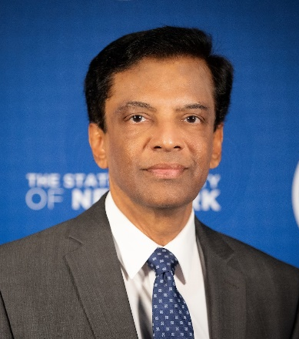
Dr. Ramasubramanian joined The Research Foundation for SUNY from the University of Virginia, where he was Vice President for Research and Professor of Mechanical and Aerospace Engineering. There, he developed and led a strategy to grow research focused on five key areas: democracy, digital technology and society, environmental resilience and sustainability, brain and neuroscience, and precision medicine. The strategy yielded significant gains in research expenditures for UVA from a base of $397 million in FY2016 to $611 million in FY2021, which led to a rise in the university's ranking by the National Science Foundation during that time from 56 to 48. In addition, new awards rose from $353 million in FY2017 to $532 million in FY2023, a record for UVA. To date, nearly $1 billion has been committed by UVA for 66 different strategic initiatives, including research infrastructure, professorships, scholarships, and large investments in the five strategic focus areas.
At the same time, Dr. Ramasubramanian directed key investments to expand UVA's capacity in the areas of brain and neurosciences, environmental resilience, digital technology and society, and precision health. He also developed and directed a seed-funding program to support early-stage interdisciplinary research concepts that provided funding for 77 teams across schools of three faculty members each, granting each team $60K per project, including student support. He also developed and executed an annual faculty awards program to recognize excellence in research and scholarship.
Prior to his years at UVA, Dr. Ramasubramanian was Program Director for engineering research centers at the National Science Foundation's Division of Engineering Education and Centers. He was a faculty member at Clemson University as a D.W. Reynolds Distinguished Professor and Department Chair for mechanical engineering. He started his career as an Assistant Professor of Mechanical and Aerospace Engineering at North Carolina State University.
Dr. Ramasubramanian is a first-generation graduate who arrived in the United States with modest financial resources after earning his bachelor's in mechanical engineering from the National Institute of Technology in Durgapur, India. He received a master's degree in applied science from Miami University and a doctorate in mechanical engineering from Syracuse University.

Procedure for Candidacy
All applications, nominations, and inquiries are invited. Applications should include, as separate documents, a CV or resume and a letter of interest addressing the themes in this profile.
WittKieffer is assisting the Research Foundation for SUNY in this search. For fullest consideration, candidate materials should be received by August 17, 2026.
Application materials should be submitted using WittKieffer’s candidate portal.
Nominations and inquiries can be directed to:
Lauren Bruce-Stets, Robin Mamlet, and Tyler Workman:
lstets@wittkieffer.com | tworkman@wittkieffer.com
The salary range for this position is $325,000 - $375,000.
As an Equal Opportunity / Affirmative Action Employer, The Research Foundation for SUNY will not discriminate in its employment practices due to an applicant's race, color, creed, religion, sex, pregnancy-related conditions, reproductive health decisions, childbirth or related medical conditions, sexual orientation, gender identity or expression, transgender status, age, national origin or ancestry, marital status, familial status, citizenship, physical and mental disability, prior arrest or conviction record, genetic characteristics/genetic information, predisposition or carrier status, domestic violence victim status, military status or service, veteran status, or any other characteristics protected under federal, state or local law. The Company will not discharge or in any other manner discriminate against employees or applicants because they have inquired about, discussed, or disclosed their own pay or the pay of another employee or applicant.
The Company will not discharge or in any other manner discriminate against employees or applicants because they have inquired about, discussed, or disclosed their own pay or the pay of another employee or applicant.
Review of applications will begin immediately and continue until the position is filled.
The Research Foundation for the State University of New York is not an agency or instrumentality of the State of New York. Employees of the Research Foundation for the State University of New York are not state employees, do not participate in any state retirement system, and do not receive state fringe benefits. The Research Foundation for the State University of New York operates under a contract with The State University of New York and receives no directly appropriated state funding.

