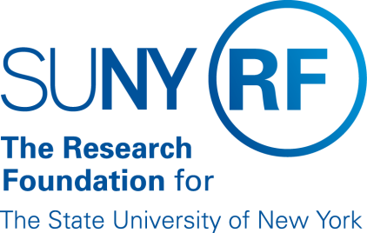

SUNY Technology Accelerator Fund
Conflict of Interest Disclosure Form

TAF Project Title: ________________________________________________________

TAF Project Team Member: ___________________________________________________

Please answer the following questions.

- Do you or any related party (spouse, domestic partner, significant other, dependent, member of household, family member, or business partner) have any financial or other interest that you believe may be relevant to the exercise of your duties in performing the project articulated in the TAF Class of 2017 proposal that you are involved with? If so, please detail below or enter N/A in the space provided.

- Is any technology that is related to the proposed TAF Class of 2017 project currently licensed or optioned to a for-profit entity? ___ Yes ___No

If yes, are you performing any services to the licensee outside of SUNY (e.g., consulting, board service)? ___ Yes ___No
If yes, please explain below.

I certify that the above information is true and correct to the best of my knowledge and that I have read and agree to be bound the RF’s Conflict of Interest Policy. I further certify that I will advise the TAF Managing Director or delegate immediately upon any material change in circumstance that may occur during the period of performance of the proposed TAF Project, if funded.

__________________________________ ________________
Signature Date

