[Type the company name]
Safety Reviewers Reference Guide
October 2016

Table of Contents
Navigation and Basic Tasks 2
Where do I find? 2
What do I do? 2
Open a Submission 2
View Submission History 2
Find All Submissions 3
Filter Data in a Table 3
Review a Safety Submission 4
Prerequisites for this task 4
Review submission details 4
Request Clarification on a Submission 5
Prerequisites for this task 5
Add Reviewer Notes to Protocol 5
Send Change Requests to the PI 5
Submit a Biosafety Risk Assessment 6
Prerequisites for this task: 6
Where do I start? 6
Characterize your assessment and Submit. 6
Submit a Member Review 7
Prerequisites for this task: 7
Where do I start? 7
Characterize your review and submit 7

Navigation and Basic Tasks
When you first log in, you will be on the My Inbox page. This topic lists where to find Safety submissions and the basic tasks you will perform.
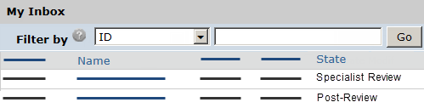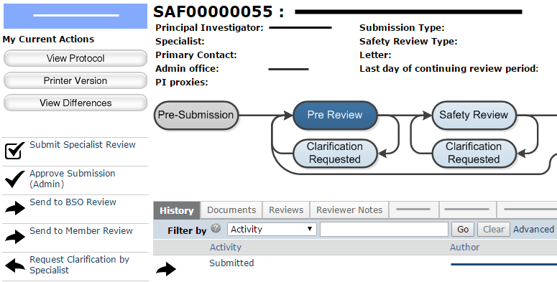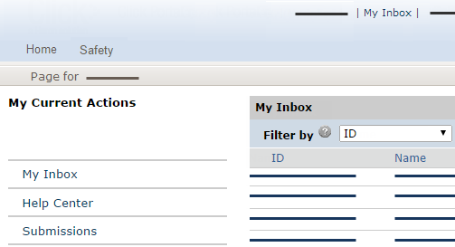  1  4  3  2  6 | Where do I find?
From My Inbox, you can find:
- Submissions that require you to take action.
- Shortcuts to other items such as all submissions in the system.
 | What do I do?
 | - Review the state of submissions in My Inbox. The state gives a clue as to what to do next. For example, “Specialist Review” means the submission is currently ready for review or being reviewed by a Safety specialist.
 | Open a Submission
- From My Inbox, click the submission name.
- The submission workspace opens.
 | View Submission History
- From the submission workspace, click the History tab.
The history lists the actions performed on a submission to date, including any comments, attachments, or correspondence added.

(This topic continues on the following page.)

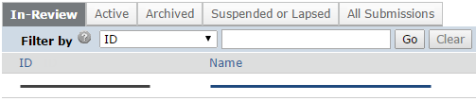  7  8  9  10  11  13  12 | Find All Submissions
- Under My Current Actions, click Submissions.
- Click the appropriate tab to see all submissions you have permissions to view:
- In-Review: All submissions undergoing Safety review
- Active: All approved submissions
- Archived: All discarded and closed submissions
- Suspended or Lapsed: All submissions that have been suspended or whose continuing review deadline has passed
- All Submissions: All submissions, in any state
 | Filter Data in a Table
To find a specific item in a table, use the Filter by feature:
- Select the column to
filter by.
- Type the beginning characters for the items you want to find. You can also type a % symbol as a wildcard before the characters. For example:
- 71 shows all items
beginning with 71
- %71 shows all items containing 71
- For a list of operators you can type in the text box, click the Help icon.
- Click Go to apply the filter.
- To combine multiple filter criteria, click Advanced and then click Add Another Row.

Review a Safety Submission
When a protocol, amendment or continuing review is submitted, the submission appears in the Inboxes of users authorized to perform the next step in the review process.
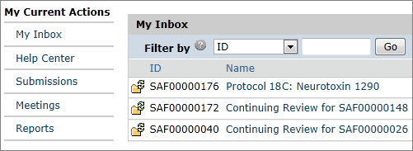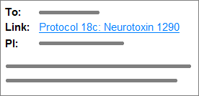  2  3  4  1  1  OR | Prerequisites for this task
 | - You are logged in as a role that has privileges to view the submission in its current state.
 | Review submission details
- Click the e-mail link to open the submission workspace.
If you no longer have the e-mail message, find the submission on the My Inbox tab, and click its name.
- Click View Protocol and add reviewer notes to specific pages of the submission as needed.
  - To print out the submission, click Printer Version.
  - To see what changed between this and a previous version, click View Differences and select the version to compare against.
- To see details about other reviews, click the Reviews Tab.
- To see notes added by other reviewers, click the Reviewer Notes tab. (It appears only if reviewer notes have been added.)
To request changes, see Request Clarification on a Submission on page 5.

Request Clarification on a Submission
At nearly every stage of the review process, it is possible to request clarifications or modifications to a submission. You can do this by adding reviewer notes to specific pages or by making a general change request.
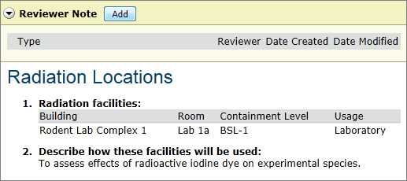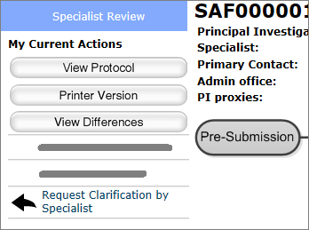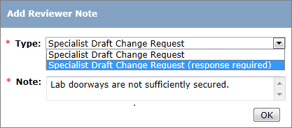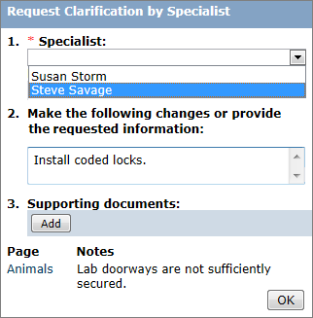  2  7  3  4  8  9  10  11 | Prerequisites for this task
 | - You are assigned to review the submission in its current state. (The submission appears in your Inbox.)
 | Add Reviewer Notes to Protocol
- Open the submission workspace and view the protocol (see Review a Safety Submission on page 4).
- Navigate to a page that you want to comment on and click Add in the Reviewer Note bar.
- Select whether a response is required or not.
- Type your change request in the Note box and click OK.
Your comment appears at the top of the page.
- Repeat steps 2–4 for all the pages you want to comment on.
- When done adding notes, exit
the submission.
 | Send Change Requests to the PI
- In the submission workspace, click Request Clarification by Specialist.
- If desired, assign a different user as the safety specialist for this submission.
- To make a general request or alert the research team about reviewer notes within the submission, type a comment in the text box.
- Add any supporting documents.
- Click OK.

Submit a Biosafety Risk Assessment
This activity is a response to a request for a risk assessment made during specialist review.
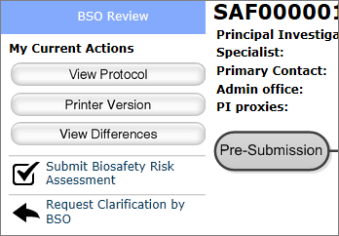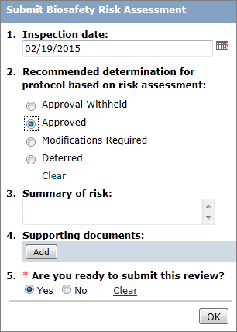  2  4  5  6  7  3  8 | Prerequisites for this task:
- The submission is in the BSO Review state.
- You are logged in as a user with the Biosafety Officer role.
 | Where do I start?
- Open the submission workspace.
- From the submission workspace, click Submit Biosafety Risk Assessment.
 | Characterize your assessment and Submit.
- Select the inspection date if applicable.
- Select your determination.
- Type details about the determination in the Summary of risk box.
- If applicable, add any supporting documents.
- To submit your review, click Yes.
- Click OK.
The protocol reverts to the Specialist Review state.

Submit a Member Review
A safety specialist can request reviews by individual members of the Safety Review Committee. This procedure shows committee members how to supply a review.
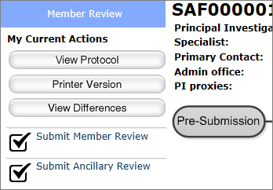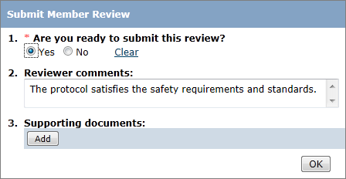  2  5  4  3  6 | Prerequisites for this task:
- The submission is in the Member Review state.
- You are logged in as a user with the Committee Member role.
 | Where do I start?
- Open the submission workspace.
- Click Submit Member Review.
 | Characterize your review and submit
- Select Yes to submit the review.
- Supply any comments you have about the submission.
- Add any supporting documents if applicable.
- Click OK.

