[Type the company name]
Safety Researcher’s Reference Guide

October 2016

Contents
Create and Submit a Safety Protocol 3
Create a Protocol 3
Submit a Protocol for Review 3
Respond to Reviewer Requests 4
Review the Request Details 4
Respond to Reviewer Notes 4
Submit Response 4
Create and Submit a Follow-On Submission 5
Create a Follow-On Submission 5
Submit Follow-On Submission for Review 5
Navigation and Basic Tasks 6
Where do I find? 6
What do I do? 6
Open a Submission 6
View Submission History 6
Find Previous Submissions 7

Create and Submit a Safety Protocol
When you create a Safety protocol, you will complete a series of pages. The number of pages depends on
the type of review required (biosafety, chemical safety, etc.)
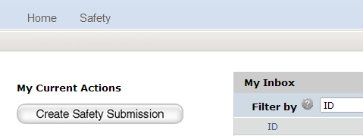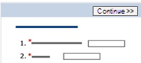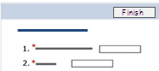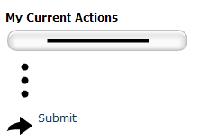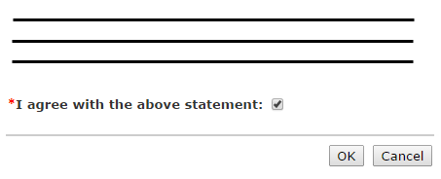  1  2  3  4  5  6 | Create a Protocol
- From My Inbox, click Create Safety Submission.
- Complete the pages. To move to the next page, click Continue.
- On the last page, click Finish.
You can continue to edit the protocol until you submit it for review.

 | Submit a Protocol for Review
- From the submission workspace, click Submit.
- Read the statement and click the check box at the bottom in agreement.
- Click OK to submit the protocol
for review.

Respond to Reviewer Requests
If a reviewer has questions or requires you to change your submission, you will receive an e-mail indicating this.
Review the request details and then respond to the request.
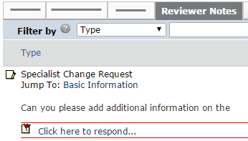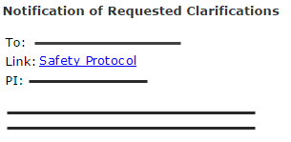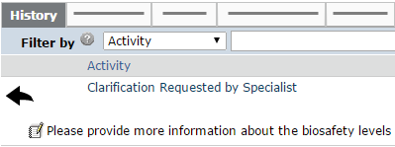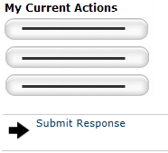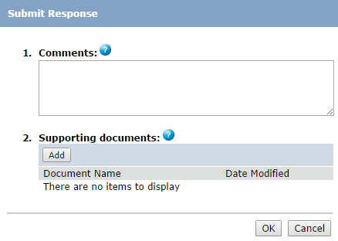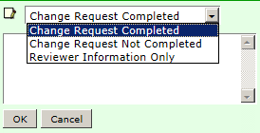  9  8  3  4  6  5  10  7  1  2 | Review the Request Details
- Click the e-mail link to open
the submission.
If you no longer have the e-mail,
see Open a Submission and then View Submission History to see reviewer comments.
- On the History tab, find the “Clarification Requested…” activity and read the comments.
- If the reviewer added reviewer notes, click the Reviewer Notes tab and go to Respond to Reviewer Notes. If not, go to Submit Response.
 | Respond to Reviewer Notes
For each reviewer note:
- To edit the protocol in response to the reviewer note, click the Jump To link.
- From the protocol page or the Reviewer Notes tab, click the Click here to respond link.
- Select a response from the list and explain your response in the box.
- Click OK. If on a protocol page, exit the protocol when done.
Go to Submit Response.
 | Submit Response
- On the protocol workspace, click Submit Response.
- In the Comments box, explain your response to the reviewer.
- Click OK.
You can log off the system (top right).

Create and Submit a Follow-On Submission
If you need to make changes to an approved Safety protocol or submit a continuing review, follow these steps.
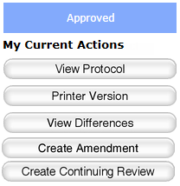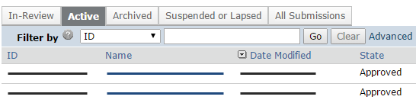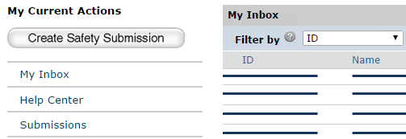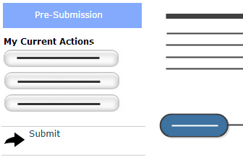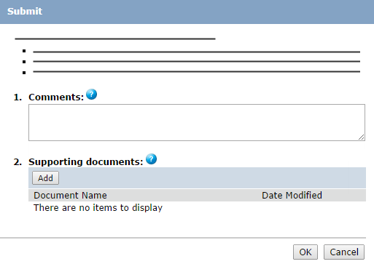  2  1  4  5  7  6  3 | Create a Follow-On Submission
- From My Inbox, click Submissions on the left.
- On the Active tab, select the name of the approved protocol.
- On the left, click the “Create…” button.
- Complete the pages. Click Continue to move to the next page.
- When done, click Exit and save changes or Finish on the final page.
You are taken to the submission’s workspace page. You can continue to edit the submission (“Edit…” button) until you submit it for review.

 | Submit Follow-On Submission for Review
- From the follow-on submission’s workspace, click Submit.
- Click OK to agree to the statement and submit it for review.
You can log off the system (top right).

Navigation and Basic Tasks
When you first log in, you will be on the My Inbox page. This topic lists where to find Safety protocols and the basic tasks you will perform.
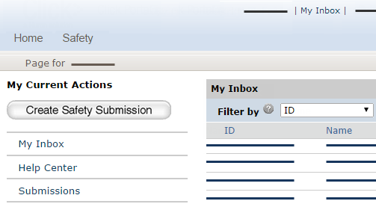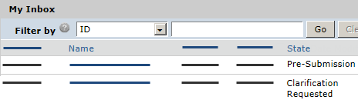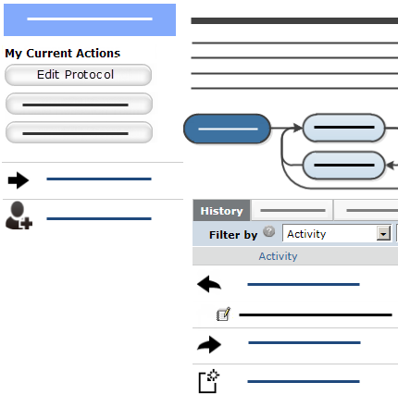  1  2  5  4  6  7  8  3 | Where do I find?
- From My Inbox, you can find: Submissions that require you to take action.
- Actions you can perform such as create a Safety submission.
- Shortcuts to other items such as your submissions.

 | What do I do?
 | - Review the state of submissions in My Inbox. The state gives a clue as to what to do next. For example, “Pre-Submission” means you haven’t submitted the Safety protocol. You can finish and submit it for review.
 | Open a Submission
- From My Inbox, click the submission name.
- The submission workspace opens.

 | View Submission History
- From the submission workspace, click the History tab.
- The history lists the activity taken on a submission including any comments, attachments, or correspondence added.

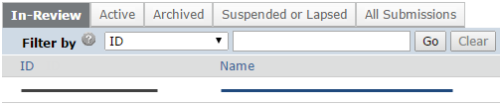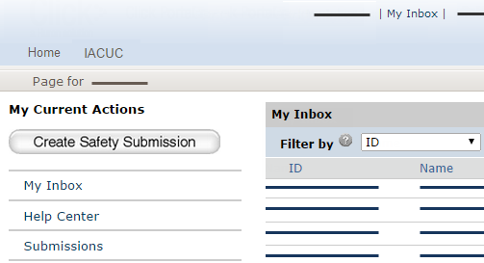  9  10 | Find Previous Submissions
- On the left, click Submissions.
- Click the appropriate tab to see all of your submissions:
- In-Review: All submissions undergoing Safety committee review
- Active: All approved submissions
- Archived: All discarded and closed submissions
- Suspended or Lapsed: All submissions that have been suspended or whose continuing review due date has passed
- All Submissions: All submissions, in any state

