Safety Protocol Work Flow

Protocol States:
The diagram located in the protocol workspace will show the state of your protocol within the Safety review process.
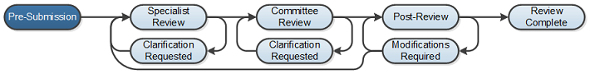
Pre-Submission: During Pre-Submission, the PI will create the protocol.

Specialist Review: In the Specialist state, the protocol has been submitted and the Safety coordinator reviews.
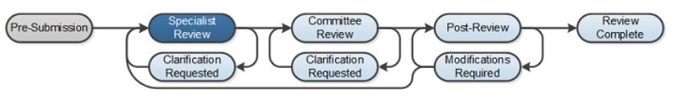
Specialist Review / Clarification Requested: The Safety specialist review staff can send the protocol back to the Safety Team for more information or clarifications if needed, which lets the Safety Team change the protocol.
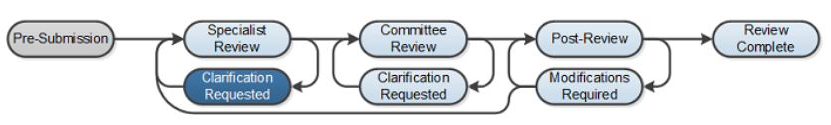
Committee Review: Safety review is where the Safety staff will review the submission for completeness.
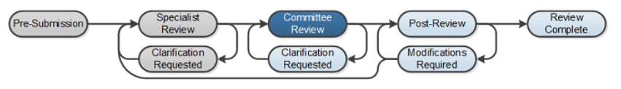

Committee Review / Clarification Requested: The Committee Review staff can send the protocol back to the Safety Team for more information or clarifications if needed, which lets the Safety Team change the protocol.
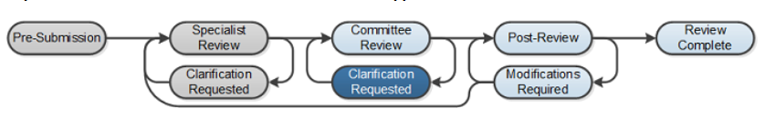
Post-Review / Modifications Required: The Post-Review state gives the Safety staff the opportunity to:
  - Approve documents that were attached to a protocol
  - Prepare a letter to inform the safety team about the decision
  - Send the letter
  - Request modifications
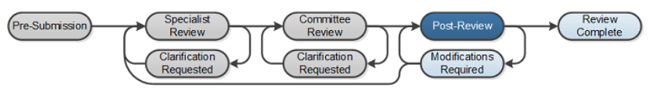
Review Complete: When the safety team submits modifications that are acceptable, the submission returns to the Post-Review state. The submission will reach its final determination, Review Complete, after the letter is sent.
