Create and Submit a Safety Protocol
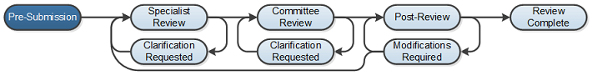

Work Instructions:
- Log into Click Portal and click on the Safety tab on the top navigation bar which will then display only Safety protocols which is the same as clicking on your “My Inbox”.

- Under My Current Actions, select the Create Safety Submission button to create a new safety protocol.

- Enter the required information on the first page of the Basic Information SmartForm
  - Required information fields are marks with an asterisks (*)

- Select the appropriate safety review:
  - Biosafety
  - Stem Cell Research Oversight
  - Chemical Safety
  - Radiation Safety

Note: Depending on the review you choose, the smart forms will branch to another set of smart forms that are related to that review.

- Click Continue at either the top or bottom of the form

- Navigate through all of the SmartForms and complete all of the required fields
  - Click the help icon ( ) for more information about a question or field

- Click the Hide/Show Errors link near the top of the SmartForm page to display any unanswered questions
- Use the Jump To: link to navigate directly to SmartForm pages that are missing information
- Protocols with any incomplete information will be redirected to the research team for updates

- When all of the required fields have been completed, click Finish in the footer of the last SmartForm page to be redirected to the protocol workspace.

Your protocol has not yet been submitted for review.

- The PI must go to My Inbox to access the protocol. The PI is able to assign a PI Proxy at this time by clicking on Assign PI Proxy.
- The PI will have to ensure that the proxy is added as a Study Team member.

- The PI will then need to click the Submit icon located under My Current Actions on the left side of your workspace. This activity will prompt the PI of their responsibilities and ask them to agree to the Investigator’s Assurance and then the system will check the submission for any missing fields. The PI will to click the OK button to submit the protocol.

- If the submission is successful, the page will refresh and the protocol will transition from the “Pre-Submission” state to the “Specialist Review” state.
