[Type the company name]
Safety Advanced Reports Reference Guide

October 2016

Contents
Generate Advanced Reports 2
Open Advanced Reports 2
Filter Data on Reports 2
Export and Print Advanced Reports 3
Export a Report 3
Print a Report 3
Days in State 4
Report Filters 4
Chart Description 4
Table Description 4
Other Report Features 4
Days in State by Year 5
Report Filters 5
Chart Description 5
Table Description 5
Other Report Features 5
Turnaround by Review Type 6
Report Filters 6
Chart and Legend Description 6
Other Report Features 6
Turnaround by Year 7
Report Filters 7
Chart and Legend Description 7
Other Report Features 7
Volume by Submission Type 8
Report Filters 8
Chart Description 8
Legend Description 8
Other Report Features 8
Volume by Year 9
Report Filters 9
Chart Description 9
Legend Description 9
Other Report Features 9

Generate Advanced Reports
Only Safety staff (specialists and administrators) and committee members can access Safety Advanced Reports.
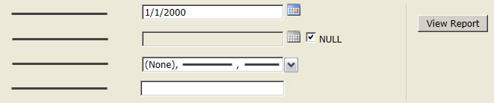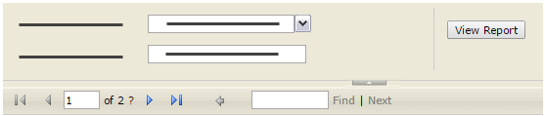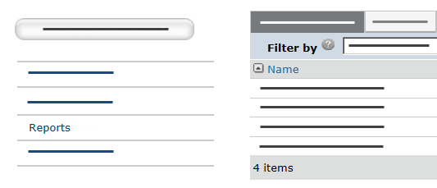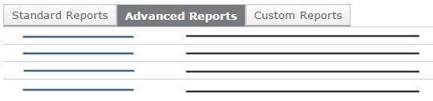  2  3  5  6  1  4 | Open Advanced Reports
- From My Inbox, click Reports on the left.
- Click the Advanced Reports tab.
- Click the report name to open it. Expand the report window to see the whole report.
- To view all pages of the report, use the navigation features in the report toolbar.
Tip: Click the arrow above the report toolbar to hide the filter options.
 | Filter Data on Reports
- Specify criteria for data on the report:
- Drop-down lists: Click the down arrow and select the data to show on the report. Select “(None),” if available, to include items with no data.
Tip: If a drop-down list stops responding, click View Report.
- Dates: Type the date in MM/DD/YYYY format or click the calendar icon and select the date.
Note: Some browsers do not support the calendar icon function. Use Internet Explorer for best results.
- Text boxes: Type any characters. The report will show items containing that text.
- Click View Report on the right to see only data meeting all criteria.
Tip: If nothing displays, click View Report again.

Export and Print Advanced Reports
From the report toolbar, you can export advanced reports to a variety of file formats, such as PDF or Excel, as well as print the report. Tip: Some browsers may not support the printing function. Use Internet Explorer for best results.
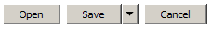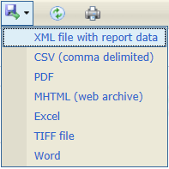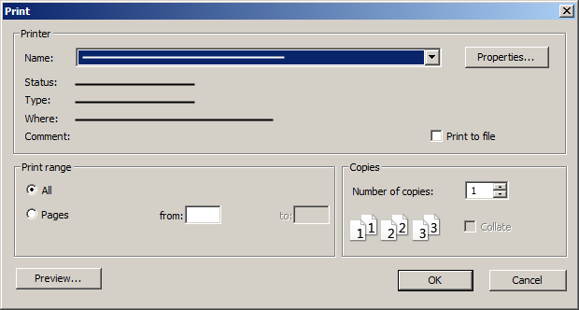  1  1  4  2  5  3 | Export a Report
- In the report toolbar, click the export icon down arrow.
- Select a file format from the list.
- Click Open to open the file or Save to save the file to your computer or network.

 | Print a Report
- In the report toolbar, click the printer icon.
Tip: Your version of Internet Explorer may require certain SQL Server Reporting Services add-on software be installed to print a report. If so, follow the browser instructions to install the required software.
- In the Print window, select your print options and click OK.

Days in State
This report shows the total and average number of days that submissions were in a particular state. Use this report to assess workflow efficiency and identify bottlenecks in the review process.
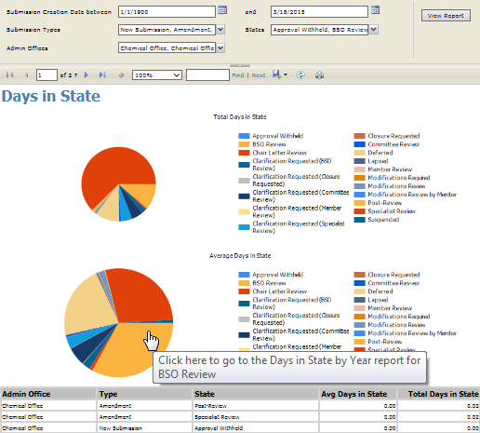

4

1

2

3

5
Report Filters | Chart Description
- You can filter approved submissions on:  - Submission Creation Date: The date the protocol team first saved the submission in the system  - Submission Types: The type of submission such as initial protocol or amendment  - States: The workflow state of the submission  - Administrative Offices: The administrative office assigned to the submission | - Two charts show the filtered data:  - Total Days in State: The total number of days submissions were in each state  - Average Days in State: The average number of days submissions were in each state  - The legend and chart show only those states selected in the States filter.
 | Table Description
 | - Several table rows showing total and average days may appear for each selected state. State data is first separated into rows by admin office, then by submission type, and then by state.
 | Other Report Features
- On a slice of pie in the chart:
- Hover over the slice to identify the state represented.
- Click the slice to view the data for that state, by year. See Days in State by Year for details.

Days in State by Year
This report shows the number of days, by year, that submissions were in a particular state.
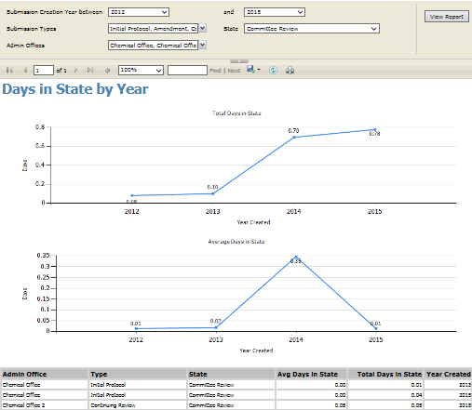

4

3

2

1

Report Filters | Chart Description
- You can filter submissions on:  - Submission Creation Year: The year the protocol team first saved the submission in the system  - Submission Types: The type of submission such as initial protocol or amendment  - State: The workflow state of the submission. By default, this filter is set to Specialist Review, however, you can select any state  - Administrative Offices: The administrative office assigned to the submission | - Two charts show the filtered data:  - Total Days in State: The total number of days submissions were in the selected state  - Average Days in State: The average number of days submissions were in the selected state
 | Table Description
 | - Several table rows showing total and average days may appear for the selected state. State data is first separated into rows by admin office, then by submission type, and then by year created.

Other Report Features
- If you reached this report by clicking the Days in State chart, the Back arrow takes you back to that report showing your original criteria.

Turnaround by Review Type
This report shows the average number of days it took for submissions (protocols, amendments, and/or continuing reviews) to go through a Safety review to approval, by review type.
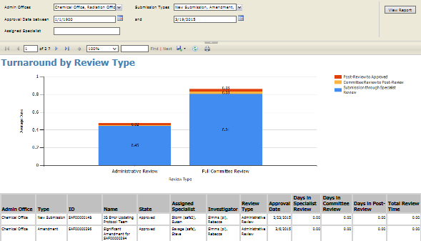

2

1

3
Report Filters | Chart and Legend Description
- You can filter all previously approved submissions on:  - Administrative Offices: The administrative office assigned to the submission  - Submission Types: The type of submission such as initial protocol or amendment  - Approval Date: The date the submission was approved  - Assigned Specialist: The name of the specialist assigned to the submission | - For each review type (determined by the last review performed), the chart shows the average number of days for a submission to move between milestones.  The height of the bar shows the total days from submission to approval. The numbers on each bar indicate the days to complete these milestone intervals:  Post-Review to Approved  - From: Date the administrative approval or committee review was submitted  - To: Date the approval determination letter was sent to the PI. Alternatively, the date the submission was sent to specialist review again, which can occur after the PI submits a response when approval was withheld or modifications were required.  Committee Review to Post-Review  - From: Date the specialist review was submitted  - To: Date the committee review was submitted  Submission through Specialist Review  - From: Date first submitted to the Safety office for review  - To: Date the specialist review or administrative approval was submitted

Other Report Features
- Click a bar in the chart to view the data for that review type, by year. See Turnaround by Year for details.

Turnaround by Year
This report shows the average number of days it took for submissions (protocols, amendments, and/or continuing reviews) to go through a Safety review to approval, by year.
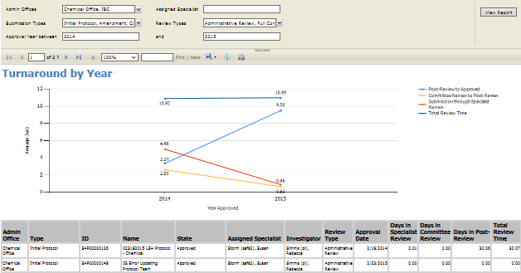

3

2

1
Report Filters | Chart and Legend Description
- You can filter all previously approved submissions on:  - Submission Types: The type of submission such as initial protocol or amendment  - Review Types: The type of review such as administrative or committee review  - Approval Year: The year the submission was approved | - For each year, the chart shows the average number of days for a submission to move between milestones. The Total Review Time points show the total days from submission to approval for each year. The numbers near the colored points indicate the days to complete these milestone intervals:  Post-Review to Approved  - From: Date the administrative approval or committee review was submitted  - To: Date the approval determination letter was sent to the PI. Alternatively, the date the submission was sent to specialist review again, which can occur after the PI submits a response when approval was withheld or modifications were required.  Committee Review to Post-Review  - From: Date the specialist review was submitted  - To: Date the committee review was submitted  Submission through Specialist Review  - From: Date first submitted to the Safety office for review  - To: Date the specialist review or administrative approval was submitted

Other Report Features
- If you reached this report by clicking the Turnaround by Review Type chart, the Back arrow takes you back to that report showing your original criteria.

Volume by Submission Type
This report shows the number of submissions (protocols, amendments, and/or continuing reviews) received by the Safety administrative offices, by submission type.
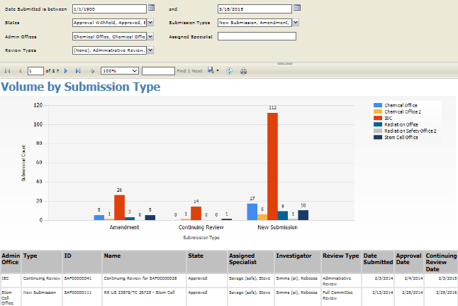

2

1

3

4
Report Filters | Chart Description
- You can filter submissions received by the Safety offices on:  - Date Submitted: The date the protocol team sent the submission to the Safety office for review  - States: The current state of the submission at the time of generating the report  - Submission Types: The type of submission such as initial protocol or amendment  - Administrative Offices: The administrative office assigned to the submission  - Review Types: The type of review such as administrative or committee review | - The chart shows the number of submissions for each submission type, and includes a bar for each administrative office.
 | Legend Description
 | - The legend and chart show only submissions assigned to the Safety administrative offices selected in the Administrative Offices filter.
 | Other Report Features
 | - Click a bar in the chart to view the data for that submission type, by year. See Volume by Year for details.

Volume by Year
This report shows the number of submissions received by the Safety office, by year.
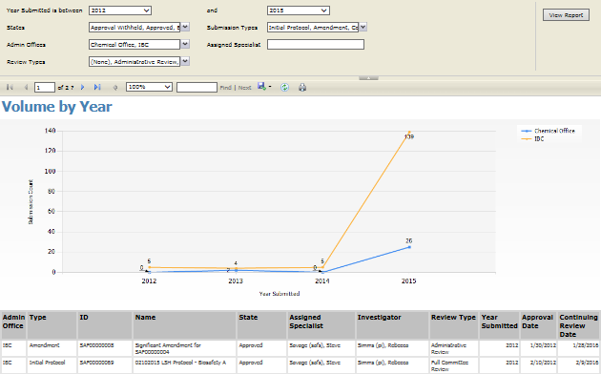

3

1

2

4
Report Filters | Chart Description
- You can filter submissions received by the Safety office on:  - Year Submitted: The year the protocol team sent the submission to the Safety office for review  - States: The current state of the submission at the time of generating the report  - Submission Types: The type of submission such as initial protocol or amendment  - Administrative Offices: The administrative office assigned to the submission  - Review Types: The type of review such as administrative or committee review | - The chart shows the number of submissions for each year.
 | Legend Description
 | - The legend and chart show only submissions assigned to the Safety administrative offices selected in the Administrative Offices filter.
 | Other Report Features
 | - If you reached this report by clicking the Volume by Submission Type chart, the Back arrow takes you back to that report showing your original criteria.

