[Type the company name]
IRB Study Submission Reference Guide

October 2016

Table of Contents
Logging In 3
Automatically Logging In 3
Creating a New Study 4
Finding More Information 5
Editing a Study 6
Checking the Study for Errors 6
Submitting the Study for Review 7
What to Expect After Submitting 8
Checking the Status of Your Study 9
Changing the Primary Contact 9
Accessing a Study 10
Responding to a Request for Clarifications or Modifications 11
Changing Documents on Your Study 12
Submitting Continuing Reviews and New Information 14
Responding to Action Required 15
Checklist of Information to Attach 17
Contacting Support 18

Logging In
The IRB system is secure, which means only authorized individuals have access to it. When you log in to the system, you get a personalized view of the information and possible actions pertinent to you.
To log in:  - If you do not see the form shown  to the right, click the Login link located at the top right corner of your screen.  - Type the user name and  password you received into the boxes. | 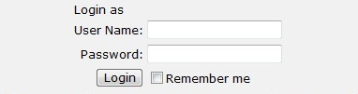
Tips: Press the Tab key after typing your user name to move to the Password box.
If you do not know your user name or password, contact the IRB for assistance. (See Contacting Support on page 16.)
- Click Login (or press Enter).

Automatically Logging In
You can set the IRB system to log you in automatically when you access the IRB web site.
Important! Do not enable autologin if you are using a shared or public computer. Autologin could cause a security breach by allowing others to take actions as though they were you.

To turn on autologin:  - The next time you log in, check the Remember me box before clicking Login. | 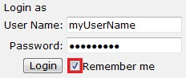
To turn off autologin:  - Click the Logoff link in the upper right corner.  - Click Clear Autologin. | 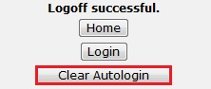

Creating a New Study
You can prepare a new study for IRB review by entering information into a series of online forms. The number of forms included may change based on the answers you provide. The forms tell you where to attach files to provide supporting information.
The simplest approach is to follow the forms in order, answering the questions and clicking Continue to save your information and move to the next form. When you reach the end of the series of forms, click the Finish button.
Note: A continuing review, modification, or RNI (reportable new information) submission can be handled similarly to a study. For differences, see Submitting Continuing Reviews and New Information on page 14.
Before you begin, gather files and information about your study such as:
- Supporting information files (for a list, see Checklist of Information to Attach on page 16)
- Financial interest status for each of your study team members
- Contact information and IRB oversight information for external sites involved in the study
Tips: If you regularly create studies with a similar set of team members, you can save time by defining the default team members to be added to each study you create. For instructions, see the online help.
Similarly, you can save time by defining the default list of ancillary reviewers to be added to each study you create. For instructions, see the online help.
To create a new study for review:
- From My Inbox, click Create New Study.
Note: If you do not see the Create New Study button, click the My Inbox link (upper right).
- Fill in the applicable boxes and answer the questions.
Tip: When you create a study, you are assigned to be the primary contact who receives all communications from the IRB on behalf of the study team. (The principal investigator you specified also receives the communications.) You can change the primary contact later as described in Changing the Primary Contact on page 3.
- Click Continue to move to the next form.
Tip: A red asterisk (*) precedes each question that requires an answer. If you cannot answer a required question at this time, or if you need to stop and continue at a later time, see the tips in the online help. If you do not answer a required question initially, you must return and answer it before you can submit the study for review.
- When you reach the final page, click Finish to exit the study.
You can continue to edit the study until you submit it for review. See Editing a Study on page 6.
Important! The study has not been submitted for review yet. For instructions, see Submitting the Study for Review on page 7.

Finding More Information
Resource | Description | How to Access It
Help for a field or page | More information about a question or form. | Click next to the question or at the top of the form.
Help system | The full online help system, with search and table of contents.  The online help contains procedures and information for all users. | - Click the Help Center link on the left.  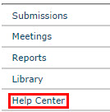  - Then click Help with Search at the top of the page.
IRB Study Submission Guide | Instructions for submitting a study for review. | - Click the Help Center link on the left.  - On the Guides tab, click the name of the guide to open it.
IRB Study Reviewer's  Guide | Instructions for reviewing an IRB submission.
IRB Staff Administration Guide | An overview of the IRB review and administration process.
IRB Library | Document templates, checklists, and IRB procedures. | Click the Library link on the left.

Editing a Study
You can continue to make changes to a study until you submit it for IRB review. You can also make changes if the IRB requests clarifications (except during committee review) or modifications.
To edit a study:
- From My Inbox, click the name of the study to open it.
Note: If the study does not appear in your inbox, see Accessing a Study on page 10.
- Click Edit Study on the left.
- Make changes as appropriate. When updating a study document previously submitted to the IRB, revise it in tracked-changes format and replace the original document with the tracked-changes version. When the IRB approves the document, all tracked changes will be accepted and comments removed in the final version.
- Exit the study.
Tip: Choose one of these ways to exit:
- Click the Exit link. If prompted to save the study, click Yes.
- Click Continue on each form, and then click the Finish button on the final form.

Checking the Study for Errors
Checking the study for errors and omissions helps you include all the relevant information, which is critical for receiving a timely review of your study.
Using these types of error checking helps you supply all the information the IRB needs:
- Automatic system error checking identifies any omitted answers to required questions on the form when you click Continue. A red asterisk (*) precedes each blank or question that requires an answer. Keep in mind that the system cannot catch every omission while you edit the study if you skip questions that cause more forms to be added to your study.
- Visually inspecting the forms to see what you may have missed, especially:
- Questions that are relevant to your study but are not required for all studies
- Documents that should be attached (see Checklist of Information to Attach on page 16)
To perform a visual inspection, open the study and look through the forms in order. To open the study, see Editing a Study on page 6.
- Using the Hide/Show Errors option to find and correct all errors before submitting the study. The system automatically checks for errors when the PI attempts to submit the study. However, if you are filling out the forms on behalf of the PI, it is best to check the study for errors before the PI attempts to submit it, using the steps below.

To use Hide/Show Errors to find and correct errors:
- Open the study, as explained in Editing a Study on page 6.
- From the top navigation area, click Hide/Show Errors.
The Error/Warning Messages pane appears at the bottom of the window, listing all the current errors and where to find them.
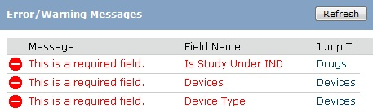
- For one of the errors listed, click the link in the Jump To column to go to the form containing the error.
- Click Continue to identify the specific questions on the form with errors.
- Fill in the missing information.
- Click Refresh in the Error/Warning Messages pane to update the list of errors.
- Continue correcting errors until no errors are listed.

Submitting the Study for Review
After entering all required information into the forms and attaching files, the principal investigator must submit the study for IRB review.
Tips:
- Make sure you attach all applicable information to the study, as identified in Checklist of Information to Attach on page 16.
- Check for missing information before attempting to submit the study, as described in Checking the Study for Errors on page 6. Any errors or omissions not corrected are shown when attempting to submit the study and must be corrected before you can submit it for review.
- Identify any person or organization outside the IRB who needs to review the study. Add them to the list of ancillary reviewers by clicking Manage Ancillary Reviews. For instructions, see the online help.

To submit the study for IRB review:
Important! Only the principal investigator can complete the following steps.
- Log in to the system.
- Make sure you are in My Inbox.
Note: If you do not see My Inbox, click the My Inbox link (top right part of the page).
- Click the name of the study to open it.
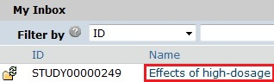
Tip: If the study does not appear in the list, perhaps it was already submitted, or it does not include you as a study team member. To find the study, try clicking IRB in the top left navigation area. If you do not see it in that list, see Accessing a Study on page 10 for more ideas.
- Click Submit from the My Current Actions list on the left.
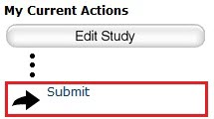
Tip: If any errors or warnings are shown, click the link in the Jump To column to go to the form containing the problem. For more information, see Checking the Study for Errors on page 6. When all errors are corrected, try submitting the study by clicking Submit again.
- Click OK to agree to the statement presented on the screen.
- When prompted, log in again to verify your identity as the study's PI.
- Click Submit.

What to Expect After Submitting
Submitting information to the IRB initiates a series of activities that may include:
- Review within your department
- Pre-review by an IRB staff member
- Review by the IRB committee or a designated reviewer
- Communication of the IRB decision to the investigator
Any of these may lead to a request for the study team to take further action, such as providing clarifications or modifying the study. Whenever the study team needs to act, the PI receives an e-mail notification, and the study appears in My Inbox for all study team members when they log in to the IRB system.
Important! Make sure the appropriate person is listed as the primary contact to receive e-mail and see the study in My Inbox (along with the PI and any PI proxies, who also receive these). By default, the person who created the study is the primary contact. See Changing the Primary Contact on page 9.

Checking the Status of Your Study
You can see a diagram showing the state of your study within the IRB review process by opening the study. For example:
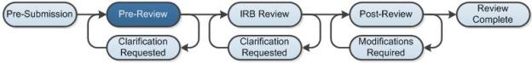
You can easily open your study from one of the following lists (depending on its status):
- My Inbox
- IRB In-Review Studies
- IRB Active Studies
For instructions about opening your study from these lists, see Accessing a Study on page 10.

Changing the Primary Contact
The study's primary contact for receiving communications from the IRB can be changed at any time. For example, it may help to provide a contact person in addition to the PI if the PI does not check e-mail frequently.
The primary contact can also edit the study just as a study team member can.
Notes:
- To change the primary contact, you must be a member of the study team or the IRB coordinator assigned to the study.
- By default, the person who created the study in the system is the primary contact.
- The PI and any PI proxy continue to receive notifications regardless of the primary contact assignment.
- Modifications or continuing reviews have the same primary contact as the initial study. To change the primary contact on these submissions, do so in the initial study.
To change the primary contact:
- Open the study by clicking the study's name. (For instructions about finding the study, see Accessing a Study on page 10.)
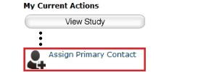
- Click Assign Primary Contact from the My Current Actions list on the left.
A new window opens.
- Click Clear to remove the current contact.
- Begin typing the name of the new contact.
A list of matching names appears.
- Select the correct name using the mouse or down arrow key.
- Click OK.
Note: If the primary contact is also engaged in the research, make sure the list of team members within the study includes the person.

Accessing a Study
You may want to open a specific study to view or update its contents, submit it for review, review it, or take other actions on the study.
Note: Your access to a study is personalized based on your role in the system and the role you play in relation to the particular study. In addition, the actions you can take on a study are personalized.
To open a study, click its name when you find it in a list of studies.
To find a list that includes the study, try these suggestions:
Check this list... | For... | How to find this list
My Inbox | Studies assigned to you for action, such as a study you are:  - Preparing to submit  - Assigned to review | Click the My Inbox link in the top right navigation header.
IRB In-Review tab | Studies the IRB has not reviewed or for which it has not communicated a decision | Click IRB in the top left navigation area and select the In-Review tab.  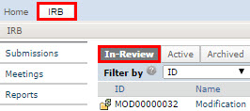
IRB Active tab | Studies approved by the IRB and currently in progress | Click IRB in the top left navigation area and select the Active tab.
IRB All Submissions tab | All studies, continuing reviews, modifications, and reportable new information (RNI) entered into the system that you have permissions to view | Click IRB in the top left navigation area and select the All Submissions tab.  Tip: Try filtering this list by the study name or principal investigator. Next to Filter by, select Name or Investigator. Then type the beginning of the name and click Go.
IRB New Information Reports tab | Reportable new information (RNI) submissions, possibly related to one or more studies | Click IRB in the top left navigation area and select the New Information Reports tab.

Responding to a Request for Clarifications or Modifications
At any stage during the review process, the IRB may request clarifications to the study content. Similarly, the official IRB determination may be that the study requires changes before research can begin.
Both situations require the study staff to take similar actions. In either case, the PI, any PI proxy, and the study's primary contact receive an e-mail. The study also appears in My Inbox for each member of the study team.
Important!
- Any study team member can update the study, but only the PI can submit the response to the IRB.
- Failure to respond promptly slows the review and approval process for your submission. In some cases, your submission may be rescheduled for review at a later IRB meeting because the committee requires your response before making a decision.

To view the details of the request and respond with the changes:
- From My Inbox, click the name of the study to open it.
- Locate the details of the request, as described here:
For clarification requested: In the Activity column under Clarification Requested, read the request details.
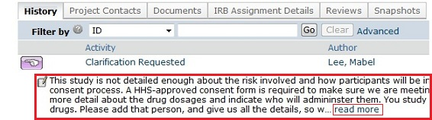

If applicable, click the read more link to display the remaining text.

For modifications required: Click the letter link near the top of the page on the right side. The letter contains the modification requirement details.
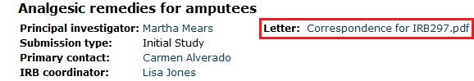

- Edit the study to incorporate changes as needed. For instructions, see Editing a Study on page 6.
Notes:
- In most cases, you can update all aspects of the study, including adding, updating, or removing attached documents.
- When updating a study document previously submitted to the IRB, revise it in tracked-changes format and replace the original document with the tracked-changes version. When the IRB approves the document, all tracked changes will be accepted and comments removed in the final version.
- If clarifications were requested during committee review, you cannot edit the study, and you see the View Study button instead. In that case, respond to the reviewer by commenting in the Submit Response form, as described in the next step.
- (PI only) Click Submit Response to return the study to the reviewers.
Notes:
- The Submit Response form gives you space to type a point-by-point response to the requests and to attach a file. However, any permanent study information should be incorporated into the study itself.
- If clarifications were requested during committee review, you may be asked to make changes to the study after the review is complete.
- For an RNI submission, click Submit RNI Response instead.
- Click OK.
The study returns to the review process.
For information about completing an action plan for an RNI submission, see Responding to Action Required on page 15.

Changing Documents on Your Study
You may need to modify a study's documents when:
- The IRB requires changes prior to approval.
- Submitting a modification to an approved study.
To change documents prior to study approval:
Note: These steps apply if the IRB decision was modifications required, disapproved, or deferred.
- From My Inbox, click the name of the study to open it.
- Click the Documents tab.
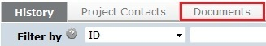
- Click the document in the Draft column and save it to your computer.
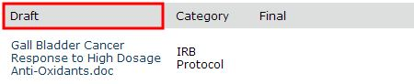
- Open the document.
- Enable the Track Changes feature and update the document.
- When finished, replace the original study document with the tracked-changes version. When the IRB approves the document, all tracked changes will be accepted and comments removed in the final version.
To change documents on an approved study:
- Click IRB in the top left navigation area and select the Active tab.
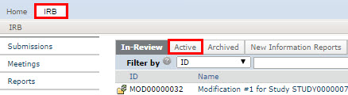
- Click the name of the approved study.
- Click the Documents tab.
- Click the document in the Final column and save it to your computer.
Tip: In some cases, you may only be able to use the draft document because the final document is a PDF. In this case, the draft document may contain tracked changes and comments. To make its content match the final PDF, use the review features in Word to accept all the changes and remove any comments. Use this clean document as a starting point for your revisions.
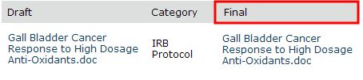
- Open the document and revise it in tracked-changes format.
- When finished, replace the original document with the tracked-changes version in the modification. When the IRB approves the document, all tracked changes will be accepted and comments removed in the final version.

Submitting Continuing Reviews and New Information
The table below summarizes how to get started submitting each type of information to the IRB.

To submit this type of information... | ...start here... | ...and click this button | Notes
Continuing review updates for an active study | From the Active tab, click the study name (see Accessing a Study on page 10) |  | You can submit a continuing review and a modification at the same time. The first form prompts you to identify the type of information to submit. To request study closure, submit a CR. Based on the research milestones completed, the study may be closed.
Modifications to an active study
Request to close study
New information or an adverse event report | For new information about a particular study, start from the Active tab and click the study name (see Accessing a Study on page 10) |  | Report new information as soon as you become aware of it. The form identifies the types of information you must report.
 | For information affecting multiple studies, start in My Inbox
New study for review | My Inbox |  | See Creating a New Study on page 4.
Updates to a new study that hasn't been submitted for IRB review yet | Within the study (see Accessing a Study on page 10) |  | See Editing a Study on page 6.

Responding to Action Required
After reviewing a new information report (or adverse event), the IRB may require specific actions to be taken in response to the reported issue. A responsible party is assigned to complete the action.
The system sends e-mail to notify the responsible party, the submitter of the RNI (reportable new information), as well as the PIs, PI proxies, and primary contacts of all related studies. The RNI also appears in My Inbox for the responsible party.
To view the action plan and respond to the IRB:
- From My Inbox, click the name of the RNI submission to open it.
- View the details of the RNI submission and the action plan, as described here:
Read the letter: Click the letter link near the top of the page on the right side. The letter typically contains the action plan and a summary of the IRB's decisions.
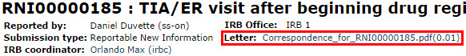
Review the action plan: Click the Action Plan tab and read the action plan listed there, plus any history of the action plan that might be helpful.
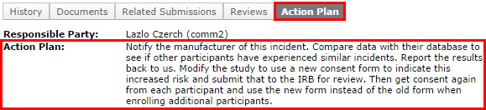
Review the RNI submission details: If you aren't already familiar with the details of the information report, read it by clicking View RNI on the left side.
- Take action inside or outside the system to complete the action plan.
Tip: You can add related studies to the RNI submission to indicate that the information report applies to the studies. From the RNI submission, click Add Related Submission on the left.
If the action plan requires a change to a study, create a modification and submit it for review as mentioned in Submitting Continuing Reviews and New Information on page 3. Then return to the RNI and add the modification using Add Related Submission. The study being modified must be added as a related submission before the modification can be added.
- Click Submit Action Response to indicate that the action plan is complete.
The Submit Action Response form gives you space to type notes and attach a file. Summarize the actions taken to resolve the reported issue and complete the action plan.
- Click OK.
The RNI submission is returned to the IRB to verify completion of the action plan.

Checklist of Information to Attach
Be prepared to attach several files to your study. While editing the study, several forms provide places to attach related files. In some cases, a template file is provided, such as for the protocol.
When attaching each file, name it as you want it to appear on the IRB approval letter.
Attach the information listed below (if relevant to your study) to the location identified.

Protocol: (Basic Information page)
- Investigator protocol  - Complete sponsor protocol  - Site supplement to sponsor protocol | - HHS (Department of Health and Human Services) protocol
Funding information: (Funding Sources page, with each source)
- Grant applications
Drug details: (Drugs page, with each drug, or on main Drugs page if not specific to one drug)
- Package insert  - Investigator brochure | - Verification of each IND number (one of these):  - Sponsor protocol with the IND number  - Communication from the FDA or sponsor with the IND number
Device details: (Devices page, with each device, or on main Devices page if not specific to one device)
- Product labeling/device instructions  - Investigator brochure | - Verification of each IDE or HDE number (one of these):  - Sponsor protocol with the IDE / HDE number  - Communication from the FDA or sponsor with the IDE / HDE number
Recruitment and consent details: (Recruitment Materials page)
- Consent documents:  - Consent forms  - HHS-approved consent document  - For non-written consent, a script of the information provided orally to the subjects | - All material to be seen or heard by subjects, such as:  - Evaluation instruments and surveys  - Advertisements, including printed, audio, and video  - Recruitment materials and scripts  - Foreign-language versions of materials for subjects
All other relevant documents: (Supporting Documents page)
- Conflict of Interest Committee's determination for each financial interest related to the research | - Completed checklist of meeting Department of Energy requirements

