[Type the company name]
IRB Study Reviewer's Reference Guide
October 2016

Table or Contents
Logging In 3
Automatically Logging In 3
Locating Your To-Do List 4
Understanding My Inbox 5
Locating Meeting Agenda Items 5
Locating Checklists for Reviewers 8
Key Checklists and Worksheets 9
Viewing the Study Details 10
Requesting Clarifications to a Study 11
Viewing Changes to a Study 12
Preparing Comments for a Meeting 13
Submitting a Review Decision 14
Accessing a Study 17
Finding More Information 18
Contacting Support 18

Logging In
The IRB system is secure, which means only authorized individuals have access to it. When you log in to the system, you get a personalized view of the information and possible actions pertinent to you.
To log in:  - If you do not see the form shown to the right, click the Login link located at the top right corner of your screen.  - Type the user name and password you received into the boxes. | 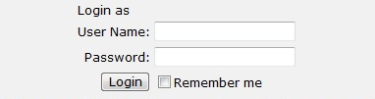
Tips: Press the Tab key after typing your user name to move to the Password box.
If you do not know your user name or password, contact the IRB for assistance. (See Contacting Support on page 18.)
- Click Login (or press Enter).

Automatically Logging In
You can set the IRB system to log you in automatically when you access the IRB web site.
Important! Do not enable autologin if you are using a shared or public computer. Autologin could cause a security breach by allowing others to take actions as though they were you.

To turn on autologin:  - The next time you log in, check the Remember me box before clicking Login. | 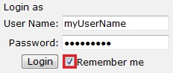
To turn off autologin:  - Click the Logoff link in the upper right corner.  - Click Clear Autologin. | 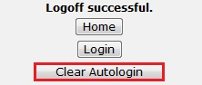

Locating Your To-Do List
IRB studies that are assigned to you for action generally appear in My Inbox with a link to the study. You may also receive an e-mail with a link to the study. An e-mail indicates that you must take action or informs you of important changes, such as an IRB decision about your study.
Note: A continuing review, modification, or RNI (reportable new information) submission can be handled similarly to a study.
To access a study that does not appear in My Inbox, see Accessing a Study on page 17.
Note for committee members: You can view the list of all submissions to be reviewed for a committee meeting as described in Locating Meeting Agenda Items on page 5.
To access studies or other submissions assigned to you:
- Click the My Inbox link in the top right navigation header.
- Identify the reason the study appears in My Inbox by looking at the State column.
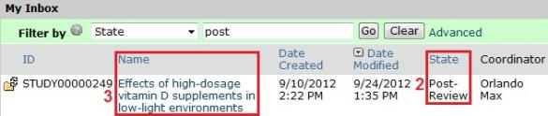
- Open the study by clicking the link in the Name column.
The study workspace opens.
To view the details of the study, click View Study on the left. For instructions, see Viewing the Study Details on page 10.

Understanding My Inbox
The list called My Inbox contains studies or other submissions that require you (or your team members) to take action. See the examples below to understand what you should and should not expect to appear in My Inbox.
Tip: Look at the State column in My Inbox, and see the explanation for that state in the table below.
Your role | In My Inbox |  | Not in My Inbox
 | State | Explanation
IRB committee member or occasional reviewer | Non-Committee Review | You have been designated as the reviewer for this exempt or expedited study. You must submit your final review before the IRB decision can be communicated to the study team. If you request clarifications, the study comes back to you to finish the review after the clarifications are made. | Studies assigned to other reviewers
 | Committee Review | You may be part of the committee that will review this study. If so, review the study details in advance. You can request clarifications. Record your notes and recommendations in the system before the meeting as described in Preparing Comments for a Meeting on page 13. | Studies assigned to other committees
Ancillary reviewer | One of several | You have been selected as a reviewer (either by name or representing a specific organization). The IRB can begin its review before you submit your review. The IRB may or may not wait for your input before completing its review of the study. | Studies not yet submitted for review

Locating Meeting Agenda Items
As a committee member, you can get a meeting agenda listing the studies and other submissions to be reviewed in an upcoming meeting. You can get the agenda in two forms:
- As a web page with links to the studies
- As a printable document
The procedures below describe how to access both forms of the agenda in two alternative ways:
- From an agenda notification e-mail you receive
- By navigating to the agenda within the IRB system
To access the agenda from an e-mail you receive:
- Open the e-mail informing you about an IRB meeting agenda.
The notification content should resemble this:
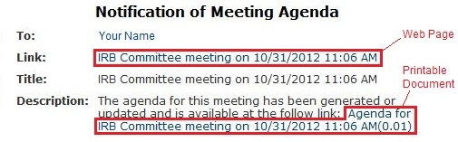
- Click the appropriate link:
- To access the meeting workspace web page containing links to the studies, click the link next to Link (shown above). The meeting workspace and its important links are shown below.
- To open or save the printable document, click the link next to Description (shown above).
Note: The most up-to-date agenda is in the web page format.
- If prompted, log in to the IRB system.
Tip: For more details about opening the document or using the web page, see the procedure below about navigating to the agenda.
To access the agenda by navigating to it:
- Click IRB and then Meetings on the left.
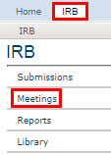
- From the list of meetings shown in the center of the page, click the name of the meeting to view.
The meeting workspace displays the list of agenda items in the center of the page, resembling this:
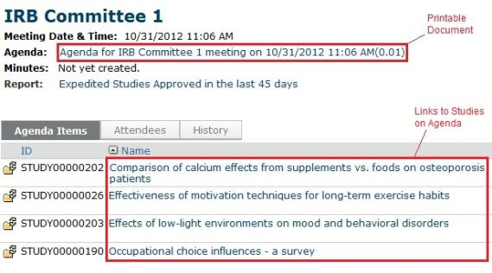
- Click the appropriate link:
- To access a study directly from the agenda items list, click the link to the study (shown above).
- To open or save the printable document, click the link in the page header next to Agenda (shown above). The agenda is in Microsoft Word format.
Tip: Microsoft® Word documents open differently in different web browsers. If the document does not open promptly:
- Click the Word icon if it is flashing at the bottom of your screen, and then click one of your open Word documents.
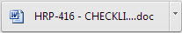
- Check the bottom of the browser window to see if the document icon and name is shown there. If so, click the name to open it.

Locating Checklists for Reviewers
Several worksheets and checklists are provided in the system to guide your review process and document your decisions. They are intended for pre-reviewers, designated reviewers, and committee reviewers.
- Worksheets are for the reviewer's benefit only.
- Checklists must be completed and attached when submitting your review comments to document your decisions.
Tip: First identify the pertinent documents using the topical list in Key Checklists and Worksheets on page 9. Then locate them using the procedure below.
To locate the worksheets and checklists:
- Click IRB and then Library on the left.
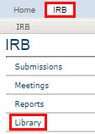
- Click the Worksheets or Checklists tab, depending on the document you want to view.
- Click a link to open or save the applicable document, which is in Microsoft Word format.
Tip: Microsoft® Word documents open differently in different web browsers. If the document does not open promptly:
Click the Word icon if it is flashing at the bottom of your screen, and then click one of your open Word documents.

Check the bottom of the browser window to see if the document icon and name is shown there. If so, click the name to open it.

Key Checklists and Worksheets
Many checklists and worksheets for reviewers are available in the IRB Library to provide reminders, guide decisions, and help document decision criteria.
Important! Checklist information is required by regulations to document the findings that justify your determinations. Fill out the pertinent checklists and attach them when you submit the review form. For committee reviews, attach your individual checklists as described in Preparing Comments for a Meeting on page 13.
Worksheets also provide important guidance, but regulations do not require them to be retained.
The following table summarizes the pertinent checklists and worksheets, organized by the types of review decisions you must make.
Topic | Checklists (use and attach) | Worksheets (for reviewer's use)
Approval criteria |  | - Criteria for Approval (HRP-314)
Level of review |  | - Engagement (HRP-311)  - Exemption (HRP-312)  - Expedited (HRP-313)
Consent / recruitment | - Waiver or Alteration of Consent (HRP-410)  - Waiver of Written Documentation of Consent (HRP-411)  - Waiver of Consent for Emergency Research (HRP-419)  - HIPAA Waiver of Authorization (HRP-441)
Special populations | - Pregnant Women (HRP-412)  - Non-Viable Neonates (HRP-413)  - Neonates of Uncertain Viability (HRP-414)  - Prisoners (HRP-415)  - Children (HRP-416)  - Cognitively Impaired Adults (HRP-417)
Devices / drugs | - Non-Significant Risk Device (FDA) (HRP-418)
Federal agencies / laws | - HIPAA Waiver of Authorization (HRP-441)

Viewing the Study Details
As a reviewer or IRB staff member, you often need to view all the information submitted as part of the study.
To view the details of a study:
- From My Inbox, click the name of the study to open it.
Note: If the study does not appear in your inbox, see Accessing a Study on page 17.
- Click View Study on the left.
Tips:
- For a continuing review or modification, click View Modification / CR instead.
- For a new information report, click View RNI instead.

- Use the Continue and Back buttons to view all of the forms.
Tip: Clicking Continue from the Supporting Documents page (the last page of the forms) exits the study.
To view the documents submitted as part of the study, you have these options:
- While viewing the details of the study (as instructed above), click the name of each document when you encounter it on the various forms. Documents are listed in tables throughout the forms.
- When you have opened the study workspace (as in step 1 above), you can view a list of all the attached documents in one place by clicking the Documents tab.
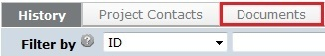
Tip: If the study team updated the documents, they may contain tracked changes. You can use the review features in Word to toggle between showing the original and final versions of the document. When the IRB approves the documents, all tracked changes will be accepted and comments removed in the final versions.
To view the information entered for pre-review:
- Open the study as instructed in step 1 above.
- Click the Reviews tab.
Tip: If the information entered for pre-review is inaccurate, contact the study's IRB coordinator to request a change. The coordinator can change the pre-review information until the decision from designated or committee review is submitted.

Requesting Clarifications to a Study
If a study is confusing or needs additional information to receive IRB approval, you can request clarifications. Requesting clarifications sends the study back to the study team so they can edit it.
To request clarifications to a study:
- From My Inbox, click the name of the study to open it.
- Click Request Clarification... on the left.
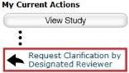
- In the Request Clarification form, provide detailed questions or requests for changes.
Note: You can also attach documents that explain, show the study text, or show screen captures of the problematic areas, or that show suggestions for resolving the problems.
- Click OK to send the request to the study team.
Unless the study is in committee review, you will receive an e-mail notification when the study team submits their response to the clarification request.
Requests for clarifications are handled differently during committee review than during other types of review in that study team members are not solely in control of the submission:
- Committee members can continue to request clarifications after a request has been made. This allows multiple reviewers to communicate with the study team at once.
- Study team members cannot edit the study when the clarifications requested are from committee review, but they can submit comments back to the committee.
- The committee cannot record a decision for the submission when it is in the Clarification Requested state. The options are:
- The IRB coordinator can remove the submission from the agenda before the meeting and reassign it to a later meeting.
- At the time of the meeting, the committee chair or administrator can use the Convene Meeting activity to return all submissions still in the Clarification Requested state to the Committee Review state so their reviews can be recorded.

Viewing Changes to a Study
When a study changes based on reviewer requests, you may want to:
- View the response submitted for a particular request
- View the differences between two versions of a study
To view the response submitted for a clarification request:
- From My Inbox, click the name of the study to open it.
- Click the History tab.
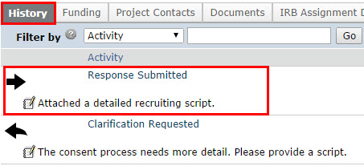
- Click the Response Submitted activity link to see any notes or documents added to the study.
To view the differences between two versions of a study:
- From My Inbox, click the name of the study to open it.
- Click View Differences on the left.
- Next to Show Changes, select a version to compare the current study to.
- Look for red and green changes in the current form.
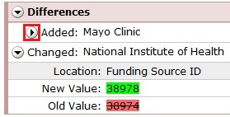
Click the arrow to show the details. The changes since the version you selected appear as follows:
- Additions to text since that version are shown with green highlighting.
- Deletions to text show in a light red box below the current text.
- Additions and deletions of selectable items show the changes (such as old values) in a light red box after the current values that appear normally.

- Next to Changed Steps, click the arrow (or use the drop-down list) to view each of the other forms that have changed.
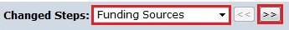
- Exit the View Differences screen by clicking Close on the right.
Tip: If the study team updated the documents, they may contain tracked changes. You can use the review features in Word to toggle between showing the original and final versions of the document. When the IRB approves the documents, all tracked changes will be accepted and comments removed in the final versions.

Preparing Comments for a Meeting
While reviewing a study, you can record your review comments within the IRB system. You can also upload required checklists and any review-related documents. This lets committee members view each other's comments before and during the meeting.
All of your comments and the files you attach will be purged from the system when the approval letter is sent. Your comments are never visible to the study team members.
To record your review comments:
- Open the study. For details, see Accessing a Study on page 17 or Locating Meeting Agenda Items on page 5.
- Click Add Review Comments on the left.
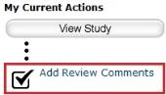
- Type in notes, and upload any relevant reviewer checklists and other related documents.
- Click OK.
Note: Before and during the committee meeting, you can go to the study's Reviews tab as shown below to view your comments and comments from other reviewers.
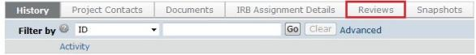

Submitting a Review Decision
After reviewing a study or other submission, you must record the decision in the system. Recording the decision completes the review and moves the study forward in the IRB process.
Note for committee members: An IRB staff member must submit the decision on behalf of the committee. If you are a reviewer of the study, record your comments and attach relevant files (such as reviewer checklists) as described in Preparing Comments for a Meeting on page 13.
Tip: You can include comments when you record your decision. To avoid regulatory issues, it is best to phrase your comments as questions or requests for information. If you need the study team to answer a question before you can complete the review, request clarifications as described in Requesting Clarifications to a Study on page 11.
There are several types of review, with procedures for each identified below:
- Ancillary review
- Pre-review
- Designated review
- Committee review
Note: The procedures below assume that the study team has completed any requested clarifications.
To open the study:
- From My Inbox, click the name of the study to open it.
- Choose the appropriate procedure below.
To complete an ancillary review:
- Click Submit Ancillary Review on the left.
- Select the review you are completing from the list.
- Indicate whether you think the submission is acceptable as it is currently written.
- (Optional) Add comments and attach documents related to the review.
- Click OK.
The review comments are shown in the study.
To complete a pre-review:
- Click Submit Pre-Review on the left.
- Answer the relevant questions, paying special attention to each required question marked with a red asterisk (*).
- (Optional) Attach documents related to the review, such as checklists.
- If you are ready to move the study to the next stage of IRB review, answer Yes when asked if you are ready to submit this pre-review.
Otherwise, answer No, which enables you to return and perform Submit Pre-Review again to update the information.
- Click OK.
Important! If you moved the review to the next stage, now you must assign the study to a committee meeting or a designated reviewer.
To complete a designated (or non-committee) review:
Tip: If the information entered for pre-review is inaccurate, contact the study's IRB coordinator to request a change. The coordinator can change the pre-review information until the decision from designated or committee review is submitted. Make sure it is corrected before you submit your review decision.
- Click Submit Designated Review on the left.
- If true, check the box to indicate that you do not have a conflicting interest. (For more details about conflicting interests, click the icon.)
- Answer the relevant questions, paying special attention to each required question marked with a red asterisk (*).
- (Optional) Add comments and attach documents related to the review.
- If you have entered all the relevant information and are ready to submit the final IRB decision, answer Yes when asked if you are ready to submit this review.
Otherwise, answer No, which enables you to return and perform Submit Designated Review again to update the information.
- Click OK.
If you submitted the final decision, the IRB can now officially communicate the decision to the study team.

To complete a committee review:
Important! An IRB staff member must submit the decision on behalf of the committee. If you are a reviewer of the study, record your comments and attach relevant files (such as reviewer checklists) as described in Preparing Comments for a Meeting on page 13.
Tip: If the information entered for pre-review is inaccurate, contact the study's IRB coordinator to request a change. The coordinator can change the pre-review information until the decision from designated or committee review is submitted.
- Click Submit Committee Review on the left.
- Answer the relevant questions, paying special attention to each required question marked with a red asterisk (*).
- (Optional) Add notes and attach documents related to the committee's review.
- Click OK.
The IRB coordinator assigned to the study can now officially communicate the decision to the study team.

Accessing a Study
You may want to open a specific study to view or update its contents, submit it for review, review it, or take other actions on the study.
Note: Your access to a study is personalized based on your role in the system and the role you play in relation to the particular study. In addition, the actions you can take on a study are personalized.
To open a study, click its name when you find it in a list of studies.
To find a list that includes the study, try these suggestions:

Check this list... | For... | How to find this list
My Inbox | Studies assigned to you for action, such as a study you are:  - Preparing to submit  - Assigned to review | Click the My Inbox link in the top right navigation header.
IRB In-Review tab | Studies the IRB has not reviewed or for which it has not communicated a decision | Click IRB in the top left navigation area and select the In-Review tab.  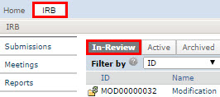
IRB Active tab | Studies approved by the IRB and currently in progress | Click IRB in the top left navigation area and select the Active tab.
IRB All Submissions tab | All studies, continuing reviews, modifications, and reportable new information (RNI) entered into the system that you have permissions to view | Click IRB in the top left navigation area and select the All Submissions tab.  Tip: Try filtering this list by the study name or principal investigator. Next to Filter by, select Name or Investigator. Then type the beginning of the name and click Go.
IRB New Information Reports tab | Reportable new information (RNI) submissions, possibly related to one or more studies | Click IRB in the top left navigation area and select the New Information Reports tab.

Finding More Information
Resource | Description | How to Access It
Help for a field or page | More information about a question or form. | Click next to the question or at the top of the form.
Help system | The full online help system, with search and table of contents.  The online help contains procedures and information for all users. | - Click the Help Center link on the left.  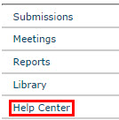  - Then click Help with Search at the top of the page.  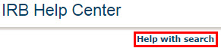
IRB Study Submission Guide | Instructions for submitting a study for review. | - Click the Help Center link on the left.  - On the Guides tab, click the name of the guide to open it.
IRB Study Reviewer's Guide | Instructions for reviewing an IRB submission.
IRB Staff Administration Guide | An overview of the IRB review and administration process.
IRB Library | Document templates, checklists, and IRB procedures. | Click the Library link on the left.

