[Type the company name]
IRB Staff Administration Reference Guide

October 2016

Table of Contents
IRB Process Overview 4
IRB Submission Types 4
Study Process Overview 5
Ancillary Review Overview 6
Initiating Ancillary Reviews 6
Notifications and Ancillary Review Feedback 7
Decisions Regarding Ancillary Review Feedback 7
External IRB Process Overview 8
Modification / CR Process Overview 9
Modifications 9
Study Closure Through Continuing Review 10
Combined and Separate Modifications and Continuing Reviews 10
Pre-Review for Modifications and Continuing Reviews 10
RNI Process Overview 11
RNI Review Workflow 12
Action Required Workflow 13
Related Studies and Modifications 13
Document Change Process Overview 14
Access to Studies by Role 15
Performing Basic Administration Tasks 15
Locating Your To-Do List 16
Navigation Elements Within a Study 17
Accessing a Study 18
Assigning Ownership of a Study 19
Viewing the Study Details 19
Understanding My Inbox 20
Checklist of Committee Meeting Tasks 22
Preparing for Each Meeting 22
Conducting the Meeting 22
Wrapping Up After the Meeting 24
Generating Standard Reports 25
Producing the AAHRPP Annual Report 25
Finding More Information 27

IRB Process Overview
The IRB system treats all types of submissions—studies and follow-on submissions—very similarly. You perform the same activities and follow the same process for each, with small exceptions. The questions asked are different for each type of submission, but the workflow is almost the same.
At the highest level, all submission types use the following IRB process workflow:
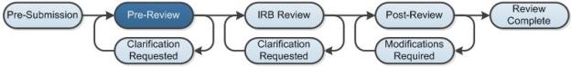
The system shows the diagram above when you view an individual study and shows the current state of the study in dark blue (Pre-Review in this case). Pre-Review indicates that an IRB coordinator is reviewing the study before the IRB committee members review it.

IRB Submission Types
The IRB system accepts these types of submissions:
- Initial submissions (studies)
- Follow-on submissions:
- Modifications and continuing reviews (either combined or separate) for approved studies
- New information reports (often called RNI for reportable new information) for approved studies or active research in general
All submission types follow a very similar workflow. Some differences include:
- Each type of follow-on submission has its own set of determinations that differs from the study determinations.
- Studies, modifications, and continuing reviews include optional ancillary reviews that can be conducted concurrently with the IRB's reviews. RNI submissions do not include ancillary review.
- RNI submissions may skip certain states or require committee review after designated review has been completed.

Study Process Overview
The basic process for a study—or initial submission—is shown in the following diagram. The exploded view shows what occurs during the IRB review process.
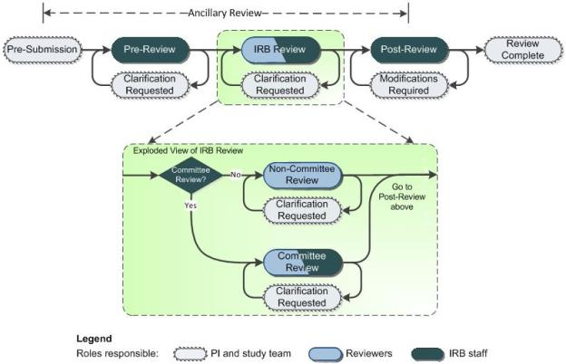
The legend indicates who can take major actions during each state within the process. Keep in mind that the diagram does not show all possible paths that a submission may take. The diagram shows the most likely path through the review process with common options identified.
Studies include optional ancillary reviews that can be conducted concurrently with the IRB's reviews. For more ancillary review information, see Ancillary Review Overview on page 6.
Before IRB review activities can begin, the submission must be assigned to an IRB coordinator, as described in Assigning Ownership of a Study on page 19.
Notable information about several states is identified below.
Pre-Review and Clarification Requested: In the Pre-Review state, the IRB coordinator answers questions about oversight agencies, special populations, etc., that apply to the study. Instead of asking the study team to answer the questions, the IRB staff takes responsibility for reviewing the submission information and answering them. Answering these questions before a committee review can save the committee's time if information is found to be missing or inconsistent. The IRB coordinator can send the study back to the study team for clarification if needed, which lets the study team change the study. For details about allowing the IRB coordinator to edit the study, see the online help.
IRB Review: IRB review is not a single state, but a collection of other states.

Post-Review and Modifications Required: The Post-Review state gives the IRB staff the opportunity to:
- Mark selected documents attached to a submission as approved to create final copies
- Prepare a letter to inform the study team about the IRB's decision
- Send the letter
Sending the letter transitions the submission to the state determined by the IRB, such as Modifications Required or Approved. If the IRB decided to require modifications to the study before approving it or considering it Not Human Research, etc., the submission moves to the Modifications Required state to allow the study team to respond.
When the study team submits modifications, the IRB coordinator, director, or committee chair can choose to review the modifications using the Review Required Modifications activity. The IRB coordinator and director can also assign the modifications to non-committee or committee review, as appropriate. If not acceptable, the submission is sent back to the Modifications Required state. If the modifications are acceptable, the submission returns to the Post-Review state and receives its final determination (for example, Approved) when the letter is sent.
The system purges all individual comments from committee review (everything submitted through the Add Review Comments activity) when the letter reflecting the final state is sent.

Ancillary Review Overview
The review process for studies, modifications, and continuing reviews optionally includes ancillary reviews. Ancillary reviews allow individuals, departments, and other organizations to give feedback on the submission in parallel with the IRB review. The system does not prevent a submission from being reviewed or approved by the IRB with ancillary reviews outstanding. Decisions about how, when, and whether to interrupt the IRB review process to wait for ancillary reviews are left to your IRB policies and staff.
Ancillary reviews can occur at any time from the Pre-Submission to Post-Review states, as illustrated here.
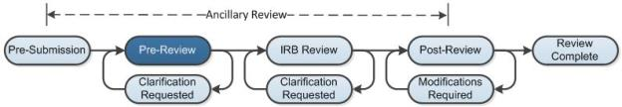

Initiating Ancillary Reviews
Both study team members and IRB staff can add ancillary reviewers to a study, modification, or continuing review as follows:
- Study team members can add ancillary reviewers to a submission before submitting it for IRB review.
- IRB staff can add ancillary reviewers before or after it has been submitted for IRB review.
- Both can add individuals and organizations as reviewers.
Organizations must be set up in advance with specific ancillary reviewers or no one will receive the ancillary review notification for the organization. A PI's profile can be set up with a set of default ancillary reviewers, such as her department, to be included in all new studies (but not modifications or CRs) she creates. If your standard process includes ancillary reviews, performing these setup steps is critical. For instructions, see the online help.
For example, when a study is created, any ancillary reviewers identified in the PI's profile gain access to the study. When the PI adds more ancillary reviewers, they also gain access. When the study is submitted for IRB review, the reviewers receive notifications.
The IRB staff can add ancillary reviewers at any time before the study transitions from Post-Review to its final state, such as Approved. Any reviewers added after the study is submitted receive notifications when the IRB staff member adds them.
Note: Ancillary reviewers identified in the PI's profile are not automatically included in modifications and CRs created by the PI. Any ancillary reviewers must be added manually for each modification and CR.

Notifications and Ancillary Review Feedback
Ancillary reviewers are identified as required or optional by the person adding them to a PI’s profile or an individual submission. A required ancillary reviewer receives the submission in My Inbox, where it remains until the review accepts the submission. An optional reviewer does not see the submission in My Inbox. Both required and optional reviewers receive a notification and can use the Submit Ancillary Review activity to provide feedback.
If any reviewer, required or optional, contacts the IRB to provide feedback, the IRB staff can add the reviewer's comments into the system using the Manage Ancillary Reviews activity to update the review. IRB staff can also modify the optional/required setting of a reviewer on the submission.
Ancillary review feedback is visible on the Reviews tab to everyone who can access the submission. For details, see the online help.

Decisions Regarding Ancillary Review Feedback
Depending on your IRB policies and the individual situation, the IRB staff may choose to use ancillary reviews in many different ways. For example:
- Treating all ancillary reviewers as optional and not waiting for responses.
- Letting the IRB review and approval proceed without the response of a required ancillary reviewer.
- Letting the IRB review proceed, but waiting for an required ancillary reviewer response before approving the submission.
- Pausing the IRB review process at any point until the required ancillary reviewers respond. This may involve forcing completion of the ancillary review by requesting clarifications or modifications from the study team (to officially put the submission back in the study team members' inboxes).

External IRB Process Overview
When the local IRB cedes authority over a study to an external IRB of record, the local IRB system tracks minimal information about the study throughout its life cycle. The basic process for reviewing and tracking an external IRB study locally is shown in the following diagram.
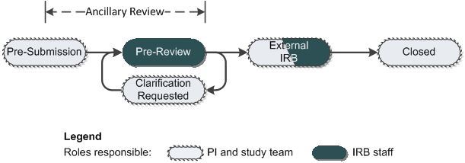
The legend indicates who can take major actions during each state within the process. Keep in mind that the diagram does not show all possible paths that a submission may take. The diagram shows the most likely path through the review process with common options identified.
Studies include optional ancillary reviews that can be conducted concurrently with the IRB's reviews. External IRB studies have a shortened IRB review process and allow ancillary reviews to be submitted only until the study enters the External IRB state. For more ancillary review information, see Ancillary Review Overview on page 6.
Notable information about several states is identified below.
Pre-Submission: During Pre-Submission, the PI typically identifies the study as being reviewed by a specific external IRB of record. In response, the forms greatly reduce the required information to submit the study to the local IRB, but add questions about the external IRB and its approval of the submission.
Pre-Review and Clarification Requested: In the Pre-Review state, the IRB coordinator reviews the study, including the external IRB information provided by the PI. The IRB coordinator can send the study back to the study team for more information or clarifications if needed, which lets the study team change the study.
When all of the needed information is supplied, the coordinator confirms the external IRB as the IRB of record, and the study enters the External IRB state.
External IRB: The study remains in the External IRB state until the external IRB closes the study. The PI and IRB staff can add or update the approval letter and the last day of approval as the external IRB approves the study and extends the approval period. When the external IRB closes the study, the PI or IRB staff must close the study in the local system.

Modification / CR Process Overview
The basic process for either a modification or continuing review (CR)—or both combined—is shown in the following diagram. The exploded view shows what occurs during the IRB review process.
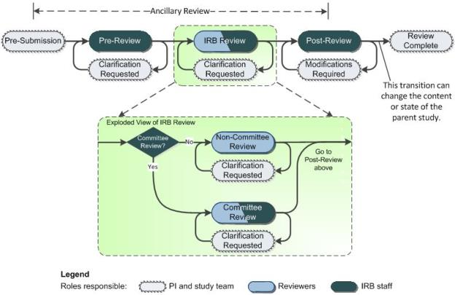
The legend indicates who can take major actions during each state within the process. Keep in mind that the diagram does not show all possible paths that a submission may take. The diagram shows the most likely path through the review process with common options identified.
Modifications and continuing reviews include optional ancillary reviews that can be conducted concurrently with the IRB's reviews. For more ancillary review information, see Ancillary Review Overview on page 6.
Because a continuing review often reminds the study staff to submit a modification, modifications and continuing reviews can be combined into a single submission or submitted separately. The beginning of the process prompts the PI to identify which submission type to create.

Modifications
When a study is approved, the system copies the approved study to create a draft study. When a modification is created, the draft study is updated with the proposed changes, while the approved study remains unchanged. When the modification is approved, the changes are published into the approved study.
A modification can apply to the study team membership, to the other parts of the study, or to both. The system allows only one modification at a time to each part of the study. For example, you cannot open a modification of study team membership if the study already has an open modification applying to study team membership or to the entire study.

Study Closure Through Continuing Review
When a CR indicates that the top four research milestones listed on the form have been met, the parent study is closed automatically when the CR is approved. The top milestones indicate that all enrollment, interventions, and handling of subjects' private identifiable information is complete.
In the Post-Review state for a study being closed, the study closure letter template is presented instead of the approval template. The letter, along with the closure e-mail notification that is sent, inform the PI of the study closure.

Combined and Separate Modifications and Continuing Reviews
Modifications and continuing reviews can be created either separately or combined into a single submission. Combining them often makes sense. For example, suppose the study team wants to submit a consent form change about the same time that a continuing review is due. Both can be submitted and reviewed together, reducing the overhead for the study team, IRB staff, and reviewers.
Caution for separate modifications and CRs:
In one situation, separate modification and CR submissions that are open concurrently can both affect the study's attached documents. This creates potential contention over the finalization and stamping of documents. Contention can occur when a CR (or a combined modification / CR submission) is open concurrently with a separate modification that includes other parts of the study (not limited to study team membership).
To handle potential conflicts in these situations, we recommend this approach:
- Approve the modification first before approving the CR (completing it through the Send Letter activity). This prevents contention.
- If you must approve the CR first, be aware that the modification will later overwrite the stamping of documents done by the CR. To correct this, make sure you finalize again in the modification all documents you finalized in the CR.

Pre-Review for Modifications and Continuing Reviews
Pre-review information is read-only for continuing review submissions and for modification submissions that are limited to study team membership changes. These types of submissions should not affect the pre-review information, so only the final question on the Submit Pre-Review form requires an answer.
For modifications and modification / CRs that include other parts of the study, the Submit Pre-Review form is fully editable, and the answers update the study's pre-review information when the modification is approved.

RNI Process Overview
The basic process for reportable new information (RNI) is shown in the following diagram. The exploded view shows what occurs during the IRB review process.
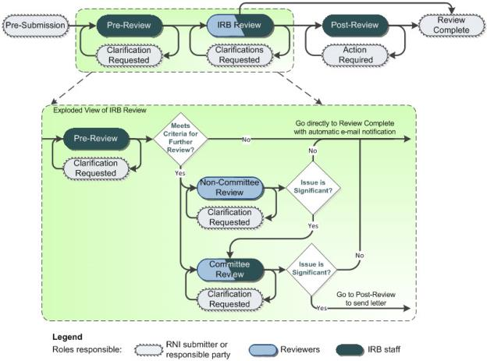
The legend indicates who can take major actions during each state within the process. Keep in mind that the diagram does not show all possible paths that a submission may take. The diagram shows the most likely path through the review process with common options identified.
Unlike all other submission types, an RNI submission:
- Does not include ancillary review.
- Can be reviewed and closed by an IRB coordinator if not deemed to be serious.
- Transitions from completion of designated review to committee review if deemed to be serious.
- Can be assigned to a responsible party for follow-up action.
Any registered user can create and submit new information.

RNI Review Workflow
The RNI workflow uses similar states to a study, but the IRB review process routes the submission differently depending on the significance of the determinations selected. This reduces the IRB's time spent handling insignificant issues. The rules are:
- When an RNI submission is not considered a serious* issue, the submission transitions directly to the Acknowledged state and sends an e-mail notification indicating that the review is complete.
- Any RNI submission that represents a serious* issue must eventually go through committee review to determine any follow-up actions. After committee review, serious* submissions go to the Post-Review state so the coordinator can prepare and send a letter.
* Serious: For an RNI submission to be considered a serious issue, the determinations selected must include an unanticipated problem involving risks, serious or continuing non-compliance, or suspension or termination of IRB approval. If none of these are selected, the workflow routing handles the RNI as less significant.
RNI Pre-Review
The review process starts with a pre-review that enables the coordinator to make the final determinations regarding any RNI submission that is not considered serious.
- If the RNI submission is not considered a serious issue and is not marked as "Additional review required," the submission transitions directly to Acknowledged.
- Otherwise, the coordinator can assign the submission to a designated reviewer or to committee review.
Important! For RNI submissions related to VA studies, a designated reviewer or committee must always review the submission. The coordinator should select the determination "Additional review required" and then assign the submission for further review.
If the related studies are added to the RNI, the forms for Submit RNI Pre-Review and Submit RNI Designated Review display text to alert the reviewer that the submission is associated with a VA study.
RNI Designated Review
The RNI designated reviewer starts from the determinations selected in pre-review and can modify them as needed.
- If the RNI submission is not considered a serious issue, the submission transitions directly to Acknowledged.
- Otherwise, the submission transitions to Committee Review so it can be assigned to a meeting.
RNI Committee Review
The committee review starts from the determinations selected in the previous review and can modify them as needed.
- If the RNI submission is not considered a serious issue, the submission transitions directly to Acknowledged.
- Otherwise, the submission transitions to Post-Review so a letter can be prepared and sent.
The committee can also require follow-up actions to resolve the issue, as described below.

Action Required Workflow
For issues considered serious based on the selected determinations, the committee can indicate that follow-up action is required to resolve the reported issue, specify an action plan, and assign a responsible party for carrying out the plan. In Post-Review, the generated letter includes the action plan and is sent to the responsible party in addition to the other involved individuals.
If action is required, the submission transitions from Post-Review to Action Required when the letter is sent. The responsible party can respond using the Submit Action Response activity when the action has been completed. Then the completed action can be reviewed and verified in the Action Submitted state by the coordinator, director, committee administrator, or committee chair. Alternatively, the submission can be assigned to a designated reviewer or to committee review to verify the completed action.
To assist reviewers, the Action Plan tab displays the latest action plan and all activity history that may have specified or changed the action plan, reviewed the completed actions, or changed the responsible party.
Tip: If you assign a submission to committee to review the required actions, follow these steps to capture the correct information to be shown in the meeting minutes:
- Make sure you use Assign to Meeting to get the submission on a meeting agenda.
- Use the Review Required Actions activity to verify completion of the action.
- If the actions were completed as required, from the Post-Review state, use Submit RNI Committee Review as follows:
  - If the action was completed correctly, leave "Is further action required" set to Yes. Don't make changes to the action plan or other action-related questions.
  - Add text to the additional information and notes to say that the action was verified as completed.
  - Record the votes and other details from the meeting that should display in the meeting minutes.
- Review the generated minutes document and update it if necessary to ensure that all the appropriate information for this review is included.

Related Studies and Modifications
An RNI submission can be associated with one or more studies, or with no study at all. For example, a research coordinator might allege that an investigator is conducting research that was never submitted to the IRB for review. It would not make sense to associate this RNI submission with a study within the system.
An RNI submission can also be associated with a modification to a study, such as a modification that is created in response to the reported information.
There are a few methods for associating an RNI submission with related submissions:
- When the RNI is created from a study's workspace, that study is added to the RNI's list of related submissions.
- When creating the RNI, one of the questions enables the submitter to add related studies and modifications.
- After creation of the RNI, the Add Related Submissions activity can be used activity to add related studies and modifications. The activity is available to the submitter, coordinator, director, committee chair or administrator, responsible party, and the PI or PI proxy of any study that is already related.
The PIs, PI proxies, primary contacts, and study team members of all related studies are given read access to the RNI submission. All of these parties except the study team members receive the same e-mail notifications as the RNI submitter throughout the workflow.
When adding a related modification, you must add the study that is being modified first. For additional tips, see the Help for the specific question or form where you are adding the related submission.

Document Change Process Overview
As a result of IRB reviews or changes to research, the study team may need to make changes to a study's documents.
We recommend using Track Changes functionality to easily identify changes for reviewers. When the documents are approved, the IRB software will automatically accept the changes and remove any comments in the final versions.

Process | Recommended steps for using tracked changes
Study staff updates the original study documents. | Retrieve the documents from the Documents tab for the study.  Edit the original documents with change tracking enabled and then replace the originals with the tracked-changes versions.
IRB reviewers review the study. | Use the review features in Word to toggle between showing the original and final versions of the document.  No changes are made to the documents; documents remain in tracked-changes format.
IRB coordinator or director approves the documents using the Finalize Documents activity. | Finalizing the documents accepts the tracked changes and removes any comments to create a final version of the document. The draft version will still have the tracked changes.  The draft and final documents appear on the Documents tab for the study.

Access to Studies by Role
Your access to a study is personalized based on your role in the system and the role you play in relation to the particular study. The following table summarizes the policies controlling the visibility of submissions (both studies and follow-on submissions):

User role | Information visibility
Study staff, registered user | Access to submissions that include you on the study team or guest list. You cannot view the assigned reviewers or committee members, or gain access to the reviewers' comments. You can view the date and time of any meeting to which the submission is assigned.
IRB staff, IRB committee members | Access to all submissions. For studies that include you on the study team, you cannot gain access to the IRB reviewers' comments.
Ancillary reviewers, other reviewers who are not IRB committee members | Full access to submissions assigned to you for review.
Site manager | Full access to all submissions.

Performing Basic Administration Tasks
IRB staff members play a key role in preparing for reviews, moving a submission through the stages of review, and communicating the results to the study team. Here are a few keys to the process:
- Assigning each submission to an IRB coordinator is a crucial step to allowing further actions to be taken on the submission. Any IRB staff member can assign a coordinator, as described in Assigning Ownership of a Study on page 19.
- Your inbox provides a helpful list of items that need your attention. For details, see Locating Your To-Do List on page 16 and Understanding My Inbox on page 20.
- One of the more complex IRB processes is running a committee meeting. For a checklist to help you through the process, see Checklist of Committee Meeting Tasks on page 22.

Locating Your To-Do List
IRB studies that are assigned to you for action generally appear in My Inbox with a link to the study. You may also receive an e-mail with a link to the study. An e-mail indicates that you must take action or informs you of important changes, such as an IRB decision about your study.
Note: A continuing review, modification, or RNI (reportable new information) submission can be handled similarly to a study.
To access a study that does not appear in My Inbox, see Accessing a Study on page 18.
To access studies or other submissions assigned to you:
- Click the My Inbox link in the top right navigation header.
- Identify the reason the study appears in My Inbox by looking at the State column. (For explanations, see Understanding My Inbox on page 20.)
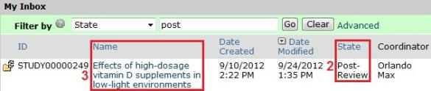
- Open the study by clicking the link in the Name column.
The study workspace opens.
To view the details of the study, click View Study on the left. For instructions, see Viewing the Study Details on page 19.

Navigation Elements Within a Study
Once you open a study, you see the study workspace. The workspace is your access point for:
- Viewing the study contents and details, including all actions performed on it
- Performing actions on the study
The figure below identifies the key workspace elements that help you find your way around the IRB system and perform actions on the study.
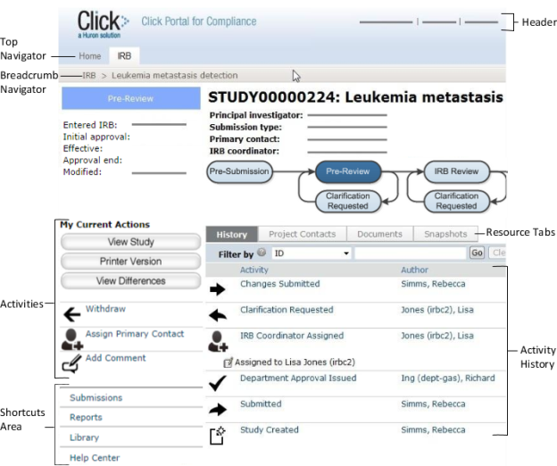
The key elements shown (from top to bottom) are:
- Header: Provides links to your profile and to My Inbox, and lets you log in and log off
- Top navigator: Provides links to the major sections of the system you are allowed to access
- Breadcrumb navigator: Tracks your movement through the hierarchy of pages and enables you to quickly move back to a previous location
- Activities: Lets you take appropriate actions—such as viewing the study—based on the study's current status
- Resource tabs: Gives access to collected study information, such as the study team membership, documents attached to the study, and older versions of the study.
- Activity history: Displays the actions taken previously on this study
- Shortcuts area: Provides quick links to other frequently used areas of the system, and to documentation resources

Accessing a Study
You may want to open a specific study to view or update its contents, submit it for review, review it, or take other actions on the study.
Note: Your access to a study is personalized based on your role in the system and the role you play in relation to the particular study. In addition, the actions you can take on a study are personalized.
To open a study, click its name when you find it in a list of studies.
To find a list that includes the study, try these suggestions:
Check this list... | For... | How to find this list
My Inbox | Studies assigned to you for action, such as a study you are:  - Preparing to submit  - Assigned to review | Click the My Inbox link in the top right navigation header.
IRB In-Review tab | Studies the IRB has not reviewed or for which it has not communicated a decision | Click IRB in the top left navigation area and select the In-Review tab.  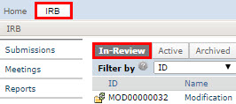
IRB Active tab | Studies approved by the IRB and currently in progress | Click IRB in the top left navigation area and select the Active tab.
IRB All Submissions tab | All studies, continuing reviews, modifications, and reportable new information (RNI) entered into the system that you have permissions to view | Click IRB in the top left navigation area and select the All Submissions tab.  Tip: Try filtering this list by the study name or principal investigator. Next to Filter by, select Name or Investigator. Then type the beginning of the name and click Go.
IRB New Information Reports tab | Reportable new information (RNI) submissions, possibly related to one or more studies | Click IRB in the top left navigation area and select the New Information Reports tab.

Assigning Ownership of a Study
Before an IRB coordinator can take action on a study, the study must be assigned to the coordinator. Any coordinator or the IRB director can take ownership of the study or assign it to another coordinator. The study can be reassigned at any point to handle vacations, changes in workloads, etc.
When a study is first submitted to the IRB, all IRB coordinators see the study in My Inbox. After a coordinator is assigned, only the assigned coordinator sees the study in My Inbox, only when the IRB needs to take action.
To assign a coordinator:
- Open the study.
- Click Assign Coordinator on the left.
- Select yourself or another coordinator.
- Click OK.
The coordinator gains access to activities that are reserved for the assigned coordinator and can move the study through the IRB process.

Viewing the Study Details
As a reviewer or IRB staff member, you often need to view all the information submitted as part of the study.
To view the details of a study:
- From My Inbox, click the name of the study to open it.
Note: If the study does not appear in your inbox, see Accessing a Study on page 18.
- Click View Study on the left.
Tips:
- For a continuing review or modification, click View Modification / CR instead.
- For a new information report, click View RNI instead.

- Use the Continue and Back buttons to view all of the forms.
Tip: Clicking Continue from the Supporting Documents page (the last page of the forms) exits the study.

To view the documents submitted as part of the study, you have these options:
- While viewing the details of the study (as instructed above), click the name of each document when you encounter it on the various forms. Documents are listed in tables throughout the forms.
- When you have opened the study workspace (as in step 1 above), you can view a list of all the attached documents in one place by clicking the Documents tab.
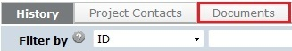
Tip: If the study team updated the documents, they may contain tracked changes. You can use the review features in Word to toggle between showing the original and final versions of the document. When the IRB approves the documents, all tracked changes will be accepted and comments removed in the final versions.
To view the information entered for pre-review:
- Open the study as instructed in step 1 above.
- Click the Reviews tab.
Tip: If the information entered for pre-review is inaccurate, contact the study's IRB coordinator to request a change. The coordinator can change the pre-review information until the decision from designated or committee review is submitted.

Understanding My Inbox
The list called My Inbox contains studies or other submissions that require you (or your team members) to take action. See the examples below to understand what you should and should not expect to appear in My Inbox.
Tip: Look at the State column in My Inbox, and see the explanation for that state in the table below.
Your role | In My Inbox |  | Not in My Inbox
 | State | Explanation
Research team
Study team member or study's primary contact  Note: Any team member can make changes to the study, but the PI must personally submit the changes or response to the IRB. | Pre-Submission | Complete the study forms. The PI must submit it to the IRB to let the review begin. | Studies the IRB is reviewing
 | Clarification Requested | Change the study to clarify as needed, and provide summary notes to the IRB when submitting the changes.  Note: If the clarification was requested from Committee Review, you can only provide notes. You are not allowed to change the study. | Approved studies
 | Modifications Required | Modify the study to meet IRB requirements and submit it with changes. | Closed studies
Reviewers and committee members
IRB committee member or occasional reviewer | Non-Committee Review | You have been designated as the reviewer for this exempt or expedited study. You must submit your final review before the IRB decision can be communicated to the study team. If you request clarifications, the study comes back to you to finish the review after the clarifications are made. | Studies assigned to other reviewers
 | Committee Review | You may be part of the committee that will review this study. If so, review the study details in advance. You can request clarifications. Record your notes and recommendations in the system before the meeting as described in the online help. | Studies assigned to other committees
Ancillary reviewer | One of several | You have been selected as a reviewer (either by name or representing a specific organization). The IRB can begin its review before you submit your review. The IRB may or may not wait for your input before completing its review of the study. | Studies not yet submitted for review
IRB administrative staff
IRB coordinator (IRBC) | Pre-Review | Newly submitted studies appear in all coordinators' inboxes until a coordinator is assigned. (See the Coordinator column of My Inbox.) The assigned coordinator must submit a pre-review and assign the study to designated review or a committee. | Studies not yet submitted to the IRB
 | Post-Review | The IRB decision has been made. You must prepare correspondence and send it to notify the investigator of the decision. You can also finalize study documents to create a permanent record. | Studies being reviewed by individual reviewers
 | Committee Review | You can assign the study to a particular meeting, remove it from a meeting agenda and reassign it to another, and assign specific reviewers. The IRB director, IRB chair, or you must submit the committee's review decision. | Studies assigned to other IRBCs
Committee chair | Committee Review | The study has been assigned to your meeting. The IRB director, IRB coordinator, or you must submit the committee's review decision. | Studies assigned to other committees

Checklist of Committee Meeting Tasks
The checklists below identify the major steps for preparing for, conducting, and completing a committee meeting. The checklists assume you have already created the committee and the meeting.
Most steps are performed by the committee chair or committee administrator in the meeting workspace unless otherwise specified.

Preparing for Each Meeting
Well in advance of the meeting:
- Assign studies (Modifications/CRs/RNIs) to the meeting (from the study workspace).
- Assign reviewers to the studies assigned to the meeting (from the meeting or study workspace). Reviewers will be notified when you send out the agenda.
- Prepare the agenda.
- Send the agenda to committee members and any additional recipients.
Note: If you change the agenda after you have sent it out, use the Notify Reviewers action to inform reviewers of the change.
Just before the meeting:
- Edit the meeting attendance if you know who is planning to attend.
- Remove any studies in the Clarification Requested (Committee Review) state from the agenda if the missing clarifications warrant delaying a committee decision. Reassign the submissions to a later meeting.
Tip: Studies in the Clarification Requested (Committee Review) state that remain on the agenda will transition back to the Committee Review state when the meeting is convened.

Conducting the Meeting
We recommend dedicating one person to fill out the Submit Committee Review forms and record the non-submission information such as meeting start and end times.
During the meeting, it may be helpful to display study information and committee member review comments in the course of discussion. See tips for navigating to study information below.
Meeting administration:
- Record meeting times, attendance, and other non-submission items.
Tip: You may wish to record this information using the meeting minutes template. To do so, prepare the meeting minutes, save the generated document to your computer, and then use it to record the information. When you prepare the final minutes (as instructed below), copy and paste the items recorded during the meeting into the final version of the minutes.
- Convene the meeting. Note: Convene Meeting returns agenda items in the Clarification Requested (Committee Review) state to Committee Review.
- (Optional) Under "Previous meetings with minutes for approval," click a previous meeting to go to its workspace. Then you can display its minutes, approve them, and return to the current meeting.
- Click the Expedited Submissions Approved link to display the report.
Tip: To keep a permanent record of the approved expedited submissions reviewed during the meeting, export the report to Excel and save it to your computer. Later, copy and paste the information from the report into the minutes.
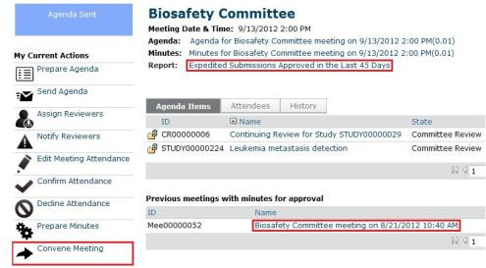
Tips for navigating to study information:
From the meeting workspace:
- To show study information, click the name of a study in the agenda items list.
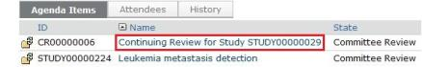
From the study workspace:
- To show study details in the forms, use View Study (Modification/CR/RNI).
- To show attached documents, use the Documents tab.
- To show information recorded during pre-review and comments from individual committee members, use the Reviews tab.
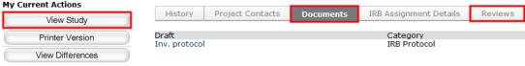

Recording decisions, events, and notes:
- From the individual reviewer checklists, reviewer comments, and committee discussion, fill out all relevant checklists to reflect the final committee opinion and reasoning. These files will be attached in the Submit Committee Review activity.
- Perform Submit Committee Review (or Submit RNI Committee Review for an RNI) to record decisions and information for each submission reviewed. Attach the relevant checklists. Note: The IRB coordinator assigned to the study can also submit the committee review.
Important! Don't miss the Submit Committee Review or Submit RNI Committee Review step. Correspondence cannot be prepared and sent to the investigator for a study until this step has been completed.
Tip: If there is not enough time to completely fill out the committee review form during the meeting, finish it as soon as possible after the meeting. You can complete some of the form and select "No" to the question "Are you ready to submit this review?" The system will save what you have entered so you can update and submit it later.

Wrapping Up After the Meeting
- If you haven't yet submitted the final committee review for each study, do so now to move to the next steps.
Tip: From the meeting workspace, look at the Record Decision column for the agenda items. The column will indicate Submit Committee Review or Submit RNI Committee Review if the action has not yet been completed.
- Prepare the minutes. The minutes will contain the committee decisions for each study.
- Open and save the minutes on your computer. Add the meeting times, attendance, and any other non-submission items to the minutes. Note: If you used the minutes template to record information during the meeting, simply cut and paste the information from that document into the minutes.
- Perform Prepare Minutes again to upload the revised minutes.
- Follow your internal processes to obtain the appropriate approvals of the meeting minutes.
- Inform the IRB coordinator(s) that they can send correspondence to the investigators. For each study, the assigned coordinators:
- Finalize the study's attached documents to create an approved, stamped copy (optional).
- Prepare a letter to inform the study's investigator about the IRB's decisions.
- Send the letter to the investigator.
- Send the minutes to the committee members.
- Close the meeting.
- After the period for receiving comments from committee members has passed, perform Approve Meeting Minutes.
Tip: Until you perform this action, the minutes are listed in the next meeting's workspace with the approve activity available there as well.

Generating Standard Reports
The IRB system includes many standard reports regarding studies and reportable new information (RNI) to help you find relevant submissions and understand the overall operation of the IRB. In addition, your institution may create custom reports.
For information about the advanced reports that can help you monitor the performance of your IRB, see the IRB Advanced Reports Guide.
The reports provide links to the individual submissions, as well as sorting and filtering options.
Any user has access to reports, but the data in the reports is limited to the studies visible to the individual. For example, a Studies Involving Children report generated by a PI will include only the studies that person is allowed to see elsewhere in the system--studies for which the person is included on the study team or guest list. IRB coordinators, directors, and committee members generally have access to all report data.
To generate a standard report:
- Click IRB in the top navigator.
- Click Reports on the left.
The list of standard study and RNI reports appears.
Tip: To find a custom report, click the Custom Reports tab.
- Identify the report to generate and click the link.
The report appears, listing the relevant submissions.
Tip: Try filtering the list by status. Next to Filter by, select Status. Then type the state to view, such as Approved for a study report or Acknowledged for an RNI report and click Go.

Producing the AAHRPP Annual Report
The IRB system can complete a large portion of the AAHRPP annual report for you, while letting you fill in the information that is not stored in the IRB system.
Note: Site manager permissions are required to perform the initial setup step. IRB director permissions are required to generate the report.
To update contact information to include in the report:
- Log in with site manager permissions.
- Update the IRB Settings area with appropriate organization and contact names to be included in the report. For detailed instructions, see the IRB Deployment Guide.
- Log off.
To generate the AAHRPP report:
- Log in with IRB director permissions.
- Click IRB in the top navigator.
- Click Reports on the left.
- Click Generate AAHRPP Report on the left.
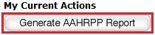
A new window opens.
- Select the IRB office to include in the report.
- Click Generate.
A link to the generated report appears in the same window.
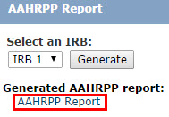
- Click the link and choose to save the report as a Microsoft® Word file.
Important! The report is not stored in the IRB system, so save the file in an appropriate location for later retrieval if you need to keep a permanent copy.
- Click Close to dismiss the window.
To complete the generated report:
- Open the saved file.
- Review the answers that are filled in, and adjust the answers as necessary if the IRB system does not contain complete data (or add the information to the IRB system and regenerate the report).
- Answer the questions that are blank, saving the file often.
Tip: To mark a check box:
  - Right-click the box and select Properties.
  - Under Default value, select Checked.

- Scroll through every page, being sure to answer each question.
- Follow the checklist located at the end of the document, verifying the report contents and creating a PDF file to send to AAHRPP.

Finding More Information

Resource | Description | How to Access It
Help for a field or page | More information about a question or form. | Click next to the question or at the top of the form.
Help system | The full online help system, with search and table of contents.  The online help contains procedures and information for all users. | - Click the Help Center link on the left.  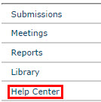  - Then click Help with Search at the top of the page.
IRB Study Submission Guide | Instructions for submitting a study for review. | - Click the Help Center link on the left.  - On the Guides tab, click the name of the guide to open it.
IRB Study Reviewer's Guide | Instructions for reviewing an IRB submission.
IRB Staff Administration Guide | An overview of the IRB review and administration process.
IRB Library | Document templates, checklists, and IRB procedures. | Click the Library link on the left.

