Create and Submit a New Study
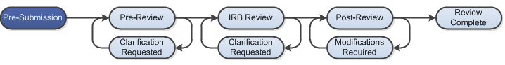

Work Instructions: THESE DIRECTIONS ARE FOR THE PI TO SUBMIT A NEW PROTOCOL FOR APPROVAL

- As the PI, log into the PACS Portal and click on the My Inbox next to your name on the top right of the screen.

- Next click the IRB tab on the left side of the navigation screen.

- Under My Current Actions, select the Create New Study button to create a new study.

- Enter the required information on the first page of the Basic Information SmartForm. You will be in the “Pre-Submission” state.
  - Required information fields are marked with an asterisks (*).

- Click Continue at either the top or bottom of the form.

- Navigate through all of the SmartForms and complete all of the required fields
  - Click the help icon ( ) for more information about a question or field

- Click the Hide/Show Errors link near the top of the SmartForm page to display any unanswered questions.
- Use the Jump To: link to navigate directly to SmartForm pages that are missing information
- Studies with any incomplete information will be redirected to the research team for updates

- When all of the required fields have been completed, click Finish in the footer of the last SmartForm page. Your study has not yet been submitted for review.

- The PI must go to My Inbox to access the study and click the Submit icon located under My Current Actions on the left side of your workspace. This activity will remind the PI of their responsibilities and the system will check the submission for any missing fields. The PI will need to re-authenticate into the system to click the OK button to submit the study to the IRB.

- If the submission is successful, the page will refresh and the study will transition from the “Pre-Submission” state to the “Pre-Review” state as identified by the workflow diagram at the top of the workspace.

Your submission will now be routed to the HSRR office for Pre-Review. The HSRR office may ask for Clarifications which is now done through PACS. You will be notified via email that you have a Clarification Requested.

See the Clarification Requested and/or Modifications Required worksheet for instruction.

