Respond to Clarification Requests
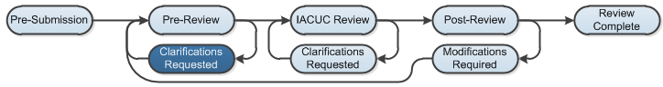

Work Instructions:
If a reviewer has questions or requires you to change your submission during either the Pre-Review or IACUC Review stages, you will receive an e-mail indicating this. Review the request details and then respond to the request.
- Click the link embedded in the email notification to open the submission.
Alternatively, log in to Click Portal, then open the submission from My Inbox.
- On the History tab, find the “Clarification by…Requested” activity and read the comments.
- Check to see if the reviewer added notes to the submission: Click the Reviewer Notes tab (in the Resource tabs).
  - For each Reviewer Note, you can either:
  - Click the link Click here to respond…. Select a response from the drop down list that appears (Change Request Completed; Change Request Not Completed; or Reviewer Information Only). Elaborate on what you did in the text box, then click OK.
  - Alternatively, click the Jump To: link to go directly to the page with the Reviewer Note so that you can see the note in context, and then respond.
  - If there are no Reviewer Notes, proceed to Step 4.
- Click Submit Response. In the Comments section, explain your response to the reviewer. Add Supporting Documents if that is appropriate, then click OK.
- The submission will move out of Clarifications Requested, and will return to either Pre-Review or IACUC Review.

