Navigation Tasks

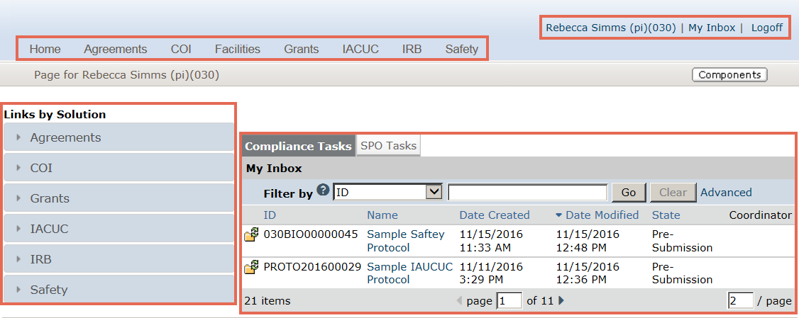
D
C
B
A

My Inbox:
My Inbox is a personal page that lists projects that require action to move forward. Think of My Inbox as your “to-do list”.
- This section lists any items that require action to move forward. The Inbox will contain items from all of the modules in the Click Portal. The Compliance Tasks tab will show protocols from the IACUC, IRB, and Safety modules.
- This is the header. The header contains a link to the My Inbox page, as well as a link to log out of the system.
- This is the top navigation menu. Click the name of the appropriate module to navigate to that solution.
- This shows the Links by Solution. Click on a link to show the actions available to you for that solution.

Basic Tasks from My Inbox:
- How do I open a submission?
Locate the Name column. Click on the submission’s Name and the submission opens to the workspace.
- How do I determine the state of a submission?
Locate the State column. The State column tells you the State, or stage, the submission is currently in. The state suggests what action you will take. For example, Pre-Submission means that you haven’t submitted the protocol. You can finish and submit it for review.
- How do I determine the actions that I can perform?
Click on the Links by Solution buttons to see the actions you can perform for the selected module.
- How do I return to the My Inbox page?
Click the My Inbox link in the header in the upper right hand corner.

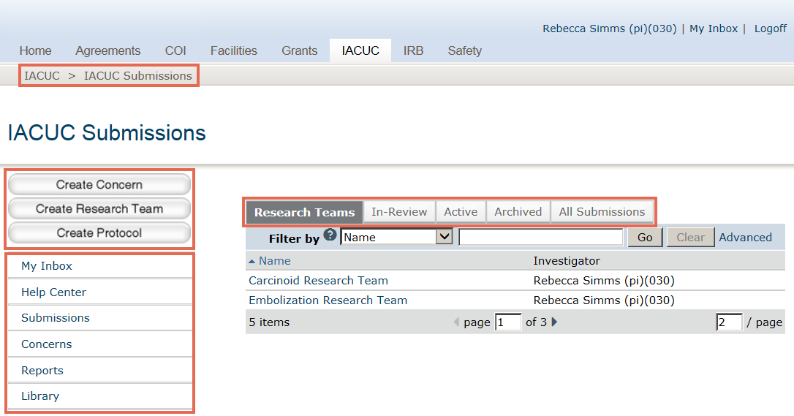
A
B
D
C

IACUC Submissions
The IACUC Submissions page collects all the IACUC studies that you have permission to see.
Note: Studies that require action to move forward are found on the My Inbox page or on your research team’s workspace.
- The resource tabs collect information.
  - Research Teams – This tab shows the research teams that you are a member of.
  - In-Review – This tab shows submissions undergoing IACUC review.
  - Active – This tab shows approved submissions.
  - Archived – This tab shows discarded and closed submissions.
  - All Submissions – This tab shows all submissions, in any state.
- The breadcrumb trail shows where you are in the system and can be used to find your way back to your starting point.
- You will use the project creator buttons to create a concern, a research team, or a protocol.
- A shortcut takes you to a specific page.
  - My Inbox – This shortcut takes you to your My Inbox page.
  - Help Center – The Help Center provides program documentation and videos.
  - Submissions –The submissions page collects all the IACUC studies that you have permission to see.
  - Concerns – This shortcut takes you to concerns and deficiencies.
  - Reports – This shortcut takes you to reports. Reports only include studies that you have permission to see.
  - Library – This tab is primarily used by other solutions, but it may contain documents used by your IACUC.

Basic Tasks from the IACUC Submissions Page
- How do I start a protocol?
Open your research team’s study workspace, then start the protocol.
- How do I see the status of a protocol that is in the hands of the IACUC?
Click the In-Review tab.
- How do I get help?
Click the Help Center shortcut.

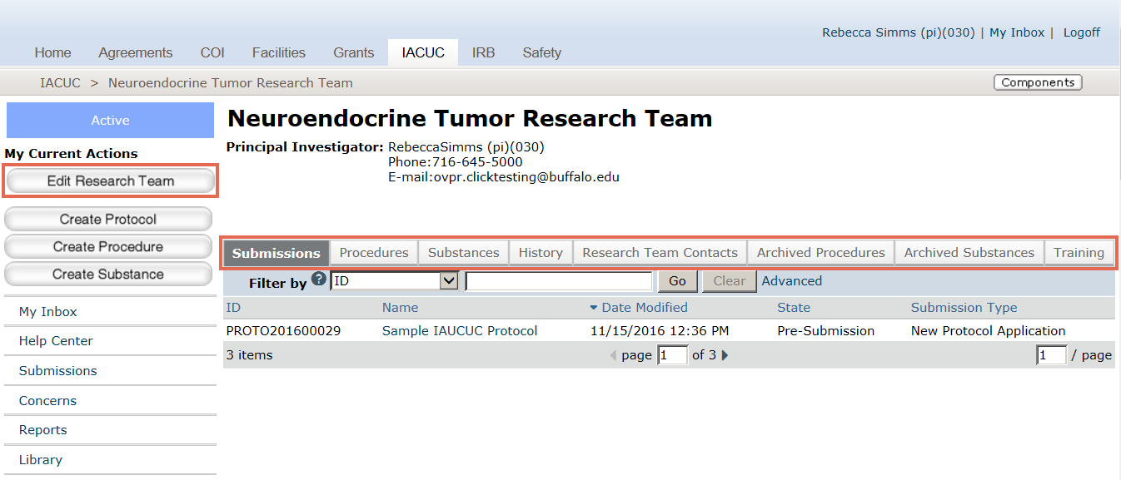
B
A

Research Team Workspace
Protocols are created from the research team workspace.
- The resource tabs collect information.
  - Submissions – This tab shows all the submissions for this research team, from pre-submission to closed.
  - Procedures – The tab shows procedures from the standard library and team procedures.
  - Substances – This tab shows substances from the standard library and team substances.
  - History – This tab shows all of activity for this research team.
  - Archived Procedures and Archived Substances – This tab shows procedures and substances that are no longer being used.
  - Training – This tab shows training for each research team member.
- This is the Edit Research Team button. Use Edit Research Team to make changes to the research team.

Basic Tasks from the Research Team Workspace
- How do I find a study submitted by my research team?
Click the Submissions tab.
- How do I determine the procedures and substances that are available for my research team?
Click on Procedures or the Substances tab.

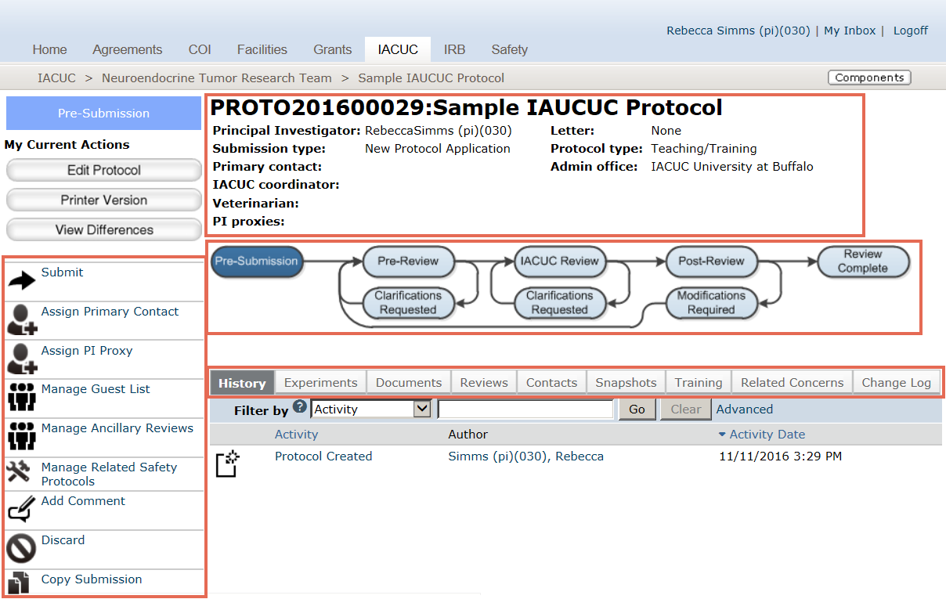
D
C
B
A

Study Workspace
All the information regarding a protocol is collected in the study workspace.
- Summary View – The summary view summarizes critical information about the protocol.
- Workflow Map – The workflow map shows the current state of the protocol.
- Resource Tabs – The resource tabs collect information about the protocol.
  - History – This tab shows the history of the protocol.
  - Experiments – This tab shows the experiments
  - Documents – This tab provides links to the documents associated with this protocol
  - Reviews – This tab displays reviews that you have permission to see based on your role.
  - Contacts – This tab lists the contacts for the study.
  - Snapshots – Snapshots are moments in the workflow captured by the system.
  - Training – This tab lists training of the research team members.
  - Related Concerns – This tab lists concerns that were submitted that are associated with this protocol.
  - Change Log – The change log shows any changes made after the initial submission.
- Activities – These are the activities that are available to you on this submission while the submission is in this state.

Basic Tasks from the Study Workspace
- How do I learn what has happened since a protocol was submitted?
Click the History tab.
- How do I access protocol documents?
Click the Documents tab.
- How do I learn the name of the IACUC Coordinator assigned to my protocol?
Look in the Summary View.

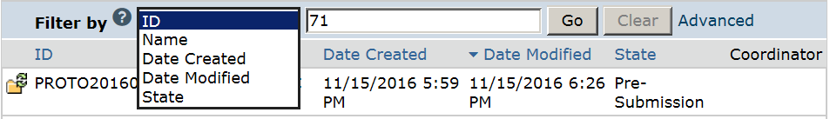
A
B
E
D
C

How to Filter Data
Any time you see a filter, you can use it to filter data.
- Select the column to Filter by.
- Use the (?) Help Icon to learn about the different operators you can type in (C).
- Type the beginning characters for the items you want to find. You can type a % symbol as a wildcard before the characters. For example, 71 shows all the items beginning with 71, whereas %71 shows all the items that contain 71.
- Click Go to apply the filter.
- To combine multiple criteria at the same time, click Advanced.

