Administrative Review: Pre-Review
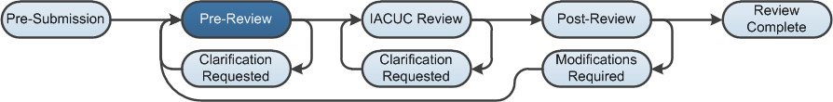

Work Instructions: Assign a Coordinator
After the Principal Investigator submits a protocol or follow-on submission for review, the protocol appears in the Inbox of all IACUC Coordinators for the University. The first step is to assign a Coordinator to handle the submission. Any user with an IACUC Coordinator or Director role can assign the protocol or follow-on submission to a Coordinator.
- Log into the Click Portal and click on the IACUC tab in the top navigation menu.
- From the In-Review tab, click the submission’s Name.
- Under My Current Actions, click Assign Coordinator
.
- Click the Select button, and select an IACUC Coordinator for this submission. It may be yourself, or you may need to assign another Coordinator to balance workloads, vacations, etc.
- Add Comments and Supporting Documents if necessary, and then click OK.
- The selected IACUC Coordinator will appear on the History tab.
- Click the Edit Protocol button to review the submission; use the Continue button to move through the SmartForm pages.

Work Instructions: Request Clarification
- While reviewing the submission, you may determine that some changes are necessary, or that you require additional information before you can submit a Pre-Review.
- Click Add in the Reviewer Notes bar to add notes on any of the SmartForm pages.
- Click the Exit or Finish button to return to the workspace.
- Under My Current Actions, click Request Clarification by Pre-Reviewer.
- Complete the page, making note of the change or additional information required, then click OK. The submission moves to the Clarification Requested state.

Note: The PI must submit a response to the clarification request. For the sake of this work instruction, assume the PI has responded satisfactorily. After the PI responds to the clarification request, the submission moves back to the Pre-Review state.

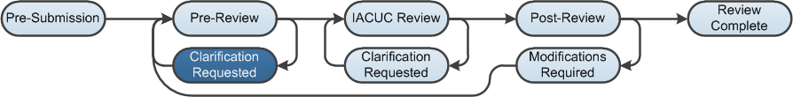

Work Instructions: Submit Pre-Review
- When you are satisfied that the submission is complete, click Submit Pre-Review.
- Complete the page, paying special attention to the fields listed below.
Note: Required fields are marked with an asterisk.
Question 1 - Select the committee:
Select the committee that will review this protocol.
Question 2 - Forward directly to full committee review?
- Yes: The submission moves to the Meeting Assignment state so the IACUC Coordinator can assign it to an IACUC Meeting for review.
- No: The submission will not be forwarded directly to a full committee review. It will move to the Grace Period state so that IACUC Committee Members can review it and determine whether it should go to full committee review.
Question 6 - Are you ready to submit this pre-review?
- Yes: If this submission will be forwarded directly to a full committee review, then submitting the Pre-Review will move the submission to the Meeting Assignment state so the IACUC Coordinator can assign it to an IACUC Meeting for review.
If the submission will not be forwarded directly to a full committee review, it will move to the Grace Period state so IACUC Committee Members can review it and determine whether it should go to full committee review.
- No: The submission stays in the Pre-Review state and you can return and finish the Pre-Review at another time (by clicking the Submit Pre-Review activity again).
- Click OK. If the submission is going to full committee review, the state moves to the IACUC Review: Meeting Assignment. If the submission is not going to full committee review, the submission moves to the IACUC Review: Grace Period state.
Note: After submitting the Pre-Review, an IACUC Coordinator can change some of the Pre-Review information by clicking Edit Pre-Review. This is possible until the decision from a designated member or committee review is submitted.

