Administrative Review: Designated Review
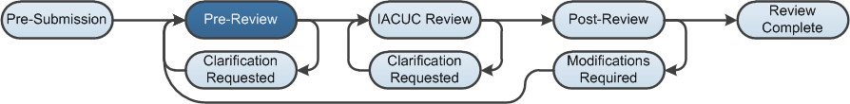

Work Instructions: Assign a Coordinator
If a submission is not forwarded directly to a full Committee Review, it will move to the Grace Period state so IACUC Committee Members can review it and determine whether it should go to full Committee Review.
If the Grace Period passes and it was not assigned to a Committee Review, the submission moves to a Designated Reviewer Assignment state and the IACUC Committee Chairperson can assign it to an individual Committee Member to review. After the Designated Reviewer is assigned, the submission moves to the Designated Review state.
- Log into the Click Portal and click on the IACUC tab in the top navigation menu.
- From the In-Review tab, click the submission’s Name.

Work Instructions: Request Clarification
- While reviewing the submission, the Designated Reviewer may determine that some changes are necessary, or that they require additional information before they can submit a Designated Review.
- Click the View Protocol button to review the submission; use the Continue button to move through the SmartForm pages.
- Click Add in the Reviewer Notes bar to add notes on any of the SmartForm pages.
- Click the Exit or Finish button to return to the workspace.
- Under My Current Actions, click Request Clarification by Designated Reviewer.
- Complete the page, making note of the change or additional information required, then click OK. The submission moves to the Clarification Requested state.

Note: When a Designated Reviewer requests a clarification, the submission is editable by the Principal Investigator (PI), and the PI must respond before the submission can move forward in the review process.
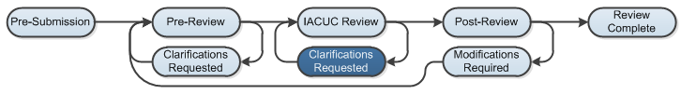

Work Instructions: Submit Designated Review
- When you are satisfied that the submission is complete, click Submit Designated Review.
- Complete the page, paying special attention to the fields listed below:
Note: Required fields are marked with an asterisk (*).
- Question 1 – Determination
Select from Approved and Modifications Required to Secure Approval.
- Question 2 - Last day of annual review period
The system enters this date, but it can be changed. Specify the last day of the annual review period; typically, this is: (Date of Approval) + (1 year) – (1 Day).
- Question 3 - Last day of triennial approval period
The system enters this date but it can be changed. Specify the last day of the triennial approval period; typically, this is: (Date of Approval) + (3 years) – (1 Day).
- Question 5 - Approval date
Specify the date the IACUC decision was made. Select the date the Designated Reviewer made the decision, not the date that you are submitting the Committee Review.
- Question 6 - Identify the modifications required or reasons for withholding approval
This field becomes required if the determination is Modifications Required to Secure Approval.
- Click OK. The submission moves to the Post-Review state.
Note: If the determination of Modifications Required to Secure Approval is selected, the submission moves to the Modifications Required state.
